Part C
Exhibits and Forms

EXHIBIT A
PROJECT MAP
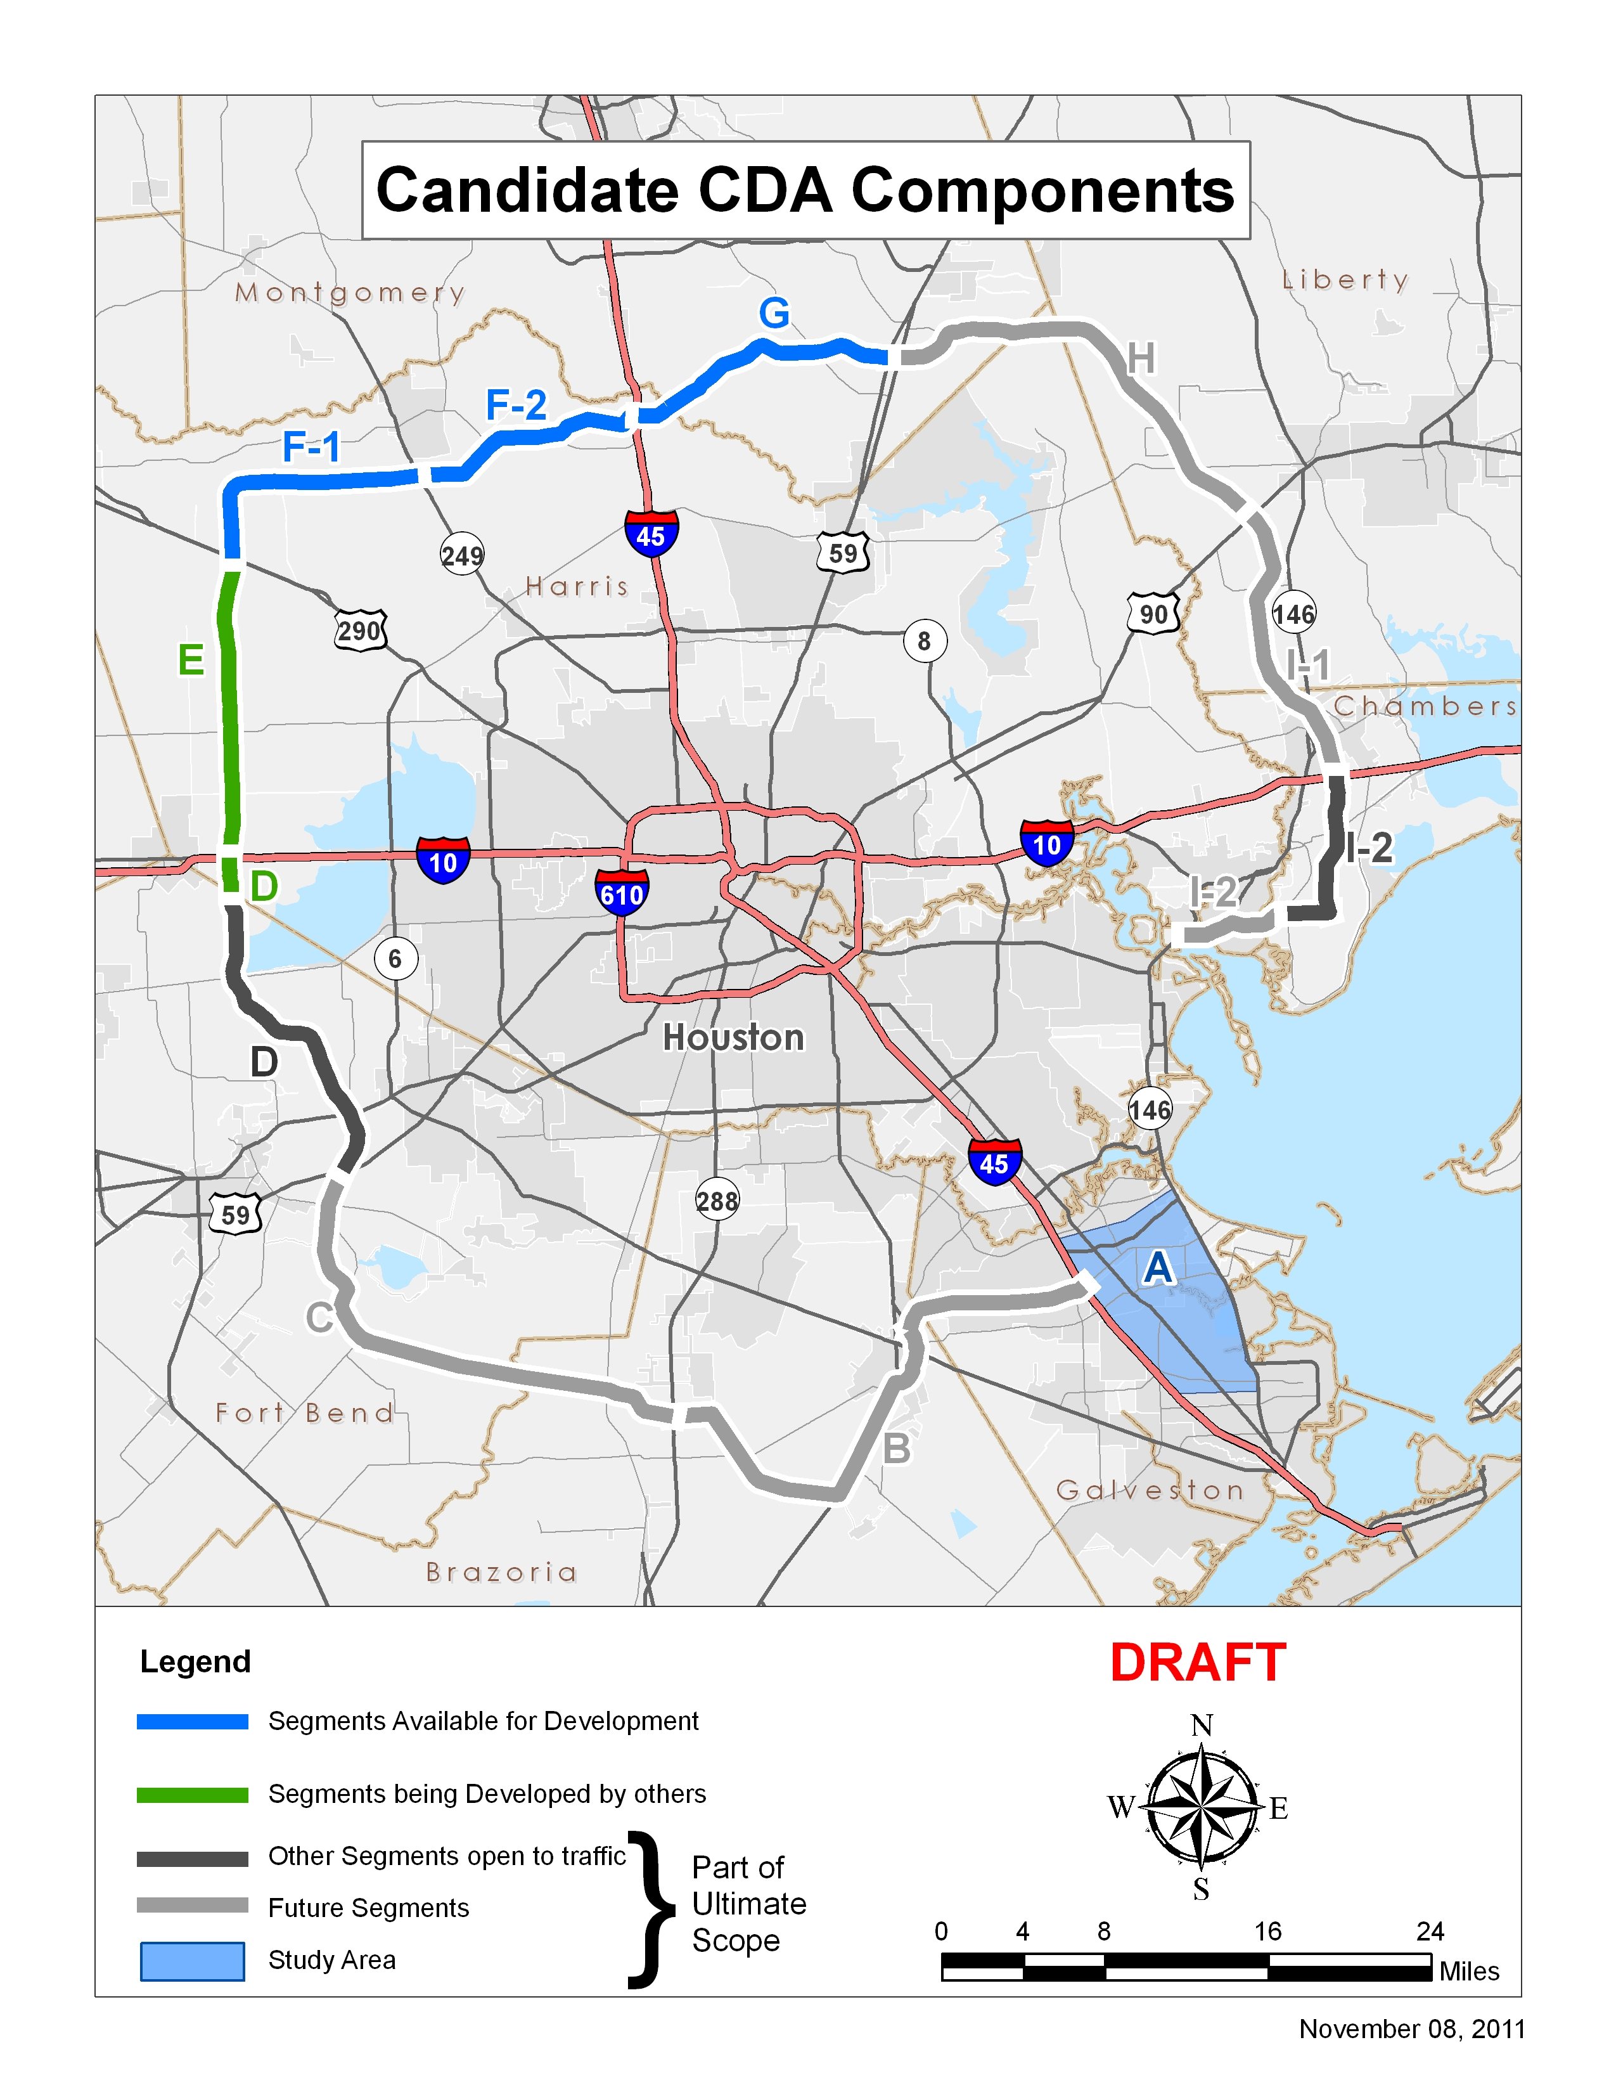
EXHIBIT B-1
TERM SHEET FOR DBA
[Provided Separately]

EXHIBIT B-2
TERM SHEET FOR CMA
[Provided Separately]

EXHIBIT B-3
TERM SHEET FOR CONCESSION P3A
[Provided Separately]

EXHIBIT C
ENVIRONMENTAL STATUS

Segment A: No environmental work has been undertaken for this Segment.

Segment B: A Draft Environmental Impact Statement (DEIS) is currently under development. A Final Environmental Impact Statement (FEIS) is anticipated to be released in 2013. A request for issuance of a Record of Decision (ROD) by the Federal Highway Administration (FHWA) is anticipated in 2014.

Segment C: A DEIS was released in May 2000. A DEIS re-evaluation received concurrence in July 2011. An FEIS is currently under development.

A request for issuance of ROD by the FHWA is anticipated by late-2012.

A Section 7 consultation with the US Fish & Wildlife Service (USFWS) has been completed regarding a protected species located within the project study area. A Biological Assessment and Biological Opinion have been approved by USFWS.

Wetland delineations and verification by the U.S. Army Corps of Engineers have been completed for the Preferred Alternative Alignment.

Segment D: This Segment has been open to the public since August 31, 1994. Mainlane overpasses from Westpark Tollroad south to US 59 will be constructed as toll facilities by Fort Bend County. An Environmental assessment (EA) Re-evaluation was issued in February 2008 and approved by TxDOT Environmental Affairs Division in September 2008.

Segment E: A DEIS was released in February 2003. The FEIS was signed by FHWA on November 19, 2007. The ROD was issued on June 24, 2008 by FHWA.

An FEIS re-evaluation was approved and a revised ROD was issued by FHWA on June 9, 2009. A FEIS re-evaluation for detention ponds was approved in March 2011.

USACE issued a 404 Permit June 2011.

Segment F-1: A DEIS was released on October 17, 2003. The FEIS was signed by FHWA on April 18, 2008. The ROD was issued on November 20, 2008 by FHWA.

An FEIS re-evaluation was approved on June 11, 2009 by FHWA and a revised ROD was issued by FHWA on June 12, 2009.

Another FEIS re-evaluation will be required for detention ponds included in this Segment.

Segment F-2: A DEIS was released on February 6, 2004. A revised DEIS was released on June 9, 2006. The FEIS was signed by FHWA on July 2, 2008. The ROD was issued on December 31, 2009 by FHWA.

Another FEIS re-evaluation will be required for detention ponds included in this Segment.

Segment G: A DEIS was released in February 2007. The FEIS was signed by FHWA on January 15, 2009. The ROD was issued on December 29, 2010 by FHWA.

Another FEIS re-evaluation will be required for detention ponds included in this Segment.

Segment H & I-1: A combined DEIS was approved by FHWA on May 10, 2011. The FEIS is anticipated to be released in mid-2012. Issuance of a ROD by FHWA is anticipated in 2013.

Segment I-2: A DEIS and FEIS were prepared and FHWA issued a ROD in August 1998.

The first phase of Segment I-2 (IH 10 to FM 1405) was opened to traffic on March 25, 2008. TXDOT is currently working on the design of Segment I-2 from FM 1405 to SH 146. An FEIS re-evaluation is currently under development.
FORM A
TRANSMITTAL LETTER

PROPOSER:____________________________________________
QS Date: [Insert Date]

Texas Department of Transportation
Major Projects Office
7721 Washington Ave.
Houston, Texas 77007
Attn: Mr. Eddie Sanchez, P.E.
The undersigned (“Proposer”) submits this qualification submittal (this “QS”) in response to that certain Request for Qualifications dated as of November 18, 2011 (as amended, the “RFQ”), issued by the Texas Department of Transportation (“TxDOT”) to develop, design and construct, and to, potentially, finance, operate and maintain tolled main lanes and related facilities along portions of SH 99 (the “Project”), through a Public Private Partnership Agreement (“P3A”). Initially capitalized terms not otherwise defined herein shall have the meanings set forth in the RFQ.
Enclosed, and by this reference incorporated herein and made a part of this QS, are the following:
Volume 1: Transmittal Letter (this Form A), Executive Summary, Confidential Information List, Proposer Information/Project Experience, Statement of Technical Approach, [Project Financing Experience and Conceptual Project Financing Discussion];
Volume 2: Financial Qualifications; and
Volume 3: Forms B and C, Surety Letter, Personnel Qualifications, Express Commitment Regarding Key Personnel, and Project Descriptions.
Proposer requests TxDOT to evaluate this QS for the following Project delivery method: [Proposer to list design-build or toll concession].
Proposer acknowledges receipt, understanding and full consideration of all materials posted on TxDOT’s Project Website (www.txdot.gov/grandparkway.htm) and the following addenda and sets of questions and answers to the RFQ:
[Proposer to list any addenda to this RFQ and sets of questions and answers by dates and numbers prior to executing Form A]
Proposer represents and warrants that it has read the RFQ and agrees to abide by the contents and terms of the RFQ and the QS.
Proposer understands that TxDOT is not bound to short-list any Proposer and may reject each QS TxDOT may receive.
Proposer further understands that all costs and expenses incurred by it in preparing this QS and participating in the Project procurement process will be borne solely by the Proposer, except, to the extent of any payment made by TxDOT for work product, as described in Part A, Section 3.2 of the RFQ.
Proposer agrees that TxDOT will not be responsible for any errors, omissions, inaccuracies or incomplete statements in this QS.
This QS shall be governed by and construed in all respects according to the laws of the State of Texas.
Proposer's business address:
___________________________________________________________
(No.) (Street) (Floor or Suite)
___________________________________________________________
(City) (State or Province) (ZIP or Postal Code) (Country)
State or Country of Incorporation/Formation/Organization: ________________

[insert appropriate signature block from following pages]
1. Sample signature block for corporation or limited liability company:
[Insert Proposer’s name]

By: ________________________________
Print Name: ___________________________
Title: ________________________________
2. Sample signature block for partnership or joint venture:
[Insert Proposer’s name]
By: [Insert general partner’s or member’s name]
By: _________________________________
Print Name: ____________________________
Title: _________________________________
[Add signatures of additional general partners or members as appropriate]
3. Sample signature block for attorney in fact:
[Insert Proposer’s name]
By: ________________________________
Print Name: ___________________________
Attorney in Fact
FORM B
INFORMATION REGARDING
PROPOSER, EQUITY MEMBERS AND MAJOR NON-EQUITY MEMBERS
(for Public Release)
Name of Proposer: ____________________________________________________________________
Name of Firm: ________________________________________________________________________
Year Established: _____________________ Individual Contact: ____________________________
Individual’s Title: _______________________________
Federal Tax ID No. (if applicable): _______________ Telephone No.: __________________
North American Industry Classification Code: ________________Fax No.: _______________________
Name of Official Representative (if applicable): __________________________________________
Business Organization (check one):
Corporation (If yes, then indicate the State and Year of Incorporation.)
Partnership (If yes, complete Sections A-C and the Certification form (Form C) for each member.)
Joint Venture (If yes, complete Sections A-C and the Certification form (Form C) for each member.)
Limited Liability Company (If yes, complete Sections A-C and the Certification form (Form C) for each member.)
Other (describe)
A. Business Name:
B. Business Address:
Headquarters:
Office Performing Work:
Contact Telephone Number:
C. If the entity is a Joint Venture, Partnership or Limited Liability Company, indicate the name and role of each Equity Member and Major Non-Equity Member firm in the space below. Complete a separate Information form (Form B) for each Equity Member and Major Non-Equity Member firm and attach it to the QS. Also indicate the name and role of each other financially liable party and attach a separate form.
Name of Firm Role

Under penalty of perjury, I certify that the foregoing is true and correct, and that I am the firm’s Official Representative:
By: _____________________________________ Print Name: ____________________________
Title: ____________________________________ Date: _________________________________
[Please make additional copies of this form as needed.]
FORM C
CERTIFICATION

Proposer: ddddddd
Name of Firm:
1. Has the firm or any affiliate* or any current officer thereof, been indicted or convicted of bid (i.e., fraud, bribery, collusion, conspiracy, antitrust, etc.) or other contract related crimes or violations or any other felony or serious misdemeanor within the past five years?
Yes No
If yes, please explain:

2. Has the firm or any affiliate* ever sought protection under any provision of any bankruptcy act?
Yes No
If yes, please explain:

3. Has the firm or any affiliate* ever been disqualified, removed, debarred or suspended from performing work for the federal government, any state or local government, or any foreign governmental entity within the past ten years?
Yes No
If yes, please explain:

4. Has the firm or any affiliate* ever been found liable in a civil suit or found guilty in a criminal action for making any false claim or other material misrepresentation to a public entity within the past ten years?
Yes No
If yes, as to each such inquiry, state the name of the public agency, the date of the inquiry, the grounds on which the public agency based the inquiry, and the result of the inquiry.

5. Has any construction project performed or managed by the firm or, to the knowledge of the undersigned, any affiliate* involved repeated or multiple failures to comply with safety rules, regulations, or requirements?
Yes No
If yes, please identify the team members and the projects, provide an explanation of the circumstances, and provide owner contact information including telephone numbers.

6. Has the firm or any affiliate* been found, adjudicated or determined by any federal or state court or agency (including, but not limited to, the Equal Employment Opportunity Commission, the Office of Federal Contract Compliance Programs and any applicable Texas governmental agency) to have violated any laws or Executive Orders relating to employment discrimination or affirmative action, including but not limited to Title VII of the Civil Rights Act of 1964, as amended (42 U.S.C. Sections 2000 et seq.); the Equal Pay Act (29 U.S.C. Section 206(d)); and any applicable or similar Texas law?
Yes No
If yes, please explain:

7. Has the firm or any affiliate* been found, adjudicated, or determined by any state court, state administrative agency, including, but not limited to, the Texas Department of Labor (or its equivalent), federal court or federal agency, to have violated or failed to comply with any law or regulation of the United States or any state governing prevailing wages (including but not limited to payment for health and welfare, pension, vacation, travel time, subsistence, apprenticeship or other training, or other fringe benefits) or overtime compensation?
Yes No
If yes, please explain:
8. With respect to each of Questions 1-7 above, if not previously answered or included in a prior response on this form, is any proceeding, claim, matter, suit, indictment, etc. currently pending against the firm that could result in the firm being found liable, guilty or in violation of the matters referenced in Questions 1-7 above and/or subject to debarment, suspension, removal or disqualification by the federal govsdfsadfsdaasdfernment, any state or local government, or any foreign governmental entity?
Yes No
If yes, please explain and provide the information requested as to such similar items set forth in Questions 1-7 above.

_______________________
* The term “Affiliates” includes parent companies, subsidiary companies, joint venture members and partners in which the entity has more than a 15% financial interest.
Under penalty of psdfsadfsdafdsasdfaerjury, I certify that the foregoing is true and correct, and that I am the firm’s Official Representative:

By: sdafsdafsdafdsasdfa
Print Name:
Title: sdfasdfasd
Date:
FORM D
REFERENCE SUMMARY
Respondents should consolidate references for all project experience included in their QS within the Table below. References unable to be contacted may be disregarded by TxDOT at its own discretion

Responding Team Member | Project | Contact Name | Company / Agency | Current Address | Phone Number | E-mail | Fax
Lead Contractor | 1.dfdsfsdafsdfsd
Lead Contractor | 2.sdfasdfasd
Lead Contractor | 3.
Lead Contractor | 4.
Lead Contractor | 5.
Lead Contractor | 6.
Lead Engineering Firm | 1.
Lead Engineering Firm | 2.
Lead Engineering Firm | 3.
Lead Engineering Firm | 4.
Lead Operations & Maintenance Firm (Required for QSs being evaluated for Toll Concession Delivery Method) or  Capital Maintenance Firm (Required for QSs being evaluated for Design-Build Delivery Method) | 1.
 | 2.
 | 3.
 | 4.

FORM E-1 - TECHNICAL EXPERIENCE – DESIGN
EXPERIENCE OF THE LEAD ENGINEERING FIRM IN THE DESIGN AND ENGINEERING OF REFERENCE PROJECTS

COMPANY NAME (1) | PROJECT NAME AND LOCATION (2), (3) | PROJECT COST (4) & (5) | START/END DATES | % OF WORK COMPLETED BY December 31, 2011 | LEVEL OF COMPANY’S PARTICIPATION (6) & (8) | ROLE OF COMPANY FOR THE PROJECT (7)
Notes:
- A maximum of four projects may be included. In the case of an experience provided by a company related to the Lead Engineering Firm (to the extent permitted under Part A, Section 5.1), specify its relation to the Lead Engineering Firm.
- Only list projects on which the Lead Engineering Firm worked within the past ten (10) years.
- Only list projects where the Lead Engineering Firm held a minimum thirty percent (30%) of the ultimate responsibility for the design and engineering experience. If the Lead Engineering Firm is a joint venture, only list projects from members of the joint venture that will perform at least thirty percent (30%) of the Lead Engineering Firm’s potential design and engineering work for the Project.
- In thousands of United States Dollars. Identify exchange rates of amounts in other currencies using the exchange rate as of December 31, 2011, including the benchmark on which the exchange rate is based.
- Project Cost means the total construction cost budgeted or, if the project is complete, the total construction cost of the completed project.
- Show company's participation in terms of money and percentage of the work and provide a brief summary of the role the company played in the listed project (scope of work).
- In Volume 3 of the QS provide a maximum two-page narrative description for each project listed in this column (on separate 8-1/2” x 11” sized white paper). The description should, at a minimum, give an overview of the project, and explain why the experience the company gained on the project is relevant.
- For projects/contracts listed for design firms that were traditional consultant/engineering services contracts (as opposed to, for example, design-build contracts), the information sought above shall be limited only to the consultant/engineering services contract, rather than any ensuing construction contract where such entity had limited or no involvement.
FORM E-2 - TECHNICAL Experience - CONSTRUCTION
EXPERIENCE OF THE LEAD CONTRACTOR IN THE CONSTRUCTION OF REFERENCE PROJECTS

COMPANY NAME (1) | PROJECT NAME AND LOCATION (2), (3) | PROJECT COST (4) & (5) | START/END DATES | % OF WORKS COMPLETED BY DECEMBER 31, 2011 | LEVEL OF COMPANY’S PARTICIPATION (6) | ROLE OF COMPANY FOR THE PROJECT (7)
 | dfasdfsdafds
 | sdfsadfsda
 | sdfsdaf
 | sdfsdfsda
 | dsfsdafsda
 | dsfsdafsda
Notes:
- A maximum of six projects may be included. In the case of an experience provided by a company related to the Lead Contractor (to the extent permitted under Part A, Section 5.1), specify its relation to the Lead Contractor.
- Only list projects on which the Lead Contractor wodsfsdafsdfsdarked within the past ten years.
- Only list projects where the Lead Contractor held a minimum thirty percent (30%) of the ultimate responsibility for the construction experience. If the Lead Contractor is a joint venture, only list projects from joint-venture members that will perform at least thirty percent (30%) of the Lead Contractor’s potential construction work for the Project.
- In thousands of United States Dollars. Identify exchange rates of amounts in other currencies using the exchange rate as of December 31, 2011, and identify the benchmark on which the exchange rate is based.
- Project Cost means the total construction cost budgeted or, if the project is complete, the total construction cost of the completed project.
- Show company's participation in terms of money and percentage of the work.
- In Volume 3 of the QS provide a maximum two-page narrative description for each project listed in this column (on separate 8-1/2” x 11” sized white paper). The description should, at a minimum, give an overview of the project and explain why the experience the company gained on the project is relevant.
- For projects/contracts listed for construction firms using the traditional design/bid/build delivery method, the information sought above shall be limited only to the construction contract, rather than any design contract where such entity had limited or no involvement.

FORM E-3 - TECHNICAL Experience – OPERATIONS AND MAINTENANCE/CAPITAL MAINTENANCE

COMPANY NAME (1) | PROJECT NAME AND LOCATION (2), (3) | PROJECT COST (4) & (5) | START/END DATES | LENGTH OF ROAD UNDER OPERATION | LEVEL OF COMPANY’S PARTICIPATION (6) | ROLE OF COMPANY FOR THE PROJECT (7)
Notes:
- A maximum of four projects may be included. In the case of experience provided by a company related to the Lead Operations & Maintenance Firm or Capital Maintenance Firm (as permitted in Part A, Section 5.1), specify its relation to the Lead Operations & Maintenance Firm or Capital Maintenance Firm, as applicable.
- Only list projects on which the Lead Operations & Maintenance Firm or Capital Maintenance Firm, as applicable, worked within the past ten years.
- Only list projects where the Lead Operations & Maintenance Firm or Capital Maintenance Firm as applicable, held a minimum fifty percent (50%) of the ultimate responsibility for the operations and/or maintenance experience. If the Lead Operations & Maintenance Firm or Capital Maintenance Firm, as applicable, is a joint venture, only list projects from joint venture members that will be responsible for at least fifty percent (50%) of the Lead Operations & Maintenance Firm’s or Capital Maintenance Firm’s, as applicable, potential operations and/or maintenance work for the Project.
- In thousands of United States Dollars. Identify exchange rates of amounts in other currencies using the exchange rate as of December 31, 2011, and identify the benchmark on which the exchange rate is based.
- Project Cost means the total construction cost budgeted or, if the project is complete, the total construction cost of the completed project.
- Show company's participation in terms of money and percentage of the work.
- In Volume 3 of the QS provide a maximum two-page narrative description for each project listed in this column (on separate 8-1/2” x 11” sized white paper). The description should, at a minimum, give an overview of the project, specify the type of payment mechanism or type of revenue used by the project owner to pay the company, state the current Annual Average Daily Traffic for the project and explain why the experience the company gained on the project is relevant.

FORM F
Financsdfsdfdsial Reference Summary
(Required for QSs being evaluated for Toll Concession Delivery Method)

Project Name and Size | Dates of Conditional Award and Financial Close | Capital Structure ($debt & $equity) | Contact Name | Company/Agency | Current Address | Phone Number | E-mail

