Best Management Practice Section and Design Job Aid: Spill and Leak Response
Construction stormwater Best Management Practice (BMP) must be installed, inspected, maintained and removed in accordance with Texas Department of Transportation (TxDOT) manufacturer specifications, where applicable, and the Construction General Permit (TXR150000).

Description
Spill and leak controls are procedures used to manage accidental spills or leaks of chemicals, fuel, motor oil, or other hazardous materials on a construction site. The objective of these controls is to minimize the discharge of pollutants into drainage systems.
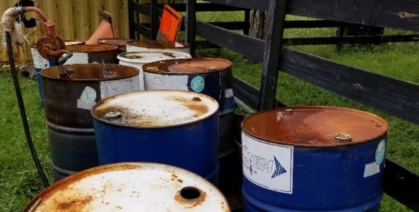
Figure 1. Chemical drums, some with mission caps, staged outside exposed to the elements.

Types
Minor Spill and or Leak - Minor spills and or leaks involve small quantities that can be controlled by the first responder at the discovery of the spill and or leak. Typically, less than 5 gallons.
Semi-Significant Spill and or Leak - Semi-significant spills and or leaks involve larger quantities that may be controlled by first responder and other personnel. More likely to require response by 3rd party spill response personnel.
Significant or Hazardous Spill and or Leak - Significant or hazardous spills and or leaks involve very large quantities or extremely hazardous materials that cannot be controlled by personnel onsite. Must be remediated by 3rd party spill response personnel.

Application
Spill and leak controls are applicable to all construction sites where chemicals and hazardous materials are used or stored onsite. These controls should be used as secondary control. Chemical management BMPs should be used as primary controls associated with spill and leak controls.

Advantages
- Reduces stormwater pollution
- Prevents worker injury

Disadvantages
- Only applies to spills caused by the contractor
- Not applicable to long-term contamination remediation

Design Criteria
- Require the contractor to designate a Contractor Responsible Person Environmental (CRPE) who is on the construction site daily for the coordination of spill and or leak response.
- Spill and leak response procedures must be developed and located on the construction site for use in the event of a spill of leak.
- Site personnel should be trained in identifying the severity of a spill or leak (for example, minor, semi-significant, significant, etcetera).
- Site personnel should be trained in spill and leak responses based on contaminant, location, surface, and severity.
- Emergency contact information and spill and or leak responses should be clearly posted and easily assessable by all site personnel.
- The spill and leak coordinator should be responsible for reporting spills or leaks based on notification requirements.
- Spills and leaks that exceed the Reportable Quantity (RQ) for hazardous materials must be reported in accordance with Federal and State regulations. The Texas Commission on Environmental Quality – Spills, Discharges and Release reporting hotline is 1-800-832-8224.
- Spill and leak containment kits should be used in response to minor spill and or leaks and should be maintained for chemicals that are regularly onsite.
- Spill and leak containment kit locations must be identified on the construction plans, where applicable.
- Larger spills and spills of extremely hazardous materials must be handled by 3rd party spill response personnel.

References
Texas Department of Transportation (TxDOT)’s Stormwater Management Program
TxDOT’s Spill Response Checklist
TxDOT’s Spill Response Poster

