Spill Response

Project Information
Project Name:
Control-Section-Job (CSJ):
Limits:

Contact Information
Contractor Responsible Person—Environmental (CRPE) Contact:
Texas Department of Transportation (TxDOT) Contact:
Regional Texas Commission on Environmental Quality (TCEQ) Office:
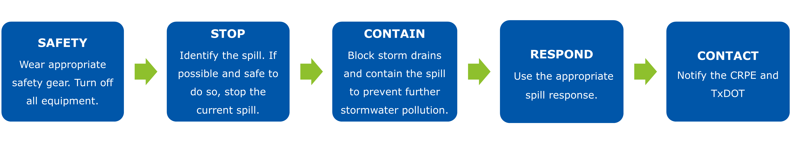
Figure 1. Spill response process flowchart for immediately addressing spills

Detailed Spill Cleanup and Storm Drain Protection
- Quickly stop the spill. This may require up righting a container or patching a hole.
- For larger spills, place a sock berm or barrier around the spill to prevent further contamination.
- Protect storm inlets with a berm, dike, cover, or absorbent sock.
- Soak up liquids with items from the spill kits. This may include mats, kitty litter, or absorbent pads.
- Sweep or pick up the material.
- Put all spill material in a secure container.
- Refer to the Safety Data Sheet (SDS) for waste disposal procedures.
- Note where the spill has leaked onto any grass, soil, gravel, or water.
- Record the spill in the spill log.
- Notify the contractor of the spill for further clean-up and notification and reporting to TCEQ or United States Fish and Wildlife (USFWS).
Common spills may include:
- Fuel
- Diesel
- Chemicals
- Paints or solvents
- Pesticides or herbicides
- Fluid or oil from vehicle

Do’s and Don’ts
- Do call 911 if the spill is harmful to human life or is flammable
- Do protect storm drain inlets
- Do report the spill to the CRPE and TxDOT
- Do not put yourself in danger
- Do not hose down spills or leaks

