Best Management Practice Section and Design Job Aid: Biodegradable Erosion Control Log
Construction stormwater Best Management Practice (BMP) must be installed, inspected, maintained and removed in accordance with Texas Department of Transportation (TxDOT) manufacturer specifications, where applicable, and the Construction General Permit (TXR150000).

Description
Biodegradable Erosion Control Logs (ECLs) are long flexible logs comprised of a core material that is biodegradable, or recyclable, wrapped in a biodegradable containment mesh. ECLs intercept sediment from sheet flow adjacent to various structures, can act as velocity dissipation devices, and can serve as a perimeter sediment barrier control.
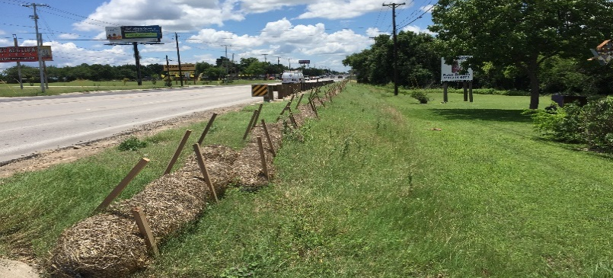
Figure 1. Biodegradable erosion control logs installed along a roadside shoulder to reduce soil erosion and support vegetation establishment.

Types and Configurations
Erosion Control Log Dam
Erosion Control Log on Slopes
Erosion Control Log at Back of Curb
Erosion Control Log at Drop Inlet
Erosion Control Log at Edge of Right of Way
Erosion Control Log at Curb Inlet
Erosion Control Log at Cur and Grade Inlet

Application
Biodegradable Erosion Control Logs are used to slow flow and act as sediment barriers. Control logs should be used for the following:
- Perimeter protection
- Slope protection
- Stockpile controls
- Curb and grade inlet protection
- Sediment traps
- Sediment barriers
- Drainage ditch dam
- Dewatering activities

Advantages
- Able to treat sheet flows over short distances
- Able to provide perimeter control where other best management practices are not suitable due to soil type or paved surfaces
- Easy to install
- Can be used on steep slopes

Disadvantages
- Difficult to remove when wet or filled with sediment
- Limited drainage area for sediment capture
- Additional controls may be needed to remove fine soils from runoff

Design Criteria
- The drainage area for a log sediment trap should not exceed 5 acres.
- The trap capacity should be 1800 cubic feet per acre (0.5 inches over the drainage area).
- Space logs a minimum of 500 feet on center when used in drainage ditches (dam).
- Use logs immediately preceding ditch inlets (inlet protection).
- Logs used for inlet protection must not impede vehicle traffic or flood the roadway.
- Ensure logs used for slope protection are spaced according to the diameter and slope (See Sheet 2 of 3 in EC (9)-16).
- Use logs before drainage leaves the right-of-way or construction site (perimeter control).
- Use logs to control sediment before drainage enters a water course.

References
TxDOT Temporary Erosion, Sediment and Water Pollution Control Measures: Erosion Control Log: EC (9) – 16
TxDOT Standard Specifications for Construction and Maintenance of Highways, Streets, and Bridges, September 1, 2024, Item 506, Temporary Erosion, Sedimentation, and Environmental Controls (Sections 2.10 & 4.4.9)

