Best Management Practice Section and Design Job Aid: Preservation of Existing Vegetation
Construction stormwater Best Management Practice (BMP) must be installed, inspected, maintained and removed in accordance with Texas Department of Transportation (TxDOT) manufacturer specifications, where applicable, and the Construction General Permit (TXR150000).

Description
Preservation of existing vegetation is the planned protection of existing trees, shrubs, and ground cover. This vegetation provides erosion and sediment control, natural habitat protection, water resource protection, natural biofiltration, and aesthetics for the project area.
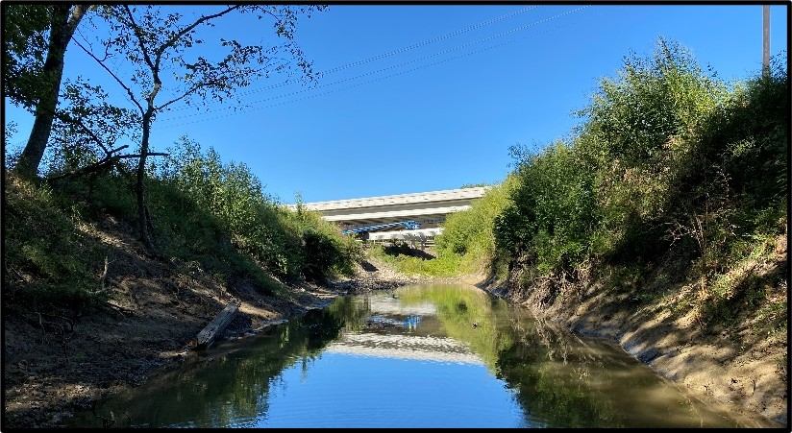
Figure 1. Preservation of existing vegetation along the channel helps stabilize banks, reduce erosion, and protect water quality.

Types
Orange Construction Fence
Chain-link Fence
Wood Barricade

Application
Preservation of existing vegetation is applicable to any project with natural vegetation. Preservation of existing vegetation is the most effective way to protect the construction site and surrounding area from erosion and sediment runoff. In addition, it is a standard Texas Parks and Wildlife Department (TPWD) water quality BMP for aquatic species protection.

Advantages
- Naturally prevents erosion
- Controls sediment loss
- Requires less resources for final stabilization
- Inexpensive erosion control

Disadvantages
- Can limit the area available for construction activities
- Can be difficult and or expensive to preserve vegetation sites with diverse topography
- Limited by projects that do not include existing vegetation in their site design

Design Criteria
- Requires detailed site planning and phasing.
- Areas where existing vegetation will be preserved must be clearly identified on the site plans.
- Preserved areas must be clearly marked onsite prior to clearing and grubbing activities, typically marked off with construction perimeter fence.
- Wherever possible, existing vegetation should be preserved where no construction activity is planned or will occur later.
- Typical areas that are designated for preservation are slopes, forested areas, and natural water features.
6) Trenching and tunneling should occur as far away from tree trunks as feasible for the project.
7) Construction materials, equipment storage, and parking areas should be located where they will not cause damage to preserved vegetation.
8) Preserve vegetation in blocks or large sections at the construction site.

References
Texas Pollutant Discharge Elimination System (TPDES) Construction General Permit TXR150000 Part III.F and Part IV.

