Best Management Practice Section and Design Job Aid: Sediment Control Fence
Construction stormwater Best Management Practice (BMP) must be installed, inspected, maintained and removed in accordance with Texas Department of Transportation (TxDOT) manufacturer specifications, where applicable, and the Construction General Permit (TXR150000).

Description
A Sediment Control Fence (or silt fence) (SCF) is a temporary barrier made of woven geo-textile fabric that filters sediments and temporarily retains runoff before the runoff discharges from the project.
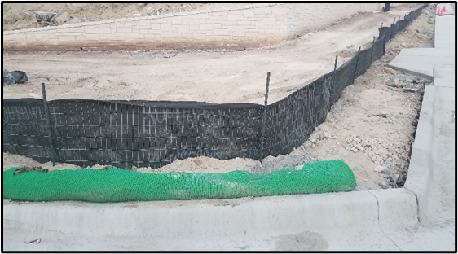
Figure 1. Best Management Practice (BMP) sediment control fence installed along a construction site to minimize erosion and prevent sediment from leaving the project area.

Types
Temporary Sediment Control Fence (SCF) – a fence used in standard conditions

Application
SCF is used to treat overland, non-concentrated flows. General use includes:
- Along perimeter of project (if the roadway elevation is higher than the Right of Way (ROW) elevation)
- Down-slope of exposed soil areas
- Along streams and channels Around temporary stockpiles
- Around areas of higher flow
- Below the toe of exposed and erodible slopes

Advantages
- Cost effective sediment control device
- Filters out sediment during rain events
- Slows down stormwater runoff

Disadvantages
- Localized flooding due to minor ponding at the upslope side of the sediment control fence
- Can fail structurally under heavy storm flows
- Must be removed and disposed of
- For projects using Amphibian and Reptile Exclusion Fence (AREF), contractors may confuse usage with silt fence

Design Criteria
- SCF placement must be parallel to slope contours along a line of constant elevation.
- Should not be used in areas of concentrated flow.
- A 2-year storm frequency may be used to calculate flow rate to be filtered.
- SCF should be sized to filter a maximum flow rate through rate of 100 gallons per minute per square foot.
- Not recommended to control erosion from a drainage larger than 2 acres. Additional controls may be needed.
- Provide space for sediment removal activities and equipment between the SCF and other obstructions.
- SCF is primarily used as a perimeter control on the down slope side of disturbed areas.

References
TxDOT Temporary Erosion, Sediment and Water Pollution Control Measures: Fence & Vertical Tracking: EC (1) – 16
TxDOT Standard Specifications for Construction and Maintenance of Highways, Streets, and Bridges, September 1, 2024, Item 506, Temporary Erosion, Sedimentation, and Environmental Controls (Sections 2.9 & 4.4.8)

