Best Management Practice Section and Design Job Aid: Stabilized Construction Exit
Construction stormwater Best Management Practice (BMP) must be installed, inspected, maintained and removed in accordance with Texas Department of Transportation (TxDOT) manufacturer specifications, where applicable, and the Construction General Permit (TXR150000).

Description
Stabilized Construction Exits (SCEs), sometimes roads, are designated points of entrance or exit to a construction site that are stabilized with rock, timber, or manufactured SCE products to reduce tracking of sediment onto public roadways by construction vehicles.
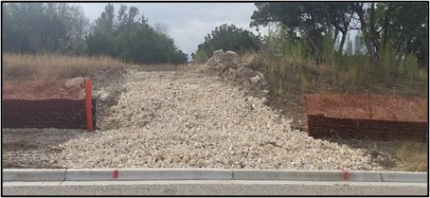
Figure 1. Stabilized Construction Exit constructed of coarse aggregate.

Types
Type 1 Rock Construction - Long-term, constructed using coarse aggregate
Type 2 Timber Construction - Long-term, constructed using railroad ties and timbers
Type 3 Short-term - can be constructed of crushed aggregate, plywood, or wafer board
Type 4 An alternative type to types 1-3 as specified on the plans

Application
SCEs are used to limit the tracking of mud and dust by vehicles leaving the project site. SCEs must be used for project sites that disturbed one acre or more and are recommended for smaller project sites if tracking is likely. SCEs should be constructed for the following site conditions:
- Where sediments can be tracked onto public roads
- Where poor soils are encountered
- Where dust is a problem - dry weather conditions
- Where there are steep grades which require additional traction for vehicles
- Adjacent to bodies of water

Advantages
- Reduces tracking of sediments onto public roadways
- Directs traffic to a controlled access point
- Protects other sediment control Best Management Practices (BMPs)
- Increases the efficiency of dislodging sediments from the tires of construction vehicles

Additional Considerations
- Site conditions will dictate design and need
- Wheel washing system may also be required to remove clay soil from tires (using water to wash sediment from streets is prohibited)
- Street sweeping and vacuuming may be required

Design Criteria
Design in accordance with requirements outlined for each type on EC (3) -16
- Include SCEs on the Stormwater Pollution Prevention Plan (SWP3) layout sheet. Locations may change during construction.
- A special specification may be required for Type 4 or manufactured devices.
- For type 1 and 2 the approach transitions should be no steeper than 6‑to‑1 (H:V) gradient.
- For types 1 and 2 the length should be no less than 50 feet.
- For types 1 and 2 the SCE should be graded to allow drainage to a sediment trapping device.
- For types 1 and 2 width should be at least 14 feet for one-way traffic and 20 feet for two-way traffic for the full width of the exit.

References
Texas Department of Transportation (TxDOT) Temporary Erosion, Sediment and Water Pollution Control Measures: Construction Exits: EC (3) – 16
TxDOT Standard Specifications for Construction and Maintenance of Highways, Streets, and Bridges, September 1, 2024, Item 506, Temporary Erosion, Sedimentation, and Environmental Controls (Section 2.4 & 4.4.4)

