Best Management Practice Section and Design Job Aid: Stockpile Management
Construction stormwater Best Management Practice (BMP) must be installed, inspected, maintained and removed in accordance with Texas Department of Transportation (TxDOT) manufacturer specifications, where applicable, and the Construction General Permit (TXR150000).

Description
Stockpile management is implemented to prevent air and stormwater pollution from stockpiles of soil, sand, paving materials, and other loose materials used during the construction process. Management practices are based on the type of material being stored. Stockpiles can be difficult to manage in windy and rainy conditions.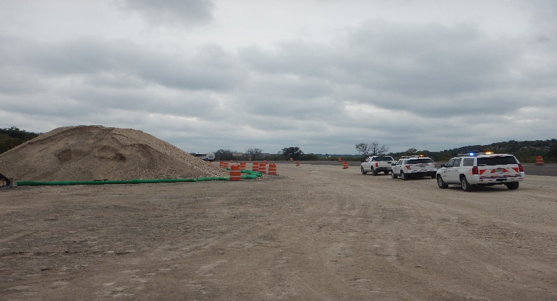
Figure 1. Stockpile management, including the use of erosion control logs and traffic drums, implemented for a stockpile adjacent to a construction access road.

Types
Inactive Stockpiles - Stockpiles that are not scheduled to be used within 14 days
Active Stockpiles - Stockpiles that are scheduled to be used within 14 days

Application
Stockpile management is applicable on all construction sites where materials are stockpiled. Materials include, but are not limited to, the following:
- Soil
- Sand
- Construction debris
- Mulch
- Topsoil
- Asphalt
- Aggregate base and subbase
- Pressure treated wood
Controls typically used to manage stockpiles include:
- Stockpile duration restriction
- Plastic sheeting cover
- Sediment control fence
- Diversion of runoff
- Biodegradable erosion control logs
- Soil stabilization

Design Criteria
- If stockpiles are permitted onsite, a designated stockpile area should be identified on the Stormwater Pollution Prevention Plan (SWP3) Layout Sheets.
- Stockpile locations should be located away from concentrated flows of stormwater, drainages, inlets, water bodies, and other sensitive environmental areas.
- All stockpiles, inactive or active, should have the proper Best Management Practices (BMPs) implemented until stockpiling activities cease.
- Stockpiles of contaminated soils should be managed in accordance with the Soil and Groundwater Management Plan.
- Include construction plan note indicating the duration that inactive stockpiles are permitted. This is dependent on-site conditions and stockpile needs.
- Identify permitted stockpile material and prohibit stockpiling of any material not previously permitted.

References
Texas Pollutant Discharge Elimination System (TPDEs) Construction General Permit TXR1500000 Part III Section F and Part IV
2024 Texas Department of Transportation (TxDOT) Specifications Item 6 Control of Materials Section 6 Storage of Materials

