Best Management Practice Section and Design Job Aid: Chemical Management
Construction stormwater Best Management Practice (BMP) must be installed, inspected, maintained and removed in accordance with Texas Department of Transportation (TxDOT) manufacturer specifications, where applicable, and the Construction General Permit (TXR150000).

Description
Chemical management addresses the potential for stormwater to be polluted with chemical materials and wastes that are used or stored on a construction site. 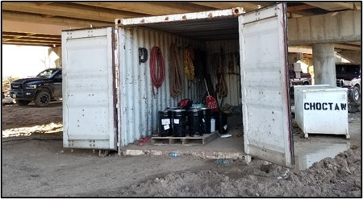
Figure 1. Designated storage container for chemicals and construction supplies illustrating proper chemical management practices that reduce weather exposure and support site safety and compliance.

Application
Chemical management is applicable on all construction sites where chemicals and hazardous materials are used or stored. The objective of chemical management is to minimize the potential of stormwater contamination by construction chemicals through appropriate recognition, handling, storage, and disposal practices. Some target chemicals include, but are not limited to, the following:
- Paints
- Solvents
- Stains
- Wood Preservatives
- Cutting Oils
- Greases
- Pesticides
- Herbicides
- Fertilizers
- Concrete Curing Compound

Advantages
- Reduces stormwater pollution
- Helps prevent spills and leaks

Disadvantages
- Not used to manage pre-existing site contamination
- Does not address contaminated soils, spill and leak response procedures, or chemicals associated with vehicle and equipment management

Design Criteria
- Controls and locations for all chemicals, hazardous materials, and their wastes that have potential to be exposed to precipitation or stormwater runoff must be included in the Stormwater Pollution Prevention Plan (SWP3) layout sheets.
- Include construction note that requires the contractor to have designated personnel manage all chemicals to ensure they are being managed and stored properly (limiting their exposure to precipitation or stormwater).
- Only permit the storage of chemicals required to complete the scheduled construction activities.
- Chemical management should be used in conjunction with the following BMPs:
- Spill and Leak Responses
- Vehicle and Equipment Maintenance
    - Designate a location for chemical storage away from runoff drainage pathways to avoid surface water contamination.
    - Include construction notes that require the contractor to keep spill kits on site.

References
Texas Pollutant Discharge Elimination System (TPDES) Construction General Permit TXR150000 Part III. Section F and Part IV

