Best Management Practice Section and Design Job Aid: Construction Perimeter Fence
Construction stormwater Best Management Practice (BMP) must be installed, inspected, maintained and removed in accordance with Texas Department of Transportation (TxDOT) manufacturer specifications, where applicable, and the Construction General Permit (TXR150000).

Description
Construction perimeter fence is temporarily placed along the boundary of the project site, around environmentally sensitive areas, and used as safety precaution for certain areas.
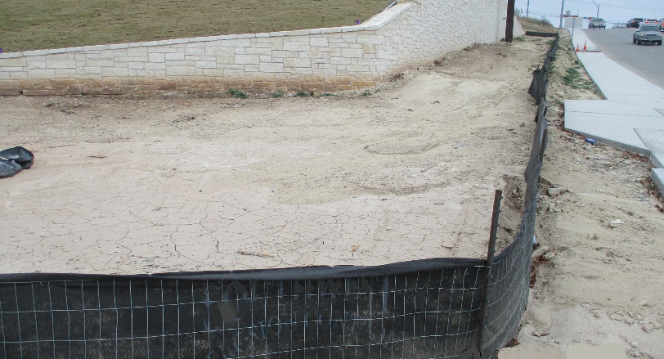
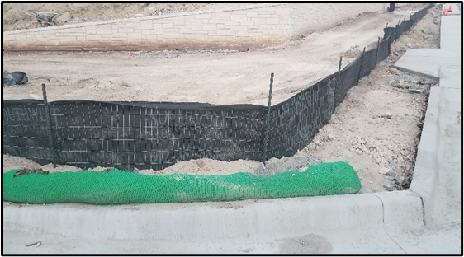
Figure 1. Construction perimeter fence has been installed along the boundary of the project site to contain sediment.

Types
Standard Sediment Control Fence
Orange Construction Fence
Metal Chain-Link Fence
Wooden Barricade

Application
Construction perimeter fence is used to limit access to the construction site which protects site personnel and the public from onsite safety hazards. Additionally, it alerts site personnel to environmentally sensitive areas that may exist within the project boundary. Finally, it can aid in keeping construction debris on-site. Construction perimeter fences should be placed in the following locations:
- Along the boundary of the construction site
- Around hazardous areas
- Along the boundary of prohibited areas (environmentally sensitive areas, preserved vegetation, tree protection, etcetera)

Advantages
- Can be used in conjunction with other perimeter controls
- Allow for limited access to the site
- Durable
- Easily installed

Disadvantages
- May be practical in certain circumstances
- Can fail structurally under heavy storm flows

Design Criteria
- Determine construction site access routes prior to the addition of construction perimeter fence to the plans sheet.
- Construction perimeter fence must be installed around all prohibited areas where construction activities are not allowed (environmentally sensitive areas, waterbodies, wetlands, preserved vegetation, tree protection, etcetera).
- Implement construction perimeter fence in areas that are deemed a safety concern for the public and or for site personnel (fall protection, additional personal protective equipment (PPE) needs, contaminated soil, etcetera), as well as in areas with privacy concerns.
- Construction perimeter fence should be installed prior to soil disturbing activities.
- Safety signage may be installed along the construction perimeter fence if required for the project site.

References
Texas Pollutant Discharge Elimination System (TPDES) Construction General Permit TXR150000 Part III. F and Part IV.
Texas Department of Transportation (TxDOT) Standard Specifications for Construction and Maintenance of Highways, Streets, and Bridges, September 1, 2024, Item 506, Temporary Erosion, Sedimentation, and Environmental Controls (Sections 2.7 & 4.4.6)

