Best Management Practice Section and Design Job Aid: Street Sweeping
Construction stormwater Best Management Practice (BMP) must be installed, inspected, maintained and removed in accordance with Texas Department of Transportation (TxDOT) manufacturer specifications, where applicable, and the Construction General Permit (TXR150000).

Description
Street sweeping is the practice of removing tracked sediment from construction sites and from public roads. Removing the tracked sediment prevents it from entering storm drains and water bodies. It also helps to alleviate vehicular safety hazards.
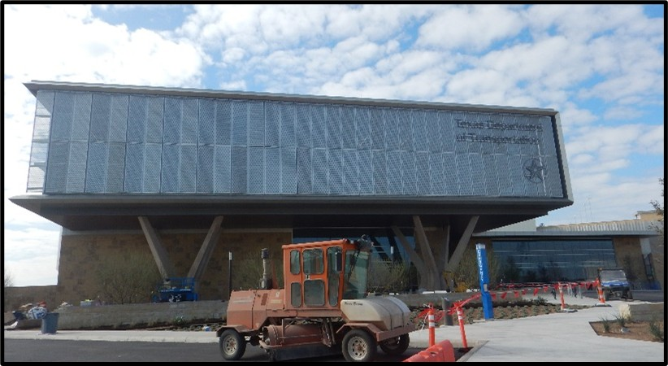
Figure 1. Street sweeping equipment stationed adjacent to a construction project.

Types
Mechanical sweeper
Vacuum-assisted, dry, waterless sweeper
Vacuum-assisted sweeper
Regenerative-air sweeper

Application
All tracked sediment originating from the construction site should be removed from public and private roadways via sweeping or vacuuming. Street sweeping is utilized for sediment control, waste management, and good housekeeping.

Advantages
- Cost effective form of sediment capture
- Easily performed during construction activities
- The use of centralized entrances and or exits will help minimize tracked soil from leaving the site

Disadvantages
- Difficult to sweep and or vacuum soil that is wet or compact
- Street vacuums man not be allowed in cities

Design Criteria
- Implement street sweeping practices wherever construction exits enter a public roadway.
- Limit egress and ingress locations to minimize tracked soil.
- Clearly indicate where and when street sweeping must be implemented on the site plans or construction notes.
- Used with the implementation of a stabilized construction exit.

References
Texas Pollutant Discharge Elimination System (TPDES) Construction General Permit TXR150000 Part III.F and Part IV.
Texas Department of Transportation (TxDOT) Standard Specifications for Construction and Maintenance of Highways, Streets, and Bridges, September 1, 2024, Item 506, Temporary Erosion, Sedimentation, and Environmental Controls (Sections 2.4 & 4.4.4)

