Best Management Practice Section and Design Job Aid: Sanitary Waste Management
Construction stormwater Best Management Practice (BMP) must be installed, inspected, maintained and removed in accordance with Texas Department of Transportation (TxDOT) manufacturer specifications, where applicable, and the Construction General Permit (TXR150000).

Description
Sanitary waste management is the practice of collecting and disposing of sanitary waste to minimize exposure to precipitation and stormwater runoff. This is most often accomplished by providing portable facilities for construction site workers and managing the proper disposal of sanitary waste at the site.
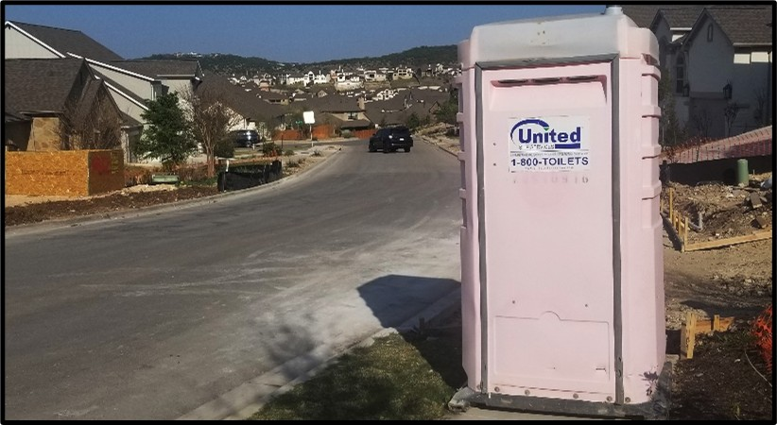
Figure 1. Portable sanitary waste facility placed at a construction site.

Application
Sanitary waste management should be implemented at each construction site where construction staff have no other facility options available. The objective of sanitary waste management is to provide for collection and disposal of sanitary waste in a manner that minimizes the exposure to precipitation and stormwater runoff. Sanitary waste management assists in waste management and housekeeping practices at the construction site.

Advantages
- Easily incorporated into most construction sites
- Maintained by outside septic waste company

Disadvantages
- Multiple facilities or facilities in several locations may be needed to adequately serve a construction site
- Facilities are subject to vandalism if not within a secured construction site

Design Criteria
- Sanitary waste management must be implemented on all projects that have the need for sanitary waste facilities.
- Provide sanitary waste facilities at the rate of one toilet per 10 workers for a 40-hour work week.
- Locate sanitary waste facilities a minimum of 50 feet away from storm drain inlets, conveyance channels, or surface waters.
- If unable to meet the 50-foot requirement, locate sanitary waste facilities at least 20 feet away and provide secondary containment.
- The location of sanitary waste facilities shall be accessible to maintenance trucks without damaging erosion and sediment controls or causing erosion or tracking problems.
- Sanitary waste facilities shall be fully enclosed and designed in a manner that minimizes the exposure of sanitary waste to precipitation and stormwater, as well as anchored for wind.
- Only licensed sanitary and or septic waste haulers should be used for disposal of waste.
- Provide the location of sanitary waste facilities on construction plans to allow for quick response if a leak or spill occurs.

References
Texas Pollutant Discharge Elimination System (TPDES) Construction General Permit TXR150000 Part III.F and Part IV.
Texas Department of Transportation (TxDOT) Standard Specifications for Construction and Maintenance of Highways, Streets, and Bridges, September 1, 2024, Item 7, Legal Relations and Responsibilities (Sections 9)

