Best Management Practice Section and Design Job Aid: Soil Stabilization
Construction stormwater Best Management Practice (BMP) must be installed, inspected, maintained and removed in accordance with Texas Department of Transportation (TxDOT) manufacturer specifications, where applicable, and the Construction General Permit (TXR150000).

Description
Soil Stabilization practices reduce erosion by establishing vegetation, increasing soil cover, or increasing soil adhesion.
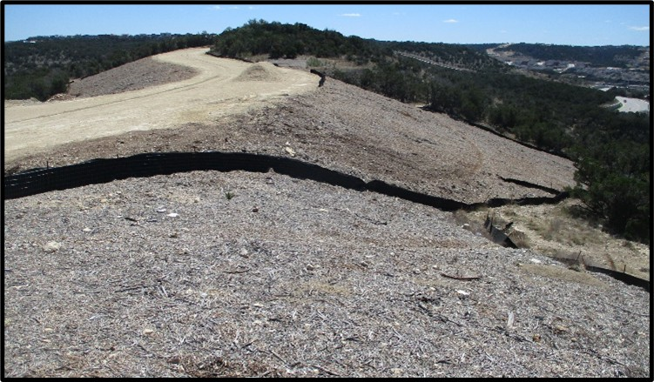
Figure 1. Mulch installed on an exposed slope for stabilization.

Types
Hydroseeding and or Hydromulching
Vegetation and or Sodding
Erosion Control Blanket
Mulching
Erosion Control Compost
Topsoiling

Application
Soil stabilization is implemented to bare soil to temporarily or permanently decrease the amount of soil lost to wind and water erosion. Soil stabilization is used for general erosion prevention, slope protection, temporary or permanently stabilization, and run on and runoff control. Soil stabilization should be constructed for the following site conditions:
- Exposed soil
- Slopes
- Fill Transitions
- Ditches
- Sediment Traps
- Adjacent to surface water

Advantages
- Decreases velocity of sheet flow
- Wide variety to choose from
- Can be applied to various areas of a construction site

Disadvantages
- Some soil stabilization types require time to be properly established
- Some soil stabilizers have limited effectiveness on slopes

Design Criteria
- The following should be considered for the selection and design of soil stabilizers:
- Soil type
- Slope
- Depth of grading
- Atmospheric conditions
- Flow direction
- Volume and velocity of incoming sheet flow
- Location (for example, stream adjacent, near roadways)
- Whether the area will continue to be subject to construction activities
- Further design criteria for each soil stabilization method should be in accordance with the manufacturer specifications.
- Limit vehicle and equipment traffic in stabilized areas when vegetation and binders are being used.
- This BMP is generally implemented after construction site commencement.
5) Soil stabilization practices must be implemented no more than 14 days following the ceasing of soil disturbing activities.
6) Wildlife-friendly products are now available which prevent wildlife entrapment. It is strongly encouraged that these products are utilized.

References
Texas Department of Transportation (TxDOT) Standard Specifications for Construction and Maintenance of Highways, Streets, and Bridges, September 1, 2024 (Item 506 temp erosion, sedimentation, and environmental controls Sections 4.2.2 & 4.3.2, Items 160 topsoil, 161 compost, 162 sodding for erosion control, 164 seeding for erosion control, and 169 soil retention blankets)
TxDOT Approved Products List

