Best Management Practice Section and Design Job Aid: Material and Equipment Use Over Water
Construction stormwater Best Management Practice (BMP) must be installed, inspected, maintained and removed in accordance with Texas Department of Transportation (TxDOT) manufacturer specifications, where applicable, and the Construction General Permit (TXR150000).

Description
Material and equipment use over water addresses general procedures for use, storage, and disposal of materials and equipment located over water. These procedures minimize the potential for pollutants to be discharged into receiving waters.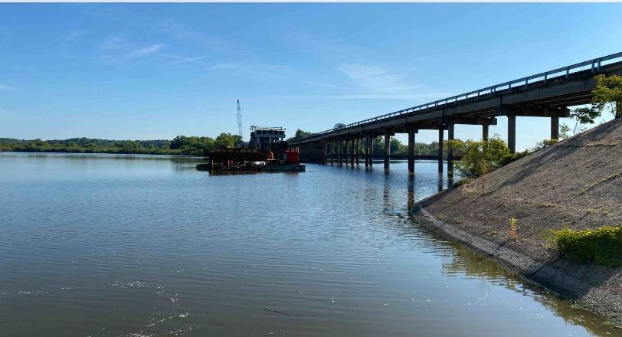
Figure 1. Construction equipment staged on a barge beneath an existing bridge to support work over water.

Application
Material and equipment use over water controls are applicable when construction materials and wastes (solid and liquid) are used on platforms located within or adjacent to bodies of water. Applicable platforms include, but are not limited to, the following:
- Barges
- Boats
- Bridges
- Docks
- Temporary construction pads

Advantages
- Reduce stormwater pollution
- Can be used in conjunction with other Best Management Practices (BMPs)

Disadvantages
- Requires permitting

Design Criteria
- All construction sites must implement the material and equipment use over water BMP if construction activities are scheduled within or adjacent to surface waters.
- This BMP should be implemented in accordance with all required permits (for example, Regional Water Quality Control Board (RWQCB), United States Army Corps of Engineers (USACE), Department of Fish and Wildlife, etcetera).
- Material and equipment use over water BMPs must be documented in the Stormwater Pollution Prevention Plan (SW3P) layout sheets.
- Watertight curbs or toe boards should be installed to contain spills and prevent materials from leaving the platform.
- All materials should be secured to prevent accidental discharge via wind.
- Accumulated waste and unused materials should be regularly removed from the platform and stored or disposed of daily.
- Maintain vehicles and equipment in accordance with “Vehicle and Equipment Management”.
- Any accidental discharges should be reported upon discovery. Refer to “Spill and Leak Control”.
- This BMP must be used in conjunction with the following BMPs:
- Vehicle and Equipment Management
- Street Sweeping
- Chemical Management
- Contractor Waste Management
- Sanitary Waste Management
- Spill and Leak Control
- Stockpile Management

References
Texas Pollutant Discharge Elimination System (TPDES) Construction General Permit TXR150000 Part III Section F and Part IV

