Best Management Practice Section and Design Job Aid: Rock Filter Dam
Construction stormwater Best Management Practice (BMP) must be installed, inspected, maintained and removed in accordance with Texas Department of Transportation (TxDOT) manufacturer specifications, where applicable, and the Construction General Permit (TXR150000).

Description
Rock filter dams are small barriers consisting of various sized aggregate that are used to reduce the velocities of concentrated flows, provide a sediment barrier, and reduce erosion in channels, swales, dikes, or ditches.
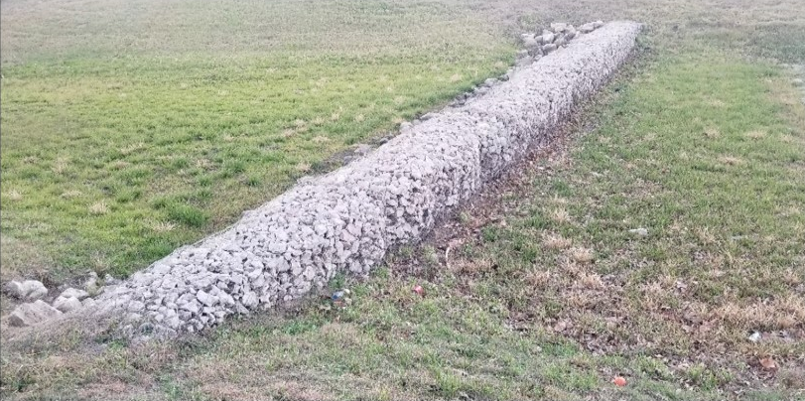
Figure 1. Rock filter dam installed in a vegetated drainage swale.

Types
Type 1–18 inches high with no wire mesh and 3 inches to 6 inches aggregate
Type 2–18 inches high with wire mesh and 3 inches to 6 inches aggregate
Type 3–36 inches high with wire mesh and 4 inches to 8 inches aggregate
Type 4–Sack gabions with 3 inches to 6 inches aggregate
Type 5–Use rock filter dams as shown on plans

Application
Rock Filter Dams should be constructed upstream and or downstream from disturbed areas to decrease stormwater flow velocity, allowing sediment to settle out, in concentrated overland flow. Typical locations for Rock Filter Dams include the following:
- At toe of slope
- At sediment trap
- At channel sections
- In ditches, dikes, and swale outlets
- In stream flow

Advantages
- Reduces erosive velocities
- Effective at removing some sediments
- Can be used with other channel protection controls

Disadvantages
- Maintenance required after heavy or high velocity flows

Design Criteria
- Place Rock Filter Dam near the toe of slopes where erosion is anticipated, upstream and downstream from drainage structures, and in roadway ditches and channels.
- Dimensions must be indicated on the Stormwater Pollution Prevention Plan.
- The dams should be sized to filter a maximum flow through rate of 60 gallons per minute per square foot of cross-sectional area.
- A 2-year storm frequency may be used to calculate flow rate.
- Rock filter dams should be placed perpendicular to the flow of the stream or channel, unless otherwise directed.
- Side slopes should be 2‑to‑1 (H:V) gradient or flatter. Dams within the safety clear zone shall have side slopes of 6‑to‑1 (H:V) gradient or flatter.
- Type 1 should be used at toe of slope, around inlets, in small ditches, and at dike and swale outlets.
- Type 1 may not be used in concentrated high velocity flows (approximately 8 feet per second or more).
- Type 2 should be used in ditches and dike or swale outlets.
- Type 3 should be used in stream flow (anchor to stream bed).
- Type 4 should be used in ditches and small channels.

References
TxDOT Temporary Erosion and Water Pollution Control Measures: Rock Filter Dams: EC (2)-16
TxDOT Standard Specifications for Construction and Maintenance of Highways, Streets, and Bridges, September 1, 2024, Item 506, Temporary Erosion, Sedimentation, and Environmental Controls (Sections 2.1 & 4.4.1)

