Best Management Practice Section and Design Job Aid: Outlet Protection
Construction stormwater Best Management Practice (BMP) must be installed, inspected, maintained and removed in accordance with Texas Department of Transportation (TxDOT) manufacturer specifications, where applicable, and the Construction General Permit (TXR150000).

Description
Outlet Protection is a temporary erosion control and functions by dispersing concentrated flow and slowing flow velocity at drainage pipe outlets, the outlet end of an armored flume or swale, and other points where concentrated flow is discharged to an open channel.
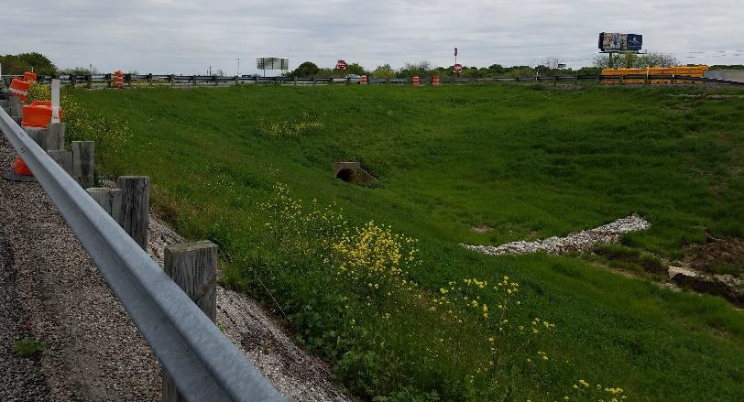
Figure 1. Outlet protection constructed of crushed rock surrounded by wire mesh installed at a culvert discharge to stabilize the embankment and prevent erosion.

Types
Crushed rock
Gabions
Manufactured velocity dissipators
Gabion drop structures
Rock riprap
Articulated concrete blocks
Temporary baffled chutes
Stabilized grade breaks

Application
Outlet protection devices are used to protect outfalls from scouring from concentrated flows by stabilizing the soil, protecting channels receiving concentrated flow, and providing permanent stabilization.

Advantages
- Protects habitat
- Protects new conveyance systems from damage due to erosion until permanent controls are installed
- May be reusable in some instances

Disadvantages
- Can increase erosion
- May not be as cost effective as permanent structures
- Can be damaged by large storm events

Design Criteria
- Outlet protection should not cause flooding or block flow of stormwater.
- Outlet protection should be installed on all outlets where the design storm velocity exceeds 4 feet per second and discharges to an unlined or natural channel.
- Install outlet protection at the following locations:
Pipe, conduit, drain, culvert, and diversion dike outlets; concentrated flow outlets to streams; outlet to larger channel; and areas where soil is susceptible to scour.
- Permanent dissipation devices should be utilized early in construction, when possible, to eliminate need for temporary devices.
- If riprap is utilized, the apron should be aligned with flow direction. The length of the apron should be 4.5 times the outlet pipe diameter and the width should be 4.0 times the outlet pipe diameter.
- Riprap cannot be used at outlets discharging to channels with different elevations.
- Design calculations should be completed for any outlet protection and should include:
Discharge velocity: stone size; and apron dimension.

References
Texas Pollutant Discharge Elimination System (TPDES) Construction General Permit TXR150000 Part III Section F
TxDOT Temporary Erosion, Sediment and Water Pollution Control Measures Temporary Pave Flumes: EC (8) - 16

