Best Management Practice Section and Design Job Aid: Concrete Waste Management
Construction stormwater Best Management Practice (BMP) must be installed, inspected, maintained and removed in accordance with Texas Department of Transportation (TxDOT) manufacturer specifications, where applicable, and the Construction General Permit (TXR150000).

Description
Concrete waste management is implemented to prevent the discharge of concrete waste materials produced by concrete saw cutting, sandblasting, and washouts from entering storm drain systems or other water courses.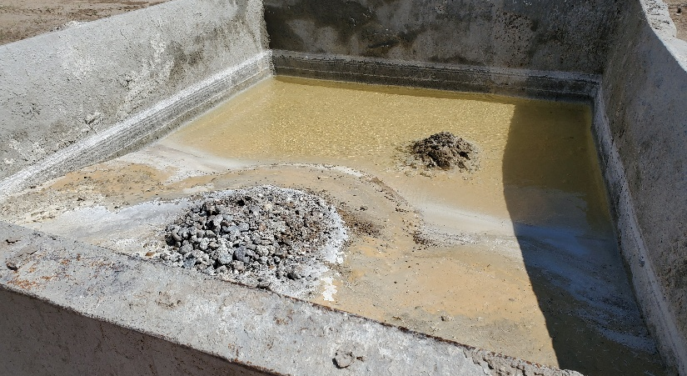
Figure 1. Concrete washout container partially filled with wash water and concrete slurry.

Types
Concrete Saw Cutting - A routine practice of sawing into concrete to reduce cracking or for repair. Saw cutting results in a slurry of water and fine concrete particles with a high potential of hydrogen (pH).
Sandblasting Waste - Uses fine abrasive materials to clean or prepare concrete surfaces for coatings. Large amounts of dust are common with this practice and are easily transported by wind and water.
Concrete Washouts - Constructed to washout excess concrete mix. All equipment (trucks, chutes, wheelbarrows, etcetera) used for concrete needs to be washed out in the designated area.

Application
Concrete waste management is applicable to all construction sites where concrete will be added, rehabbed, or demolished. The two main forms of concrete waste at construction sites are excess fresh concrete mix, including residual mix washed from trucks and equipment, and or concrete dust and concrete debris resulting from demolition.

Advantages
- Reduces stormwater pollution
- Addresses concrete saw cutting and demolition wastes

Disadvantages
- Sandblasting dust is easily transported
- BMP does not include safety procedures for workers
- Concrete waste contains high pH values

Design Criteria
- Stormwater Pollution Prevention Plan (SWP3) Layout Sheet notes shall include proper concrete waste management procedures for concrete saw cutting, sandblasting, and concrete washouts.
- The Contractor Responsible Person for Environmental (CRPE) is responsible for all concrete waste management procedures.
- Discharge of untreated waste is prohibited. Predetermined concrete washout areas must be used and depicted on the SWP3 Layout Sheets. More than one concrete washout area may be required.
- If construction of a concrete washout is planned, the following design must be implemented – dig into ground or build above grade, place hay bales or an alternative Best Management Practice (BMP) around the perimeter about 10 feet by 10 feet and overlay plastic sheeting free of tears or holes and secure to hay bales.
- Vinyl washout containers with filter bags are permitted which provide easier installation and maintenance and are reusable.
- Concrete washouts should be placed in easily accessible locations with solid (gravel or rock) approaches, a minimum of 50 feet from storm drains, open ditches, and surface waters.
- Slurry from concrete saw cutting should be continuously vacuumed or recovered for disposal.
- Grit from sandblasting should be contained. Some procedures include prohibit sandblasting during high winds, use misting equipment to remove grit from air, and install dust shielding around sandblasting areas.

References
United States Environmental Protection Agency Stormwater Best Management Practice Concrete Washout
Texas Pollutant Discharge Elimination System (TPDES) Construction General Permit TXR150000 Part IV and Part VI

