Best Management Practice Section and Design Job Aid: General Material and Equipment Management
Construction stormwater Best Management Practice (BMP) must be installed, inspected, maintained and removed in accordance with Texas Department of Transportation (TxDOT) manufacturer specifications, where applicable, and the Construction General Permit (TXR150000).

Description
General material and equipment management addresses the practices associated with proper storage, maintenance, and use of general site materials and equipment at the construction site.
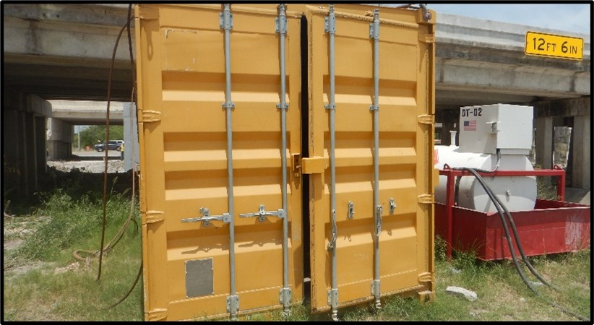
Figure 1. Designated storage container for materials and equipment illustrating proper material management practices that reduce weather exposure and support site safety and compliance.

Application
General material and equipment management is applicable to all construction sites. The objective of this Best Management Practice (BMP) is to prevent the improper storage and use of material and equipment at the construction site. General material and equipment include, but are not limited to, the following:
- Machinery
- Oils
- Antifreeze
- Pesticides
- Herbicides
- Fertilizers
- Paints
- Solvents
- Wash Water
- Safety materials
- Adhesives
- Asphalt byproducts
- Concrete byproducts

Advantages
- Keeps construction site clean and orderly
- Helps prevent improper use
- Works in conjunction with other housekeeping BMPs

Disadvantages
- Does not address spill and leak response procedures or chemical management
- Can be costly to maintain

Design Criteria
- All construction sites must implement the general material and equipment management BMP.
- Clearly identify or add notes to plan sheets to indicate where general construction material and equipment must be stored.
- The contractor should designate site personnel responsible for implementing general material and equipment management.
- All site personnel must be informed of the proper storage and use of materials.
- All general storage and equipment areas should be located at least 50 feet away from inlets, channels, and surface waters.
- Equipment should be stored orderly and according to manufacturer specifications.
- Store materials indoors in existing structures if possible, to reduce contact with stormwater.
- Evaluate the site for the need for temporary storage sheds or buildings.
- All material and equipment on site should be cataloged to determine storage and maintenance needs.
- This BMP must be used in conjunction with the following BMPs:
- Vehicle and equipment management
- Street sweeping
- Chemical management
- Contractor waste management
- Material and equipment use over water
- Sanitary waste management
- Spill and leak control
- Stockpile management

References
Texas Pollutant Discharge Elimination System (TPDES) Construction General Permit TXR 150000 Part III Section F and Part IV

