Best Management Practice Section and Design Job Aid: Earthen Berm
Construction stormwater Best Management Practice (BMP) must be installed, inspected, maintained and removed in accordance with Texas Department of Transportation (TxDOT) manufacturer specifications, where applicable, and the Construction General Permit (TXR150000).

Description
Earthen berms are temporary structures constructed of soil that assist in the filtration of sediment from stormwater runoff.
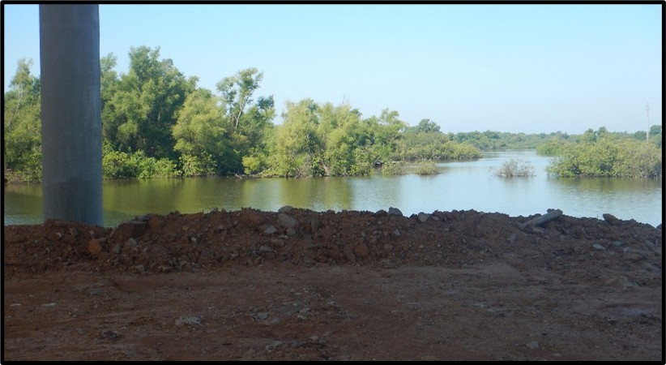
Figure 1. Earthen berm constructed adjacent to a waterbody forming a barrier along the shoreline.

Application
Earthen berms are installed in locations where standing water will not be a hindrance to construction activities. Allowing the water to settle behind the berm allows for effective filtration of sediment.

Advantages
- Prevents sediments and other pollutants from entering public waterways
- Can be applied to various areas of a construction site

Disadvantages
- Can cause localized flooding
- Not effective with concentrated flows

Design Criteria
- The following should be considered for the selection and design of all earthen berms:
- Drainage area size
- Slope of drainage area
- Distance of flow to earthen berm
- Surface conditions
- Volume and velocity of incoming sheet flow
- Soil type
- Earthen berms should not be used in concentrated flows. Berms should only be implemented and designed for sheet flow from project area.
- Berms should be installed downslope from a disturbed area and along contours.
- Effectiveness of earthen berms is dependent upon proper installation.
- Earthen berms need to be stabilized with vegetation to prevent them from eroding and becoming a source of sediment pollutants.

References
Texas Department of Transportation (TxDOT) Standard Specifications for Construction and Maintenance of Highways, Streets, and Bridges, September 1, 2024, Item 506, Temporary Erosion, Sedimentation, and Environmental Controls

