Best Management Practice Section and Design Job Aid: Runoff Interception
Construction stormwater Best Management Practice (BMP) must be installed, inspected, maintained and removed in accordance with Texas Department of Transportation (TxDOT) manufacturer specifications, where applicable, and the Construction General Permit (TXR150000).

Description
Runoff interception and diversion controls such as dikes, ditches, swales, and flumes, intercept and or divert stormwater run-on or runoff before or after it reaches disturbed areas to manage sediment from disturbed areas.
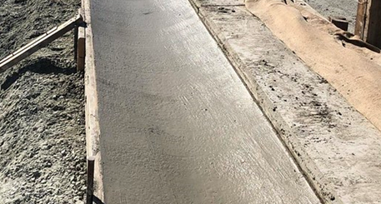
Figure 1. Temporary diversion control has been installed to intercept and direct stormwater flow.

Types
Diversion Dike - A diversion dike is a compacted soil mound used to redirect flows
Interceptor and Drainage Swale - Interceptor and drainage swales are small, shallow channels, typically vegetated, that collect and redirect flow
Lined Ditches - A lined ditch is a long, shallow channel with protective lining that collects and redirects flow
Temporary Paved Flumes - A temporary paved flume is a paved channel that drains concentrated surface runoff down slopes

Application
Runoff interception and diversion controls are primarily used in the following applications:
- To convey runoff down sloping land
- Along paved surfaces to intercept runoff
- Along the top of slopes to divert runoff
- To divert runoff to stabilized drainage systems
- Below steep grades to intercept runoff

Advantages
- Prevents erosion
- Cost effective erosion control

Disadvantages
- May require other sediment control practices
- Limited by existing grading of the project site

Design Criteria
- Runoff interception and diversion controls should be constructed to divert runoff around disturbed areas or redirect runoff discharged from disturbed areas to other sediment control devices.
- Diversion dikes can be used with interceptor and drainage swales and lined dikes, as follows:
- Drainage area contributing runoff to a swale, dike, or ditch should not exceed 5 acres
- Spacing of swales, dikes, or ditches should be based on slope of disturbed areas
- Intercepted runoff in a swale, ditch, or dike should outlet to stabilized area
- Side slopes of 6‑to‑1 (H:V) gradient in safety clear zone
- Should be constructed with compacted soil
- Evaluate risks related to erosion based on flow velocity, soil types, overtopping, and drainage.
- Temporary Paved Flumes should be designed based on the following criteria:
- Should be sized to drain the peak rate of runoff without overtopping the embankment at the earth dike entrance
- The drainage area contributing runoff to a paved flume should not exceed that in design criteria (Design Table EC (8)-16)
- 25-year storm frequency can be used for flow rate calculation
- Rock or rubble energy dissipator is required at flume outlet (ensure space for dissipator)

References
Texas Department of Transportation (TxDOT) Temporary Erosion, Sediment and Water Pollution Control Measures EC (4) - 16, EC (5) - 16 and EC (8) – 16
TxDOT Standard Specifications for Construction and Maintenance of Highways, Streets, and Bridges, September 1, 2024 Temporary Erosion, Sedimentation, and Environmental Controls: (Sections 2.3 & 4.4.3)

