Best Management Practice Section and Design Job Aid: Stream and Clear Water Diversion
Construction stormwater Best Management Practice (BMP) must be installed, inspected, maintained and removed in accordance with Texas Department of Transportation (TxDOT) manufacturer specifications, where applicable, and the Construction General Permit (TXR150000).

Description
Stream and clear water diversions are measures used to divert surface water upstream of a project site around the project site within the stream or isolate construction activities within bodies of water. These measures are used to reduce the sediment pollution.
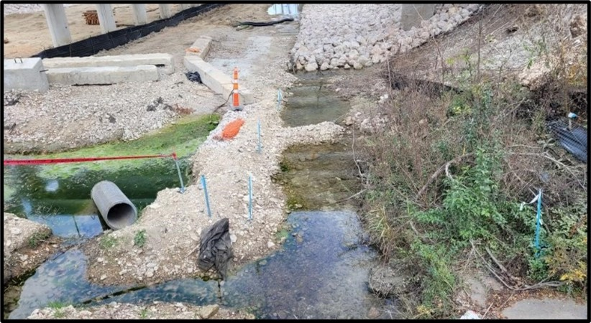
Figure 1. Aggregate berms are installed in a stream to divert clear water around a project site.

Potential Components of the Water Diversion System include:
- Diversion Ditch
- Berms
- Dikes
- Cofferdams
- Flumes
- Pumps
- Slope Stabilization
- Gravel Bags
- Sheet Piles
- Drainage and Interceptor Swales
- Floating Turbidity Curtains
- Temporary Culverts

Application
Stream and clear water diversions are applicable when construction activities occur within or adjacent to a body of water. Such construction activities include, but are not limited to, the following:
- Streambank stabilization
- Culverts
- Around temporary stockpiles
- Pier or abutment installation

Advantages
- Reduces stormwater pollution
- Can be used with other diversion controls
- Helps preserve biological habitat

Disadvantages
- Can disturb waterway during installation
- Can cause downstream flooding
- Requires additional permitting

Design Criteria
- Permitting may be required for diversion & isolation.
- Consider whether temporary diversion will cause greater environmental impacts than project alone.
- Consider fluctuation in water depth and flow volume due to tides, storms, flashflood, etcetera.
- Design diversion for appropriate storm event in region.
- Water quality monitoring should be performed before and during in-water work.
- Diversion measures must be designed in accordance with respective BMPs (Slope and or Streambank Stabilization, Runoff Interception and or Diversion, Dewatering, etcetera).
- Construction activities that encroach on flowing streams must include the appropriate BMPs to prevent muddy waters from entering streams.
- Natural streambed materials should be used for temporary slope and soil stabilization methods.
- Construction should be scheduled during periods of low flow or when streams are dry to minimize impacts.
- Diversion and or isolation activities should not be used where there is insufficient stream flow.
- Diversion activities shouldn’t completely dam flow.
- Diversion and or isolation activities should not be used in deep water.

References
Texas Department of Transportation (TxDOT) Temporary Erosion, Sediment and Water Pollution Control Measures: Swales EC (5) -16 and Dikes EC (4)-16

