Best Management Practice Section and Design Job Aid: Vegetated Filter Strips and Buffers
Construction stormwater Best Management Practice (BMP) must be installed, inspected, maintained and removed in accordance with Texas Department of Transportation (TxDOT) manufacturer specifications, where applicable, and the Construction General Permit (TXR150000).

Description
Vegetated filter strips and buffers are stretches of vegetated land that convey stormwater runoff away from adjacent disturbed areas. The strips and buffers are used to reduce flow velocities and volume of runoff. As the flow passes through the vegetated strips or buffers, the sediment and other pollutants are filtered through the vegetation and infiltrated.
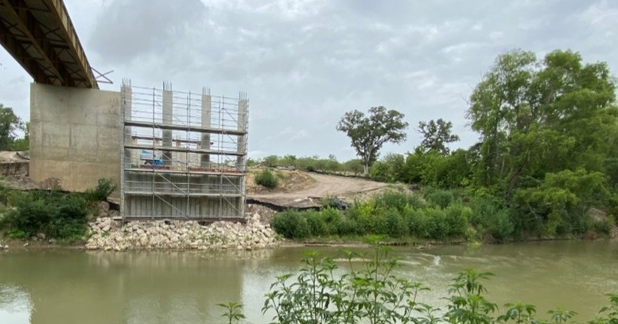
Figure 1. Vegetative buffer along the stream bank adjacent to a bridge construction project.

Types
Vegetated Filter Strips
Filter strips consist of planted vegetation established at regular intervals
Vegetated buffers
Vegetated buffers consist of existing vegetation

Application
Vegetated buffers are most applicable on projects near waterways, open pastureland, or along property lines and roads. Vegetated filter strips and buffers typically act as perimeter controls, slope protection, and sediment barriers. In addition, preservation of a vegetated buffer is a standard Texas Parks and Wildlife Department (TPWD) water quality BMP for aquatic species protection.

Advantages
- Effective at removing clay particles
- Disperses flow
- Slows flow velocity

Disadvantages
- Cannot treat large volumes or concentrated flows
- Limited access to vegetated strip

Design Criteria
- Requires detailed site planning and phasing. Must be clearly identified before clearing and grubbing activities occur.
- Filter strips or buffers must be clearly identified on the site plans.
- Clearly mark off vegetated filter strips and buffers with high visibility construction perimeter fence.
- The disturbed area contributing runoff to the vegetated strip should be no more than 2 acres if used as a primary sediment control.
- The maximum flow to the vegetated filter should be 150 feet or less.
- The vegetated strip can serve as primary sediment control if the contributing drainage area slope is less than 15% (on steeper slopes, another sediment control is required).
- Sizing of the strip should be designed based on the slope of the area contributing runoff.
- The slope of the vegetated strip should be no more than 5% across the width of the vegetation.
- Access to vegetated strips shall be prohibited.
- Existing vegetation must be well established to be used as a vegetative buffer (in other words, 80% vegetative coverage, no bare soil visible, etcetera).
- Vegetated filter strips should only be used when the site is along (parallel to) contours.
- Vegetated filter strips and buffers are frequently used as a secondary sediment control in combination with additional sediment controls.
- Vegetated filter strips and buffers may only be suitable as primary sediment controls for small, disturbed areas.

References
Texas Pollutant Discharge Elimination System (TPDES) Construction General Permit TXR150000 Part III.F and Part IV.

