Guidance: Onsite Fueling and Petroleum Storage - Spill Prevention Control and Countermeasure Plan
This document is intended to serve as Environmental Affairs Division (ENV) guidance for the applicability of 40 Code of Federal Regulations (CFR) Part 112: Oil Pollution Prevention at Texas Department of Transportation (TxDOT) Construction Projects.

Description
Authorized under Section 311 of the Clean Water Act (CWA), 40 CFR Part 112: Oil Pollution Prevention, often referred to as the Spill Prevention Control and Countermeasure (SPCC) Rule, sets forth regulations for prevention, preparedness, and response for discharges of petroleum at non-transportation-related facilities. By rule, construction sites are required to develop and implement an SPCC, when applicable.
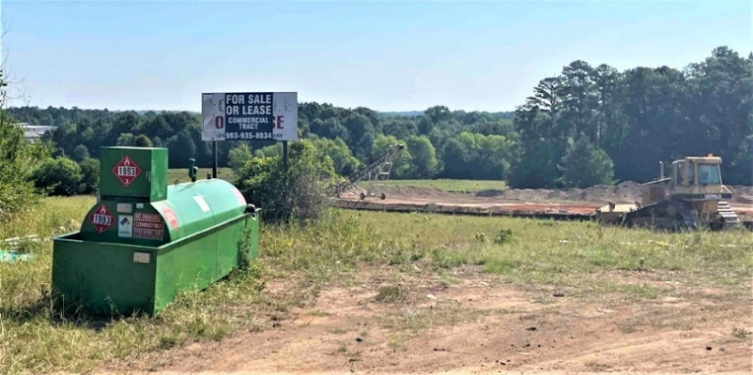
Figure 1. Onsite Fueling and petroleum storage on construction projects.

Applicability
The federal requirement to develop and implement an SPCC Plan is applicable to construction sites that meet all three of the criteria below:
- The site stores, uses, transfers, or otherwise handles oil products (such as petroleum products, emulsions, plant-based oils or greases).
- The total capacity of all aboveground bulk storage containers and oil-filled operational equipment used to store petroleum products is equal to or greater than 1,320 gallons.
- A petroleum spill occurring at the site could reasonably be expected to reach navigable waters or adjoining shorelines of the United States (including creeks, streams, and other waterways).

Compliance with regulations
- Per Item 7.7 of the TxDOT Standard Specifications for Construction and Maintenance of Highways, Streets, and Bridges September 2024, contractors are responsible for complying with all applicable regulations for Project Specific Locations (PSLs), including SPCC.
- SPCC Plans must be certified by a Professional Engineer (PE), unless the site (1) meets criteria to be considered a Qualified Facility and (2) develops a plan in accordance with 40 CFR 112.6, in which case the SPCC Plan may self-certified by the contractor.
- Should the contractor store fuel and or any petroleum products onsite in a manner that would trigger the requirement to develop an SPCC Plan, the District should require the contractor to furnish any plans or compliance documents, such as inspection reports necessary to verify compliance with the rule.
- If a spill occurs onsite, the contractor is responsible for reporting and responding to the spill, as necessary.

References
40 CFR 112 – Oil Pollution Prevention
United States (U.S.) Environmental Protection Agency (EPA) Office of Compliance – Managing Your Environmental Responsibilities: A Planning Guide for Construction and Development
TxDOT Standard Specifications for Construction and Maintenance of Highways, Streets, and Bridges: Item 7.7 Preservation of Cultural and Natural Resource and the Environment
Memorandum of Understanding (MOU) Between the Environmental Protection Agency and the Department of Transportation, December 18, 1971
EPA – SPCC Rule Amendments: Streamlined Requirements for Mobile Refuelers, December 2006

When calculating total petroleum storage capacity, only include storage containers with capacity equal to or greater than 55-gallons; fuel and fluid tanks associated with function of oil-filled operational equipment and motive power containers should also be included in calculations for applicability. However, oil-filled equipment is addressed differently in the SPCC Plan than bulk storage.

