

Guidance: Stormwater Pollution Prevention Plan
Appendix A: Completing the Construction Site Notice, Notice of Intent, Notice of Change and Notice of Termination
Contents
Guidance: Stormwater Pollution Prevention Plan 1
Appendix A: Completing the Construction Site Notice, Notice of Intent, Notice of Change, and Notice of Termination 3
1.0 Construction Site Notice Requirements 3
1.1 Large Construction Sites 4
2.0 Notice of Intent Requirements 4
3.0 Notice of Change Requirements 6
4.0 Notice of Termination Requirements for Large Construction Activity Projects 8
5.0 Small Construction Activity Termination of Coverage 9
6.0 Large Construction Activity Termination of Coverage for the Contractor 10
7.0 Large Construction Activity Termination of Coverage for the Department 11
8.0 Transfer of Day-to-Day Operational Control 12
Revision History 15

List of Figures
Figure 4. Decision flowchart for Stormwater Pollution Prevention Plan (SWP3) changes and Notice of Change (NOC) notification requirements. 7
Figure 5. Steps for terminating coverage on small construction activities 10
Figure 6. Notice of Termination requirements following project final stabilization or transfer of responsibilities to TxDOT, including submission deadlines and required notifications. 11
Figure 7. TxDOT Notice of Termination actions and timeline following achievement of final stabilization. 12
Figure 8. Construction Site Notice requirements for original and new operators when responsibility for a construction site is transferred 13
Figure 9. Notice of Termination (NOT) and Notice of Intent (NOI) submission requirements when transferring to a new operator. 14

Appendix A: Completing the Construction Site Notice, Notice of Intent, Notice of Change, and Notice of Termination
Responsible person
Texas Department of Transportation (TxDOT) District Construction Personnel and Contractor
Important Note
Information in Appendix A does not apply to projects with less than one (1) acre of soil disturbance that are not part of a larger common plan of development.
Construction General Permit (CGP) coverage authorization requires documentation throughout the life of the construction project. The following describes how to identify when a Notice of Intent (NOI), Notice of Change (NOC), and Notice of Termination (NOT) are needed for CGP compliance. This section also describes TxDOT and Contractor’s Construction Site Notice (CSN) posting and documentation requirements. Copies of TxDOT’s completed CSN, NOI, NOC and NOT forms (as applicable to each project) will be maintained as part of the Stormwater Pollution Prevention Plan (SWP3) Binder. Contractor-provided copies of the CSN, NOI, NOC and NOT forms (as applicable to each project) will also be maintained as part of the SWP3 Binder.

1.0 Construction Site Notice Requirements
TxDOT and Contractors will post CSNs at the construction site at a safe, publicly accessible location for viewing by the general public and local, state, and federal authorities. Look for locations where the public can safely pull off the road, along the shoulder, without impeding traffic. If no such location is available, look at nearby parking lots or driveways within the limits of the project (with permission from landowner) or materials storage areas with public accessibility. Ensure the posting is an appropriate height where viewers can read the information (for example, sign is eye level height).
For small construction sites, both TxDOT and the Contractor are responsible for posting the CSN as primary operators with operational control over plans and specifications and day-to-day operational control, respectively. Both TxDOT and Contractor will post the CSN with redacted signature and the copy with the original signature will be maintained as part of the SWP3 binder Attachment 2.1 and 2.2 respectively. Small CSNs must use Texas Commission on Environmental Quality (TCEQ) Form 20963. The CSN must be signed by someone with authority under 30 Texas Administrative Code (TAC) 305.44.
TxDOT and the Contractor must send copies of the respective signed CSNs to the local Municipal Separate Storm Sewer System (MS4) operator at least two days prior to commencing construction. Attachment 2.3 (TxDOT) and 2.4 (Contractor).

1.1 Large Construction Sites
For large construction activities, TxDOT (in most cases) and the Contractor are responsible for posting the CSN as primary operators with operational control over plans and specifications and day-to-day operational control, respectively. A copy of the CSNs will be maintained in Appendix 2.1 (TxDOT) and Appendix 2.2 (Contractor) of the SWP3 binder. Additionally, TxDOT and Contractor will need to comply with NOI, NOC and NOT requirements as described below. Large CSNs must use TCEQ Form 20691. For projects where TxDOT is the Secondary Operator use TCEQ Form 20962.

2.0 Notice of Intent Requirements
TxDOT and the Contractor, as Primary Operators, are required to submit separate NOI applications to TCEQ to obtain CGP authorization. Each NOI should be submitted electronically through State of Texas Environmental Electronic Reporting System (STEERS).
TxDOT must submit their NOI to TCEQ at least 10 days before the start of construction activities at the site. A copy of the completed and signed NOI must be provided to the Contractor immediately following TxDOT’s NOI submittal for use in completing the Contractor NOI. The Contractor must submit their NOI at least seven days prior to the start of construction activities at the site. Important information the Contractor needs from TxDOT to complete the NOI includes:
- The TxDOT’s Regulated Entity Number (RN) – If the contractor does not use TxDOT’s RN Number when filing their NOI then they must correct this with the TCEQ
- The name, address and county of the construction project
A $225 fee must also be included with the NOI when submitting electronically. All fees are due upon the submission of the NOI. It is not necessary to maintain payment confirmation vouchers or receipts in the SWP3 Binder.
Important Note
If an NOI is not submitted electronically, a waiver is required as well as a higher submittal fee of $325.
TxDOT and the Contractor must submit a copy of the Notice of Intent (NOI) to the appropriate TCEQ regional office if discharges occur within 10 stream miles of the Edwards Aquifer Recharge Zone. Provisions of the Edwards Aquifer Rule may require additional Best Management Practices (BMPs) and maintenance schedules. TxDOT is required to implement and follow all applicable requirements of the Edwards Aquifer Rule within the regulated zones.
In addition, a copy of the NOI from both TxDOT and the Contractor must be submitted to the local MS4 operator prior to commencing construction.
NOI forms, NOC forms, NOT forms, and Construction Site Notices that require a signature must be signed according to 30 TAC 305.44 (relating to Signatories for Applications). Section 1 (Administrative Requirements), 2.2.3 details the Delegation of Signatories requirements for large construction sites. District Engineer, Deputy District Engineer, Division Director, Deputy Division Director, Director of Construction, Maintenance, or Operations, and in most cases the Area Engineer are positions authorized to execute NOIs, NOCs, and Construction Site Notices. If a project crosses a geographic boundary, such as Area Office boundaries or District Office boundaries, signature must come from the position with responsibility of overall operations of the geographic area (in other words, District Engineer or Director of District Operations).

3.0 Notice of Change Requirements
Project details may change during construction and after the NOI has been filed. If specific information changes or information needs to be corrected on the NOI, an NOC must be submitted to the TCEQ using TCEQ’s NOC form. The following are the types of changes required to be reported to TCEQ:
- Change in legal name
- Change in address and or contact information (such as a change in the Area Engineer)
- Change in regulated entity site information
- Change to general characteristics provided on original form (such as an increase in acreage of soil disturbance)
- Change in relevant information in NOI
- Previously unidentified changes
Both TxDOT and the Contractor must submit a NOC to TCEQ through STEERS at least 14 days before the change occurs. If this is not possible, it must be done within 14 days of discovery of a change or revision to the NOI as required by the CGP. Following the NOC submittal to TCEQ, the Contractor must provide a signed copy of the NOC to the TxDOT Engineer and any MS4 operators at the time of submittal. When either party submits a NOC, it should be reviewed by both parties to ensure the other party does not need to submit a NOC, depending on what information is being changed. NOCs must be submitted electronically through STEERS on the TCEQ website, or a waiver from electronic reporting must be requested and obtained.
Small construction activities do not require the submittal of a NOI; therefore, TCEQ does not require the submittal of an NOC if small construction activities change.
Use the following flow chart to assist in determining whether a NOC should be submitted to TCEQ:

Notice of Change for Large Construction Sites: Determination Process
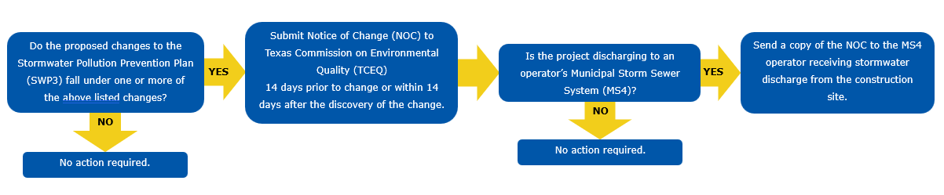
Figure 4. Decision flowchart for Stormwater Pollution Prevention Plan (SWP3) changes and Notice of Change (NOC) notification requirements.

4.0 Notice of Termination Requirements for Large Construction Activity Projects
Both TxDOT and the Contractor must submit a NOT for their respective NOIs to the TCEQ within 30 days of the TxDOT Engineer’s approval that 70% native background vegetation cover (final stabilization) is met or equivalent permanent stabilization measures have been employed in accordance with CGP. These NOTs are submitted electronically through STEERS. Authorization to discharge from large construction activities under CGP terminates immediately following confirmation of the receipt of the NOT submitted electronically by the TCEQ. TxDOT and the Contractor must submit a NOT to TCEQ and the MS4 operator receiving discharge within 30 days of meeting the following conditions:
- All portions of the construction site operated by TxDOT have achieved final stabilization
- Transfer of operational control from TxDOT or the Contractor to another primary operator
- Gaining alternative authorization from an individual TPDES permit or alternative TPDES general permit
The Contractor must provide a signed copy of the NOT to TxDOT and any local MS4 operators at the time of submittal. Once the TxDOT Engineer receives the signed NOT copy from the Contractor then TxDOT will submit their NOT.
Important Note
In some instances, the District may choose to release the contractor before final stabilization is achieved. In these cases, the Contractor should file the NOT and provide notification according to the instructions above.
TxDOT will inherit all responsibility at that point, becoming primary operator with operational control over plans and specifications and primary operator with day-to-day operational control, including the continuation of inspections and BMP maintenance requirements. At that point, TxDOT is fully responsible for the project and cannot file an NOT until the final stabilization requirements are met.
As an exception to the above stabilization requirements, in arid areas, semi-arid areas, or drought-stricken areas, as they are defined in Part I.B of the CGP, and NOT can be filed when temporary erosion control measures are selected, designed, and installed along with an appropriate seed base to provide erosion control for at least three years without active maintenance by the operator, and the temporary erosion control measures are selected, designed, and installed to achieve 70% of the native background vegetative coverage within three years.
Important Note
Compliance with the conditions and requirements of this permit is required until the NOT is submitted and approved by TCEQ, this includes continuing inspections. The following sections and figures discuss additional details about termination of coverage.

5.0 Small Construction Activity Termination of Coverage
Small construction activities are automatically authorized for discharge from the site under the CGP. A NOI is not required to apply for authorization. Therefore, a NOT is not required to terminate authorization of discharge from the construction site. Figure 5 outlines the process to properly terminate automatically authorized small construction activities authorized under CGP.
Small Construction Activity Termination of Coverage Process
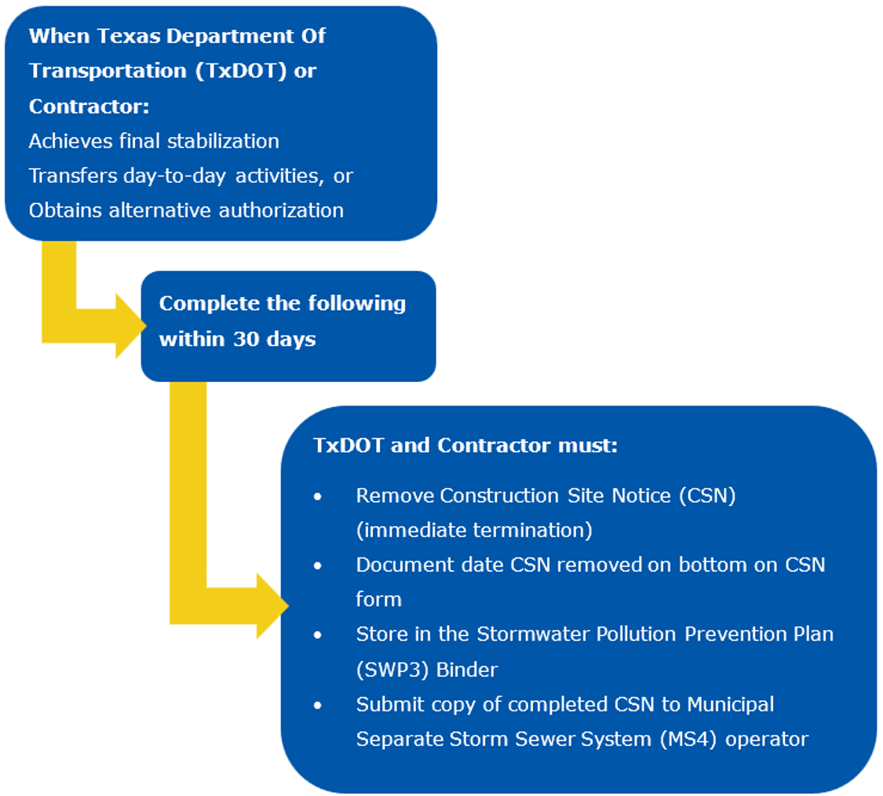
Figure 5. Steps for terminating coverage on small construction activities

6.0 Large Construction Activity Termination of Coverage for the Contractor
For Contractor termination of coverage, the Contractor must submit a NOT to the TCEQ within 30 days of the TxDOT Engineer’s approval. The Contractor will provide TxDOT and local MS4 operators with a signed copy of the NOT at the time of submittal. Once TxDOT receives the signed NOT from the Contractor, TxDOT will submit its NOT (see previous section and Figure 5). Figure 6 outlines the process to properly terminate large construction activity by the Contractor under CGP and TxDOT Policy.
Large Construction Activity Termination of Coverage Process for the Contractor
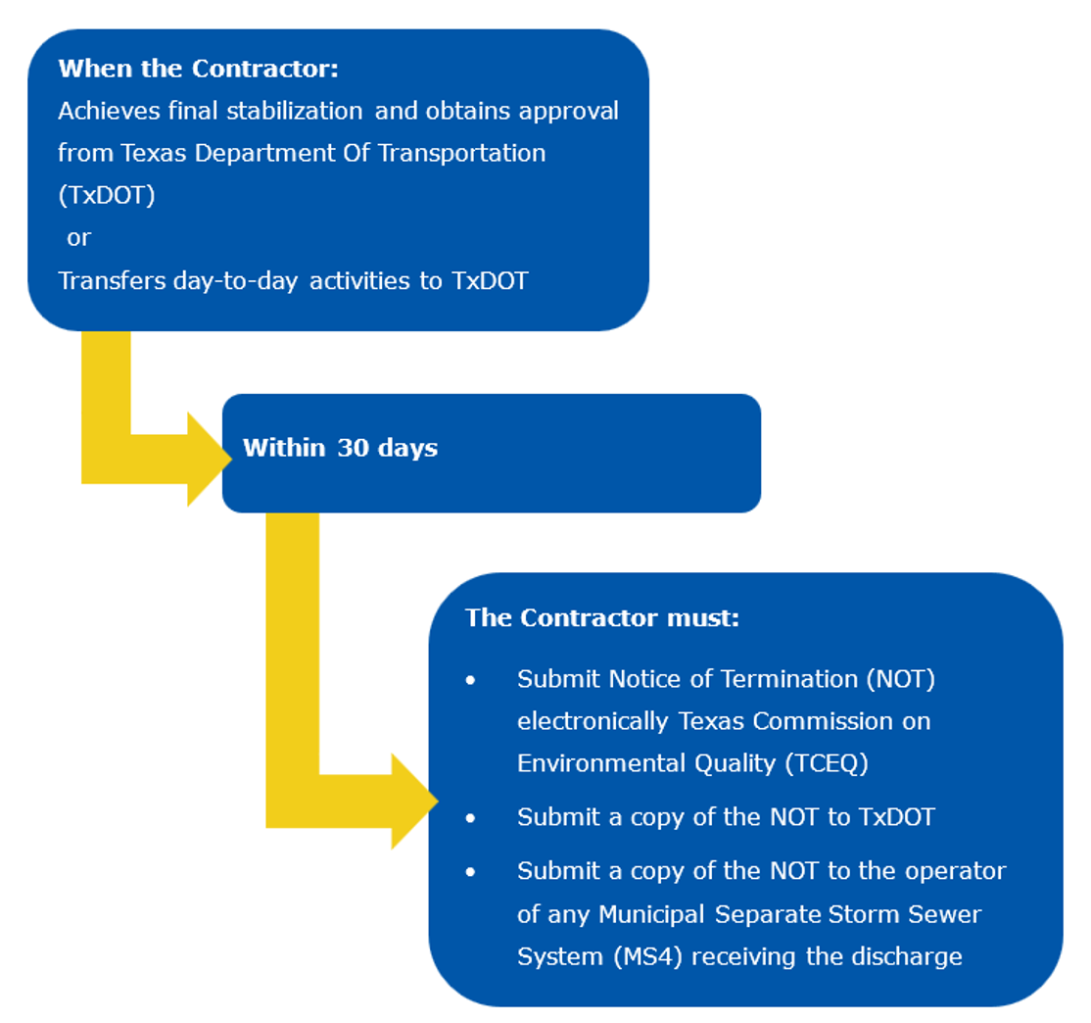
Figure 6. Notice of Termination requirements following project final stabilization or transfer of responsibilities to TxDOT, including submission deadlines and required notifications.

7.0 Large Construction Activity Termination of Coverage for the Department
For large construction activities, once final stabilization is complete and TxDOT receives the final signed NOT from all Contractors, TxDOT will submit a NOT to terminate coverage for the project through STEERS. Figure 7 outlines the process to properly terminate large construction activity authorization under the CGP.
Large Construction Activity Termination of Coverage Process for the Department
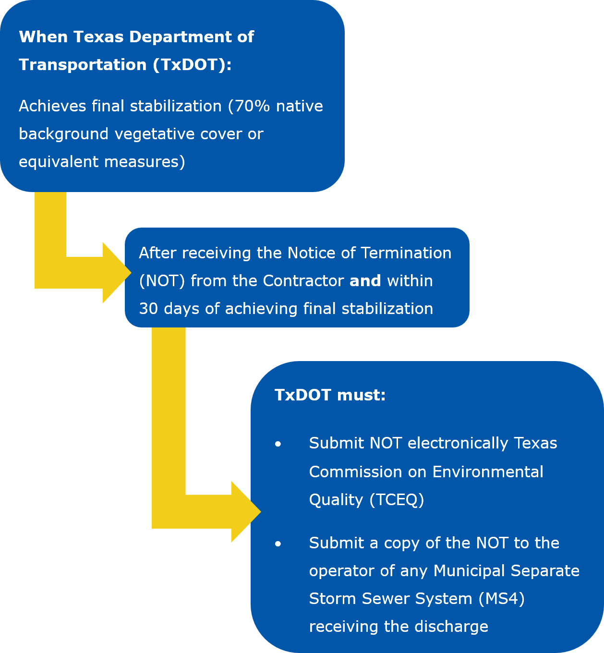
Figure 7. TxDOT Notice of Termination actions and timeline following achievement of final stabilization.

8.0 Transfer of Day-to-Day Operational Control
Transfer of day-to-day operational control may be necessary over the life a construction project. Before the transfer of operational control occurs, each operator must determine its roles and responsibilities as outlined in Section 1.12 and 1.13 Roles and Responsibilities of the SWP3 Summary Sheet. Figures 8 and 9 document the process the original operator must follow to transfer responsibilities properly.
Small Construction Activity Transfer of Day-to-Day Operational Control
Circle (blue) – Operator
Rectangle (yellow) – Operator actions
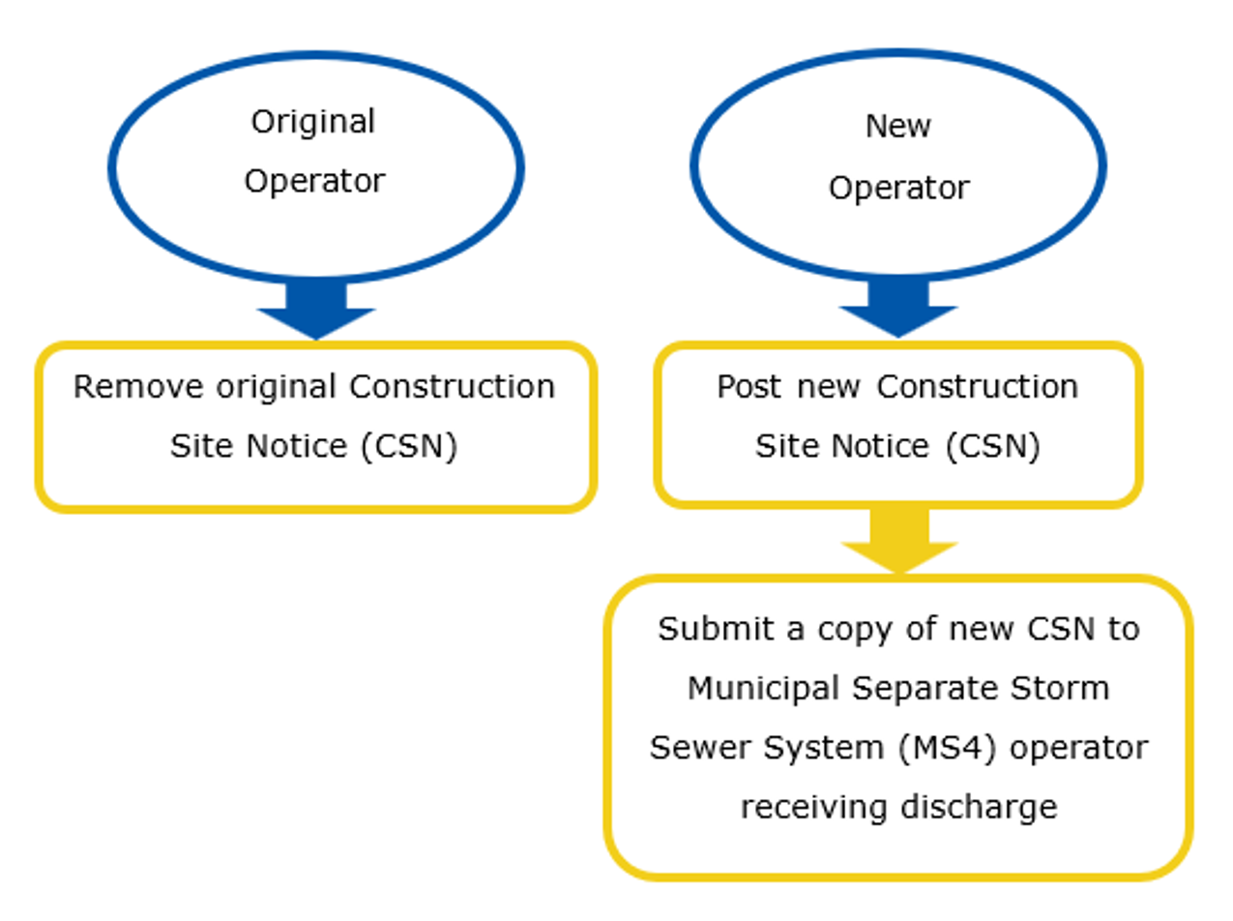
Figure 8. Construction Site Notice requirements for original and new operators when responsibility for a construction site is transferred
Large Construction Activity Transfer of Day-to-Day Operational Control
Circle (blue) – Operator
Rectangle (yellow) – Operator actions
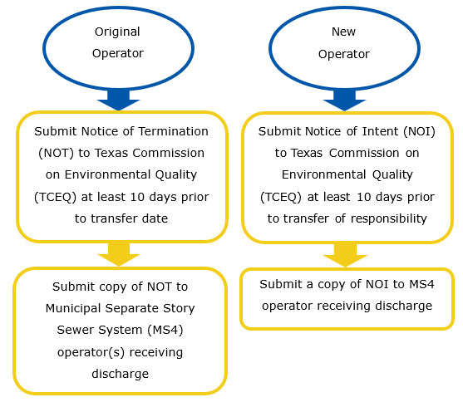
Figure 9. Notice of Termination (NOT) and Notice of Intent (NOI) submission requirements when transferring to a new operator.

Revision History
Table 1. Document revision history
Effective Date  (month, year) | Reason for and description of change
October 2026 | Version 3  - Updated to comply with accessibility and TxDOT branding standards
November 2023 | Version 2  - Revised to reflect CGP renewal of March 5, 2023. References Binder Attachment numbers (2.1 and 2.2) for Construction Site Notices and MS4 Submittals (2.3 and 2.4). Link to new Delegation of Signatories Form for Small Construction Sites. Clarification that Notices of Intent, Notices of Change, and Notices of Termination must now be submitted electronically through State of Texas Environmental Electronic Reporting System (STEERS), unless a waiver is obtained. Clarification that a Delegation of Signatories Form must be submitted electronically through STEERS. A list of positions that can sign these documents is added. Clarification that an NOC is required for change in contact such as an area engineer. Revisions to Final Stabilization requirements for arid areas. Clarification that compliance with conditions of permit is required until NOT has been submitted and approved by TCEQ.
June 2021 | Version 1  - This appendix provides information for completing the construction site notice (CSN), Notice of Intent (NOI), Notice of Change (NOT), and Notice of Termination (NOT)

Hale. 2016. “TxDOT and Contractor Co-Permittees SP 506-003 and SP 007-004” memorandum.
Williams, 2023. “Delegation of Signatories for Applications and Reports”

