Small Construction Activity Termination of Coverage Process for Texas Department of Transportation and the Contractor
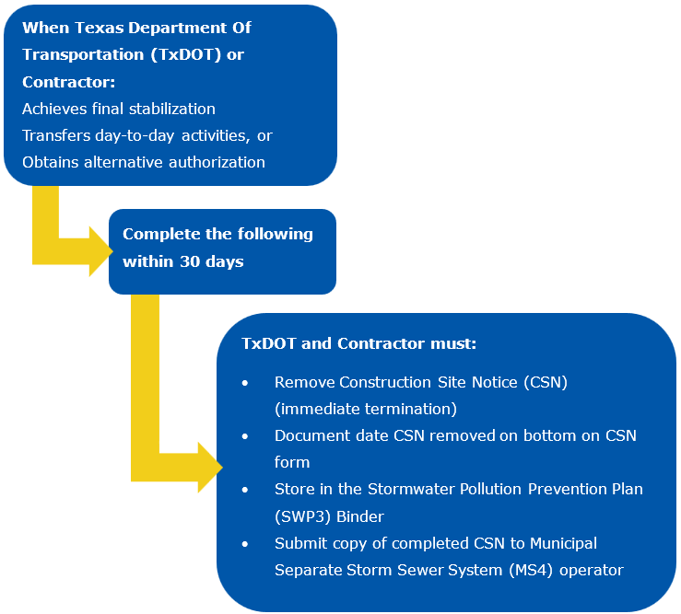
Figure 1. Steps for terminating coverage on small construction activities.

