Large Construction Activity Termination of Coverage Process for the Contractor
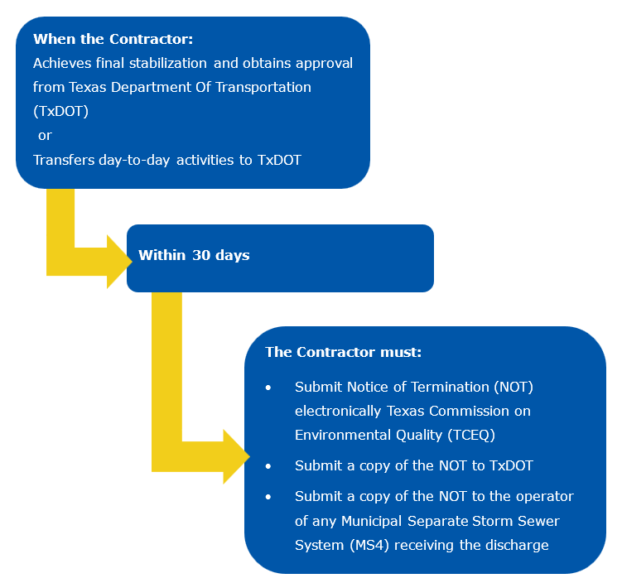Figure 1. Steps for terminating Construction General Permit (CGP) coverage on large construction activities.

Note:
Texas Department of Transportation (TxDOT) may assume duties of Primary Operator with Day-to-Day Operational Control and release the contractor prior to achieving final stabilization of 70% native background vegetative cover or in arid, semi-arid, and drought-stricken condition areas as described below.
Arid. Semi-Arid, and Drought-Stricken Condition Areas:
In arid, semi-arid, and drought-stricken condition areas, with approval of the TxDOT Engineer and for these reasons, TxDOT could utilize Part III, Section B.1.d. (Page 25) of the Construction General Permit (CGP) which allows the Primary Operator for Operational Control over plans and specifications to assume the role of the Primary Operator with Day-to-Day Operational Control. The final acceptance letter will be sent to the Contractor at which point the Contractor will no longer have obligations or rights to access the project to perform work therefore allowing Contractor to file the Notice of Termination (NOT) with the Texas Commission on Environmental Quality (TCEQ) for the project.

