

Guidance: Stormwater Pollution Prevention Plan Appendix C: Completing the Form 2118
Contents
Guidance: Stormwater Pollution Prevention Plan Appendix C: Completing the Form 2118 1
Appendix C: Completing the Form 2118 3
1.0 Project Information Section 3
2.0 If inspections cycles other than the 7-day inspection cycle are used, rainfall records are required to be kept with the SWP3 Binder in Attachment 2.5. Inspected Best Management Practices (BMPs): Areas Section 6
3.0 Corrective Actions, Maintenance, Upgrading, or Additional Controls Section 6
4.0 Temporary and Permanent Stabilization 15
5.0 Observations Section 18
6.0 Compliance Certification and Signature 20
7.0 Contractor Notification and Signature 20
8.0 Inspection Certification and Signature 21
9.0 Post Signature Updates Section 22
Revision History 23
List of Tables
Table 1. Drop Down menu options for “BMP or Area” 9
Table 2. Drop Down menu options for “Issue” 10
Table 3. Drop Down menu options for “Cause” 11
Table 4. Drop Down menu options for “Corrective Action” 12
Table 5. Drop Down menu options for “Stabilization Measure” 18
Table 6. Drop Down menu options for “Corrective Action” 18
Table 7. Document revision history 23
List of Figures
Figure 1. This is the Project Information Section of the 2118 Form. 3
Figure 2. This is section 2 of the 2118 form. 6
Figure 3. Guidance on priority levels for corrective actions. 7
Figure 4. Temporary and Permanent Stabilization section of the 2118 form. 15
Figure 5. This is the observation section of the 2118 form. 19
Figure 6. This is the compliance certification section of the 2118 form. 20
Figure 7. This is the contractor certification section. 21
Figure 8. This is the section of the 2118 form for TxDOT certifying representative signature. 22
Figure 9. this is the post signature section of the 2118 form. 22

Appendix C: Completing the Form 2118
This document is a supplemental guide to the information outlined in Section 2.2 Part 2.C Attachment 2.5 of the Guidance: Stormwater Pollution Prevention Plan.
Responsible Person
Department District Construction Personnel
Form 2118 – Construction Stormwater Pollution Prevention Plan Field Inspection and Maintenance Report is designed to meet the requirements of the Texas Pollutant Discharge Elimination System (TPDES) Construction General Permit (CGP) as administered by the Texas Commission on Environmental Quality (TCEQ). It is important that the appropriate sections are completed fully for each project inspection. Contact the Engineer for the project or the District Environmental Quality Coordinator (DEQC) if you have questions on completing on inspection form.
The following sections will detail how to complete each portion of the form correctly.

1.0 Project Information Section
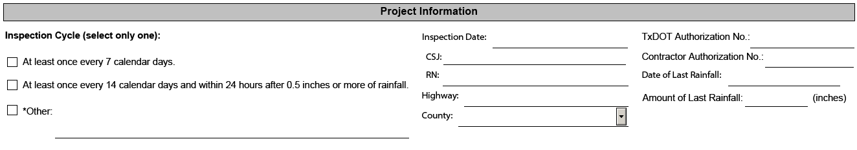
Figure 1. Project Information Section of the 2118 Form.
Complete the Project Information Section:
Inspection Cycle - Select only one of the three possible blocks. The selected box must be the same as outlined in the SWP3. The inspection cycle can be modified on a project with the approval of the Engineer and a change to the SWP3. When selecting “Other”, use the space given to document the alternative inspection cycle.
Generally, Texas Department of Transportation (TxDOT) will conduct inspections every 7 days. This is the recommended inspection cycle to implement consistent and effective enforcement of CGP requirements. Some Districts may choose an alternative inspection cycle based on arid, semi-arid, or drought-stricken conditions, if applicable, and if operations can be maintained in compliance with the CGP under an alternative inspection cycle. Changes to the inspection cycle from a typical 7-day cycle, along with the justification, should be documented in Attachment 2.5 of the SWP3 Binder (or attachment 2.3 for less than one-acre projects). More frequent inspection cycles (such as daily) may also be needed if Best Management Practices (BMPs) must be inspected to maintain compliance with Environmental Permits, Issues, and Commitments (EPICs).
Inspection Date - Complete this section by providing the date of the inspection.
Control Section Job (CSJ) - Complete this section by providing the controlling CSJ for the project. Enter CSJ with no dashes.
Regulated Entity (RN) – Provide the TCEQ Regulated Entity (RN) number provided on the Notice of Intent (NOI). If there is no NOI required for the project, write “NA” for not applicable.
Project - Complete this section by providing the project number for the controlling CSJ.
Highway - Complete this section by providing the highway for the project.
County - Complete this section by providing the county for the project.
TxDOT Authorization Number (No.) - On large projects (equal to or larger than 5 acres of earth disturbance) this is the number provided on TxDOT’s NOI from TCEQ. The Authorization No. must be made available prior to commencing construction. On small projects (equal to or greater than 1 acre and less than 5 acres of earth disturbance) use the general permit number, TXR150000 as the TCEQ Authorization No. For projects with less than 1 acres of earth disturbance, write “NA”.
Contractor Authorization No. - On large projects (equal to or larger than 5 acres of earth disturbance) this is the number provided on the Contractor’s NOI from TCEQ. The Authorization No. must be made available prior to commencing construction. On small projects (equal to or greater than 1 acre and less than 5 acres of earth disturbance) use the general permit number, TXR150000 as the TCEQ Authorization No. For projects with less than 1 acres of earth disturbance, write “NA”.
Date of Last Rainfall - Provide the last date of rainfall at the project.
Amount of Last Rainfall - Provide the amount of rainfall in inches. It is recommended that a rain gauge be kept on the project site for record keeping.
- Guidance: If the seven (7) day inspection cycle is selected the date or amount of last rainfall is not required to be recorded according to the CGP. However, the District may still require this on their inspections, especially within Districts with frequent rainfall events.
- If inspections cycles other than the 7-day inspection cycle are used, rainfall records are required to be kept with the SWP3 Binder in Attachment 2.5.

2.0 If inspections cycles other than the 7-day inspection cycle are used, rainfall records are required to be kept with the SWP3 Binder in Attachment 2.5. Inspected Best Management Practices (BMPs): Areas Section
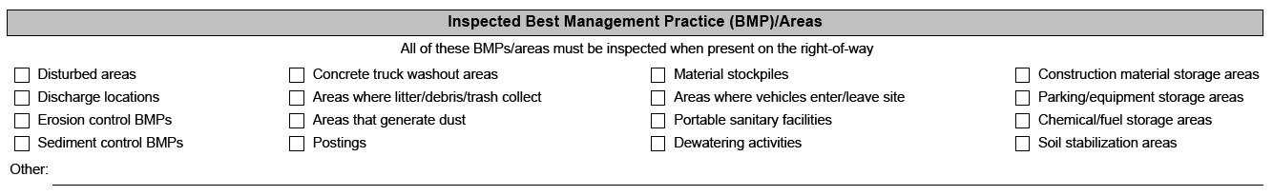
Figure 2. Section 2 of the 2118 form.
Mark all BMPs present on the project right-of-way and all areas that cause be a source of pollutant generating activities that were inspected on that day. The inspection should ensure that these BMPs are functioning properly and are being maintained in compliance with the permit. This list does not include all potential types of BMPs or areas for inspection. Make note of additional BMPs and Areas within the section entitled "Other". “Other” may include EPICs listed in the plans (such as, swallow nesting areas) that have BMPs or compliance issues to monitor.

3.0 Corrective Actions, Maintenance, Upgrading, or Additional Controls Section
Except the items listed in this section, all areas and or BMPs indicated in the previous section have been inspected and do not require maintenance, upgrading or additional controls. If multiple highways or project locations are involved, identify the highway or project location of the BMP and or area requiring maintenance or improvement. EPIC BMPs and compliance issues should also be documented in this section. Document all changes to the SWP3. Use additional sheets if needed.
The priority escalation is defined on the Form 2118. These definitions follow the Form 2118 Priority Escalation Ladder SWP3 Enforcement and Consistency guidance document released April 2021:
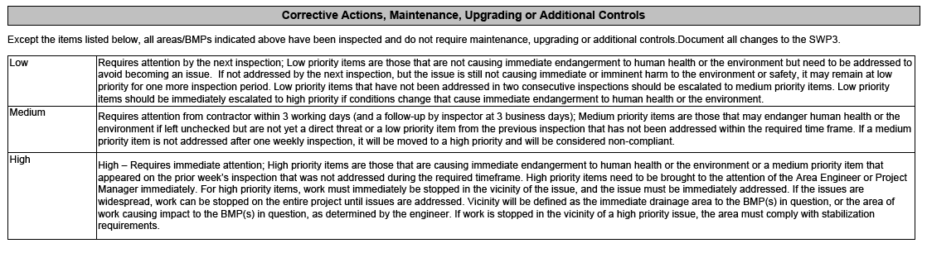
Figure 3. Guidance on priority levels for corrective actions.
In accordance with Item 506 Article 4.4, Contractors are required to implement corrective actions as soon as possible before the next anticipated rain event or within 7 calendar days of being able to enter the worksite for each control measure. The only acceptable reason for not accomplishing the corrections with the time frame specified is when site conditions are “Too Wet To Work” or when adverse conditions such as those outlined in Part III.F.8. of the CGP are present.
For each BMP or area inspected requiring corrective action, fill out the following fields in the table set:
BMP No. - List the BMP’s identifying number or label from the plan set.
New or Existing - Note if this issue is new to this inspection, or an existing carryover from the previous week.
Station of Location - Provide the station of the area and or BMP needing corrective action. This information is typically available on the plan sheets.
Left or Right of Centerline - Select Left, Right of Centerline, or Both.
Notes – Use this box to document any comments, notes, or observations that are helpful in communicating the issue or corrective action.
BMP and or Area - List the BMP or area being inspected for corrective action. Select a BMP or area from the drop-down options or type in a description in the space.
Issue – List the issue identified during the inspection. Select an issue from the drop-down options or type in a description in the space.
Cause - Document the specific cause of the potential non-compliance issue. Select cause from the drop-down options or type in a description in the space.
Corrective Action - Document the activity required to bring the BMP and or Area into compliance and resolve the issue. Select corrective action from the drop-down options or type in a description in the space.
Potential Non-Compliance – Check this box if the listed issue is a potential non-compliance. A non-compliance is generally considered something with a “high” priority, or a low or medium priority item that has gone unaddressed for multiple inspections.
Priority - Document how soon this issue and or BMP must be corrected. Use low, medium, or high following the Form 2118, Priority Escalation Ladder guidance. Districts can implement more stringent escalation processes as well.
Date of Corrective Action Completed - Provide the date when the issue or potential non-compliance was corrected. This box will remain unlocked in the Portable Document Format (PDF) when the form is signed, so the Construction Personnel completing the follow up will be able to fill in this field on the corrective action is completed.
TxDOT Representative Initials of Verification – Type in initials after completing “Date of Corrective Action Completed” field. This box will remain unlocked in the PDF when the form is signed, so the Construction Personnel completing the follow up will be able to fill in this field on the corrective action is completed.
Use a new table set for each BMP and or Area by clicking on the “Add More” button. To remove a table set click “Remove”.
The following tables show the drop-down menu choices for the fields indicated.
Table 1. Drop Down menu options for “BMP or Area”
BMP or Area | BMP or Area | BMP or Area
Silt Fence | Disturbed Area | Sediment Basin
Rock Filter Dam | Disturbed Slope | Sod
Inlet Protection | Diversion Dike and or Swale | Soil Retention Blanket
Construction Site Notice (CSN) Posting | Dust Control | Soil Stabilizer
Erosion Control Log | Fertilizer | Stabilized Construction Exit
Amphibian & Reptile Exclusion Fence | Floating turbidity barrier | Staging Area
Bonded Fiber Matrix and or Hydromulch | Mulch | Stockpile
Buffer Zone | Parking Area | Tackifier
Channel Liner | Permanent Vegetation | Temporary Paved Flume
Chemical and or Fuel Storage Area | Perimeter Control | Temporary Pipe Slope Drain
Compost (Erosion Control) | Portable Sanitary Facility | Temporary Stream Crossing
Concrete Washout | Prepared Seed Bed | Temporary Vegetation
Construction Fencing | Topsoil | Vegetated Buffer
Dewatering Activities | PSL (on right of way (ROW) | Vegetated Filter Strip
Dirt Berm | Riprap | Vertical Tracking
Discharge Location | Sediment Trap | Water body or water crossing
Table 2. Drop Down menu options for “Issue”
Issue | Issue | Issue
BMP has reached design capacity | Additional BMPs needed | Noted sediment discharges to water body or water crossing
BMP is over design capacity | Improper storage of fuel | Noted chemical discharges to water body or water crossing
BMP is damaged | Improper storage of chemicals | Noted fuel discharge to water body or water crossing
BMP is missing | Fuel leak and or spill noted | Noted litter, debris or trash discharges to water body or water crossing
BMP is improperly installed | Chemical leak and or spill noted | Noted concrete discharges to water body or water crossing
BMP is improperly designed | Rills and or gullies forming | Noted concrete discharges to ground
BMP has not been installed according to SPW3 | Rocks tracking into the roadway | Dust causing visibility issue
BMP has not been maintained | Sediment tracking into the roadway | CSN Posting missing - Contractor
BMP has not been maintained for 2+ weeks | Erosion issues noted | CSN Posting missing – TxDOT
BMP has worn out | Discharging sediment laden water
Table 3. Drop Down menu options for “Cause”
Cause | Cause | Cause
Did not follow SWP3 layout | Did not follow details or specifications for installation | Amount of disturbed area is unmanageable
Did not follow pollution control measures for housekeeping | Unusual rain event or Too wet to work | Improper material for BMP
Did not maintain BMPs accordingly | Inadequate SWP3 design or control measures | Improper housekeeping
Did not maintain areas accordingly | Improper selection of BMP or measure
Table 4. Drop Down menu options for “Corrective Action”
Corrective Action | Corrective Action | Corrective Action
Install new control | Install control along contours | Re-install with stakes closer together
Install additional control | Lengthen control and extend upslope to form J hook | Relocation NOI and or CSN to publicly accessible location near construction activities
Repair control | Maintain an undisturbed buffer of natural vegetation at creek or sensitive feature | Relocation NOI and or CSN to publicly accessible location near construction activities
Remove sediment and or clean out control | Patch control | Relocate portable sanitary facility away from creek and or sensitive feature
Remove and replace control | Perform vehicle maintenance to prevent leaks | Relocate stockpiles away from drainage, creek or creek banks
Toe in control | Pick up and properly dispose of trash and or debris | Remove construction debris
Install additional control | Post contractor’s CSN at on-ROW PSL | Remove control
Extend control length | Post CSN | Remove escaped sediment
Extend upslope to form J hook | Prepare seed bed properly, re-install control if necessary | Remove rock
Add rock | Preserve Natural Buffer Strip | Remove sediment from roadway (sweep)
Apply control and or product at specified rate | Preserve Vegetation | Remove sediment from inlet
Clean up chemical | Prohibit concrete washout during rain events | Repair erosion rill and or gully
Clean up fuel leak | Prohibit concrete washout in this area | Repair erosion rill and or gully and re-install control
Clean up concrete waste | Prohibit vehicle egress from this location | Splice control
Complete final grade and stabilize | Properly store chemical, materials or debris | Stabilize between control and inlet
Control is installed backwards – reverse it | Provide secondary containment | Stockpile and or windrow topsoil
Cover chemical and or materials | Readjust floating turbidity barrier that has been displaced | Temporarily stabilize area
Cover dumpster | Redistribute topsoil | Tie down portable sanitary facility
Cover stockpile | Re-install blanket vertically along slope | Track slope vertically
Relocate stockpile away from waterbody | Re-install blanket with proper staple pattern | Use non-erodible material for temporary stream crossing
Divert stormwater around this area | Re-install control so the ends are higher than the center | Windrow topsoil
Install BMPs around stockpile | Re-install control with more space between inlet and control
Install as perimeter control | Re-install control with more space between the toe of slope and control

4.0 Temporary and Permanent Stabilization
When construction activities permanently cease or temporarily cease and are not expected to resume for 14 or more days, on a disturbed portion of the site, erosion control and stabilization measures must be initiated immediately, unless excluded by Part III.F.2(b)(iii) of the CGP.
Use a new table set for each area of soil disturbing activity by clicking on the “Add More” button. To remove a table set click “Remove”.
Hide all table sets by clicking on the “Hide Temporary & Permanent Stabilization” button.
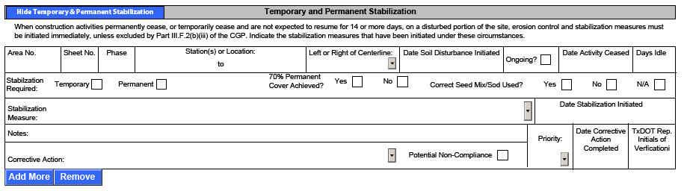
Figure 4. Temporary and Permanent Stabilization section of the 2118 form.
Area No. – The identified area for the stabilization practices, taken from the plan sheet (such as, Area A1, Area B3).
Sheet No. – Corresponding SWP3 layout sheet where stabilization practice is documented.
Phase – Project phase in which stabilization is occurring.
Station - Provide the station information of the location of the disturbed area. This information is typically available on the plan sheets.
Left or Right of Centerline - Select Left, Right of Centerline, or Both.
Date Soil Disturbance Initiated - Document the date when the contractor started soil disturbing activities in an area.
Ongoing? – Check the box if activities dependent on the soil disturbance are ongoing. This will collapse the non-applicable sections. When activity has ceased, uncheck this box and fill in “Date Activity Ceased”.
Date Activity Ceased – Date activities dependent on the soil disturbance have temporarily or permanently ceased.
Days Idle – This will calculate the number of days the area has been idle based on the inspection date and the date activities ceased.
Stabilization Required – Check whether temporary or permanent stabilization measures are required.
70% Permanent Cover Achieved – If permanent stabilization measures are required, check if 70% permanent cover has been achieved. Checking this box will collapse non-applicable sections.
Correct Seed Mix and or Sod Used? – Determine if the correct seed mix or sod was used in accordance with the plans.
Stabilization Measure - Document the stabilization measure that has been used for the noted area. Select a stabilization measure from the drop-down options or type in a description in the space.
Notes - Document notes concerning the stabilization efforts such as if the stabilization measures are installed correctly and are being maintained appropriately. If there are concerns (example - the installed sod is not receiving enough watering) about the stabilization measures it should be noted. Additionally, if the contractor is using a stabilization measure that is not listed in the form, describe the selected stabilization measure taken.
Corrective Action - Document the activity required to bring the BMP and or Area into compliance and resolve the issue. Select a corrective action from the drop-down options or type in a description in the space.
Potential Non-Compliance – Check this box if the listed issue is a potential non-compliance. A non-compliance is generally considered something with a “high” priority, or a low or medium priority item that has gone unaddressed for multiple inspections.
Priority - Document how soon this issue and or BMP must be corrected. Use low, medium, or high following the Form 2118, Priority Escalation Ladder guidance. Districts can implement more stringent escalation processes as well.
Date of Corrective Action Completed - Provide the date when the issue or potential non-compliance was corrected. This box will remain unlocked in the PDF when the form is signed, so the Construction Personnel completing the follow up will be able to fill in this field on the corrective action is completed.
TxDOT Representative Initials of Verification – Type in initials after completing “Date of Corrective Action Completed” field. This box will remain unlocked in the PDF when the form is signed, so the Construction Personnel completing the follow up will be able to fill in this field on the corrective action is completed.
The following tables show the drop-down menu choices for the fields indicated.
Table 5. Drop Down menu options for “Stabilization Measure”
Stabilization Measure | Stabilization Measure | Stabilization Measure
Channel Liner | Slope stair-stepping or terracing | Soil stabilizer
Erosion Control Blanket | Slope Texturing | Tackifier
Mulch | Sod | Temporary Vegetation
Permanent Vegetation | Soil retention blanket
Table 6. Drop Down menu options for “Corrective Action”
Corrective Action | Corrective Action | Corrective Action
Install new control | Preserve Natural Buffer Strip | Remove control
Repair control | Preserve Vegetation | Repair erosion rill and or gully
Remove and replace control | Redistribute topsoil | Repair erosion rill and or gully and re-install control
Apply control and or product at specified rate | Re-install blanket vertically along slope | Track slope vertically
Prepare seed bed properly, re-install control if necessary | Re-install blanket with proper staple pattern

5.0 Observations Section
Observations are not identified as issues or potential non-compliance items but are items to monitor so they do not progress to the point of becoming an issue or potential non-compliance. Observations should be thought of as notes, comments, reminders, or warnings to the Contractor. If additional observations remain unchecked, they could be re-classified and prioritized using the escalation ladder priority levels (low, medium, high). The observation category is not the appropriate category for items that are an issue, such as BMPs that require maintenance, sediment discharges, housekeeping issues, or other potential non-compliant items. Inspector should follow up on any “additional observations” during the next inspection to ensure those items have not progressed to issues or potential non-compliant items. Observations can also be used to communicate information to the contractor about issues related to EPICs (such as, a reminder that protected species may occur within the project area).
Add a new table set for additional observations by clicking on the “Add More” button. To remove a table set click “Remove”.
Hide all table sets by clicking on the “Observation” button.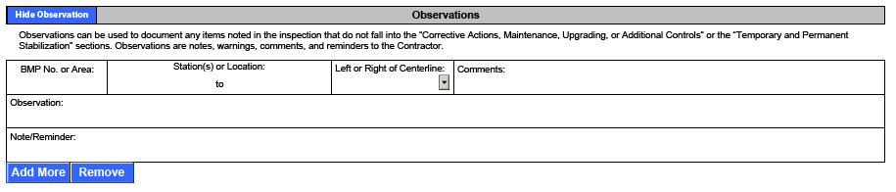
Figure 5. Observation section of the 2118 form.
BMP No. - List the BMP’s identifying number or label from the plan set.
Station(s) of Location - Provide the station of the area and or BMP of the observation. This information is typically available on the plan sheets.
Left or Right of Centerline - Select Left, Right of Centerline, or Both.
Comments – Include any relevant comments regarding the observation.
Observation - State the note, comment, reminder, or warning and what was noted regarding that issue.
Note and or Reminder – State the take-away point from the observation.

6.0 Compliance Certification and Signature
Check one of the two boxes to indicate that with corrective actions, the site is in compliance with CGP and SWP3 requirements, or to indicate that potential non-compliance issues were identified during the inspection. Print the TxDOT representative's name and title. Click “get date” to fill in the date. Then apply a digital or ink signature.
If the box indicating potential noncompliance is marked, immediately notify Engineer of the potential non-compliance. This inspection report must be completed no later than 24 hours after the inspection was conducted in accordance with Part III.F.7(f) of the TPDES CGP.
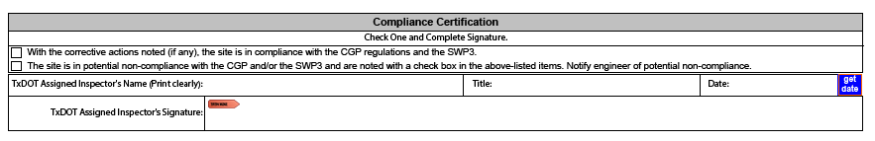
Figure 6. Compliance certification section of the 2118 form.

7.0 Contractor Notification and Signature
Furnish a copy of this inspection report to the Contractor within one working day of the inspection. The Contractor must sign and return this form within one working day of receiving it. Corrective actions must be taken as soon as possible and before the next anticipated rain event, but no later than m calendar days after being able to access the site or as outlined in Section 3 above. If corrective actions are not made within this timeframe and become potential non-compliance issues, other work on the project may be suspended by the Engineer. Time charges will continue until the project is brought into compliance and documentation of corrective action is provided. The Contractor must print their name and title. Click “get date” to fill in the date. Then apply a digital or ink signature.
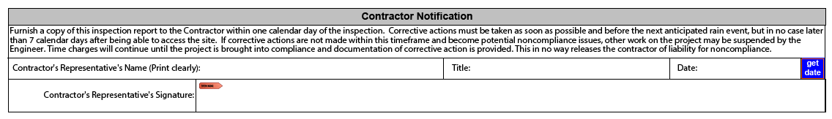
Figure 7. Contractor certification section.

8.0 Inspection Certification and Signature
This section includes a certification statement confirming that the TxDOT Certifying Representative is providing true and accurate information and that there are significant penalties for submitting false information. Print the TxDOT Certifying Representative’s name and title. Click “get date” to fill in the date. Then apply a digital or ink signature. This section should be filled out immediately upon receiving the form back from the Contractor. The certifying representative does not need to wait for corrective actions to be complete to certify the form. TxDOT Construction Engineering and Inspection (CEI) staff cannot sign this inspection certification line and signature authority for certification cannot be delegated to them. It is reasonable to assume that all signatures can be obtained within 3 working days upon completing the inspection.
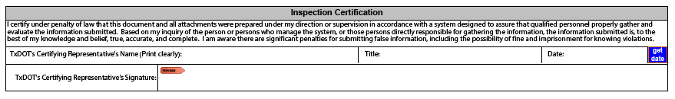
Figure 8. TxDOT certifying representative signature in Inspection Certification section.

9.0 Post Signature Updates Section
Use this section to document any items, notes, or corrections after the form was signed. This might include changes to corrective action based on additional information or changing site conditions.
Add a new table set for additional post-signature updates by clicking on the “Add More” button. To remove a table set click “Remove”.
Hide all table sets by clicking on the “Hide Post Signature Updates” button.
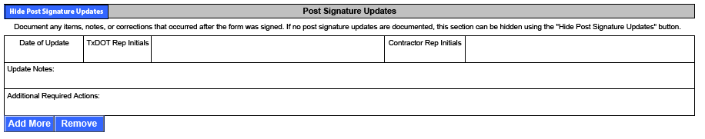
Figure 9. Post signature update section.
Date of Update – Provide the date the update was made.
TxDOT Representative Initials – Initial by the TxDOT representative approving the update.
Contractor Representative Initials – Initial by the Contractor representative acknowledging the update.
Update Notes – Describe the specifics of the update, including impacted items.
Additional Required Actions – Note any additional actions required by TxDOT or the Contractor.

Revision History
Table 7. Document revision history
Effective date (month year) | Reason for and description of change
April 2026 | Version 3  - Updated to comply with accessibility and TxDOT branding standards.
October 2023 | Version 2  - Added reference to Section 2.2 in the introduction. In Section 1 added a bullet point under “Amount of Last Rainfall” for projects on non-7-day cycles. In Section 3, added language referencing Item 506 related to Contractor's requirements for action. In Section 7, changed “calendar” to “working” days. In Section 8, added clarification on 2118 form signature and certification requirements.
August 2022 | Version 1  - This appendix provides detailed instructions for completing the Form 2118—Construction Stormwater Pollution Prevention Plan Field Inspection and Maintenance Report.

