

Guidance: Stormwater Pollution Prevention Plan
Section 2. Documentation Requirements
Part 2. Stormwater Pollution Prevention Plan Binder Contents
Contents
Guidance: Stormwater Pollution Prevention Plan 1
Introduction 6
Part 2 – Stormwater Pollution Prevention Plan Binder Contents 6
Binder Table of Contents Lists 7
1.0 Binder Contents: Environmental Plan Sheets 11
A. Attachment 1.1: SWP3 Summary Sheets 11
B. Attachment 1.2: Location Map and Environmental Layout Sheets for Markup (Stormwater Discharge Map) 11
C. Attachment 1.3: Sediment Basin or Sediment Trap Capacity Calculations 14
2.0 SWP3 Binder Attachments 15
A. Attachments 2.1 and 2.2: Copies of Completed CSN, NOI, NOC, and NOT 15
B. Attachments 2.3 and 2.4: MS4 Notifications 18
C. Attachment 2.5: Inspection Records - Form 2118 Construction Stormwater Pollution Prevention Plan Field Inspection and Maintenance Report (including Construction Activity Ceasing Records for Stabilization Requirements) 24
D. Attachment 2.5b: Dewatering Inspection and Report Requirements 29
E. Attachment 2.6: Inspector Qualifications 32
F. Attachment 2.7: Delegation of Signature Authority 34
G. Attachment 2.8: SWP3 Revisions Log 42
H. Attachment 2.9: Federal, State, and Local Compliance Documentation 44
I. Attachment 2.10: Contractor Federal, State, and Local Compliance Documentation 45
J. Attachment 2.11: Part III.A.1.C Shared SWP3 Statement 47
K. Attachment 2.12: TPDES Construction General Permit (TXR150000) 48
Appendix 50
Revision History 54
List of Tables
Table 1. Binder table of contents list for projects with 1 acre or more 7
Table 2. Binder table of contents list for projects less than 1 acre 10
Table 3. TxDOT Delegation of Signatories 35
Table 4. Document revision history 53
List of Figures
Figure 1. Sediment Basin and Sediment Trap Capacity Calculations Cover Sheet with capacity calculations attached for basin or trap 15
Figure 2. Sediment Basin and Sediment Trap Capacity Calculations Cover Sheet with no basin or trap 15
Figure 3. Attachment 2.1 TXDOT Copies of Completed CSN, NOI, NOC, and NOT Cover Sheet with table filled out 17
Figure 4. Attachment 2.2 Contractor Copies of Completed CSN, NOI, NOC and NOT documents 18
Figure 5. Attachment 2.3 TXDOT MS4 Notification Cover Sheet with no discharge to adjacent MS4 20
Figure 6. Attachment 2.3 TXDOT MS4 Notification Cover Sheet with a discharge to an MS4 21
Figure 7. MS4 Notifications Letter of Transmittal for TxDOT use only 22
Figure 8. Attachment 2.4 Contractor MS4 Notification Cover Sheet with no discharge to adjacent MS4 23
Figure 9. Attachment 2.4 Contractor MS4 Notification Cover Sheet with a project that will discharge to an MS4 24
Figure 10. Page 5 of the Form 2118, Construction Stormwater Pollution Plan Field Inspection and Maintenance Report 29
Figure 11. Attachment 2.5b Dewatering Plan and Inspection Records Cover Sheet with no dewatering activities 31
Figure 12. Attachment 2.5b Dewatering Plan and Inspection Records Cover Sheet with dewatering activities 31
Figure 13. Form 2675 – Contractor Dewatering Activities Inspection Form 32
Figure 14. Form 2672 - TxDOT Stormwater Inspector Qualifications 33
Figure 15. Form 2671 - CEI Stormwater Inspector Qualifications 34
Figure 16. Attachment 2.7 Texas Department of Transportation (TxDOT) Delegation of Signature Authority Cover Sheet with no delegation past the Area Engineer 38
Figure 17. Attachment 2.7 Texas Department of Transportation (TxDOT) Delegation of Signature Authority Cover Sheet with delegation of signatory 38
Figure 18. Delegation of Signatories to Report in STEERS 39
Figure 19. Page 1 of Form TCEQ-20403 Delegation of Signatories to Reports Memorandum 40
Figure 20. Page 2 of Form TCEQ-20403 Delegation of Signatories to Reports Memorandum 41
Figure 21. . Stormwater Pollution Prevention Plan Revisions Log 43
Figure 22. Attachment 2.9 Texas Department of Transportation Federal, State, and Local Compliance Documentation Cover Sheet with no additional permits required 45
Figure 23. Attachment 2.9 Texas Department of Transportation Federal, State, and Local Compliance Documentation Cover Sheet with additional permits required 45
Figure 24. Attachment 2.10 Contractor Federal, State, and Local Compliance Documentation Cover Sheet with no additional permits 46
Figure 25. Attachment 2.10 Contractor Federal, State, and Local Compliance Documentation Cover Sheet with additional permits 46
Figure 26. Attachment 2.11 Part III A.1.c Shared Stormwater Pollution Prevention Plan (SWP3) Statement Cover Sheet 48
Figure 27. Attachment 2.12 Texas Pollutant Discharge Elimination System (TPDES) Construction General Permit (TXR150000) Cover Sheet 49

Introduction

Part 2 – Stormwater Pollution Prevention Plan Binder Contents
The Stormwater Pollution Prevention Plan (SWP3) Binder contains all the documentation required to be kept in accordance with the Construction General Permit (CGP) and compiled into one location. The SWP3 Binder may be a physical paper document, or it may be an electronically stored file in a drive folder or in ProjectWise. If the binder is kept electronically, it must still contain all the same information outlined in this guidance document with the same organizational structure and naming conventions. Do not modify the naming convention of the SWP3 Binder attachments.
Two templates exist for the SWP3 Summary Sheets: 1) one template for projects disturbing one acre or more of soil and 2) a version of the template for projects disturbing less than one acre of soil which removes the Municipal Separate Storm Sewer System (MS4) operator list and other unnecessary attachments.
The contents outlined in this document are the minimum requirements. Everything outlined in this guidance must be included in the SWP3 Binder and in the attachments in the order laid out in this guidance. Do not modify the ordering of the attachments. Districts may choose to store additional information with their SWP3 Binders (example, Construction Stage Gate Checklists).
As with the SWP3 Summary Sheets, the binder contents are to be updated, maintained, and revised throughout the life of the project. In the case of an audit, file review, investigation, or any other circumstance that prompts the review of the SWP3 Binder, the up-to-date file must be available within 24 hours.
Generally speaking, Area Office staff or Construction Engineering Inspection (CEIs) involved in project construction are responsible for maintaining the SWP3 Binder.
Note that this guidance will designate a responsible person for each task. Specific role details may vary depending on the district, but this guidance provides general direction as to who can be reasonably expected to have ownership of a certain task. For the purposes of this guidance, the following roles are defined as:
- Design Engineer – Generally speaking, this is the engineer responsible for overseeing the development of the plan set, or the engineer who will be signing and sealing the final plan set. The “Design Engineer” may delegate the task of preparing the SWP3 Summary Sheet 1 and 2 to others involved in developing the plan set.
- Department District Construction Personnel - Generally speaking, this is a Texas Department Of Transportation (TxDOT) representative with responsibility for maintaining the SWP3 documentation through the project’s construction phase. This person varies by District and, in some cases, can be multiple people involved in the same project. Department District Construction Personnel could include inspectors, construction engineers, recordkeepers, or CEI consultants.
- Contractor Construction Personnel – Generally speaking, this is a construction contractor representative with the responsibility for managing, implementing and maintaining environmental compliance at a project site. This person varies by contractor and, in some cases, can be multiple people involved in the same project. Contractor Construction Personnel could include project managers, superintendents, project engineers, or administrative staff.

Binder Table of Contents Lists
The following table of contents is the minimum requirements for the SWP3 Binder for a project with 1 acre or more of soil disturbing activities. An optional checklist is provided in the Appendix of this guidance for use as a job aid.
Table 1. Binder table of contents list for projects with 1 acre or more
Binder Table of Contents | SWP3 Guidance Document Reference Location
Section 1. SWP3 Plan Sheets | No Text
1.1 SWP3 Summary Sheets | Section 2.1-SWP3 Summary Sheets; Section 2.2-SWP3 Binder Template, 1.0, A
1.2 Location Map and Environmental Layout Sheets for Markup (Stormwater Discharge Map) | Section 2.2-SWP3 Binder Template, 1.0, B
1.3 Sedimentation Basin Trap Capacity Calculations (if applicable) | Section 2.1-SWP3 Summary Sheets, 2.0, 2.2; Section 2.2-SWP3 Binder Template, 1.0, C
Section 2. SWP3 Binder Attachments | No Text
2.1 TxDOT Copies of Completed Construction Site Notice (CSN), Notice of Intent (NOI), Notice of Change (NOC), AND Notice of Termination (NOT) | Section 2.2-SWP3 Binder Template, 2.0, A; Appendix A: Completing the CSN, NOI, NOC, and NOT
2.2 Contractor Copies of Completed CSN, NOI, NOC, AND NOT | Section 2.2-SWP3 Binder Template, 2.0, A; Appendix A: Completing the CSN, NOI, NOC, and NOT
2.3 Texas Department of Transportation (TxDOT) MS4 Notification | No Text
Section 2.2-SWP3 Binder Template, 2.0, B; Appendix B: Municipal Separate Storm Sewer System (MS4) Notification | No Text
2.4 Contractor MS4 Notification | Section 2.2-SWP3 Binder Template, 2.0, B; Appendix B: Municipal Separate Storm Sewer System (MS4) Notification
2.5 Inspection Records: Form 2118 – Construction Stormwater Pollution Prevention Plan Field Inspection and Maintenance Report (Including Construction Activity Ceasing Records for Stabilization Requirements) | Section 2.2-SWP3 Binder Template, 2.0, C; Appendix C: Completing the Form 2118; Form 2118
2.5b Dewatering Plan and Inspection Requirements | Section 2.2-SWP3 Binder Template, 2.0, D; Form 2675
2.6 Inspector Qualifications | Section 2.2-SWP3 Binder Template, 2.0, E; Form 2671; Form 2672
2.7 TxDOT Delegation of Signature Authority | Section 2.2-SWP3 Binder Template, 2.0, F; Attachment 2.7-Delegation of Signatories to Reports Memorandum
2.8 SWP3 Revisions Log | Section 2.2-SWP3 Binder Template, 2.0, G; Attachment 2.8-SWP3 Revisions Log
2.9 TxDOT Federal, State, and Local Compliance Documentation | Section 2.2-SWP3 Binder Template, 2.0, H
2.10 Contractor Federal, State, and Local Compliance Documentation | No Text
2.11 Part III.A.1.C Shared SWP3 Standard Language | Section 1-Administrative Requirements, 2.0, 2.1; Section 2.2-SWP3 Binder Template, 2.0, J
2.12 Copy of the TPDES Construction General Permit (TXR150000) | Section 2.2-SWP3 Binder Template, 2.0, K; Attachment 2.12-Link to the Construction General Permit TXR150000Text
The following table of contents is the minimum requirements for the SWP3 Binder for a project with less than 1 acre of soil disturbing activities and are not part of a larger common plan of development. An optional checklist is provided in the Appendix of this guidance for use as a job aid.
Table 2. Binder table of contents list for projects less than 1 acre
Binder Table of Contents | SWP3 Guidance Document Reference Location
Section 1. SWP3 Plan Sheets | No Text
1.1 SWP3 Summary Sheets | Section 2.1-SWP3 Summary Sheets; Section 2.2-SWP3 Binder Template, 1.0, A
1.2 Location Map and Environmental Layout Sheets for Markup (Stormwater Discharge Map) | Section 2.2-SWP3 Binder Template, 1.0, B
Section 2. SWP3 Binder Attachments | No text
2.3 Inspection Records: Form 2118 – Construction Stormwater Pollution Prevention Plan Field Inspection and Maintenance Report (including Construction Activity Ceasing Records for Stabilization Requirements) | Section 2.2-SWP3 Binder Template, 2.0, C; Appendix C: Completing the Form 2118; Form 2118
2.4 Inspector Qualifications | Section 2.2-SWP3 Binder Template, 2.0, E; Form 2671; Form 2672
2.5 TxDOT Federal, State, and Local Compliance Documentation | Section 2.2-SWP3 Binder Template, 2.0, H
2.6 Contractor Federal, State, and Local Compliance Documentation | Section 2.2-SWP3 Binder Template, 2.0, I

1.0 Binder Contents: Environmental Plan Sheets

A. Attachment 1.1: SWP3 Summary Sheets
Responsible Person
Design Engineer will create the SWP3 Summary Sheets. Department District Construction Personnel will insert a copy of the SWP3 Summary Sheets into the SWP3 Binder.
See Guidance: Stormwater Pollution Prevention Plan, Section 2. Part 1 SWP3 Summary Sheets for additional information.
Action
Include a copy of the SWP3 Summary Sheets in the SWP3 Binder.

B. Attachment 1.2: Location Map and Environmental Layout Sheets for Markup (Stormwater Discharge Map)
Responsible Person
Design Engineer will create the map and Environmental Layout Sheets for markup. Department District Construction Personnel will insert a copy of the project location map and the Environmental Layout Sheets for inspection markup in the SWP3 Binder.
Action
Include a copy of the project location map and Environmental Layout Sheets for inspection markup in the SWP3 Binder. These sheets need to be maintained through the life of the project. Inspectors can make handwritten mark-ups or use a portable document format (PDF) editor to mark-up.
Site Location Map
TxDOT must include a site location map for the construction project in the SWP3 Binder that identifies the project location, major roadway intersections and nearby cities. The location map must show the entirety of the project limits as defined on SWP3 Summary Sheet 1. The location map can be the title sheet of the plan set. If the full project limits covered by the SWP3 cannot be shown on one map, include multiple maps to cover the appropriate project area.
Environmental Layout Sheets for Markup (also known as Stormwater Discharge Map)
The environmental layout sheets must depict the following information relative to the construction site:
- Property boundaries
- Drainage patterns and approximate slopes anticipated after major grading activities
- Surface water (including wetlands) that are adjacent or in proximity to project and indicate where those waters are impaired
Note: The CGP defines surface waters adjacent to or in close proximity of the site to mean any receiving waters within the site and all receiving waters within one mile of downstream of the site’s discharge points.
If the scale is such that this information cannot be shown on the environmental layout sheets, prepare a separate figure with the required information and include in this attachment.
- Location of sensitive environmental features (historical markers, cemeteries, habitat protection areas, etcetera)
- Locations where stormwater discharges from the site directly to a surface waterbody
- Locations where stormwater discharges to an MS4
- Locations where velocity dissipation devices are installed at discharge locations
Additionally, the following information needs to be shown on the Environmental Layout Sheets:
- Areas where soil disturbance will occur (note any phasing), including any demolition activities
- Flow arrows
- Location of all major structural controls Best Management Practices (BMPs), either planned or in place
- Location of vegetated buffer areas, either planned or in place
- Locations where temporary and permanent stabilization practices will be used
- Location of on-right-of-way (ROW) material, waste, borrow, fill, fuel or chemical storage areas, dewatering activities, concrete washouts, sanitary facilities, and equipment storage areas
- Location of off-ROW material, waste, borrow, fill, fuel or chemical storage areas, dewatering activities, concrete washouts, sanitary facilities, and equipment storage areas (within one mile of the construction site. Hand draw in area and write in Contractor’s CGP authorization number if applicable and indicate Contractor is responsible for operations. Alternatively, contractors can provide a copy of their Environmental Layout sheets for these Project Specific Location (PSL) areas)
- Location of surface waters (including wetlands) within the project limits and crossing through the project limits. Streams, creeks, rivers, tributaries, and other bodies of water with names must be labelled with their name
- Vehicle wash areas
- Designated points on the site where vehicles will exit onto paved roads (construction exit locations)
- Location of any other possible pollutant generating activity not captured in the above listed items
All the information listed above must be shown in the plan set in a manner that a regulatory agency can clearly identify all requirements that are being met.
TxDOT inspectors and recordkeepers will use these sheets to track and inspect SWP3 implementation during the life of the project. The most current version of the sheets must be kept available in the SWP3 binder and updated at a frequency such that they will be available within 24 hours of a records request. A TxDOT inspector may keep a working copy with them in the field. But the SWP3 binder must be updated with any changes based off the working copy within the week.
If information on the Environmental Layout sheet(s) changes, mark up those changes on the appropriate sheets. If the changes are extensive, it may require revised layout sheet(s) to be developed and included in Attachment 1.2: Location Map and Environmental Layout Sheets for Markup (Stormwater Discharge Map) of the SWP3 Binder. Construction personnel will track significant changes as outlined in Attachment 2.8: SWP3 Revisions Log of the SWP3 Binder.

C. Attachment 1.3: Sediment Basin or Sediment Trap Capacity Calculations
Note: Information in Attachment 1.3 does not apply to projects with less than 1 acre of soil disturbance that are not part of a larger common plan of development.
Responsible person
Design Engineer
Include a copy of the sediment trap or sediment basin detail sheets and design calculations in this section.
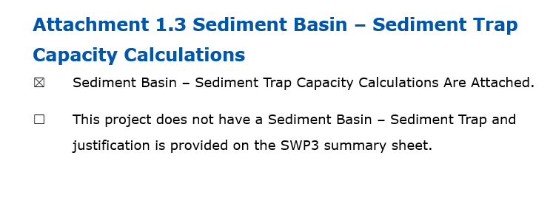
Figure 1. Sediment Basin and Sediment Trap Capacity Calculations Cover Sheet with capacity calculations attached for basin or trap
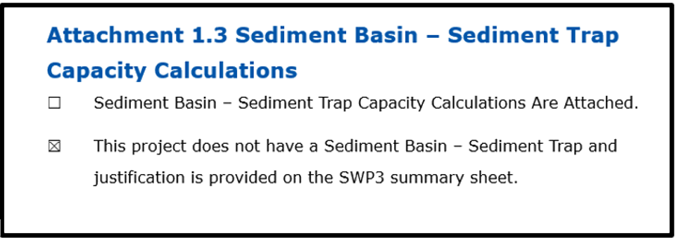
Figure 2. Sediment Basin and Sediment Trap Capacity Calculations Cover Sheet with no basin or trap

2.0 SWP3 Binder Attachments

A. Attachments 2.1 and 2.2: Copies of Completed CSN, NOI, NOC, and NOT
Note: Information in “Appendix A – Completing the Construction Site Notice (CSN), Notice of Intent (NOI), Notice of Change (NOC), and Notice of Termination (NOT)” does not apply to projects with less than 1 acre of soil disturbance that are not part of a larger common plan of development.
Responsible person
Department District Construction Personnel and Contractor Construction Personnel
CGP coverage authorization requires documentation throughout the life of the construction project. Reference Appendix A – Completing the CSN, NOI, NOC, and NOT for direction on authorization requirements.
Complete the table in the SWP3 Binder template with the notification type, date completed, and any additional notes. Insert the copies of TxDOT’s completed CSN, NOI, NOC and NOT forms (as applicable to each project) in Attachment 2.1 of the SWP3 Binder. Contractor-provided copies of the CSN, NOI, NOC and NOT forms (as applicable to each project) will be inserted in Attachment 2.2 of the SWP3 Binder.
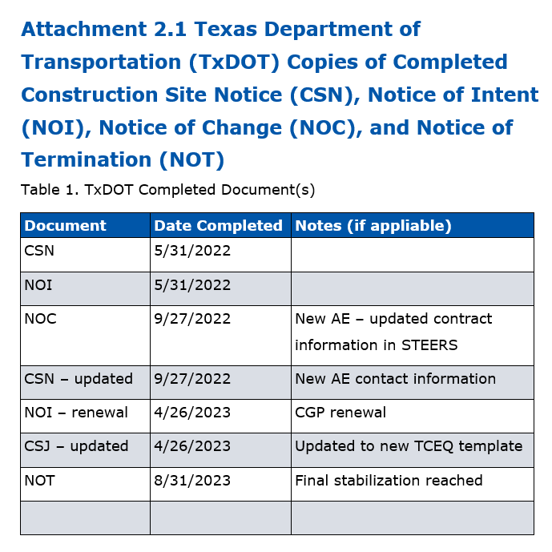
Figure 3. Attachment 2.1 TXDOT Copies of Completed CSN, NOI, NOC, and NOT Cover Sheet with table filled out
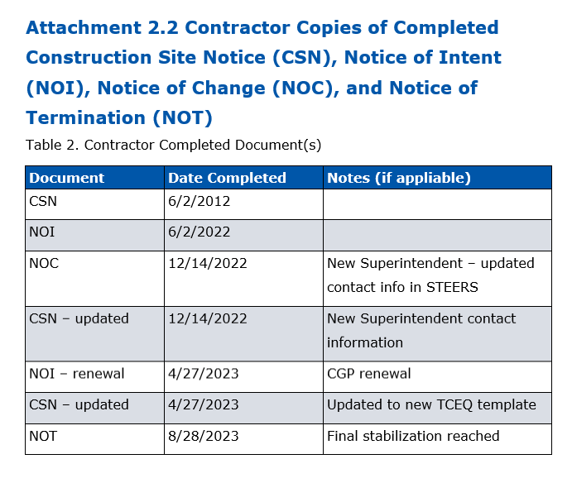
Figure 4. Attachment 2.2 Contractor Copies of Completed CSN, NOI, NOC and NOT documents

B. Attachments 2.3 and 2.4: MS4 Notifications
Note: Information in “Appendix B – Municipal Separate Storm Sewer System (MS4) Notification” does not apply to projects with less than 1 acre of soil disturbance and are not part of a larger common plan of development.
Responsible person
Department District Construction Personnel and Contractor Construction Personnel
At least 48 hours prior to the start of construction, TxDOT and the Contractor will provide notification to the local MS4 operators receiving stormwater discharge from the construction site. These MS4 operators are identified on the SWP3 Summary Sheet 1. For small construction sites, both TxDOT and the Contractor will submit a copy of the CSN. For large construction sites, TxDOT and the Contractor will submit a copy of the NOI. Additionally, for large construction activities, TxDOT must notify the local MS4 operator of any significant changes with a copy of the NOC or NOC letter. After final stabilization, the local MS4 operators must receive a copy of the completed CSN for small construction activities and signed NOT for large construction activities. Reference Appendix B – Municipal Separate Storm Sewer System (MS4) Notification for direction on authorization requirements.
In the SWP3 Binder template select “this project will discharge to the MS4(s) listed below” and complete the table with the MS4 Operator name, contact information (contact name and number), the mailing address, and the dates the NOI, CSN, NOC, and NOT were submitted to the MS4 Operator. TxDOT will use the MS4 Notification Transmittal Letter template for all CSN, NOI, NOC, and NOT notifications to the MS4 Operator(s). Insert the copies of TxDOT’s transmittal letter and notifications to the local MS4 operators in Attachment 2.3 of the SWP3 Binder. Copies of the Contractor’s notifications to the local MS4 operators will be inserted in Attachment 2.4 of the SWP3 Binder.
For projects that will not discharge to another MS4 operator select “this project will not discharge to an adjacent MS4” on the SWP3 Binder template and no further action is required.
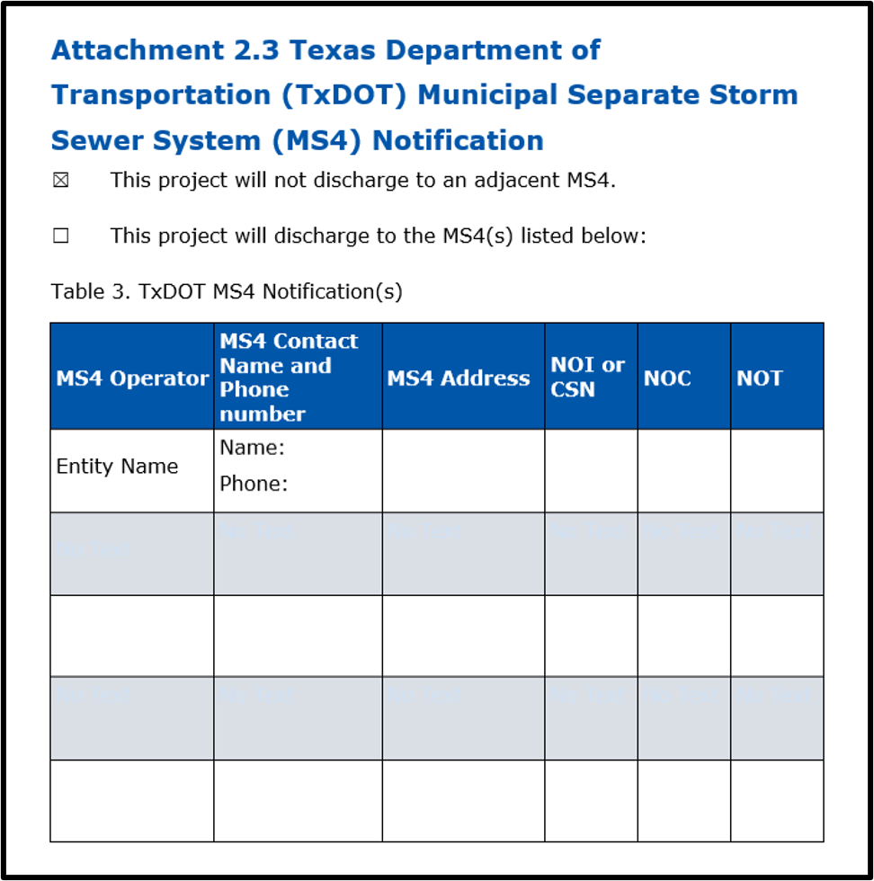
Figure 5. Attachment 2.3 TXDOT MS4 Notification Cover Sheet with no discharge to adjacent MS4
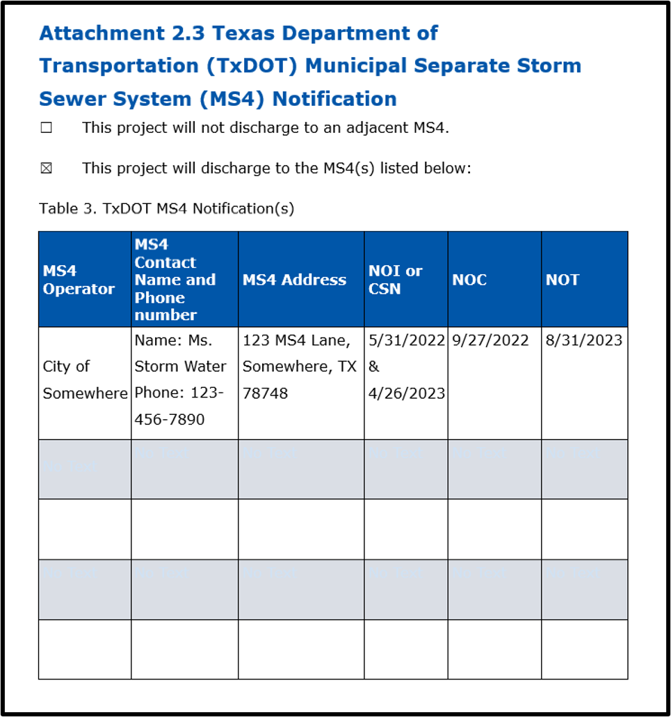
Figure 6. Attachment 2.3 TXDOT MS4 Notification Cover Sheet with a discharge to an MS4
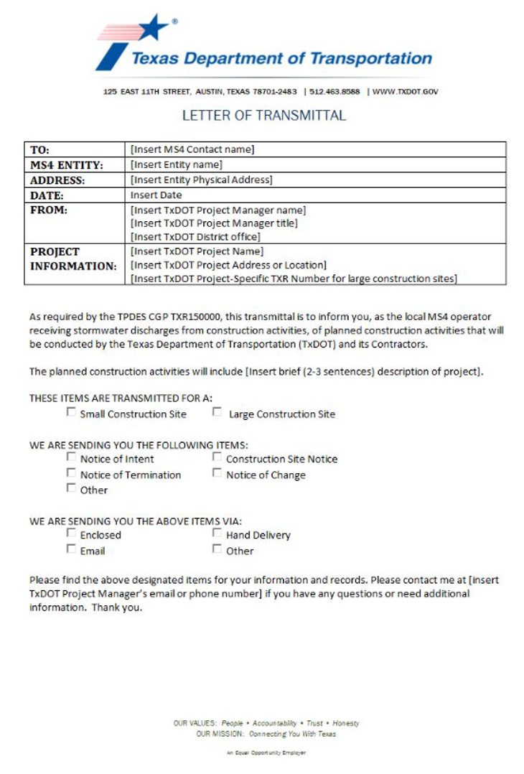
Figure 7. MS4 Notifications Letter of Transmittal for TxDOT use only
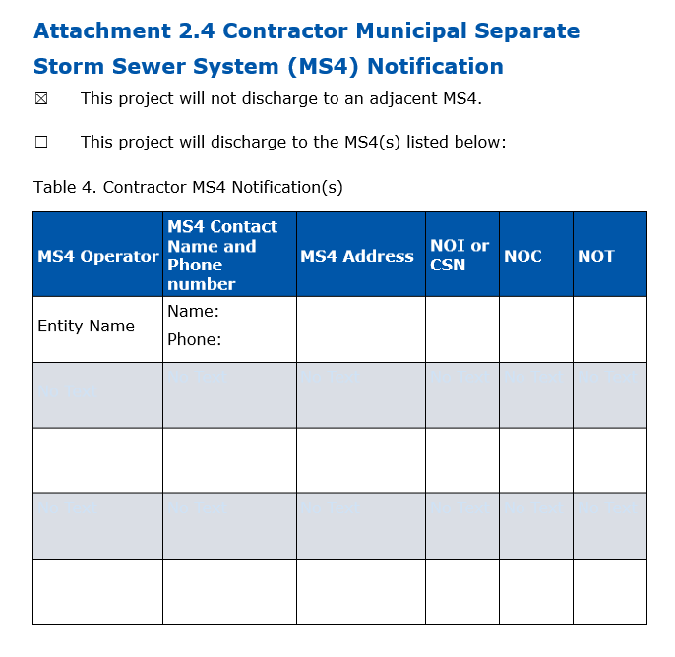
Figure 8. Attachment 2.4 Contractor MS4 Notification Cover Sheet with no discharge to adjacent MS4
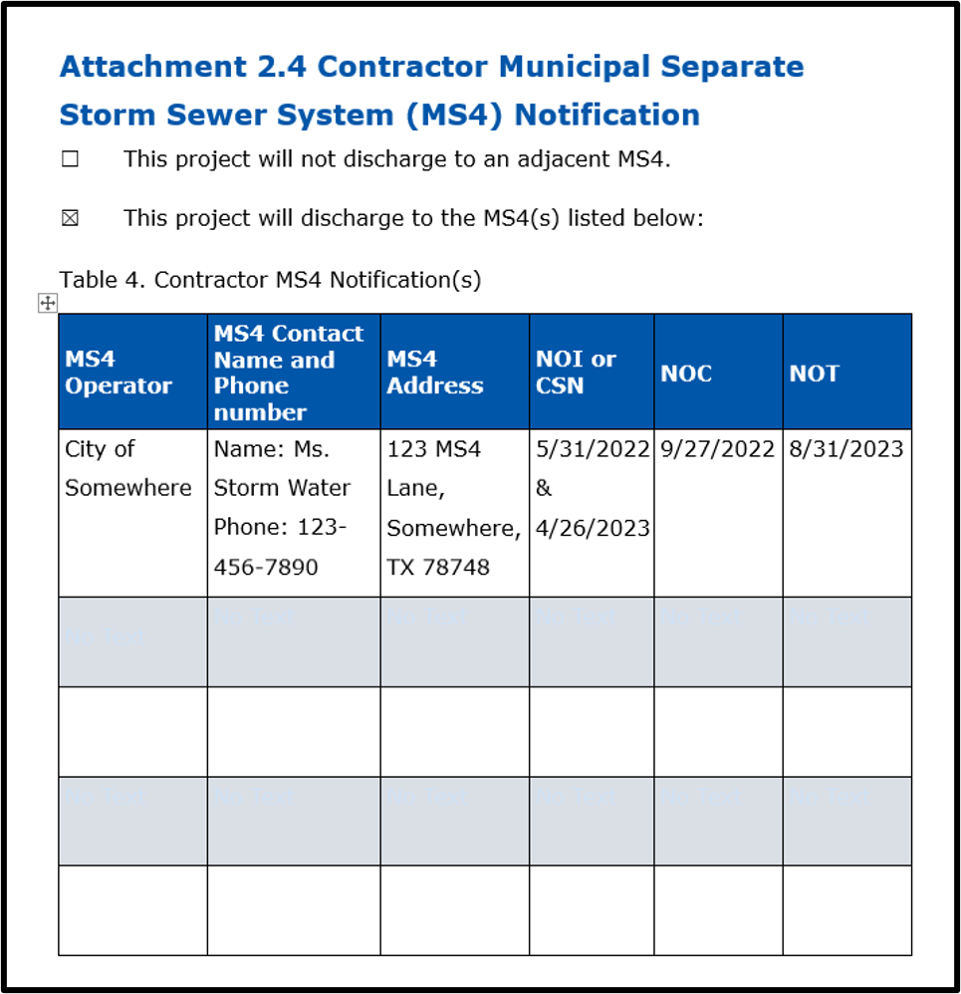
Figure 9. Attachment 2.4 Contractor MS4 Notification Cover Sheet with a project that will discharge to an MS4

C. Attachment 2.5: Inspection Records - Form 2118 Construction Stormwater Pollution Prevention Plan Field Inspection and Maintenance Report (including Construction Activity Ceasing Records for Stabilization Requirements)
Note: This is Attachment 2.3 in the SWP3 Binder for projects with less than 1 acre of soil disturbing activities and are not part of a larger common plan of development.
Responsible person
Department District Construction Personnel
Use Department “Construction Stormwater Pollution Prevention Plan Field Inspection and Maintenance Report Form 2118” to record and document inspections. See Appendix C – Completing the Form 2118 for detailed guidance on how to properly complete this form.
At a minimum, inspections need to cover the following:
- Disturbed areas of the construction site that have not been finally stabilized (this includes areas that have been temporarily stabilized, and areas where final stabilization has been initiated but not yet achieved)
- Areas exposed to precipitation used for storage of materials (on ROW)
- Structural controls (for evidence of, or the potential for, pollutants entering the drainage system) and discharge locations, including dewatering activities
- Sediment and erosion control measures identified in the SWP3 to ensure proper operation
- Locations where vehicles enter or exit the construction site to ensure off-site sediment tracking is not occurring
Inspections can be conducted by TxDOT personnel or department delegated personnel (CEIs) provided they have completed all required training in accordance with the Environmental Management System (EMS) Training Matrix located at www.txdot.gov/business/resources/environmental/environmental-management-system.html which is knowledgeable of the CGP, and are knowledgeable of construction activities at the site.
On the Form 2118 the inspector must describe how effectively the installed BMPs are performing. Note identified BMP failures during the inspection and describe any maintenance required due to the failure. If new BMPs are needed as the construction site changes, describe the additional BMPs needed and the location of installation. The Contractor must implement those revisions within 7 days. Assign escalation ladder priorities and escalate any issues not resolved within seven days in accordance with Item 506 and Form 2118 requirements. Verify dewatering practices have occurred in compliance with TxDOT and CGP requirements. Document temporary and permanent stabilization practices to determine if requirements are being met. Obtain required signatures.
Completed Form 2118 inspection reports will be stored in Attachment 2.5 (or Attachment 2.1 for less than 1-acre sites) of the SWP3 Binder. The form can be completed and stored electronically or printed and stored as a paper copy depending on how the District is managing their SWP3 Binder. The Form 2118 must be added to the SWP3 Binder within one week of completing the inspection, even if there are still outstanding corrective actions.
For Construction Activity Schedule and Ceasing Record for Soil Stabilization Requirements:
The SWP3 must contain a description of the sequence or schedule of major soil disturbing activities, including clearing, grubbing, grading and excavation. That description should also include estimated start dates and the duration of those activities. Additionally, the description should include an approximate timeline of erosion and sediment control installation and removal. The description should also address how project phasing will occur. The description should include the information pertinent to implementing the SWP3. The description can be a copy of the project schedule (containing relevant information), a spreadsheet listing relevant information, a table, a tracking sheet, recorded dates on the Environmental Layout Sheets or a written paragraph. Use the activities identified in Section 1.9 Construction Activities on the SWP3 Summary Sheet.
Additionally, TxDOT is required to maintain a record documenting the following actions:
- Date when construction activity will temporarily or permanently cease on the site
- Date when stabilization measures are or will be initiated
This information will be documented in the “Temporary and Permanent Stabilization” section of the Form 2118 to document these milestones and review compliance requirements. Per the CGP, temporary stabilization measures must be implemented when construction activities that are soil disturbing or dependent on the soil being disturbed have temporarily ceased and will not resume for 14 or more calendar days in that portion of the site. Permanent stabilization measures must be initiated immediately when construction activities that are soil disturbing or dependent on the soil being disturbed will permanently cease in that portion of the site.
Construction staff need to ensure that the “Temporary and Permanent Stabilization” section of the Form 2118 is being completed in accordance with the detailed guidance in Appendix C – Completing the Form 2118. This is required in order to meet CGP requirements.
Inspection Cycles
In most cases inspections will be conducted at least once every seven calendar days. Each inspection should be on the same day every week regardless of rainfall events.
Some Districts may utilize a 14-day inspection cycle or other alternative inspection cycle in arid, semi-arid, and drought-stricken regions. These alternate inspection cycles should be considered only when it makes sense in the scale of managing that project and when climatic conditions in the District warrant it. Projects that need increased oversight due to Contractor non-compliance should not deviate from a weekly inspection cycle. Regions that experience many rain events greater than 0.5 inches should also not consider alternative inspection cycles, as provisions in the CGP make the inspection requirements difficult to track and manage (see Part III.F.8.c.i. of the CGP). Additionally, for any alternative inspection cycle, up-to-date rainfall records are required to be kept in the SWP3 under Attachment 2.5 with the Form 2118s.
The CGP only allows inspection frequencies to be changed oncer per calendar month and implemented within the first five days of that month. The reason for the schedule change must be documented and kept in Attachment 2.5 with the Form 2118s.
The CGP also allows for the suspension of inspections during adverse weather conditions, including flooding, when dangerous conditions exist, and the site cannot be accessed. In the event that an inspection cannot be completed, document the date and time of the adverse condition and describe the conditions. This can be done as a memo or letter to the file, or on a Form 2118. An inspection must be conducted on the site within 24 hours of the adverse conditions passing and the site becoming accessible again. From there, return to the normal inspection schedule for the site.
Inspections must continue until final stabilization has been achieved, for large construction sites the NOT has been filed, and the CSNs have been removed for both TxDOT and the Contractor. Failure to continue conducting inspections until these circumstances are met is a non-compliance with the CGP.
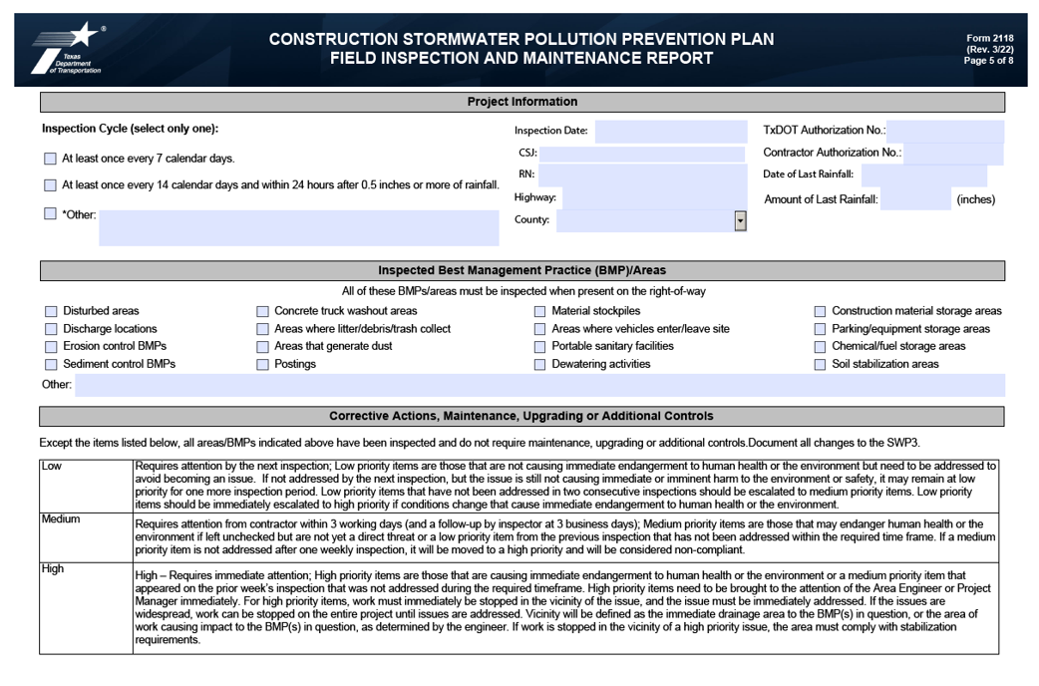
Figure 10. Page 5 of the Form 2118, Construction Stormwater Pollution Plan Field Inspection and Maintenance Report

D. Attachment 2.5b: Dewatering Inspection and Report Requirements
Note: For projects with less than 1 acre of soil disturbing activities and are not part of a larger common plan of development, but have Environmental Permits, Issues, and Commitments (EPICs), store all dewatering reports and documentation in Attachment 2.3 in the SWP3 Binder.
Responsible person
Contractor Construction Personnel
Use Department Form 2675 – Contractor Dewatering Activities Inspection Form to document the daily dewatering inspection to meet the report requirements outlined in Part III.F.7. Observation and Evaluation of Dewatering Controls Pursuant to Part IV.C. of the CGP. The contractor can submit the report in an alternative format so long as it meets all the requirements outlined in Part III.F.7. Observation and Evaluation of Dewatering Controls Pursuant to Part IV.C. of the CGP.
Department District Construction Personnel
Use Department “Construction Stormwater Pollution Prevention Plan Field Inspection and Maintenance Report Form 2118” to record and document inspections. See Appendix C – Completing the Form 2118 for detailed guidance on how to properly complete this form.
Dewatering activities pose a high level of risk for causing an unintended sediment discharge when not executed properly. Because of this TxDOT will apply additional attention to these activities during inspection.
The location of planned dewatering activities and BMPs used must be documented on the Environmental Layout Sheet(s). The dewatering plan and inspection reports will be kept in Attachment 2.5b of the SWP3 Binder.
If TxDOT identifies a dewatering activity causing an active sediment discharge, direct the contractor to cease work, immediately address the issue, and document this issue as a high priority on the Form 2118.
Utilize the tools posted to the Construction BMP webpage at www.txdot.gov/business/resources/environmental/stormwater/bmp-resources/pollution-prevention.html, to assist when conducting inspection on these activities and ensuring all proper documentation is received.
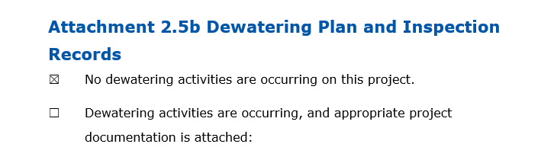
Figure 11. Attachment 2.5b Dewatering Plan and Inspection Records Cover Sheet with no dewatering activities
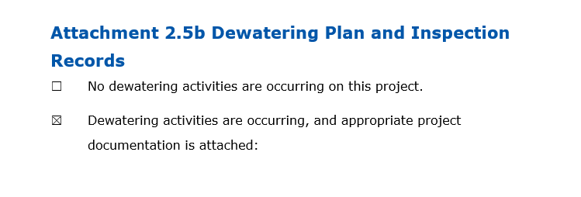
Figure 12. Attachment 2.5b Dewatering Plan and Inspection Records Cover Sheet with dewatering activities
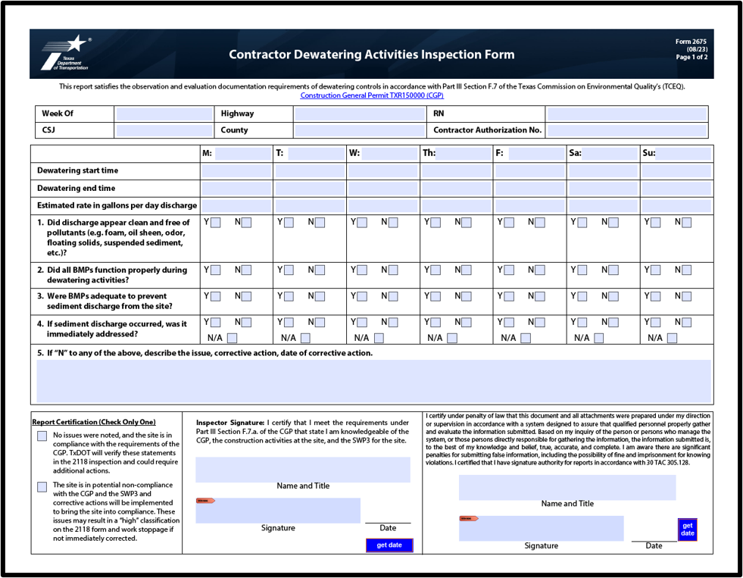
Figure 13. Form 2675 – Contractor Dewatering Activities Inspection Form

E. Attachment 2.6: Inspector Qualifications
Note: This is Attachment 2.4 in the SWP3 Binder for projects with less than 1 acre of soil disturbing activities and are not part of a larger common plan of development.
Responsible person
Department District Construction Personnel
The Department Project Manager, TxDOT recordkeeper, or others designated by the district must document the names and qualifications of Department personnel or Construction Engineering Inspection (CEI) inspectors conducting the inspections of the construction site in the SWP3. Include a copy of the “TxDOT Stormwater Inspector Qualifications Form 2672” or “CEI Stormwater Inspector Qualifications Form 2671” for each person completing Form 2118 inspections for the project. No other documentation for inspector qualifications is required in the SWP3 Binder, including certificates of completion from training programs. Note: Training requirements listed on the Inspector Qualification Form are derived directly from the EMS Training Matrix.
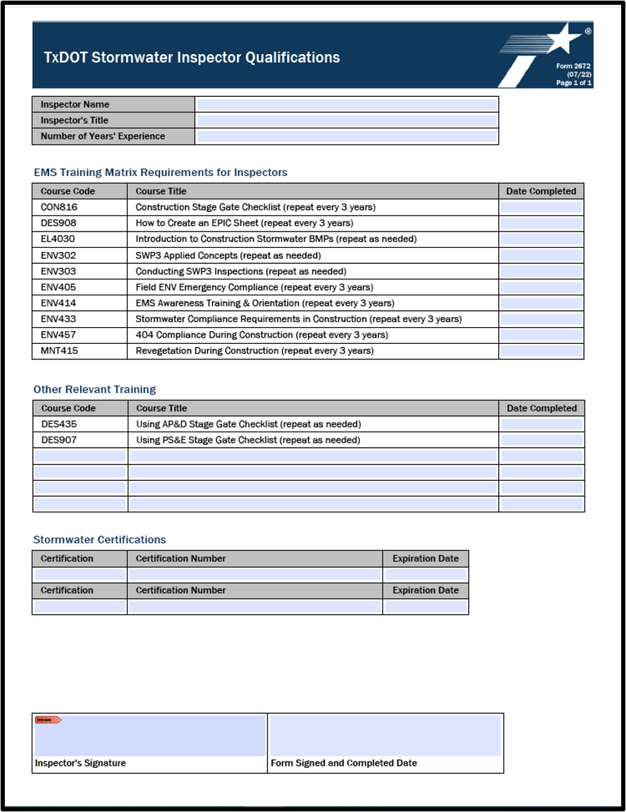
Figure 14. Form 2672 - TxDOT Stormwater Inspector Qualifications
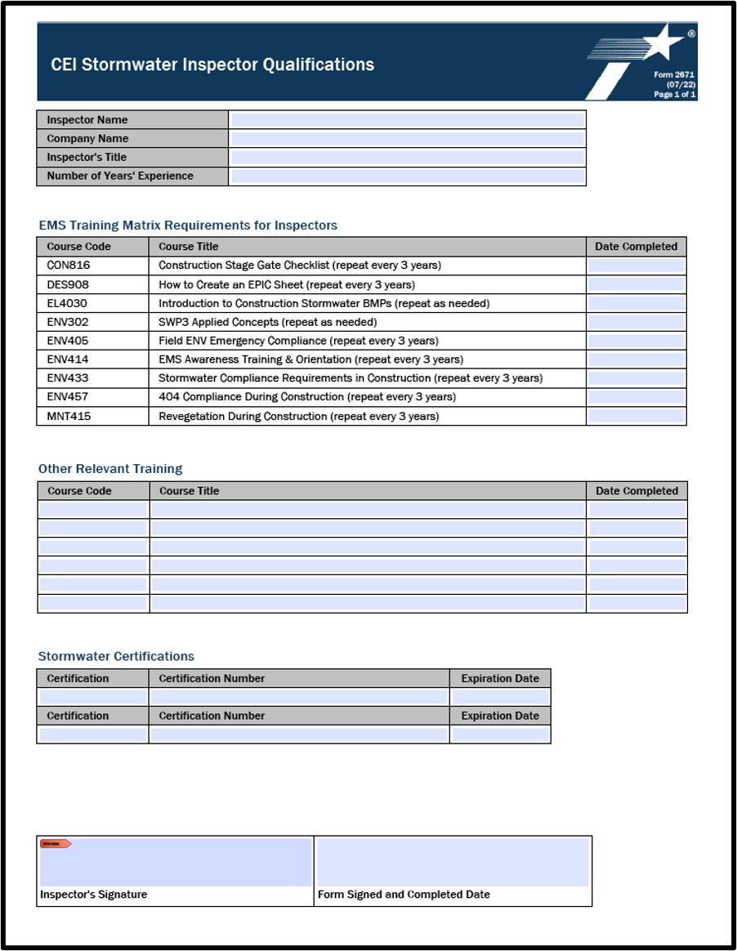
Figure 15. Form 2671 - CEI Stormwater Inspector Qualifications

F. Attachment 2.7: Delegation of Signature Authority
Note: Information in Attachment 2.7 does not apply to projects with less than 1 acre of soil disturbance and are not part of a larger common plan of development.
Responsible person
Department District Construction Personnel
TxDOT has established delegation of signatories to applications and delegation of signatories for reports authority outlined in the Department’s internal delegation of authority document. This delegation of signatures is in accordance with requirements in the Texas Administrative Code. The table below summarizes the delegation of signatory authority.
Delegation beyond what is outlined below is not permitted. CEIs cannot be delegated signature authority for report certification, including Form 2118 inspections.
For small construction sites include a copy of form Texas Commission for Environmental Quality (TCEQ)-20403, and for large construction sites include a copy of the delegation confirmation from State of Texas Environmental Electronic Reporting System (STEERS). Select “Delegation of signatory for report certification (3rd line of Form 2118) by the Area Engineer has been assigned and is attached” on the SWP3 Binder template. See Appendix A located at www.txdot.gov/business/resources/environmental/stormwater/stormwater-pollution-prevention-plan.html.
If no delegation of authority for signatures will be issued for this project, select “No delegation of signatory for report certification (3rd line of Form 2118) past the Area Engineer is allowed for this project” on the SWP3 Binder template attachment and do not attach the memo or delegation.
Table 3. TxDOT Delegation of Signatories
Document | Individual or Position Authorized (for Projects They Oversee) | Legal Basis
Execute documents relating to Texas Commission of Environmental Quality’s Texas Pollutant Discharge Elimination System (TPDES) Permits including:  - Notice of Intent (NOI)  - Notice of Termination (NOT)  - Notice of Change (NOC)  - Low Rainfall Erosivity Waiver (LREW) Application with TCEQ  - Construction Site Notice (CSN)  - Similar documents | - Director of District of Operations  - District Engineer  - Deputy District Engineer  - District Director of Maintenance, Construction, or Operations  - Division Director  - Deputy Division Director  - Division Section Director  - Area Engineer | 30 Texas Administrative Code (TAC) 305.44(a)(3) Signatories to Applications requires that applications submitted by state agencies be signed by a principal executive officer or a ranking elected official. The officer or official must have overall responsibility of a principal geographic unit of the agency.
For TPDES Permit reports requiring certification and signature:  - Certify Inspection Reports  - Certify Discharge Monitoring Reports (DMRs)  - Respond to reports and information requested by the TCEQ executive director | - Director of District Operations  - District Engineer  - Deputy District Engineer  - District Director of Maintenance, Construction, or Operations  - Division Director  - Deputy Division Director  - Division Section Director  - Area Engineer  - Assistant Area Engineer  - Project Architect or Engineer  - District Environmental Quality Coordinator  - Project Inspector with overall responsibility for the project and trained in Stormwater Construction General Permit Regulations, or Discharge of Petroleum Contaminated Water General Permit Requirements | 30 TAC 305.128(a) Signatories to Reports requires that reports must be signed by a person described in 30 TAC 305.44(a) Signatories to Applications or is an individual or position having responsibility for the overall operation of the regulated facility or activity or the environmental matters for the applicant, and that person or position has been delegated in writing to the TCEQ executive director.
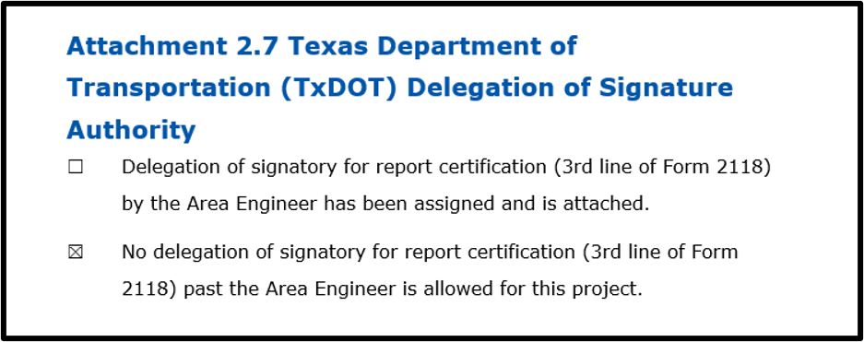
Figure 16. Attachment 2.7 Texas Department of Transportation (TxDOT) Delegation of Signature Authority Cover Sheet with no delegation past the Area Engineer
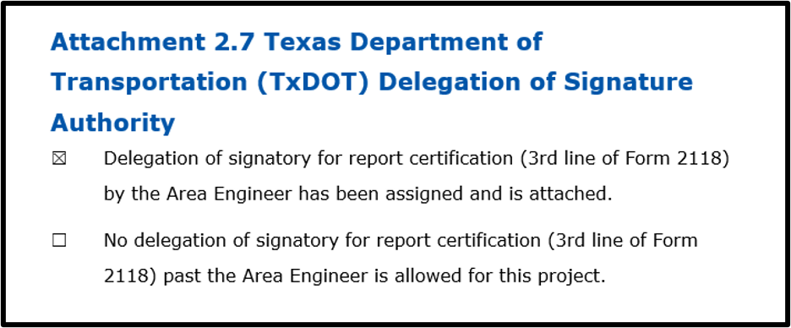
Figure 17. Attachment 2.7 Texas Department of Transportation (TxDOT) Delegation of Signature Authority Cover Sheet with delegation of signatory
For large construction sites, include a copy of the completed STEERS delegation of signatories form as Attachment 2.7 (below):
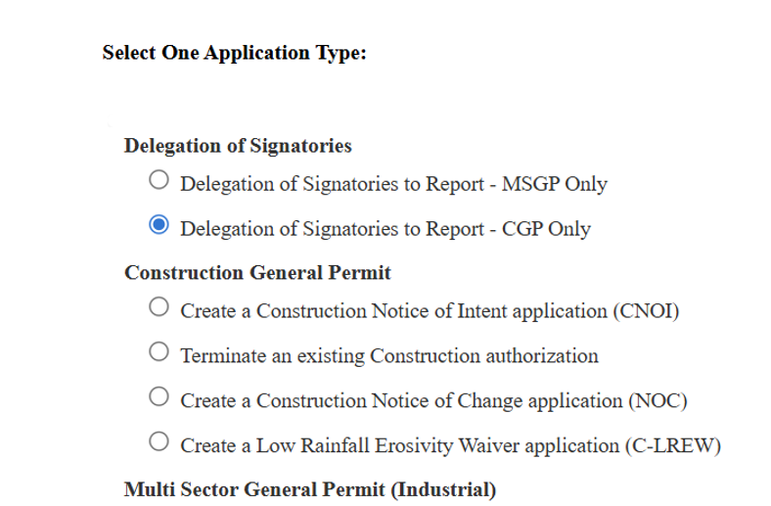
Figure 18. Delegation of Signatories to Report in STEERS
For small construction sites, include signed form TCEQ-20403 (both pages 1 and 2) as Attachment 2.7 (below):
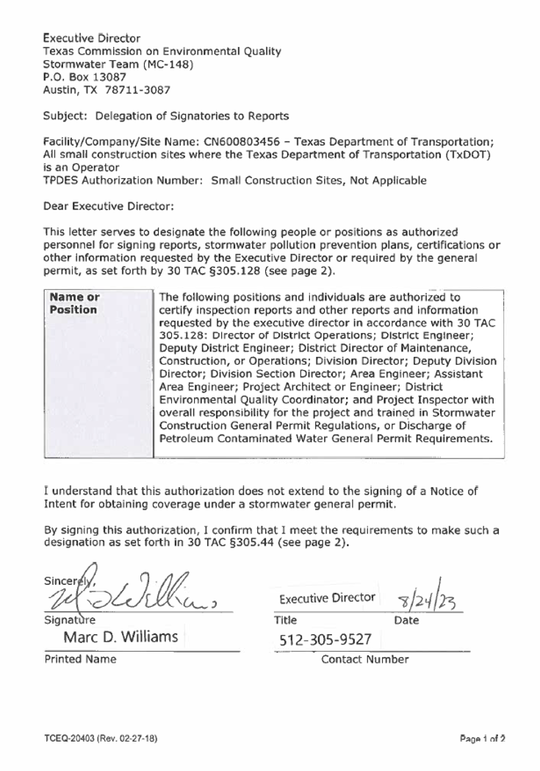
Figure 19. Page 1 of Form TCEQ-20403 Delegation of Signatories to Reports Memorandum
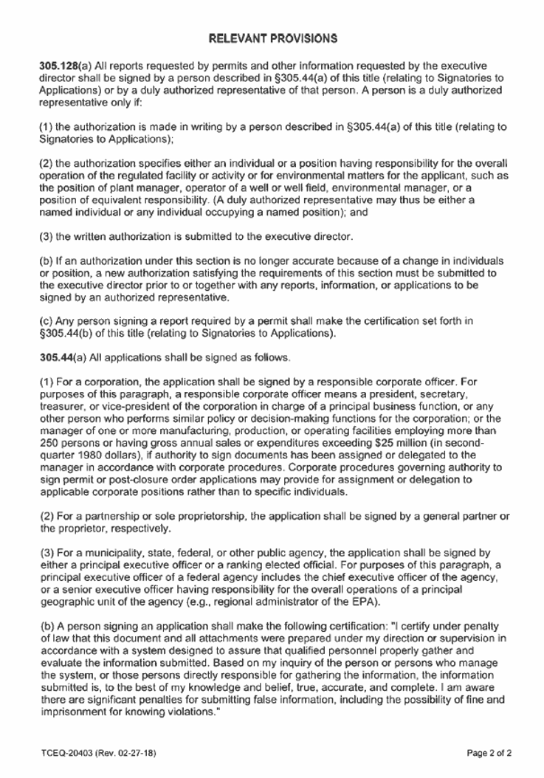
Figure 20. Page 2 of Form TCEQ-20403 Delegation of Signatories to Reports Memorandum
Download a copy of this memo (Attachment 2.7) from the TxDOT SWP3 guidance document webpage at https://www.txdot.gov/business/resources/environmental/stormwater/stormwater-pollution-prevention-plan.html, and insert it into the binder. It is not necessary to mail a copy to TCEQ – TxDOT Environmental Affairs Division has completed this requirement at a programmatic level. This District’s only responsibility is to ensure a copy of this memo is placed in the SWP3 Binder as appropriate.

G. Attachment 2.8: SWP3 Revisions Log
Note: Information in Attachment 2.8 does not apply to projects with less than 1 acre of soil disturbance and are not part of a larger common plan of development.
Responsible person
Department District Construction Personnel
TxDOT must maintain a record of all significant SWP3 revisions in Attachment 2.8 of the SWP3 Binder. Significant revisions include:
- Changes in design, construction, operation, or maintenance that significantly affect the discharge of pollutants and not previously addressed in the SWP3
- Changes in site conditions based on updated plans and specifications, new operators, new areas of responsibility or changes in BMPs
- Changes required as a result of inspections or investigations conducted by authorized Department inspection personnel, operators of a MS4 receiving stormwater discharge from the construction site, authorized TCEQ personnel or a federal, state or local agency approving sediment and erosion plans.
Use the Attachment 2.8 template or an equivalent alternative to record applicable revisions to the SWP3.
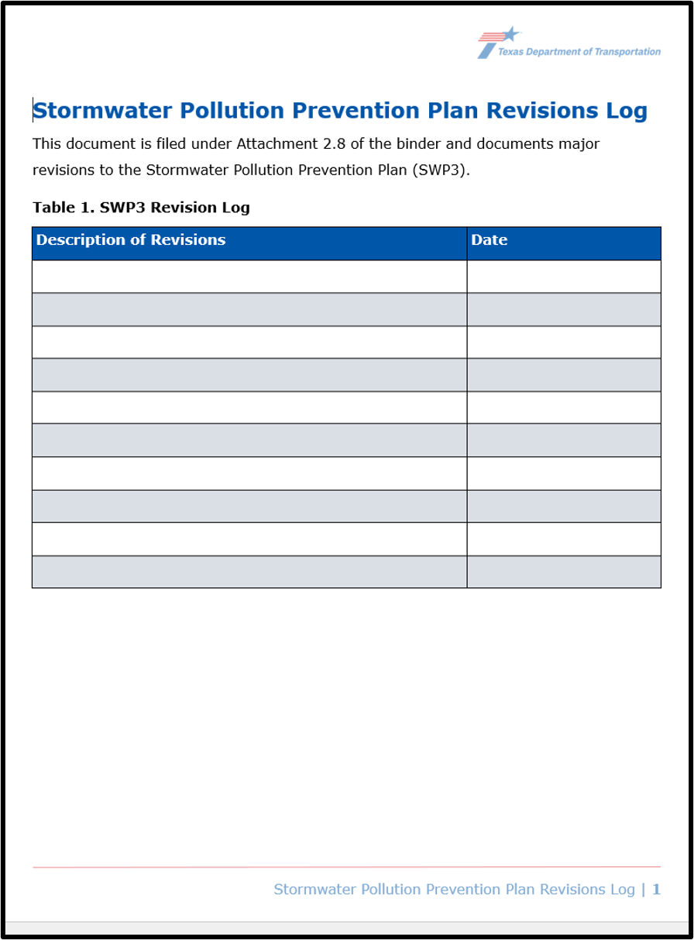
Figure 21. . Stormwater Pollution Prevention Plan Revisions Log

H. Attachment 2.9: Federal, State, and Local Compliance Documentation
Note: This is Attachment 2.5 in the SWP3 Binder for projects with less than 1 acre of soil disturbing activities and are not part of a larger common plan of development.
Responsible person
Department District Construction Personnel
TxDOT must remain in compliance with any federal, state, and local conditions as determined during the environmental clearance process. TxDOT and the Contractor shall ensure that the SWP3 is executed consistently with requirements specified in applicable environmental permits, issues, and commitments defined in the plans. Copies of permits or management plans must be kept in the SWP3 Binder in Attachment 2.9 or be readily available for review. At minimum, keep a copy of the Environmental Permits, Issues, and Commitments (EPIC) sheet and any approval letters in Attachment 2.9 of the SWP3 Binder, as applicable.
Any coordination and permits with the following federal, state, and local entities should be maintained in Attachment 2.9 of the SWP3 Binder:
- United States Army Corps of Engineers (USACE) (example: Nationwide Permits, Individual Permits)
- United States Coast Guard (USCG)
- Federal Highway Administration (FHWA)
- Texas Commission on Environmental Quality (TCEQ) (example: Water Pollution Abatement Plan)
- United States Environmental Protection Agency (USEPA)
- Local Municipalities
- Local Counties
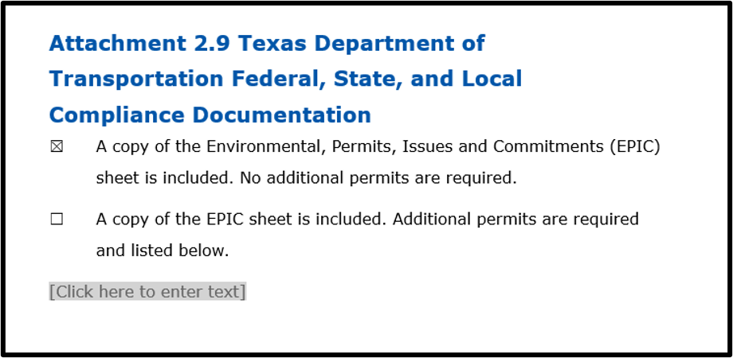
Figure 22. Attachment 2.9 Texas Department of Transportation Federal, State, and Local Compliance Documentation Cover Sheet with no additional permits required
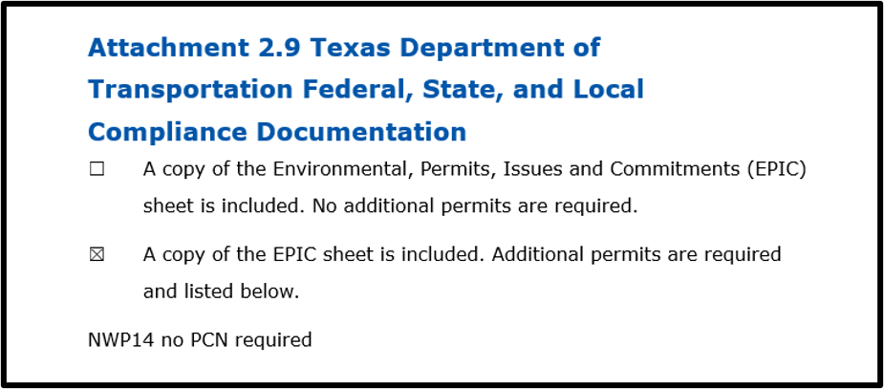
Figure 23. Attachment 2.9 Texas Department of Transportation Federal, State, and Local Compliance Documentation Cover Sheet with additional permits required

I. Attachment 2.10: Contractor Federal, State, and Local Compliance Documentation
Note: This is Attachment 2.6 in the SWP3 Binder for projects with less than 1 acre of soil disturbing activities and are not part of a larger common plan of development.
Responsible person
Department District Construction Personnel
TxDOT should utilize Attachment 2.10 for additional Contractor documentation that is specific to the construction site but not otherwise included in the co-permittee SWP3. This may include management plans or PSLs that are operated by the Contractor under their direct control and responsibility outside of the co-permitted SWP3. Include copies of any additional documentation provided by the Contractor in Attachment 2.10 of the SWP3 Binder or have them readily available for review.
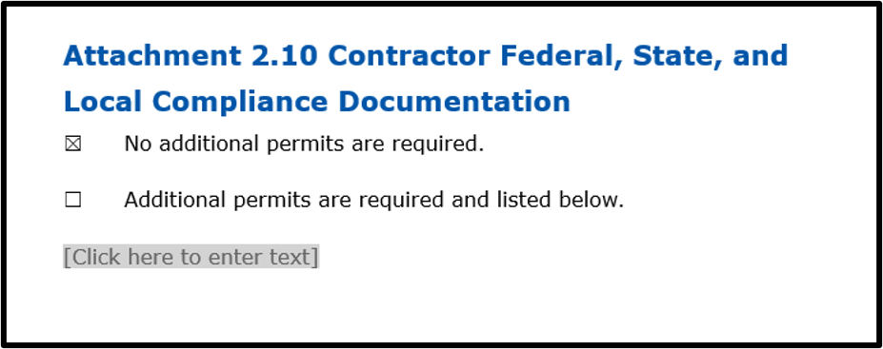
Figure 24. Attachment 2.10 Contractor Federal, State, and Local Compliance Documentation Cover Sheet with no additional permits
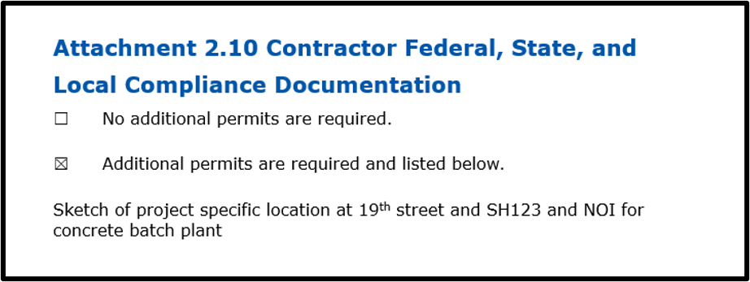
Figure 25. Attachment 2.10 Contractor Federal, State, and Local Compliance Documentation Cover Sheet with additional permits

J. Attachment 2.11: Part III.A.1.C Shared SWP3 Statement
Note: Information in Attachment 2.11 does not apply to projects with less than 1 acre of soil disturbance and are not part of a larger common plan of development.
Responsible person
Department District Construction Personnel
The following statement must be included in the SWP3 document:
“This provision requires each operator participating in a shared SWP3 to sign it. In the context of a traditional TxDOT ‘bid-build’ highway project such as this one, the SWP3 is developed prior to letting the construction contract and is made publicly available as part of the bidding process. For information on TxDOT’s public letting process, please visit Contract letting at https://www.txdot.gov/business/road-bridge-maintenance/contract-letting.html.
By submitting a bid, the construction contractor publicly accepts the terms of the SWP3 and the selected construction contractor is then contractually bound by it. See Construction General Notes, Items 7 and 506 (and special provisions), the EPIC sheet and the project plan sheets, which are part of the project package. Therefore, through the letting, bid and contract award process, both TxDOT and the construction contractor have acknowledged and agreed on the requirements of the SWP3 for the site”.
Part III.A.1.c Shared SWP3 Development Standard Language has been incorporated into the SWP3 Template for projects with 1 acre or more of soil disturbing activity, for convenience.
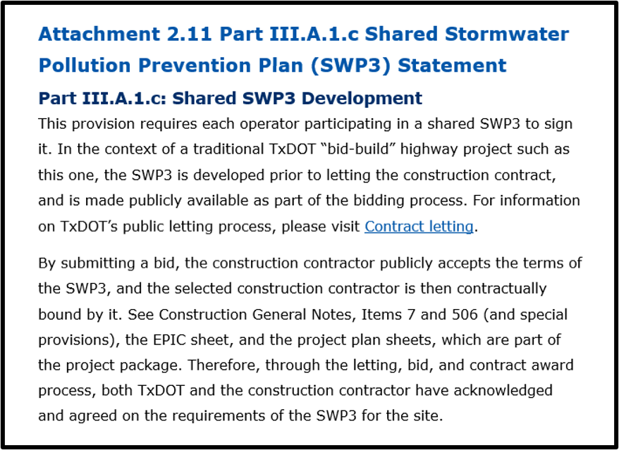
Figure 26. Attachment 2.11 Part III A.1.c Shared Stormwater Pollution Prevention Plan (SWP3) Statement Cover Sheet

K. Attachment 2.12: TPDES Construction General Permit (TXR150000)
Note: Information in Attachment 2.12 does not apply to projects with less than 1 acre of soil disturbance and are not part of a larger common plan of development.
Responsible person
Department District Construction Personnel
TxDOT is required to Include a printed copy of the CGP, an electronic copy of the CGP, or a current link to the CGP in the SWP3 Binder in accordance with Part III, Section F.1(j). An electronic copy of the CGP can be found on the TCEQ Stormwater General Permits for Construction Activities website at https://www.tceq.texas.gov/permitting/stormwater/construction. A link to the CGP on TCEQ’s website has been incorporated in Attachment 2.12 of the SWP3 Template for projects with 1 acre or more of soil disturbing activity, for convenience.
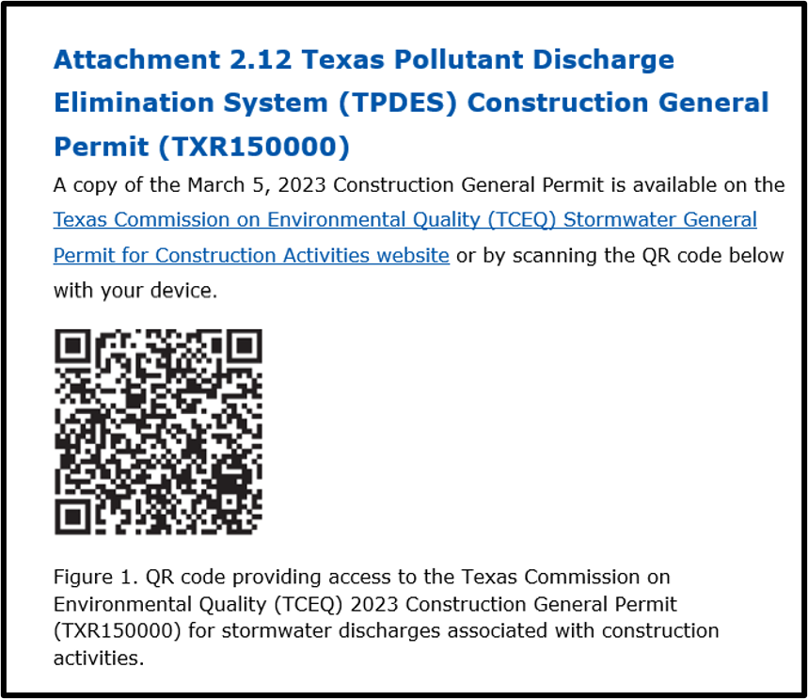
Figure 27. Attachment 2.12 Texas Pollutant Discharge Elimination System (TPDES) Construction General Permit (TXR150000) Cover Sheet

Appendix
SWP3 Binder Contents Checklists
The following checklists are the minimum requirements for the SWP3 Binders. There is a checklist for projects with 1 acre or more of soil disturbing activities and a checklist for projects with less than 1 acre of soil disturbing activities.
The checklists should be considered a job aid, and their use is completely Optional.
SWP3 Binder Contents Checklist for Projects with 1 acre or more of soil disturbing activities
Review each criterion below. For each item, check the box or mark an “X” next to the appropriate response to indicate the compliance status: Yes (Y), No (N), or Not Applicable (NA) to indicate the compliance status.
Yes – The requirement has been met.
No – The requirement has not been met.
Not Applicable – The requirement does not apply to this project or site conditions.
Section 1. SWP3 Plan Sheets
- 1.1 SWP3 Summary Sheets ☐Y ☐N ☐NA
- 1.2 Location Map and Environmental Layout Sheets for Markup
(Stormwater Discharge Map) ☐Y ☐N ☐NA
- 1.3 Sedimentation Basin Trap Capacity Calculations ☐Y ☐N ☐NA
Section 2. SWP3 Binder Attachments
- 2.1 TxDOT Completed Copies of Construction Site Notice (CSN),
Notice of Intent (NOI), Notice of Change (NOC), and Notice of
Termination (NOT) ☐Y ☐N ☐NA
- 2.2 Contractor Completed Copies of Construction Site Notice
(CSN), Notice of Intent (NOI), Notice of Change (NOC), and
Notice of Termination (NOT) ☐Y ☐N ☐NA
- 2.3 TxDOT MS4 Notification ☐Y ☐N ☐NA
- 2.4 Contractor MS4 Notification ☐Y ☐N ☐NA
- 2.5 Inspection Records: Form 2118 – Construction Stormwater
Pollution Prevention Plan Field Inspection and Maintenance
Report (Including Construction Activity Ceasing Records for
Stabilization Requirements) ☐Y ☐N ☐NA
- 2.5b Dewatering Plan and Inspection Requirements ☐Y ☐N ☐NA
- 2.6 Inspector Qualifications ☐Y ☐N ☐NA
- 2.7 TxDOT Delegation of Signature Authority ☐Y ☐N ☐NA
- 2.8 SWP3 Revisions Log ☐Y ☐N ☐NA
- 2.9 TxDOT Federal, State, and Local Compliance
Documentation ☐Y ☐N ☐NA
- 2.10 Contractor Federal, State, and Local Compliance
Documentation ☐Y ☐N ☐NA
- 2.11 Part III.A.1.C Shared SWP3 Standard Language ☐Y ☐N ☐NA
- 2.12 Copy of the TPDES Construction General Permit
(TXR150000) ☐Y ☐N ☐NA

SWP3 Binder Contents Checklist for Projects with less than 1 acre of soil disturbing activities
Review each criterion below. For each item, check the box or mark an “X” next to the appropriate response to indicate the compliance status: Yes (Y), No (N), or Not Applicable (NA) to indicate the compliance status.
Yes – The requirement has been met.
No – The requirement has not been met.
Not Applicable – The requirement does not apply to this project or site conditions.
Section 1. SWP3 Plan Sheets
- 1.1 SWP3 Summary Sheets ☐Y ☐N ☐NA
- 1.2 Location Map and Environmental Layout Sheets for Markup
(Stormwater Discharge Map) ☐Y ☐N ☐NA
Section 2. SWP3 Binder Attachments
- 2.3 Inspection Records: Form 2118 – Construction Stormwater
Pollution Prevention Plan Field Inspection and Maintenance
Report (Including Construction Activity Ceasing Records for
Stabilization Requirements, and, if applicable, Dewatering Plan
And Dewatering Inspection Requirements) ☐Y ☐N ☐NA
- 2.4 Inspector Qualifications ☐Y ☐N ☐NA
- 2.5 TxDOT Federal, State, and Local Compliance
Documentation ☐Y ☐N ☐NA
- 2.6 Contractor Federal, State, and Local Compliance
Documentation ☐Y ☐N ☐NA

Revision History
Table 4. Document revision history
Effective Date  (month, year) | Reason for and description of change
October 2026 | Version 4  - Updated to comply with accessibility and TxDOT branding standards  - Added Responsible Parties and defined Contractor Construction Personnel  - Updated Notes to reflect corresponding sections and requirements for projects that are less than 1 acre of soil disturbing activities and are not part of a larger common plan of development  - Added Appendix to include Checklists.
January 2024 | Version 3  - Provided clarification on contractor requirements related to the dewatering observation and evaluation report required by Part III.F.7. of the CGP.
October 2023 | Version 2  - Updated table of contents checklist to reflect the following updates  - Added additional clarification to the introduction on the required documentation management standards  - Added screenshots throughout the document to provide examples on how to complete the template  - Revised based on CGP Renewal included:  - updating section 1.2 to reflect the addition of property boundaries, receiving waters, and phasing in the permit;  - added additional clarification in 2.A on how to complete the table in the template; in 2.B  - added additional instruction on notification requirements and documenting information in the table; in 2.C;  - added additional elaboration on when inspections are required, escalation ladder policy, inspection cycle frequency, and document management requirements;  - created the new section 2.D “Attachment 2.5b Dewatering Plan and Inspection Requirements;”  - added additional clarification on documentation requirements for inspector qualifications in 2.E;  - updated the delegation of signature authority requirements in 2.F to reflect new TCEQ processes for small and large construction sites and the delegation of authority table was updated to reflect changes  - minor editorial updates to 2.G. through 2.K
August 2022 | Version 1  - Used as guidance on the required contents for the SWP3 Binder
7 GALVESTON WHARVES 409-766-6100 TX 104.03

