

Guidance: Stormwater Pollution Prevention Plan
Part 1. Stormwater Polution Prevention Plan Summary Sheets
Section 2. Documentation Requirements
Contents
Guidance: Stormwater Pollution Prevention Plan 1
Introduction 5
Part 1 – Stormwater Pollution Prevention Plan Summary Sheets 5
1.0 Stormwater Pollution Prevention Plan Summary Sheet 1 7
1.1 Project Control Section Job 7
1.2 Project Limits 8
1.3 Project Coordinates 11
1.4 Total Project Area 13
1.5 Total Area to be Disturbed 15
1.6 Nature of Construction Activity 17
1.7 Major Soil Types 18
1.8 Project Specific Locations 20
1.9 Construction Activities 23
1.10 Potential Pollutants and their Sources 24
1.11 Receiving Waters 26
1.12 and 1.13 Roles and Responsibilities 29
1.14 Local Municipal Separate Storm Sewer System Identification 32
2.0 Stormwater Pollution Prevention Plan Summary Sheet 2 35
2.1 Erosion Controls and Stabilization Best Management Practices 35
2.2 Sediment Control Best Management Practices 37
2.3 Permanent Controls 43
2.4 Offsite Vehicle Tracking Controls 45
2.5 Pollution Prevention Measures 46
2.6 Vegetated Buffer Zones 48
2.7 Allowable Non-Stormwater Discharges 50
2.8 Dewatering 52
2.9 and 2.10 Inspection and Maintenance 53
2.11 Sign and Sealing the SWP3 Summary Sheets 54
3.0 Abbreviations and Acronyms 55
Document Revision History 57
List of Tables
Table 1. Abbreviations and acronyms 55
Table 2. Document revision history 57
List of Figures
Figure 1. Example title sheet highlighting the Control Section Job (CSJ). The red arrow points to the CSJ. 8
Figure 2. Example of Section 1.1 Project Control Section Job (CSJ) of the SWP3 Summary Sheet with the Project Control Section Job field completed. 8
Figure 3. Example title sheet with the project limits outlined in a red box. 10
Figure 4. Example of Section 1.2 Project Limits as shown on the SWP3 Summary Sheet. 10
Figure 5. Map showing the full project extent: (Garland Road) From south of Tranquilla to Spur 244 (Northwest Highway) with red arrows pointing to the start and end of the project limits. 11
Figure 6. Map showing the full project extent: (Garland Road) From south of Tranquilla to Spur 244 (Northwest Highway) with red arrows pointing to the start and end of the project limits. 12
Figure 7. Project coordinates displayed on Section 1.3 Project Coordinates of the SWP3 Summary Sheet. 12
Figure 8. Total project area shown on Section 1.4 of the SWP3 Summary Sheet. 15
Figure 9. Total area to be disturbed documented on Section 1.5 of the SWP3 Summary Sheet. 16
Figure 10. Title sheet describing the nature of construction activity. The red box outlines the type of work for the project, showing where this information can be found. 18
Figure 11. Nature of construction activity shown on Section 1.6 of the SWP3 Summary Sheet. 18
Figure 12. Example table of major soil types shown on Section 1.7 Major Soil Types of the SWP3 Summary Sheet. 20
Figure 13. Example table of project specific locations on Section 1.8 Project Specific Locations (PSLs) of the SWP3 Summary Sheet. 22
Figure 14. Example of documenting soil disturbing construction activities on Section 1.9 Construction Activities of the SWP3 Summary Sheet. 24
Figure 15. Example of documenting potential pollutants and their sources on Section 1.10 Potential Pollutants and Sources of the SWP3 Summary Sheet. 26
Figure 16. Example of documenting receiving water tributaries and classified water bodies on Section 1.11 Receiving Waters of the SWP3 Summary Sheet. 29
Figure 17. TxDOT’s roles and responsibilities defined in Section 1.12 Roles and Responsibilities: TxDOT. 32
Figure 18. The Contractors’ roles and responsibilities defined in Section 1.13 Roles and Responsibilities: Contractor. 32
Figure 19. Example of documenting Municipal Separate Storm Sewer System (MS4) operators on Section 1.14 Municipal Separate Storm Sewer System (MS4) Operators Coordination of the SWP3 Summary Sheet. 34
Figure 20. Section 2.1 of the SWP3 Summary Sheet with erosion control and stabilization BMPs listed. 37
Figure 21. Section 2.2 of the SWP3 Summary Sheet listing sediment control BMPs.2.2.1 Sediment Control Best Management Practices Requiring Design Capacity Calculations 38
Figure 22. Section 2.2.1 of the SWP3 Summary Sheet addressing sediment trap and basin requirements. 42
Figure 23. Example of documenting permanent controls and BMPs on Section 2.3 Permanent Controls of the SWP3 Summary Sheet. 45
Figure 24. Section 2.4 of the SWP3 Summary Sheet identifying vehicle tracking controls. 46
Figure 25. Section 2.5 of the SWP3 Summary Sheet listing pollution prevention and housekeeping BMPs. 47
Figure 26. Example of documenting vegetative buffer zones and control measures on Section 2.6 Vegetative Buffer Zones of the SWP3 Summary Sheet. 50
Figure 27. Section 2.7 of the SWP3 Summary Sheet listing allowable non-stormwater discharges. 52
Figure 28. Section 2.8 of the SWP3 Summary Sheet documenting dewatering activities. 53
Figure 29. Sections 2.9 and 2.10 of the SWP3 Summary Sheet addressing inspection and maintenance. 54

Introduction

Part 1 – Stormwater Pollution Prevention Plan Summary Sheets
The Stormwater Pollution Prevention Plan (SWP3) Summary Sheets and associated Environmental Layout Sheets contain information required by the Texas Pollutant Discharge Elimination System (TPDES) Construction General Permit (CGP) TXR150000 to document how Texas Department of Transportation (TxDOT) projects will meet stormwater and water quality goals of that permit and other Environmental Permits, Issues, and Commitments (EPICs) that are dependent on stormwater controls and water quality measures (such as United States Army Corp of Engineers (USACE) Nationwide Permits and Best Management Practices (BMPs) for aquatic species). The SWP3 Summary Sheets are a living document and must be maintained and updated throughout the life of the project. When updates to the SWP3 Summary Sheets are needed the appropriate TxDOT personnel must make the necessary changes.
Two templates exist for the SWP3 Summary Sheets:
- one template for projects disturbing one acre or more of soil.
- a version of the template for projects disturbing less than one acre of soil, but EPICs that require stormwater quality controls and water quality measures.
Projects that do not disturb soil and do not have EPICs dependent on stormwater controls and water quality measures are not required to include these SWP3 Summary Sheets. Verify with environmental staff if you are unsure if EPICs apply. Projects without the need for an SWP3 should follow the guidance outlined in the Design Division’s Final PS&E Processing checklist.
Note that the Manual will designate a responsible person for each task. Specific role details may vary depending on the district, but this Manual provides general guidance as to whom can be reasonably expected to have ownership of a certain task. For the purposes of this Manual, the following roles are defined as:
- Design Engineer – Generally speaking, this is the engineer responsible for overseeing the development of the plan set or the engineer who will be signing and sealing the final plan set. The “Design Engineer” may delegate the task of preparing the SWP3 Summary Sheet 1 and 2 to others involved in developing the plan set.
- Department District Construction Personnel - Generally speaking, this is a TxDOT representative with responsibility for maintaining the SWP3 documentation through the project’s construction phase. This person varies by District and, in some cases, can be multiple people involved in the same project. TxDOT District Construction Personnel could include inspectors, construction engineers, record keepers or Construction Engineering and Inspection (CEI) consultants.

1.0 Stormwater Pollution Prevention Plan Summary Sheet 1
This section will provide guidance on completing the SWP3 Summary Sheet 1. This sheet establishes the initial site and project descriptions including the following:
- 1.1 Project Control Section Job (CSJ)
- 1.2 Project Limits
- 1.3 Project Coordinates
- 1.4 Total Project Area
- 1.5 Total Area to be Disturbed
- 1.6 Nature of Construction Activity
- 1.7 Major Soil Types
- 1.8 Project Specific Locations
- 1.9 Construction Activities
- 1.10 Potential Pollutants and Sources
- 1.11 Receiving Waters
- 1.12 and 1.3 TxDOT and Contractor Roles and Responsibilities
- 1.14 Local Municipal Separate Storm Sewer System Operator Coordination (omitted from “Less Than 1 Acre” version of template)

1.1 Project Control Section Job
Responsible Person
Design Engineer
Action
List TxDOT Controlling CSJ (CCSJ) or CSJ of the project. The project CCSJ or CSJ should be consistent between all project documents. Ensure consistency with TxDOTCONNECT. The CSJs listed should represent all CSJs that will be covered under the CGP authorization for this project, if CGP authorization is required.
Example
See the following title sheet for reference:

Figure 1. Example title sheet highlighting the Control Section Job (CSJ). The red arrow points to the CSJ.
How it will appear on the SWP3 Summary Sheet:
Figure 2. Example of Section 1.1 Project Control Section Job (CSJ) of the SWP3 Summary Sheet with the Project Control Section Job field completed.

1.2 Project Limits
Responsible Person
Design Engineer
Action
Identify the project limits in the design drawings. List the project limits based on TxDOTCONNECT.
Note: Project limits for the purposes of the CGP must include the entire limits of the area that will be covered under the specific authorization. The CCSJ and all associated CSJs must be included when determining project limits. The project limits for the entire SWP3 project area may not be the same as the limits for the CCSJ in TxDOTCONNECT because the CGP limits are based on the furthest linear “From” and “To” point.
For projects with multiple locations, a supplemental table can be attached to the SWP3 Summary Sheets.
Example
This roadway project for State Highway (SH) 78 is bound by (Garland Road) from south of Tranquilla, to the south, and SPUR (Spur route) 244 Northwest Highway), to the north. See the following title sheet for reference:
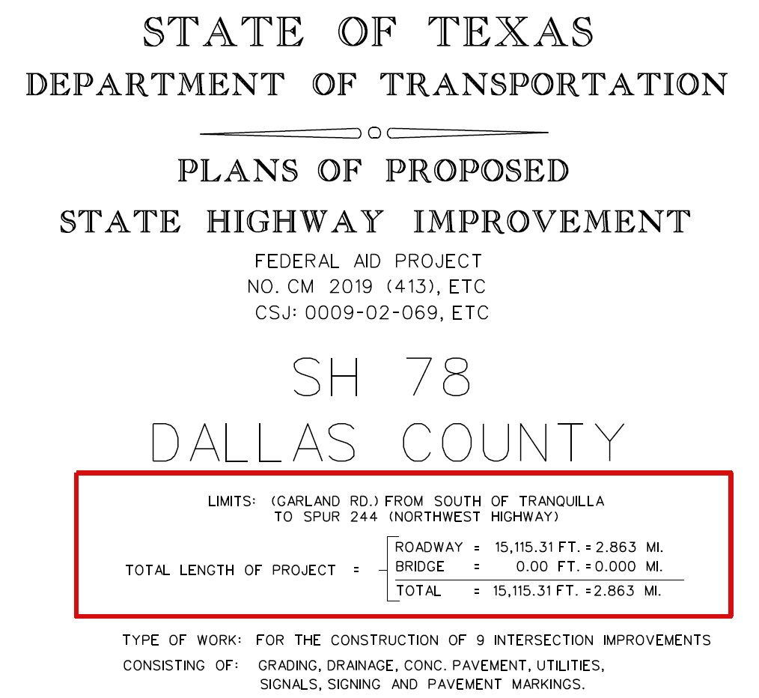
Figure 3. Example title sheet with the project limits outlined in a red box.
How it will appear on the SWP3 Summary Sheet: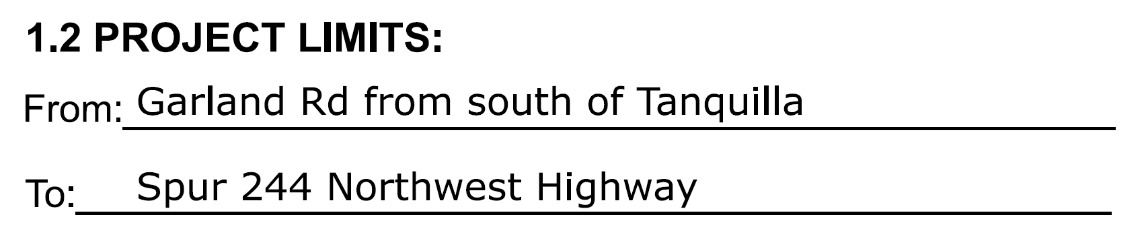
Figure 4. Example of Section 1.2 Project Limits as shown on the SWP3 Summary Sheet.

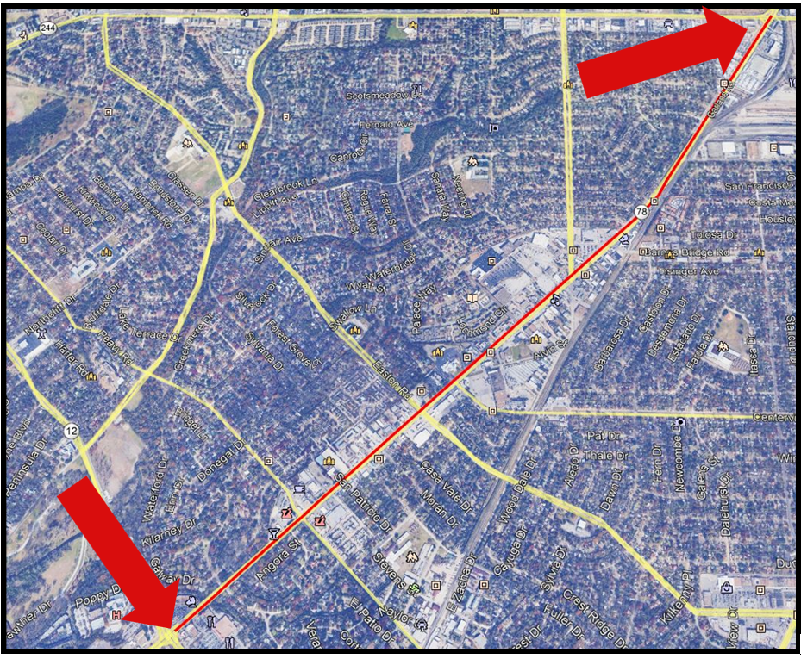
Figure 5. Map showing the full project extent: (Garland Road) From south of Tranquilla to Spur 244 (Northwest Highway) with red arrows pointing to the start and end of the project limits.

1.3 Project Coordinates
Responsible Person
Design Engineer
Action
List the longitude and latitude of the beginning and the end of the project. List the project coordinates in decimal degree format. Coordinates can be obtained from TxDOTCONNECT.
Note: Project coordinates for the purposes of the CGP must include the entire limits of the area that will be covered under the specific authorization. The CCSJ and all associated CSJs must be included when determining project coordinates. The project coordinates for the entire SWP3 project area may not be the same as the coordinates for the CCSJ in TxDOTCONNECT because the CGP coordinates are based on the furthest linear “From” and “To” point.
For projects with multiple locations, a supplemental table can be attached to the SWP3 Summary Sheets.
Example
The beginning and end of the project are depicted below along with the corresponding coordinates for reference.
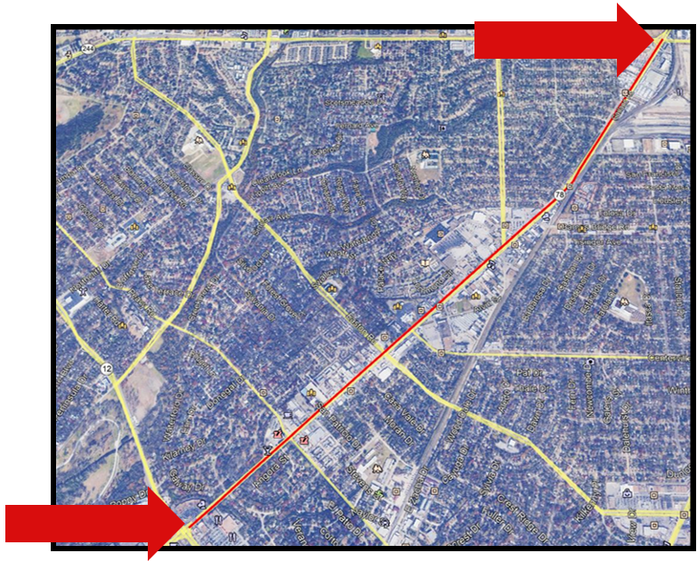
Figure 6. Map showing the full project extent: (Garland Road) From south of Tranquilla to Spur 244 (Northwest Highway) with red arrows pointing to the start and end of the project limits.
Begin Project Coordinates: Latitude (N): 32.8347° Longitude (W): 96.7011°
End Project Coordinates: Latitude (N): 32.8640° Longitude (W): 96.6706°
How it will appear on the SWP3 Summary Sheet:
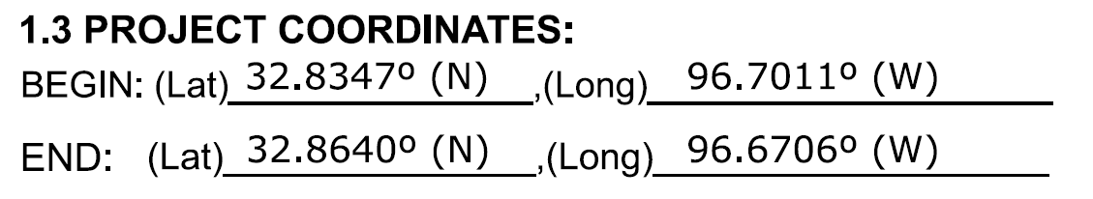
Figure 7. Project coordinates displayed on Section 1.3 Project Coordinates of the SWP3 Summary Sheet.

1.4 Total Project Area
The total project area is the total acreage of the project, including disturbed and undisturbed soil and Project Specific Locations (PSLs). PSL locations may not be known during design. If TxDOT District Construction Personnel determine that PSL locations impact the total project area, they will update this section. PSLs consist of all project supporting activities including, but not limited to, the following:
- Easements
- Asphalt Plants
- Concrete Plants
- Equipment washout and Water Disposal Areas
- Excavation Material Disposal Areas
- Chemical Storage Areas
- Material Storage Areas
- Material Borrow Areas
- Solid Waste Storage
- Dewatering Operations
- Utility Installations
When determining total project area, use the sum of the project area for all CSJs covered under the CGP authorization. If new right-of-way will be acquired, be sure to include that acreage when calculating total project area. The total area will also include any temporary and permanent easements associated with the project as shown on the plans. The total project area must include all PSLs that will be included in the co-permittee SWP3.
The Contractor is responsible for applying for separate CGP authorization for PSLs located off right-of-way.
Responsible Person
Design Engineer will initially define total project area based on design calculations. When appropriate, TxDOT District Construction Personnel will review and update.
Action
List the total number of acres of the entire project area, including known PSLs.
Note: The total project area for the purposes of the CGP must include the total area that will be covered under the specific authorization. The total project area for the SWP3 may not be the same as the TxDOTCONNECT project area because it will be a sum of the project area of all CSJs. Use the following equation to determine the total project area:
Entire Project Area = Sum of all CSJs covered under the SWP3 + PSL Total Area
Example
CSJ1 = 1.2 acres
CSJ2 = 1.1 acres
CSJ3 = 1.5 acres
PSL = 0.2 acres
Total Project Area (Acres) = 1.2 acres + 1.1 acres + 1.5 acres + 0.2 acres = 4 total acres covered under the CGP authorization.
How it will appear on the SWP3 Summary Sheet:
Figure 8. Total project area shown on Section 1.4 of the SWP3 Summary Sheet.

1.5 Total Area to be Disturbed
The total disturbed area may be less than or equal to the total project area but never more than the total project area. The disturbed soil areas must be identified on the Stormwater Discharge Map and SWP3 Layout Plan Sheets (Appendix C). PSL locations may not be known during design. If TxDOT District Construction Personnel determine that PSL locations impact the total area to be disturbed, they will update this section.
When determining total area to be disturbed, use the sum of the area to be disturbed for all CSJs covered under the CGP authorization. If new right-of-way will be acquired and soil disturbing activities will occur, be sure to include that acreage when calculating total area to be disturbed. The total area to be disturbed will also include any temporary and permanent easements associated with the project, as shown on the plans, where soil disturbing activities will occur. The total project area to be disturbed must include all disturbed soil associated with PSLs that will be included in the co-permittee SWP3.
Responsible Person
Design Engineer will initially define total area to be disturbed based on design calculations. When appropriate, TxDOT District Construction Personnel will review and update.
Action
Once calculated, list the total area of disturbed soil (acres) in this section of the SWP3 Summary Sheets.
The total area to be disturbed for the purposes of the CGP must include the entire project disturbed area of all CSJs associated to be covered under specific authorization. The CGP total disturbed area will be the sum of all combined disturbed areas of all associated CSJs, including new right-of-way, temporary and permanent easements and PSLs. Use the following equation to determine the total project area:
Entire Disturbed Area = Sum of the area to be disturbed under each CSJ covered the SWP3 + PSL Disturbed Area
Example
CSJ1 Disturbed Area = 0.3 acres
CSJ2 Disturbed Area = 1.2 acres
CSJ3 Disturbed Area = 0.6 acres
PSL Disturbed Area = 0.4 acres
Total Area to Be Disturbed (Acres) = 0.3 acres + 1.2 acres + 0.6 acres + 0.4 acres = 2.5 total acres of disturbed soil triggering covered under the CGP authorization.
How it will appear on the SWP3 Summary Sheet:
Figure 9. Total area to be disturbed documented on Section 1.5 of the SWP3 Summary Sheet.

1.6 Nature of Construction Activity
This section includes a brief description of the type of work to be conducted and what is being constructed for the project. The description should include the nature of work for all associated CSJs to be covered under the specific authorization.
Responsible Person
Design Engineer
Action
Provide a description of the type of work to be conducted and what is being constructed for the project.
Note: The nature of construction activity for the purposes of the CGP must include the entire project disturbed area of all CSJs associated to be covered under the specific authorization. This includes the nature of work being conducted under the CCSJ and all associated CSJs. Ensure the information in the description for nature of construction activity is consistent with respective entries in TxDOTCONNECT.
Example
See the following title sheet for reference:

Figure 10. Title sheet describing the nature of construction activity. The red box outlines the type of work for the project, showing where this information can be found.
How it will appear on the SWP3 Summary Sheet:
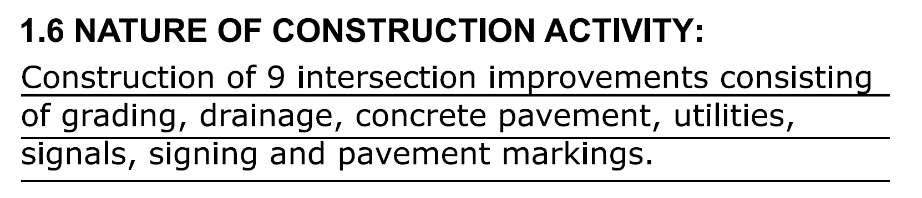
Figure 11. Nature of construction activity shown on Section 1.6 of the SWP3 Summary Sheet.

1.7 Major Soil Types
The United States Department of Agriculture Nation Resource Conservation Service (USDA-NRCS) provides access to the Web Soil Survey (WSS). The County Soil Surveys and other project specific geotechnical information can also be used to complete this section. Several types of soils can be identified at project sites but only the predominant soils within the project area need to be identified. The soil description may include the approximate percentage of rock, soil, sand and clay. Soil type is important for selecting the correct erosion control devices from the Erosion Control Approved Products List.
Responsible Person
Design Engineer
Action
List the predominant soil types and a short description of each on the SWP3 Summary Sheets. The description should include:
- Soil name with % slopes
- Composition percentage
- Soil drainage
- Rate of runoff
- Erosion potential
Department geotechnical reports can also be used to complete soils data if enough information is provided. When defining the Area of Interest (AOI) in the WSS tool ensure it is consistent with the project area defined on the SWP3 Summary Sheet 1.
Also list the stationing for the soil types in the description in the table and call out soil types on the SWP3 Layout Sheets (also known as the SWP3 Discharge Map or Environmental Layout Sheets).
For projects with multiple locations, a supplemental table can be attached to the SWP3 Summary Sheets.
Example
How it will appear on the SWP3 Summary Sheet:
The following is an example of how to document soil types in the SWP3 Summary Sheets:
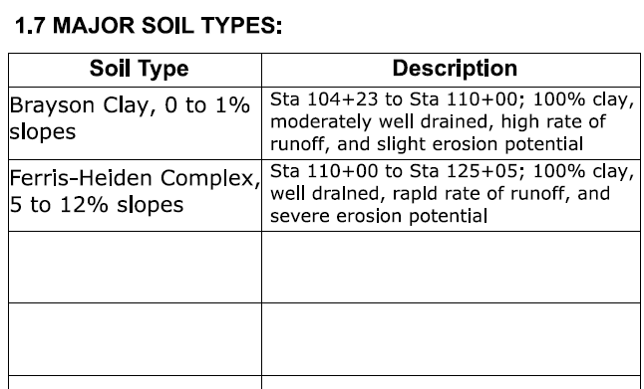
Figure 12. Example table of major soil types shown on Section 1.7 Major Soil Types of the SWP3 Summary Sheet.

1.8 Project Specific Locations
PSLs consist of all project supporting activities including, but not limited to, the following:
- Asphalt plants
- Concrete plants
- Equipment washout and water disposal areas
- Excavated material disposal areas
- Chemical storage areas
- Material storage areas
- Material borrow areas
- Solid waste storage
- Dewatering operations
- Utility installations
For PSLs to be authorized for discharge under the same permit authorization number, PSLs must only directly support the construction activity authorized under the CGP. TxDOT will include PSLs on right-of-way (ROW) in the co-permittee SWP3. Off-ROW PSLs within one mile of the project must be included in the total area to be disturbed calculation for the project that the PSL supports. The contractor shall provide diagrams and areas of disturbance for all off-ROW PSLs within one mile of the project they are supporting. All off-ROW PSLs required by the Contractor are the Contractor’s responsibility. The Contractor shall secure all authorizations and permits required by local, state and federal laws for off-ROW PSLs. PSL locations may not be known during design; once PSLs are identified by TxDOT District Construction Personnel they will update this section. The following conditions must be met for authorization of PSLs:
- Construction support activities are located within one mile from the boundary of the construction site where the construction activity authorized under the permit is being conducted that requires the support of these activities
- The permitted construction site has a developed SWP3 and includes appropriate controls and measures to reduce erosion and the discharge of pollutants in stormwater runoff
- The support activities are directly related to the construction site
- The activities are not a commercial operation, nor serve other unrelated construction projects
- The activities do not continue to operate beyond the completion of the construction activity at the project it supports
Responsible Person
Design Engineer will identify any on right-of-way PSLs known at the time of plan development. TxDOT District Construction Personnel will review and update as necessary during construction.
Action
List PSL type(s) and corresponding sheet #s for PSLs shown on the Stormwater Discharge Map/ SWP3 Layout Plan Sheets (the SWP3 “living document” in Attachment 1.2 of the SWP3 Binder).
Example
How it will appear on the SWP3 Summary Sheet:
The following is an example of how to document PSL information in the SWP3 Summary Sheets:
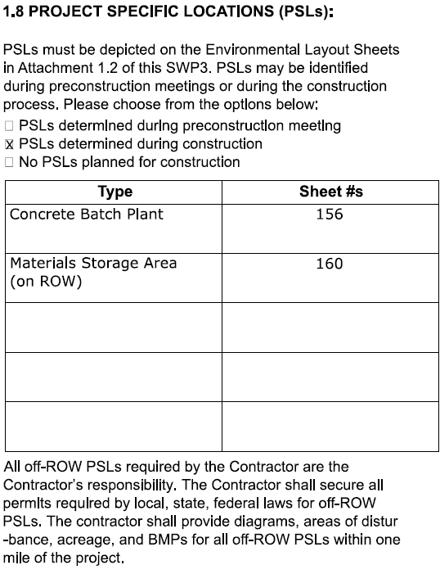
Figure 13. Example table of project specific locations on Section 1.8 Project Specific Locations (PSLs) of the SWP3 Summary Sheet.

1.9 Construction Activities
The SWP3 Summary Sheets must identify soil disturbing construction activities expected at the site.
Responsible Person
Design Engineer will initially identify soil disturbing construction activities expected at the site. When appropriate, TxDOT District Construction Personnel will review and update.
Action
Check all applicable soil disturbing construction activities associated with the project based on the nature of construction. For items not listed, check “other” and describe in the space provided. Soil disturbing activities identified in this section should be consistent with the description for the nature of the construction activity.
Example
How it will appear on the SWP3 Summary Sheet:
The following is an example of how to document soil disturbing construction activities in the SWP3 Summary Sheets:
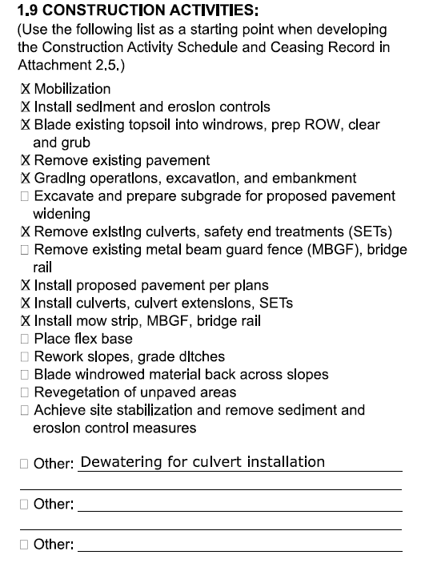
Figure 14. Example of documenting soil disturbing construction activities on Section 1.9 Construction Activities of the SWP3 Summary Sheet.

1.10 Potential Pollutants and their Sources
Potential pollutants and their sources at construction sites can consist of petroleum products from excavation equipment, chemicals used during the construction process or simply sediment from erosion of disturbed soils.
Responsible Person
The Design Engineer will initially identify potential pollutants and their sources expected at the site. When appropriate, TxDOT District Construction Personnel will review and update.
Action
Check all applicable potential pollutants and sources associated with the project based on description provided for the nature of construction. For items not listed, check “other” and describe in the space provided.
Example
How it will appear on the SWP3 Summary Sheet:
The following is an example of how to document potential pollutants and sources on the SWP3 Summary Sheets: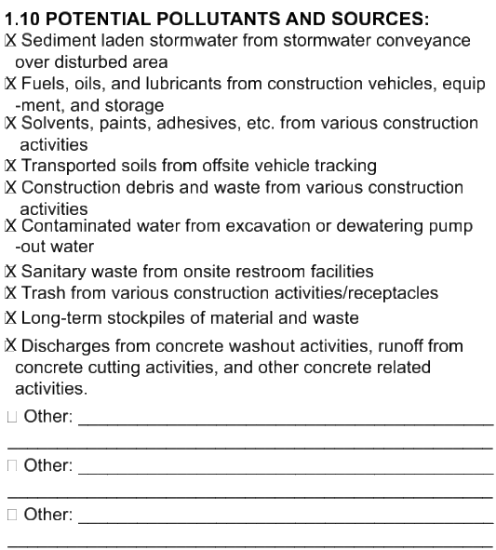
Figure 15. Example of documenting potential pollutants and their sources on Section 1.10 Potential Pollutants and Sources of the SWP3 Summary Sheet.

1.11 Receiving Waters
Receiving waters are waterbodies that receive stormwater discharges from TxDOT construction sites. Use the Texas Commission on Environmental Quality (TCEQ) Surface Water Quality Segment Viewer to follow the flow path of the receiving water until a TCEQ “classified” segment is identified or intersected. TCEQ provides a user guide on their website on how to use the Map Viewer. Please note that a TCEQ “classified” waterbody segment is not just identifying any waterbody with a TCEQ Segment Identification. The following are definitions of classified and unclassified TCEQ waterbody segments:
- Classified Segment: TCEQ waterbody segment that is associated with a four-digit segment number (i.e. 0218), as defined in the Texas Surface Water Quality Standards.
Unclassified Segment: TCEQ waterbody segment that is associated with a four-digit segment number followed by a letter (in other words, 0218A), not defined in the Texas Surface Water Quality Standards. Unclassified waterbodies are associated with the classified waterbody within the same watershed.
If the waterbody segment is determined to be unclassified, the flow path must continue until it intersects with a TCEQ classified waterbody segment. In summary, describe the flow path from unnamed tributaries all the way to a TCEQ classified waterbody segment.
If there is not flow path to a classified or unclassified waterbody segment within the limits of the project, indicate so on the table.
After describing the complete flow path, identify impairment to the TCEQ classified waterbody segment using the most recently approved Texas Integrated Report of Surface Water Quality for Clean Water Act Sections 305(b) and 303(d) (Texas Integrated Report). If a waterbody impairment is identified, further research must be conducted to determine whether the impaired waterbody has a total maximum daily load (TMDL) or implementation plan (I-plan). Most projects will not have waterbody impairments, TMDL or I-plans, and of those that do have a TMDL or I-plan, transportation related activities will rarely impact them. If an impairment, TMDL or I-plan is identified and you have questions about it, reach out to your environmental staff for guidance.
For projects with multiple locations, a supplemental table can be attached to the SWP3 Summary Sheets.
Responsible Person
Design Engineer
Action
- On the SWP3 Summary Sheets, include the following information:
- Receiving waterbody flow path names
- Whether they are unclassified and or classified segment identifications
- Type of impairment if any
- TMDL and I-Plan titles for reference
Determination of receiving waters for the project will be based of the total project limits listed on the SWP3 Summary Sheet 1.
Example
How it will appear on the SWP3 Summary Sheet:
The following is an example of how to document receiving waters in the SWP3 Summary Sheets:
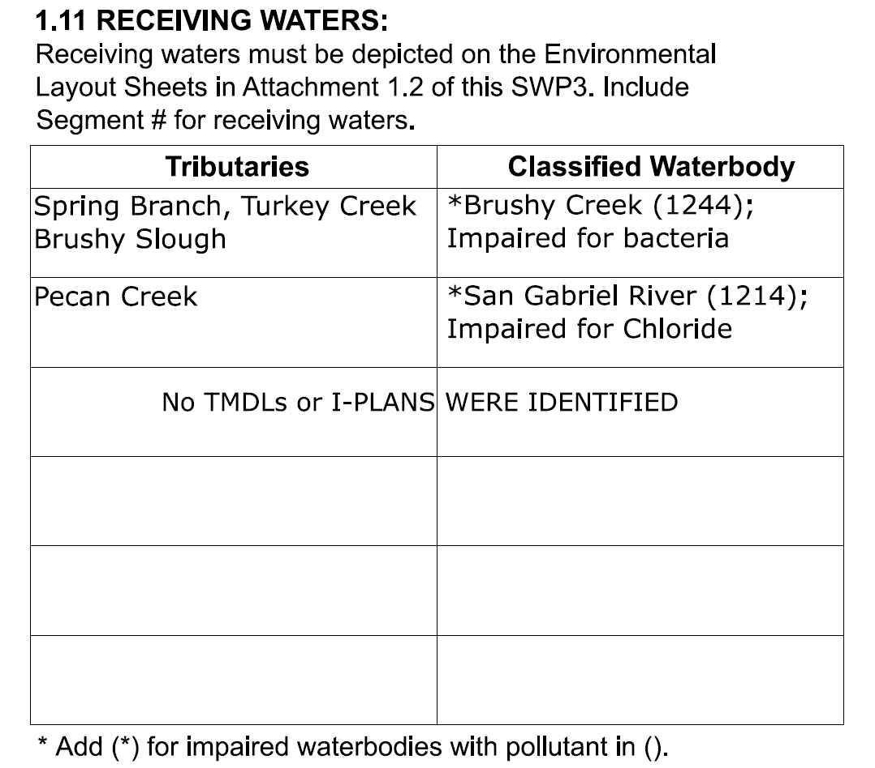
Figure 16. Example of documenting receiving water tributaries and classified water bodies on Section 1.11 Receiving Waters of the SWP3 Summary Sheet.

1.12 and 1.13 Roles and Responsibilities
As noted in Section 1 Part 1.5.1 of this Manual, TxDOT and the Contractor are defined as Primary Operators per the CGP Part III, Section B, and are operating under a shared SWP3 per the CGP Part III, Section A. Respective roles and responsibilities are defined as follows:
- TxDOT will be considered the Primary Operator with Operational Control over plans and specifications and is responsible for the development of the SWP3. The following defines this Primary Operator role:
  - Ensures the project specifications allow or provide that adequate BMPs are developed to meet the requirements of the CGP
  - Ensures that the SWP3 indicates the areas of the project where they have control over project specifications, including the ability to make modifications in specifications
  - Ensures that notification to the Contractor affected by modifications in project specifications are done in a timely manner so that the Contractor may modify site BMPs as necessary to remain compliant with the conditions of this general permit
  - Ensures that the SWP3 for portions of the project, where the Contractor has day-to-day control, indicates the name and site-specific TPDES authorization number(s) and complies with the SWP3 and other permit conditions
  - Implement appropriate recording keeping requirements for the SWP3 Binder as outlined in Section 2.2 – SWP3 Binder Template of the SWP3 Guidance Document.
- The Contractor will be considered the Primary Operator with Day-to-Day Operational Control and is responsible for the implementation of the activities that are necessary to ensure compliance with the SWP3 and other permit conditions. The following defines this Primary Operator role:
  - Meets the requirements of the CGP for those portions of the project where the Contractor is the Primary Operator
  - Identifies the parties responsible for implementation of BMPs described in SWP3
  - Indicates areas of the project where the Contractor has operation control over day-to-day activities
  - The name and site-specific TPDES authorization number for TxDOT, which has control over project specifications, including the ability to make modifications in specifications for areas where the Contractor has operational control over day-to-day activities
In some instances, TxDOT will be considered the Secondary Operator as defined in Section 1.2.3 – Administrative Requirements of the SWP3 Guidance Document. Generally, the types of projects were TxDOT would be a Secondary Operator include Design-Build projects and local-let on-system projects where TxDOT can approve or disapprove changes to the plans and specifications. TxDOT is not considered a Primary or Secondary Operator for local-let off-system projects. In cases where TxDOT is the Secondary Operator, the roles and responsibilities on this sheet need to be adjusted accordingly.
Responsible Person
Design Engineer is responsible for selecting the correct boxes in accordance with the special provision.
Action
On the SWP3 Summary Sheets 1 all applicable roles and responsibilities for TxDOT and Contractor are pre-selected as the standard condition. For items not listed, or an additional item is required, select “other” and describe in the space provided. The designer only needs to change the box selections if conditions deviate from the normal roles as defined above, such as situations where TxDOT is secondary operator.
Note: Deselect “Submit Notice of Intent (NOI) to TCEQ (≥5 acres)” under TxDOT and Contractor for projects disturbing 1 acre to less than 5 acres of soil.
Note: For projects that required dewatering, insert “conduct daily dewatering inspections” under Contractor Roles and Responsibilities
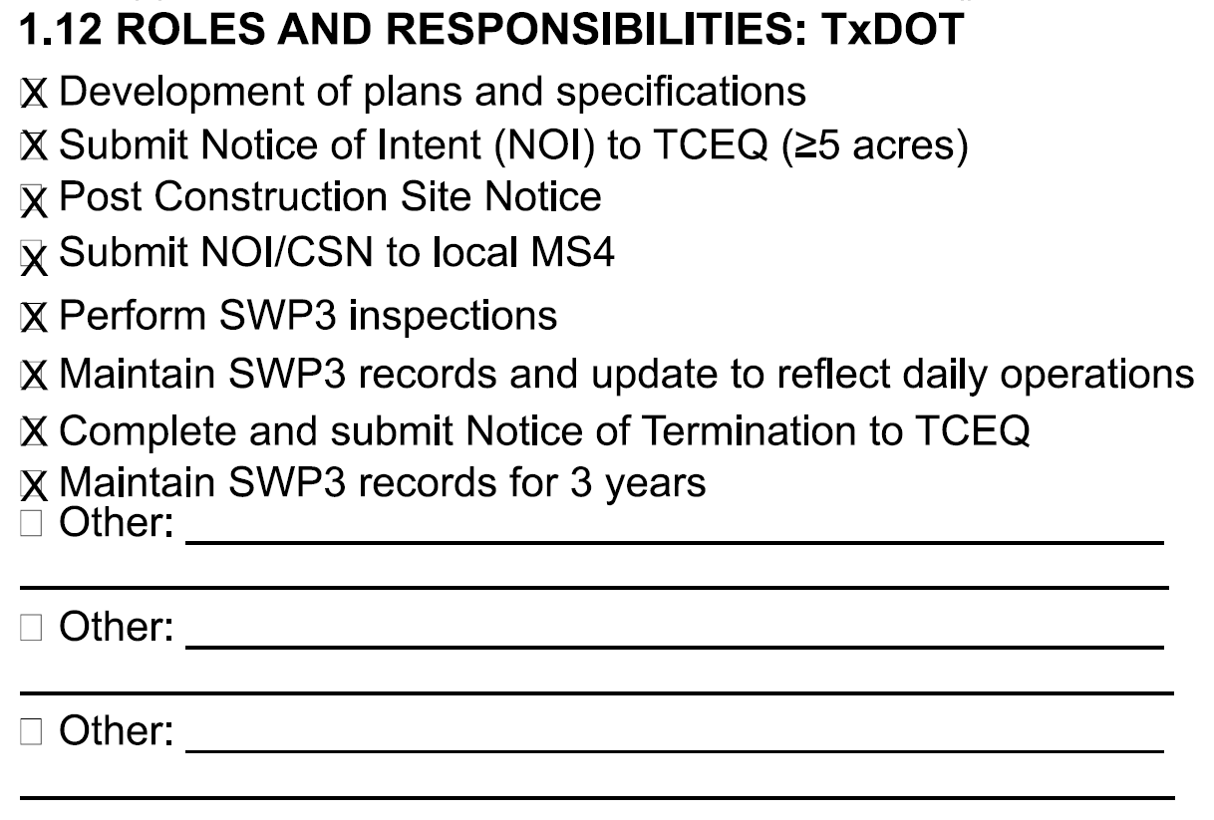
Figure 17. TxDOT’s roles and responsibilities defined in Section 1.12 Roles and Responsibilities: TxDOT.
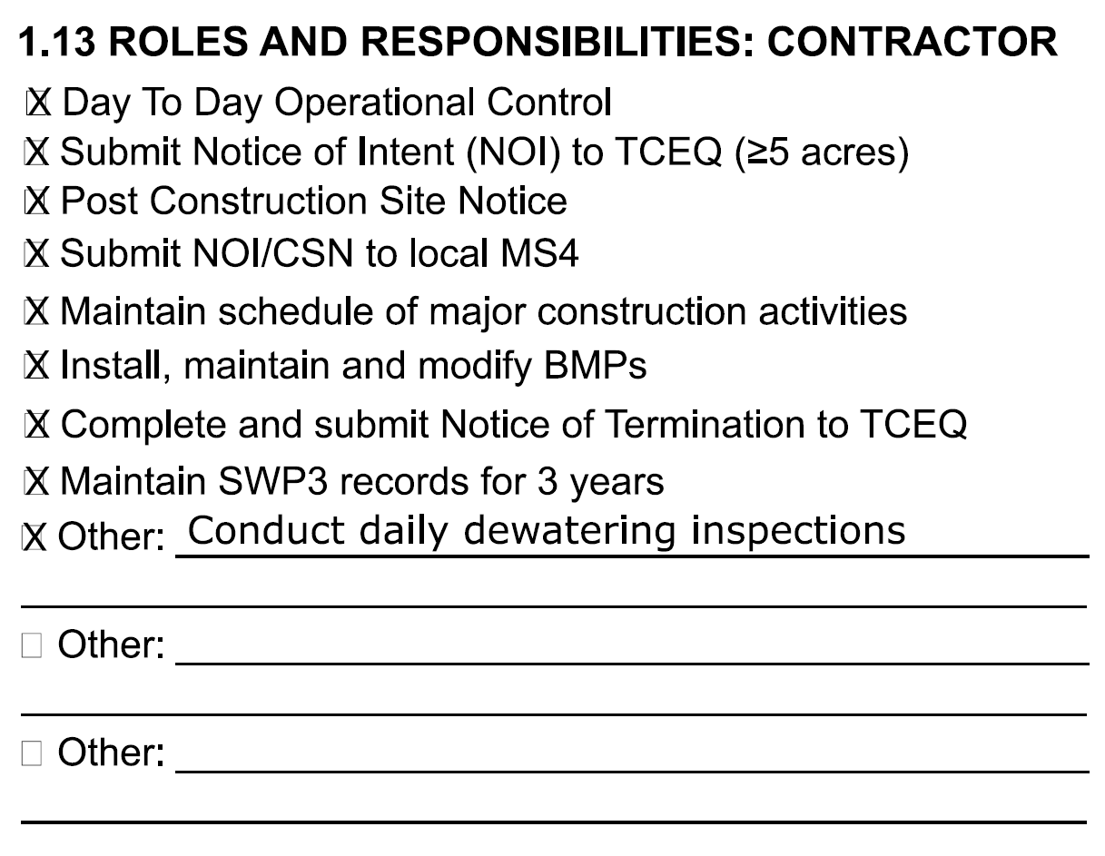
Figure 18. The Contractors’ roles and responsibilities defined in Section 1.13 Roles and Responsibilities: Contractor.

1.14 Local Municipal Separate Storm Sewer System Identification
A Municipal Separate Storm Sewer System (MS4) is a storm sewer system owned or operated by the United States, a state, city, town, county, district, association, or other public body having jurisdiction over the disposal of sewage, industrial wastes, stormwater or other wastes, including special districts under state law such as a sewer district, flood control or drainage district or similar entity, that discharges to surface water in the state. As part of the SWP3, TxDOT must identify whether any phase of the construction project will discharge stormwater to an MS4.
If you have questions regarding requirements for submitting permit notices to adjacent non-TxDOT MS4 Operators or identifying adjacent MS4 Operators, contact your District MS4 Coordinator. A list of MS4 Coordinators can be found on the internal Stormwater Crossroads webpage.
Responsible Person
Design Engineer
Action
If it is determined that the construction site has the potential to discharge stormwater to a MS4, list the name of the MS4 on the SWP3 Summary Sheet 1. If stormwater discharge from the construction site does not enter an MS4 state “No MS4s receive stormwater discharge from the site.”
Example
How it will appear on the SWP3 Summary Sheet:
The following is an example of how to document Local MS4s on the SWP3 Summary Sheet 1:
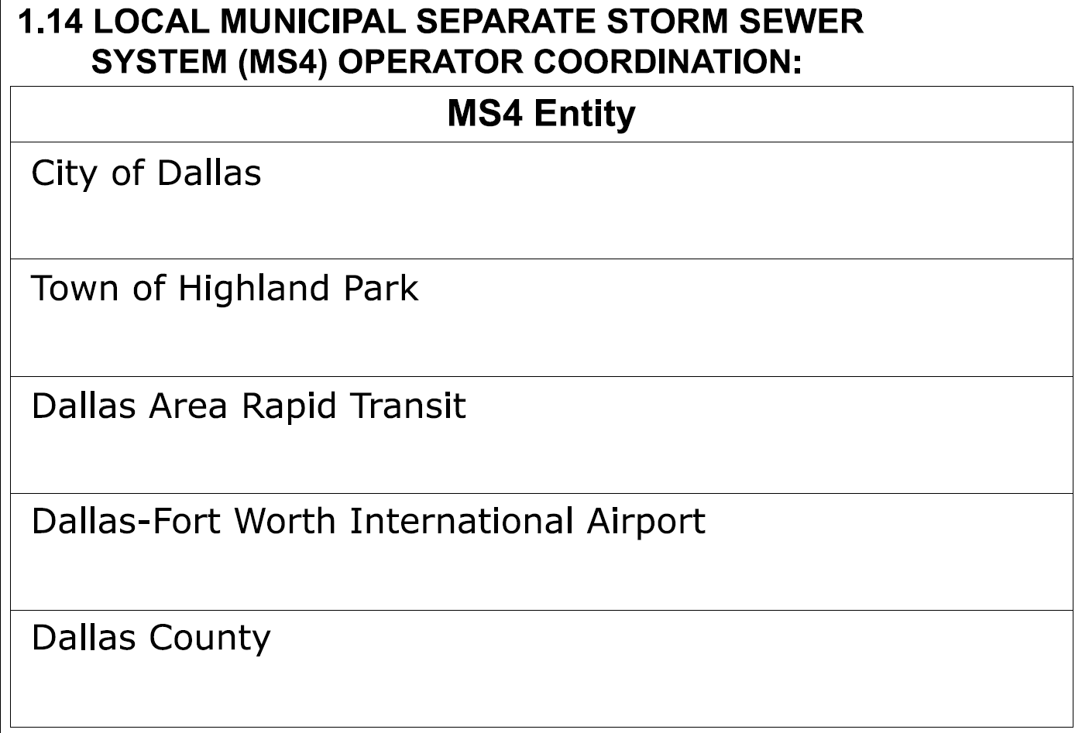
Figure 19. Example of documenting Municipal Separate Storm Sewer System (MS4) operators on Section 1.14 Municipal Separate Storm Sewer System (MS4) Operators Coordination of the SWP3 Summary Sheet.

2.0 Stormwater Pollution Prevention Plan Summary Sheet 2
This section will provide guidance on completing SWP3 Summary Sheet 2. This sheet addresses the following:
- 2.1 Erosion Control and Soil Stabilization BMPs
- 2.2 Sediment Control Practices
- 2.3 Permanent Controls
- 2.4 Offsite Vehicle Tracking Controls
- 2.5 Pollution Prevention Measures
- 2.6 Vegetated Buffer Zones
- 2.7 Allowable Non-Stormwater Discharges
- 2.8 Dewatering
- 2.9 Inspections
- 2.10 Maintenance

2.1 Erosion Controls and Stabilization Best Management Practices
To manage and reduce soil erosion utilize Best Management Practices (BMPs) at the construction site. These BMPs consist of structural controls, soil stabilization techniques and stormwater management controls. Select erosion control BMPs from Items 162 “Sodding for Erosion Control”, 164 “Seeding for Erosion Control”, 169 “Soil Retention Blanket”, and 506 “Temporary Erosion, Sedimentation, and Environmental Controls”. When selecting appropriate BMPs also reference TxDOT’s Approved Products List. If a BMP is not available in one of the Standard Items, the Design Engineer can develop a special specification for that BMP, when needed. Special specifications will be reviewed and approved by Division subject matter experts (SMEs). TxDOT training, specifically EL4030 and ENV301, provide additional information about erosion control measures to use for specific types of work. The design engineer must ensure quantities are consistent with the SWP3 Summary Sheets.
Responsible Person
Design Engineer
Action
Identify and note on SWP3 Summary Sheet 2 which erosion control BMPs are scheduled for the construction site. Use the “T/P” column to identify whether the BMP will be temporary (T) and removed after construction or permanent (P) and left in place after construction. If a box does not have an “x” it means it will not be used on the project.
Example
How it will appear on the SWP3 Summary Sheet:
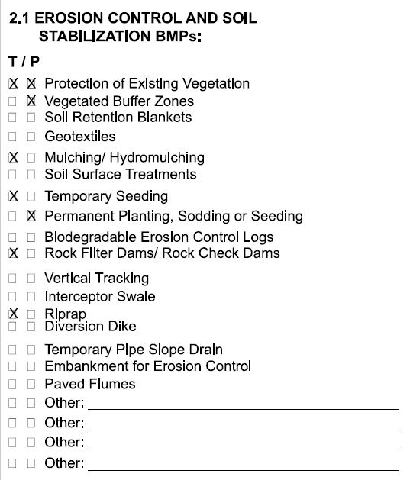
Figure 20. Section 2.1 of the SWP3 Summary Sheet with erosion control and stabilization BMPs listed.

2.2 Sediment Control Best Management Practices
Sediment controls refer to structural and non-structural practices used during the construction process to keep sediment from leaving the site. These BMPs are secondary to erosion control practices and act as a second line of defense if soils are eroded. Use sediment control BMPs within the project limits to control sediment from overwhelming downstream BMPs and along downslope and side slope boundaries. Use perimeter control devices in areas where sediment might escape along the project boundaries. The design engineer must ensure quantities are consistent with the SWP3 Summary Sheets.
Responsible Person
Design Engineer
Action
Identify and note on SWP3 Summary Sheet 2 the scheduled sediment control BMPs for the construction site. Use the “T/P” column to identify whether the BMP will be temporary (T) and removed after construction or if it will be permanent (P) and left in place after construction. If a box does not have an “x” it means it will not be used on the project.
Example
How it will appear on the SWP3 Summary Sheet:
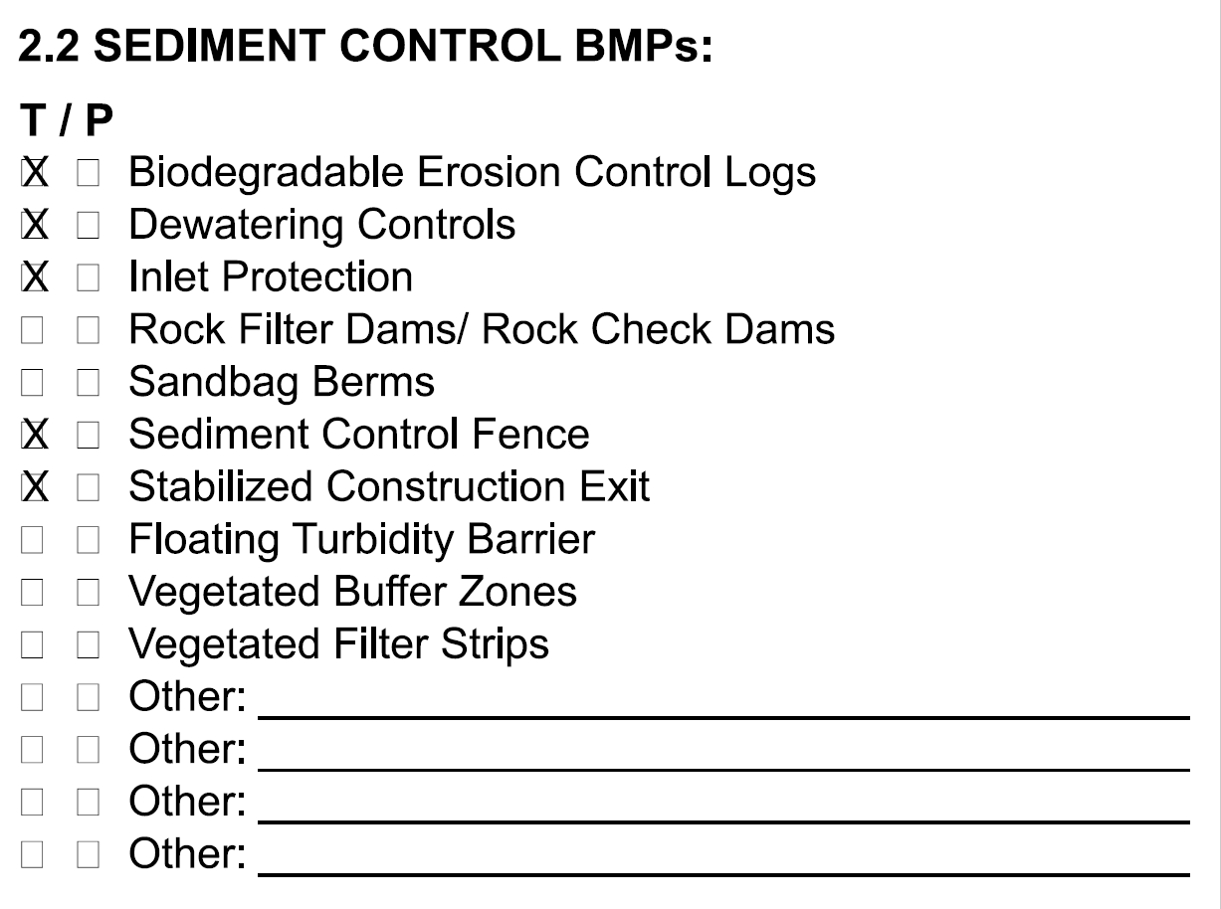
Figure 21. Section 2.2 of the SWP3 Summary Sheet listing sediment control BMPs.2.2.1 Sediment Control Best Management Practices Requiring Design Capacity Calculations
The CGP requires sediment basins on construction sites, if feasible, when 10 acres or more of soil is disturbed at one time within a common drainage basin. For projects with less than 10 acres of disturbed area, a sedimentation basin is not required. Additionally, sediment traps can be constructed for drainage basins where less than 10 acres of soil is disturbed at one time. To meet these minimum requirements, sediment traps or sedimentation basins may be used at the discretion of the Design Engineer.
Reference detail sheet EC (6)-16 Temporary Erosion, Control Measures (Sediment Basins & Traps, Earthwork for Erosion Control).
Sediment Traps
The drainage area for a sediment trap should not exceed five acres. The sediment trap capacity should be 1,800 cubic feet per acre (0.5 inch over the drainage area). Sediment traps should be placed in the following locations:
- Immediately preceding drain inlets
- Before the drainage enters a surface water or water of the United States (WOUS).
- Before the drainage leaves TxDOT right-of-way
- Before the drainage leaves the construction limits where drainage flows by sheet flow away from the project area
- Within drainage ditches spaces at ±500 feet on center
The trap outlet may either be through a perforated riser and pipe assembly designed to achieve a 40-hour draw-down time or over a level stabilized area (vegetation, rock, riprap, etc.), per the design options shown on EC (6)-16. Monitor the outlet for erosion.
Sediment Basins
The drainage area for a sediment basin should not exceed 100 acres. The basin capacity shall be at least 1,800 cubic feet per acre (0.5 inch over the drainage area). If the disturbed area draining to the basin is larger than 10 acres, the basin capacity should be 3,600 cubic feet per acre (1.0 inch over the drainage area).
The basin should have a 40-hour draw-down time with an emergency spillway. The spillway may be designed to pass the peak rate of runoff from a 25-year frequency storm. The 100-year storm should be investigated to consider possible flooding impacts.
Construction sites where drainage areas of ten acres or more in a common drainage area are required to have a sedimentation basin that serves an area with 10 acres or more of disturbed soil at one time, refer to Appendix E: Sedimentation Basin Capacity Calculations of the SWP3 Binder. Section 2 of the SWP3 Summary Sheets identifies the following three options for sedimentation basins: 1. Not Required, 2. Required (>10 acres) and implemented, and 3. Required (>10 acres) but not feasible. For sediment basins that are not feasible, an explanation on the SWP3 Summary Sheet must be provided.
Responsible Person
Design Engineer
Action
Sediment trap: Identify and check one of the available options for sediment trap. If a box does not have an “x” it means it will not be used on the project or does not apply.
Sediment Basin: Identify and check one of the available options for sediment basin. If infeasible, check the box that best describes the infeasibility of the sedimentation basin. If a box does not have an “x” it means it will not be used on the project or does not apply.
- Not required: Sedimentation basins are not required if the area of disturbed soil at one time in a common drainage area is less than 10 acres.
- Required and implemented: The area of disturbed soil at one time in a common drainage area is 10 acres or greater. Design and construct sedimentation basins in accordance with the CGP requirements.
- Required but not feasible: If a sedimentation basin is required but is not feasible, install equivalent control measures to manage sediment until final stabilization is achieved. The following BMPs are examples of equivalent control measures:
  - A series of smaller sediment basins
  - Silt fences
  - Vegetative buffer strips
  - Sediment traps
  - Rock filter dams
Example
How it will appear on the SWP3 Summary Sheet:
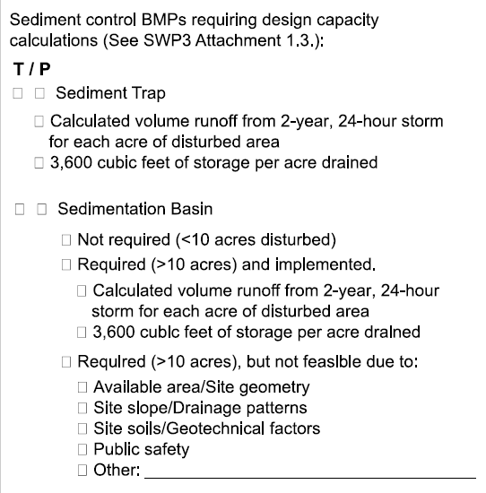
Figure 22. Section 2.2.1 of the SWP3 Summary Sheet addressing sediment trap and basin requirements.
Example Sedimentation Basin Equations
The following graphics are example equations widely used for determining the capacity of sedimentation basins. A more in-depth process is required for designing the functionality of sedimentation basins per specific project and site conditions.
The basin volume shall be the calculated volume of runoff from the temporary control design depth of 0.5 inches per disturbed acre draining to the basin. This equates to 1800 cubic feet per acre of drainage area.
For a natural basin, the storage volume may be approximated as follows:
V = 0.4 × A × D
Where:
V = storage volume in cubic feet
A = the surface area of the flooded area at the crest of the basin outlet, in square feet
D = the maximum depth in feet, measures from the low point in the basin to the crest of the basin riser.
Note 1: The volumes may be computed from more precise contour information or other suitable methods.
Note 2: Conversation between cubic feet and cubic yards is as follows:
Number of cubic feet × 0.037 = number of cubic yards.
The shape of the basin must be such that the length-to-width ratio is at least four to one according to the following equation:
Length-to-width Ration = $\frac{L}{We}$
Where:
W_{e} =$\frac{A}{L}$ = effective width
A = the surface area of the normal pool
L = the length of the flow path from the inflow to the outflow. If there is more than one inflow point, any inflow that carries more than 30 percent of the peak rate of the inflow must meet these criteria.

2.3 Permanent Controls
Permanent controls are BMPs designed to be left in place after construction is completed to mitigate the discharge of pollutants in stormwater from the site by protecting against erosion or by providing permanent water quality treatment.
Responsible Person
Design Engineer
Action
Identify permanent controls and their location (in other words, stationing) that will be left in place after construction ends.
Permanent controls can be directly or indirectly related to surface water being present on-ROW or off-ROW. For instance, a velocity dissipation device may be needed for the project even if surface waters are not associated with the project. Conversely, a permanent rock filter dam may be used to filter out suspended sediment or dissipate runoff velocity before entering surface waters. Permanent controls will be dependent on the final design characteristics (for example, slope, soil erosivity, runoff volume, etcetera.). Long-term post-construction inspection and maintenance requirements must be developed for permanent controls. If no permanent controls are planned for the final site design, state “No permanent controls are planned” on the Summary Sheet.
Example
How it will appear on the SWP3 Summary Sheet:
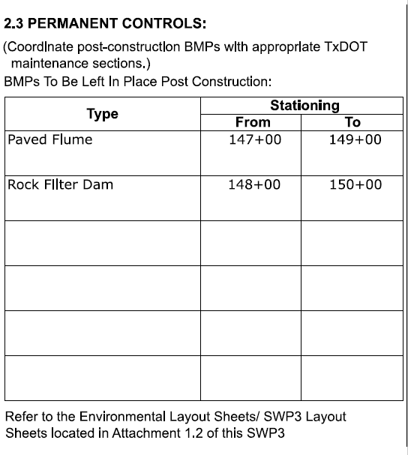
Figure 23. Example of documenting permanent controls and BMPs on Section 2.3 Permanent Controls of the SWP3 Summary Sheet.

2.4 Offsite Vehicle Tracking Controls
As the name of this BMP describes, Offsite vehicle tracking controls are implemented to prevent vehicles and equipment from tracking sediment off the construction site. Vehicle tracking controls are designed to knock off sediment from vehicle tires and to capture that sediment that falls off (for example, stabilized construction exits), to control dust that may be windblown from the construction site (for example, tarpaulin coverings) and to clean up any sediment that does escape onto the roadway (for example, street sweeping). This control assists in minimizing the extent of soil and or sediment distributed from the construction site.
Responsible Person
Design Engineer
Action
Identify and check offsite vehicle tracking controls that are scheduled for the construction site. Add additional controls in the “other” line, as applicable.
Example
How it will appear on the SWP3 Summary Sheet:
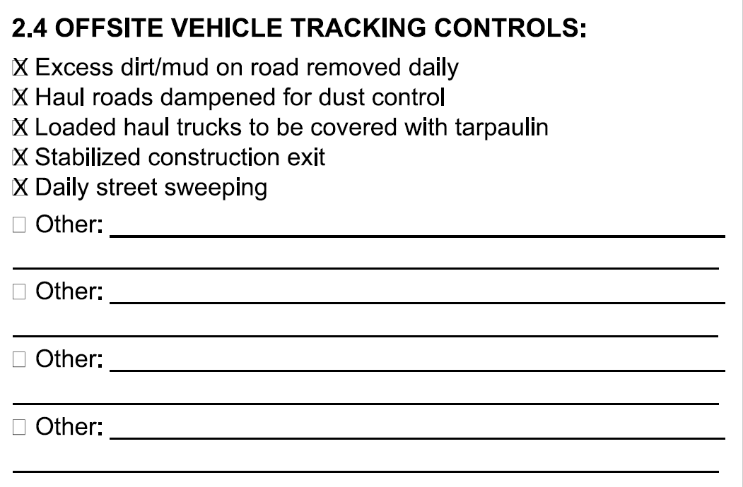
Figure 24. Section 2.4 of the SWP3 Summary Sheet identifying vehicle tracking controls.

2.5 Pollution Prevention Measures
Sediment from disturbed soil is not the only source of pollution on construction sites. Other potential sources of pollution include trash and debris, materials and chemicals used in construction, hydrocarbons from fuel, sanitary facilities and concrete wash out activities. In addition to the erosion and sediment controls discussed in the previous pages, other pollution prevention measures are needed to address this variety of pollutants that can be found on a construction site. These measures encompass those known as “housekeeping” BMPs.
Responsible Person
Design Engineer
Action
Identify and check pollution prevention measures that are scheduled for the construction site. Add additional controls in the “other” line as applicable
Example
How it will appear on the SWP3 Summary Sheet:
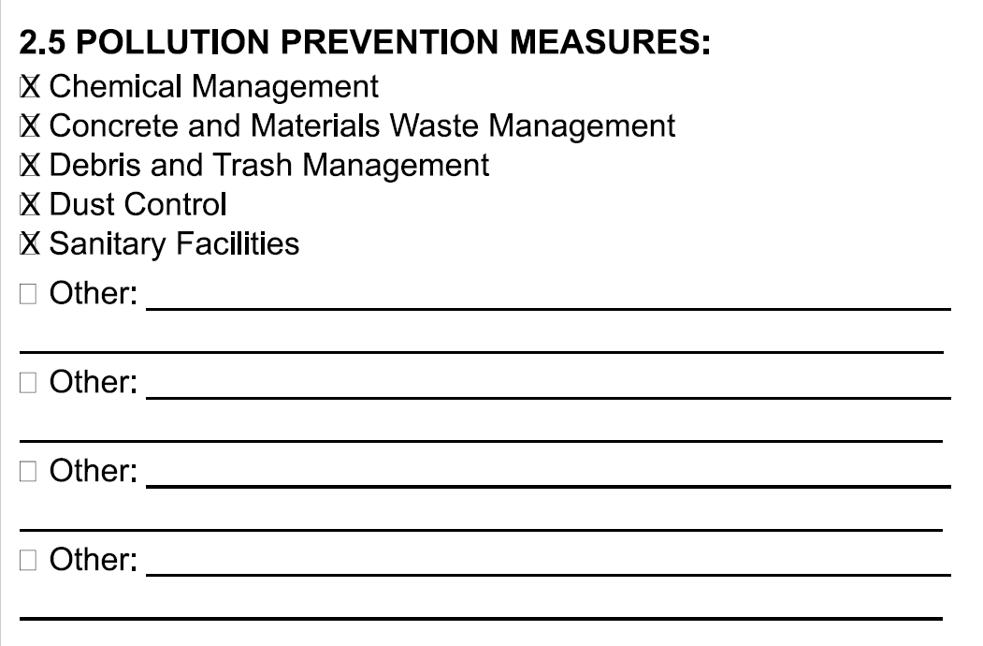
Figure 25. Section 2.5 of the SWP3 Summary Sheet listing pollution prevention and housekeeping BMPs.
Special Note on Concrete Truck Wash Out Requirements
The CGP permits land disposal of wash out water from concrete trucks used during construction activities only when the appropriate BMPs and measures are implemented. Discharge of concrete truck wash out water to surface water in the state, including discharge to storm sewers, is prohibited by the CGP.
The following requirements must be met for land disposal of concrete wash out to be permitted on a TxDOT construction project:
- Concrete truck wash-out water must be disposed of in areas at the construction site where structural controls have been established to prevent discharge to surface water in the state. These controls include:
  - Lined pits made from earthen berms
  - Line shallow pits that have been dug into the ground
- Other appropriate enclosed containers that do not allow wash out water to discharge to surface waters
- Wash out locations are not placed directly adjacent to water bodies, storm sewers or sensitive environmental features
- Avoid washing out of concrete trucks during rainfall events
- The disposal of wash out water from concrete trucks must not cause or contribute to groundwater contamination.
- The location of concrete wash out areas and concrete wash out BMPs will be documented in the SWP3.

2.6 Vegetated Buffer Zones
A vegetated buffer zone typically consists of strips or areas of managed or natural vegetation near streams, ponds, lakes and other aquatic systems. Use a vegetated buffer zone to limit the water quality impact to an adjacent waterbody receiving stormwater discharge from construction activities.
TxDOT may determine vegetated buffer zones are infeasible for specific projects. Infeasibility may be due to project layout, location and work performed. If a vegetated buffer zone is infeasible, provide equivalent control measures to manage erosion sediment at the construction site until final stabilization is achieved. Document the reason why buffers are infeasible. This documentation is required per the CGP.
Responsible Person
Design Engineer
Action
If surface waters of the state are on-ROW or adjacent to the ROW, identify the location of the vegetated buffer zone. If a vegetated buffer zone is infeasible, state the reason for infeasibility and identify control measures that will be utilized as an equivalent and include the location (in other words, stationing). Erase the provided table and use the available space to describe the reason. If no surface waters are on-ROW or adjacent to the ROW, state “No surface waters present, vegetated buffer zones are not planned.”
Example
How it will appear on the SWP3 Summary Sheet:
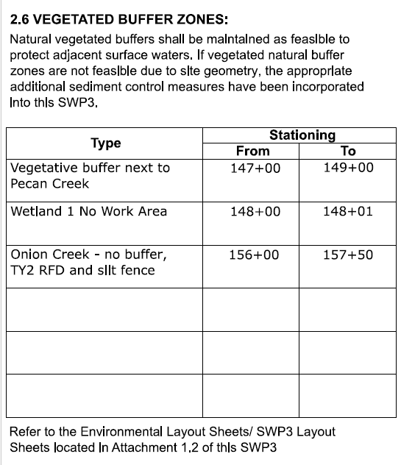
Figure 26. Example of documenting vegetative buffer zones and control measures on Section 2.6 Vegetative Buffer Zones of the SWP3 Summary Sheet.

2.7 Allowable Non-Stormwater Discharges
The following non-stormwater discharges from sites authorized under this general permit are also eligible for authorization under this general permit, refer to Appendix K: TPDES Construction General Permit (TXR150000) of the SWP3 Binder. These allowable non-stormwater discharges are only permitted if the discharge water is uncontaminated and will not impact surface water adversely:
- Discharges from fire-fighting activities (fire-fighting activities do not include washing of trucks, run-off water from training activities, test water from fire suppression systems or similar activities)
- Uncontaminated fire hydrant flushing (excluding discharges of hyperchlorinated water, unless the water is first dechlorinated and discharges are not expected to adversely affect aquatic life), which include flushing from systems that utilize potable water, surface water or groundwater that does not contain additional pollutants (uncontaminated fire hydrant flushing do not include system utilizing reclaimed wastewater as a source water)
- Water from the routine external washing of vehicles, the external portion of buildings or structures and pavement where detergents and soaps are not used, where spills or leaks of toxic or hazardous materials have not occurred (unless spilled materials have been removed; and if local, state or federal regulations are applicable, the materials are removed according to those regulations), and where the purpose is to remove mud, dirt or dust
- Uncontaminated water used to control dust
- Potable water sources, including waterline flushing, but excluding discharges of hyperchlorinated water, unless the water is first dechlorinated, and discharges are not expected to adversely affect aquatic life
- Uncontaminated air conditioning condensate
- Uncontaminated groundwater or spring water, including foundation or footing drains where flows are not contaminated with industrial materials such as solvents.
- Lawn watering and similar irrigation drainage
Responsible Person
Design Engineer
Action
Identify and check all eligible non-stormwater discharges that have the potential to occur at the construction site.
Example
How it will appear on the SWP3 Summary Sheet:
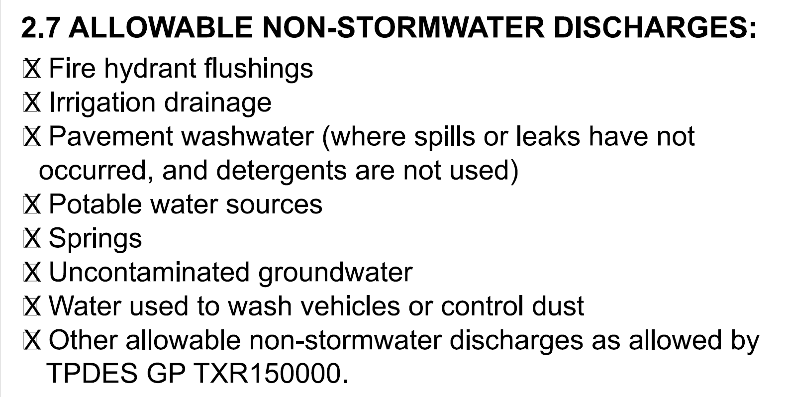
Figure 27. Section 2.7 of the SWP3 Summary Sheet listing allowable non-stormwater discharges.

2.8 Dewatering
Dewatering Activities and Discharges
During construction activities dewatering operations may be required as the result of groundwater intrusion and rainfall accumulation in trenches, vaults, foundations, excavations, and other similar points of accumulation. Dewatering operation locations must be identified on the sheets in Attachment 1.2 of the SWP3 Binder. Discharges from dewatering activities are only permitted if dewatering activities are managed by appropriate controls. Controls must remove suspended sediment from the source water, control discharge velocities and discharge location soil erosion.
The location and need for dewatering might not always be evident until construction. However, to the extent practicable designers should consider the need for dewatering and incorporate necessary BMPs and measures into the SWP3.
Responsible Person
Design Engineer
Action
When possible, the designer should identify locations of dewatering activities and implement appropriate BMPs into the SWP3 design.
Example
How it will appear on the SWP3 Summary Sheet:
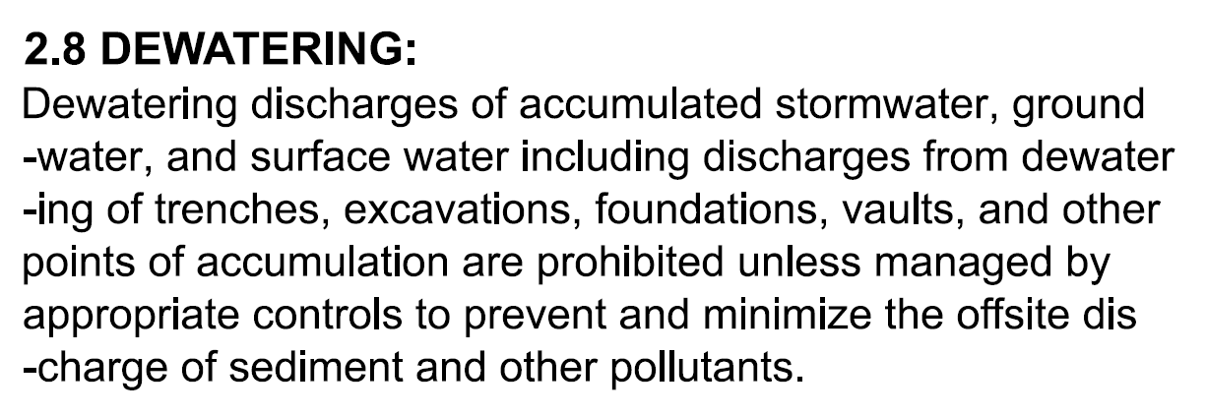
Figure 28. Section 2.8 of the SWP3 Summary Sheet documenting dewatering activities.

2.9 and 2.10 Inspection and Maintenance
These sections acknowledge stormwater inspection and BMP maintenance requirements that must occur during the life of the construction activities.
Generally, changes are not needed to this standard language. However, some projects may implement an alternative inspection cycle that the 7-day cycle in the standard language. If this is the case, limited modifications to section 2.9 may occur to reflect that. If changes are needed, design staff should consult with construction staff that will be conducting the inspections or the District Environmental Quality Coordinator.
Responsible Person
Design Engineer
Action
Make limited District-specific modifications to the inspection schedule if required. Modifications should not be made to section 2.10 as this language is derived from Item 506.
Example
How it will appear on the SWP3 Summary Sheet:
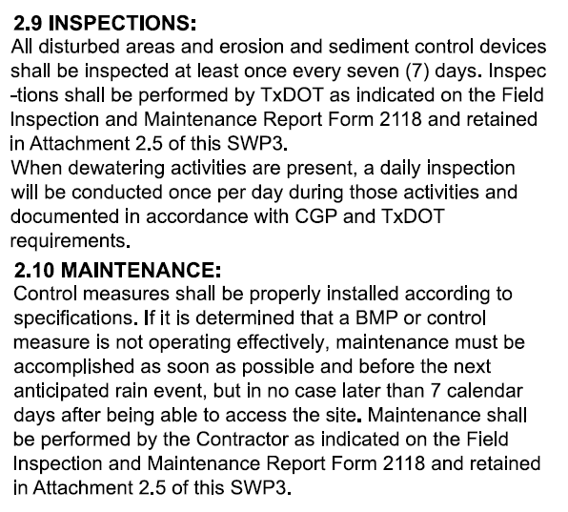
Figure 29. Sections 2.9 and 2.10 of the SWP3 Summary Sheet addressing inspection and maintenance.

2.11 Sign and Sealing the SWP3 Summary Sheets
The SWP3 Summary Sheets may require a Professional Engineer’s seal depending on the project specifics. The SWP3 Summary Sheet template provides a note to the design engineer to determine if a Professional Engineer’s seal will be required when:
- No signed or sealed SWP3 Layout (or “Erosion Control Layout” is provided for the project)
- Calculations for a sediment trap or sediment basin are included in the SWP3
- The third box is checked under Sedimentation Basin of Section 2.0: “Required (>10 acres), but not feasible due to:”
- Vegetative buffers (Section 2.6) are required but not feasible. An engineer must provide justification and sign and seal.

3.0 Abbreviations and Acronyms
Table 1. Abbreviations and acronyms
Abbreviation or Acronym | Definition
AOI | Area of Influence
BMP | Best Management Practice
CCSJ | Controlling CSJ
CEI | Construction Engineering and Inspection
CGP | Construction General Permit
CSJ | Control Section Job
EPIC | Environmental Permits Issues and Commitments
I-Plan | Implementation Plan
MS4 | Municipal Separate Storm Sewer System
NOI | Notice of Intent
NRCS | Nation Resource Conservation Service
PSL | Project Specific Location
ROW | Right-of-way
SME | Subject matter expert
SPUR | Spur route
SWP3 | Stormwater Pollution Prevention Plan
TCEQ | Texas Commission on Environmental Quality
TMDL | Total maximum daily load
TPDES | Texas Pollutant Discharge Elimination System
TxDOT | Texas Department of Transportation
USACE | United States Army Corp of Engineers
USDA | United States Department of Agriculture
WOUS | Waters of the United States

Document Revision History
Table 2. Document revision history
Effective date (month year) | Reason for and description of change
April 2026 | Version 3  - Updated to comply with accessibility and TxDOT branding standards.
June 2023 | Version 2  - Added additional clarification in section 1.2 and 1.3 regarding documentation of multiple CSJs on the summary sheet, added hyperlink to Web Soil Survey in section 1.7, added clarification for documenting long soils lists, and updated figure, corrected SWP3 binder reference in section 1.8 under “Action”, updated figure in section 1.10, added hyperlink to Surface Water Quality Viewer, Texas Integrated Report of Surface Water Quality, and the I-Plan page on TCEQ’s website, added additional clarification about TMDLs and documenting projects with no classified water bodies in section 1.11, added additional clarification in section 1.12 and 1.13 about roles related to secondary operator status and dewatering, added reference to stormwater Crossroads page in section 1.14, moved previous section 1.15 regarding signing and sealing the summary sheet to section 2.11 and deleted figure, updated figure in section 2.4, updated figure in section 2.6, added new section 2.8 Dewatering to address dewatering requirements, re-labeled section previous section 2.8 to 2.9 and 2.9 to 2.10, updated figure and moved content related to inspections to Section 2.2 of this guidance, the text here was modified to reflect the responsibility of the designer to be more consistent with the rest of the guidance.
August 2022 | Version 1  - Used as guidance for completing the SWP3 Summary Sheets for projects requiring an SWP3.

