Stormwater Pollution Prevention Plan Section 2.1 Summary Sheet Job Aid: 1.7 Major Soil Types - Web Soil Survey
This job aid will assist you in utilizing the United States Department of Agriculture (USDA) Web Soil Survey website to obtain data needed to complete Section 1.7 Major Soil Types of the Stormwater Pollution Prevention Plan (SWP3) Summary Sheet.
- Navigate to the United States Department of Agriculture Natural Resources Conservation Service Web Soil Survey (WSS) – Click “Start WSS”. This home page provides instruction on the four basic steps of using the Web Soil Survey. It is your responsibility to read and understand those steps.
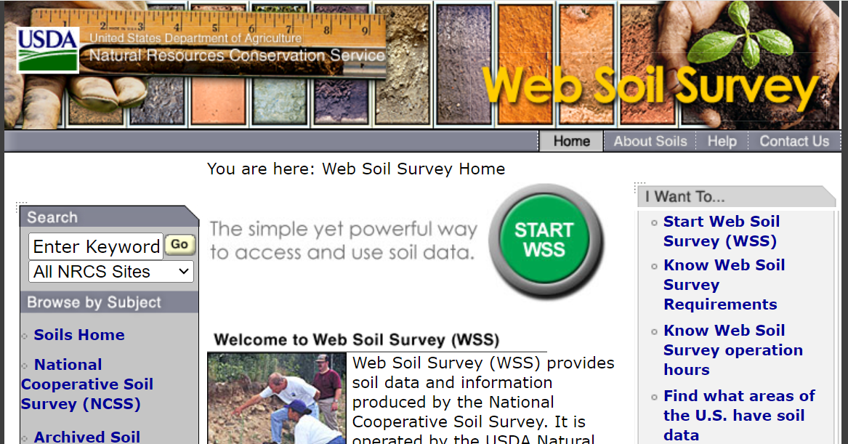
Figure 1. Web Soil Survey home page identifying the “Start WSS” button.
- Create an Area of Interest (AOI) using one of two AOI tool options:
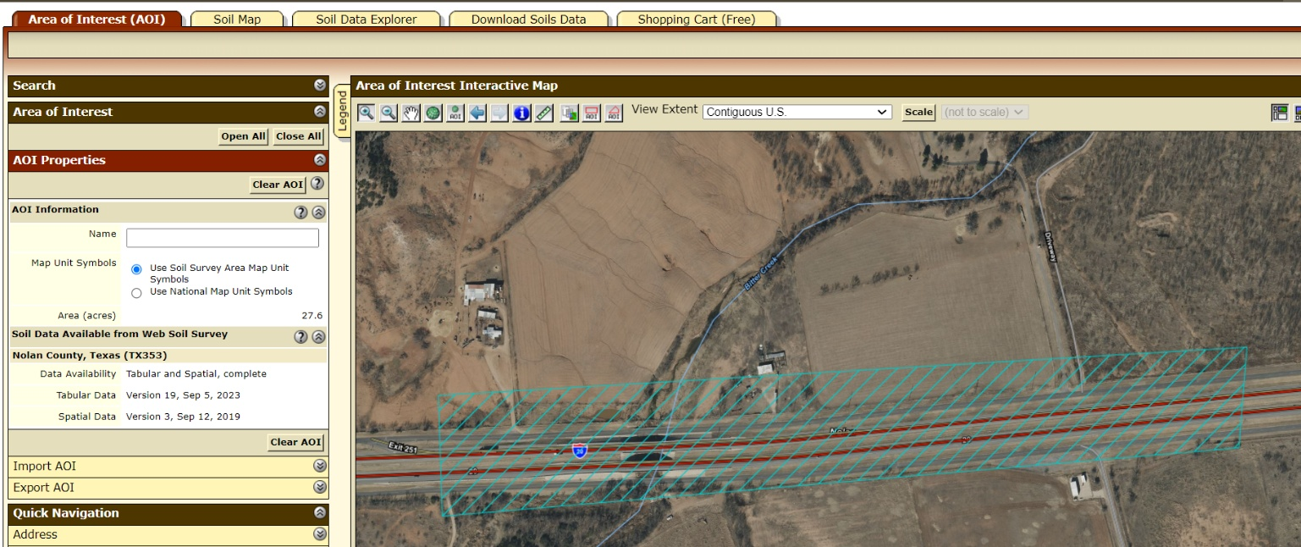
Figure 2. Area of Interest (AOI) selection tools available in the Web Soil Survey.
- Click on the “Soils Map” tab. The “Soils Map” will provide you with the information needed to identify the soil name, % slope, composition percentage, drainage characteristics, and runoff characteristics. By clicking on the “Map Unit Name” you will open a tab that provided detailed information about each soil type.
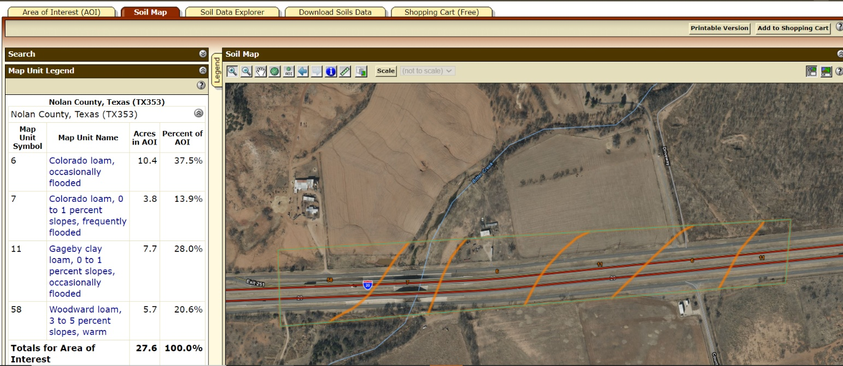
Figure 3. Soils Map tab in the Web Soil Survey interface.
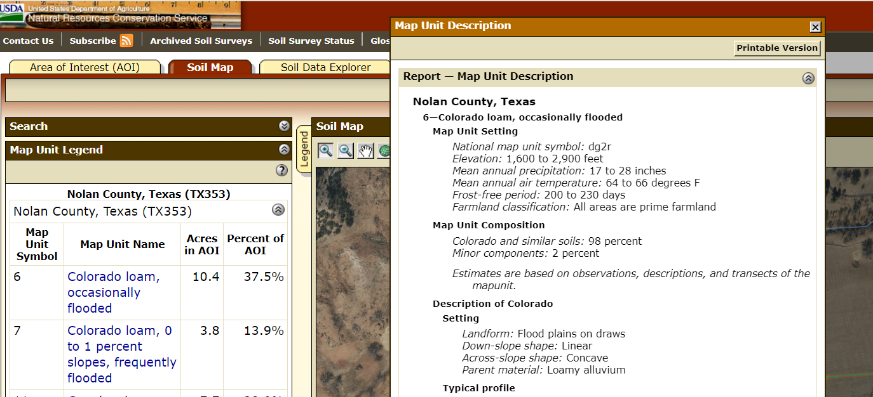
Figure 4. Soil map unit details accessed by selecting a map unit name.
- Next, click on the “Soil Data Explorer” tab then “Land management”. Select the “Erosion Hazard (Road, Trail)” tab. Then select “View Ratings” and scroll down.
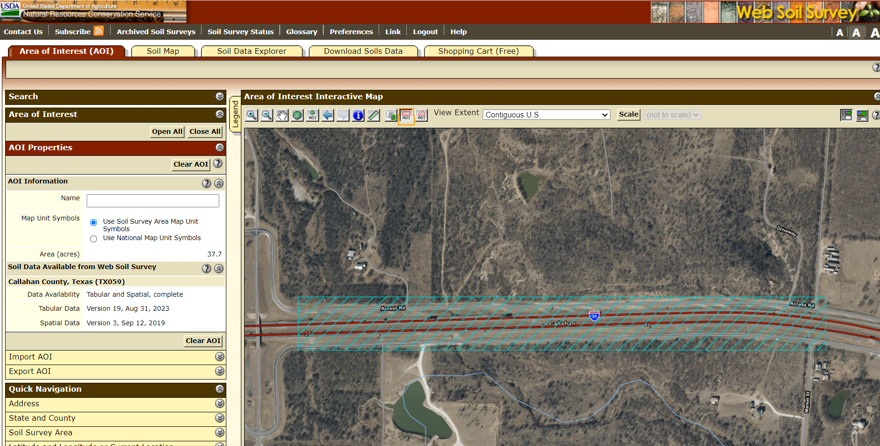
Figure 5. Soil Data Explorer tab in the Web Soil Survey interface.
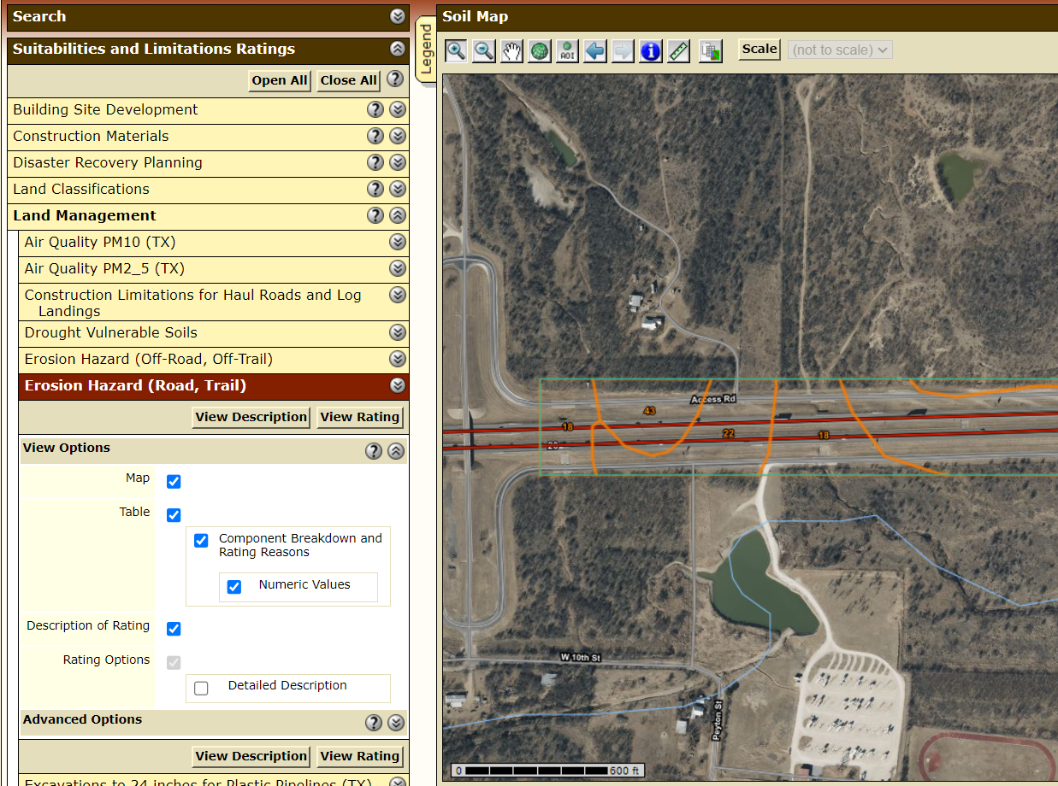
Figure 6. Land Management and Erosion Hazard (Road, Trail) subtabs on the Soil Data Explorer screen.
- You will find a map and you will see a table which list the ratings for the different soil types. Here you will be able to find the erosion potential rating.
You will see a map like this showing the soil units:
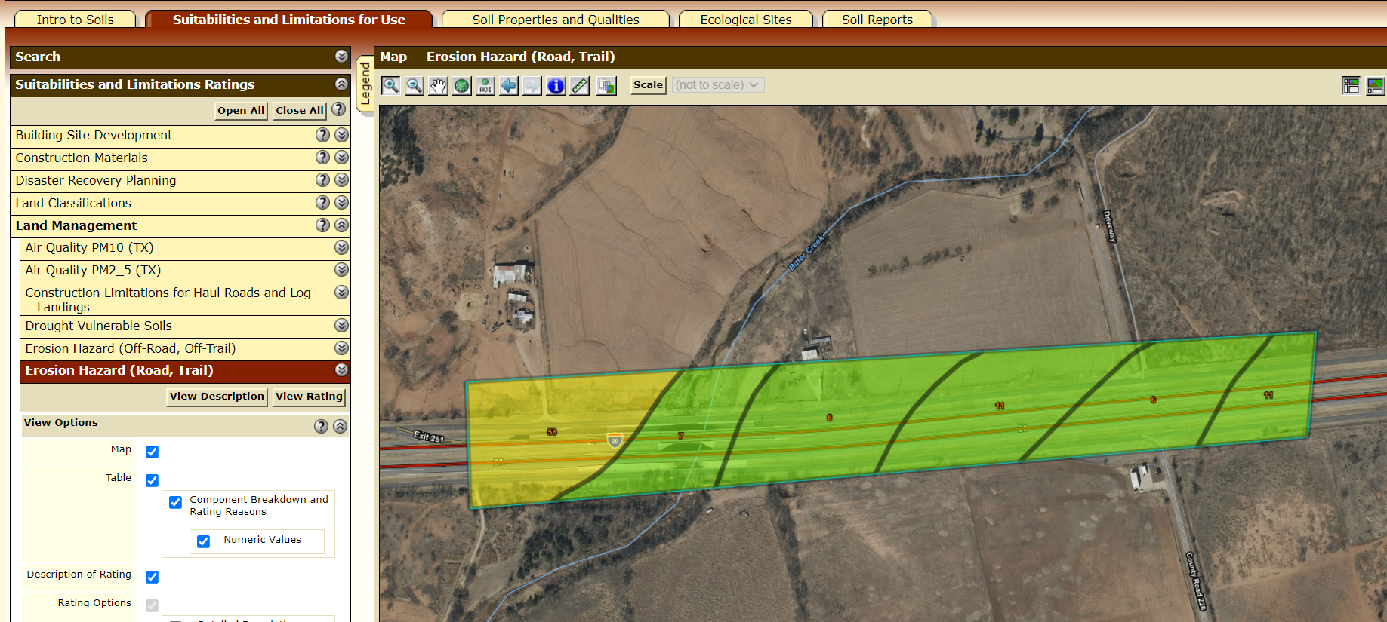
Figure 7. Map displaying soil units and erosion hazard ratings.
The table will look like this:
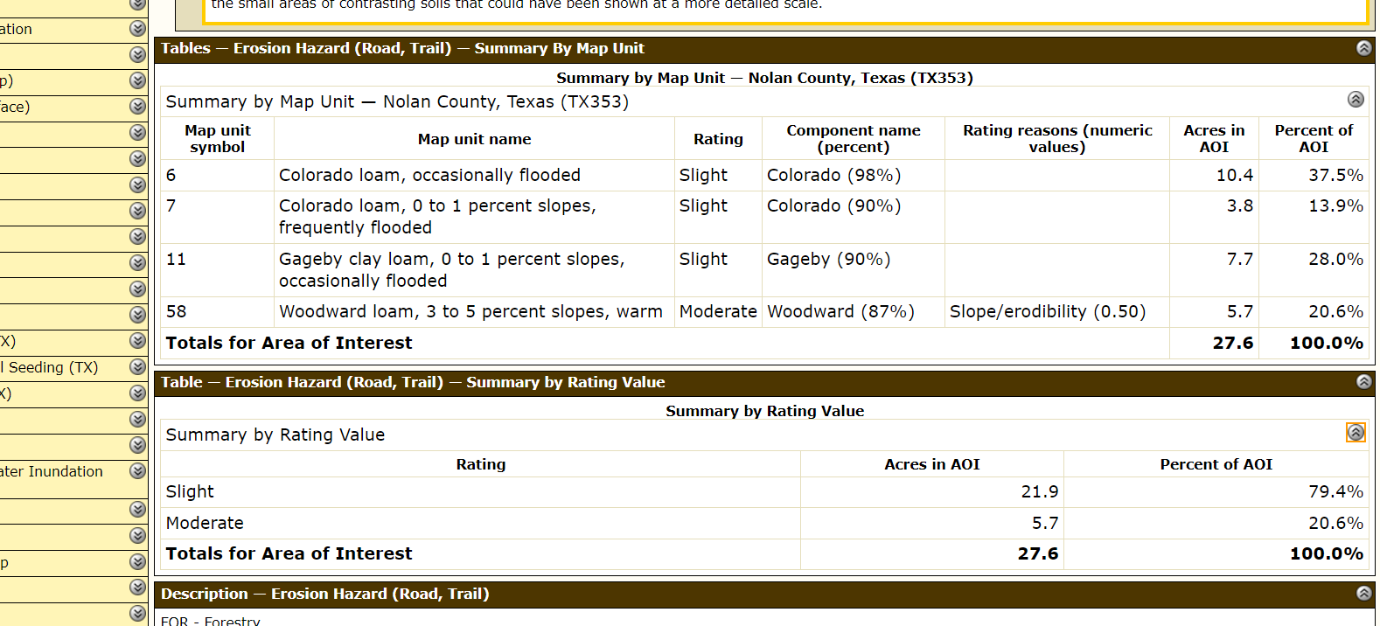
Figure 8. Erosion hazard ratings table for soil map units.
- Use the “Download Soils Data” tab to “Create Download Link” to download information from the analysis as a .zip file.
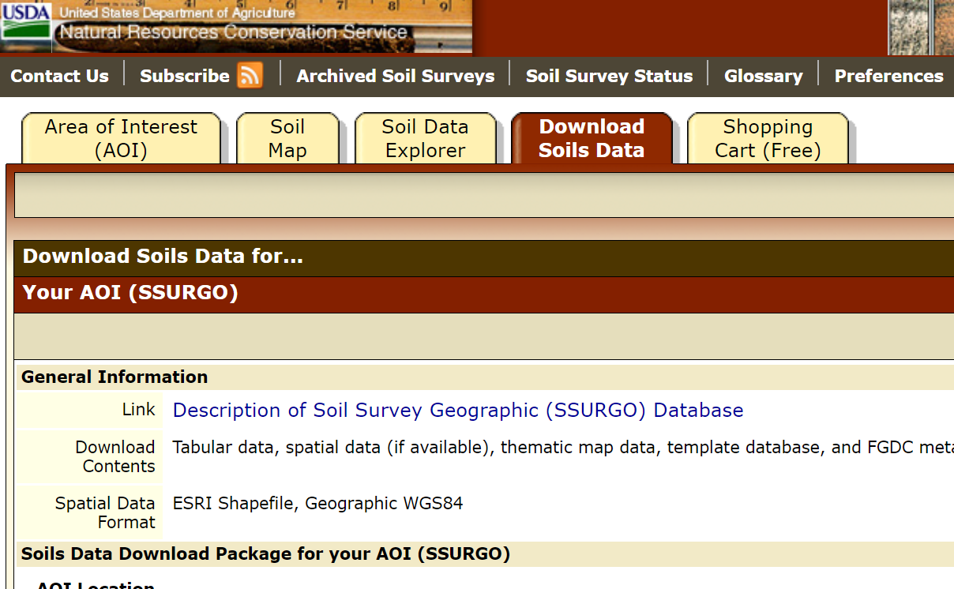
Figure 9. Download Soils Data tab used to create a data download link.
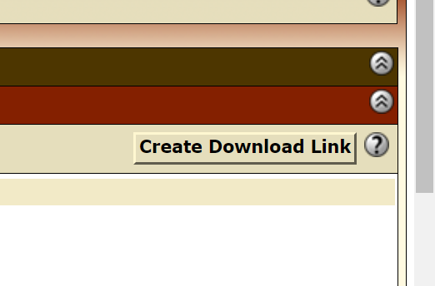
Figure 10. Download Soils Data tab Create Download Link

