Stormwater Pollution Prevention Plan Section 2.1 Summary Sheet Job Aid: 1.11 Receiving Waters
This job aid will assist you in utilizing the Texas Commission on Environmental Quality’s (TCEQ) website to determine relevant information to complete Section 1.11 Receiving Waters of the Stormwater Pollution Prevention Plan (SWP3) Summary Sheet.

Receiving Waters Determination
Use the following information to determine the receiving waters and flow path from the construction site:
- Go to the TCEQ Surface Water Quality Viewer and click on “Surface Water Quality Viewer”. This home page provides information, including a “User Guide” on how to utilize the Surface Water Quality Viewer. It is your responsibility to read and understand those steps.
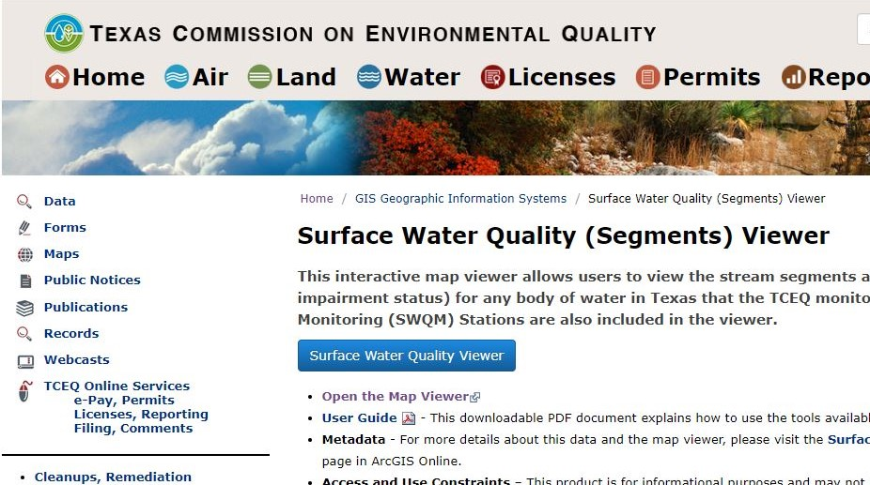
Figure 1. Screen Shot of the Texas Commission on Environmental Quality (TCEQ) Surface Water Quality Viewer home page.
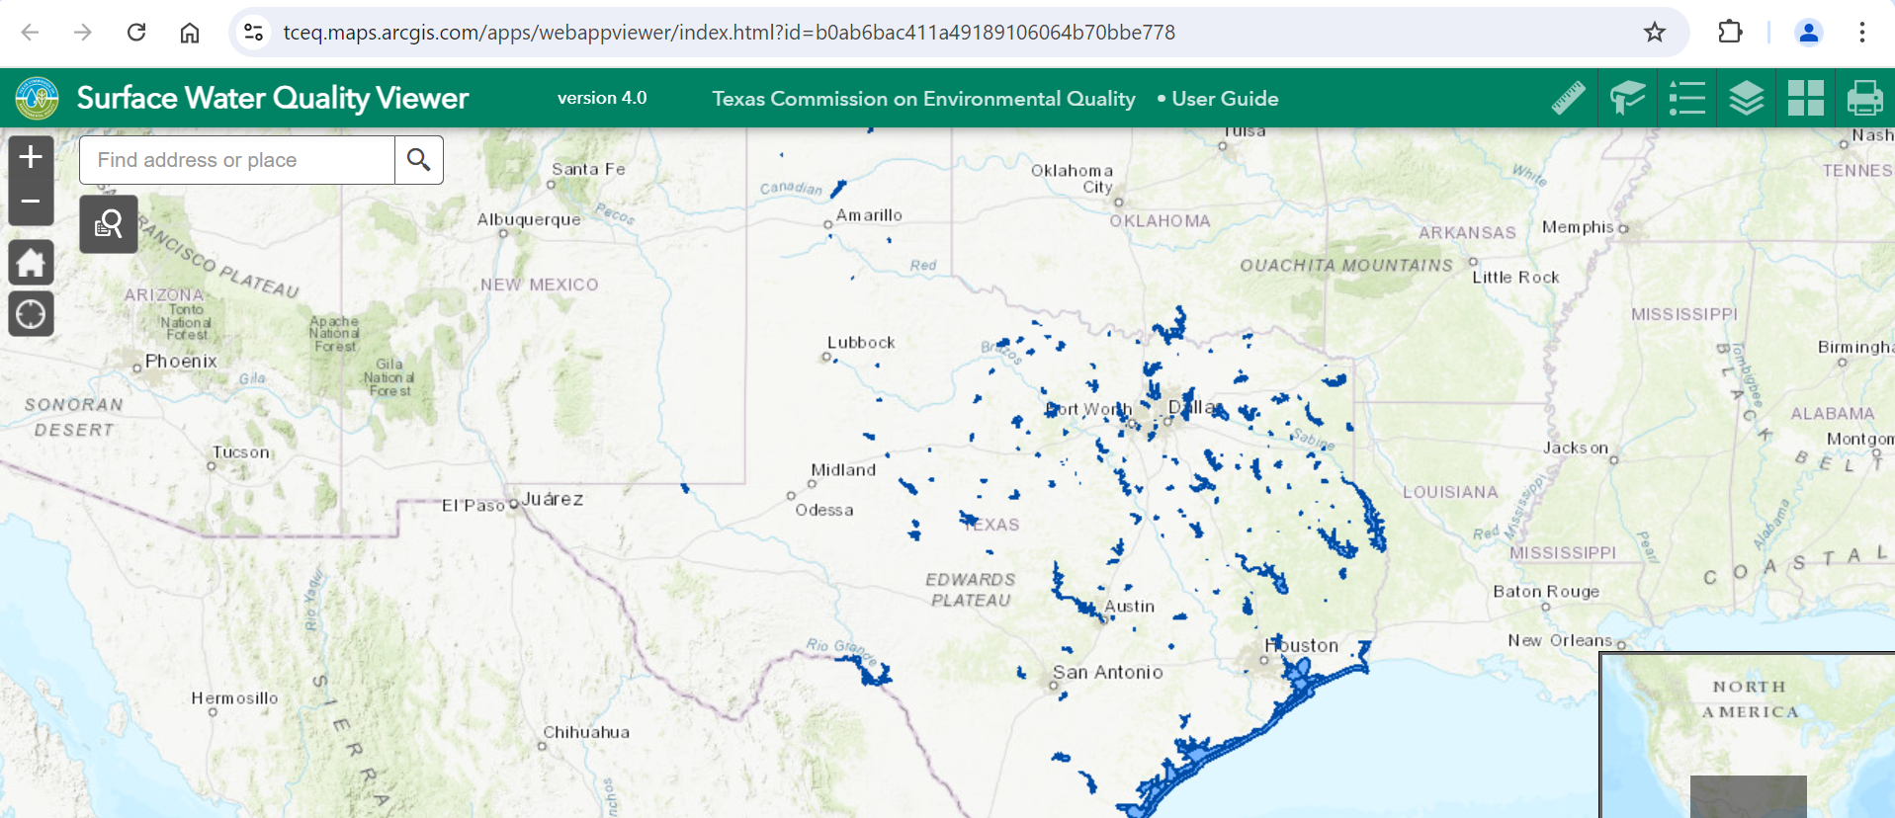
- Figure 2.This is a map of Texas showing surface waters in blue.
- Navigate to the construction project site location on the map. Adjust the basemap to depict the “USGS National Map” basemap option.
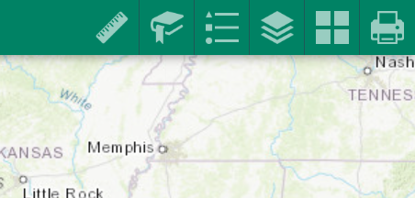
Figure 3. Navigate to construction project and select Base Map.
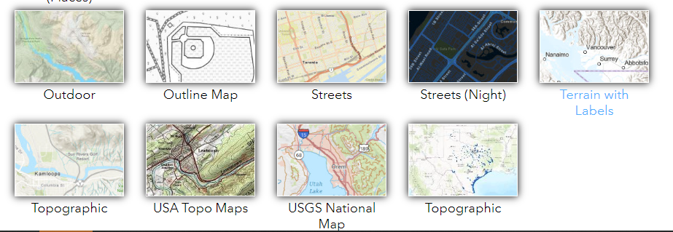
Figure 4. Screenshot of BaseMap selections.
- If not already displaying on the map, select the “Impaired Segments” layer tool.
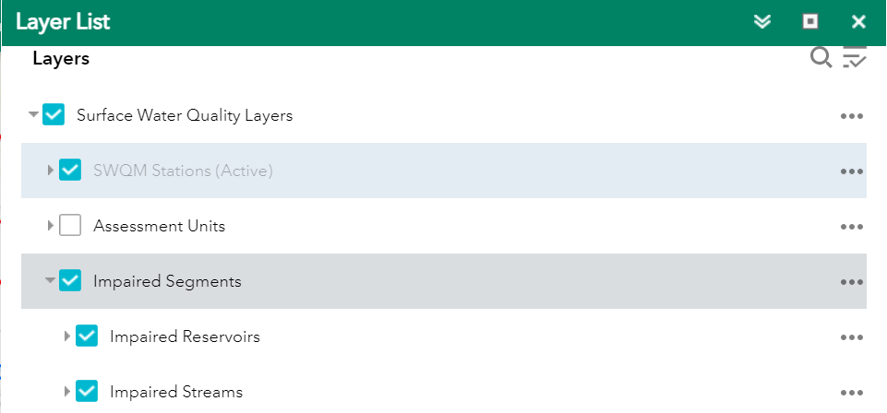
Figure 5. This figure shows the Layer List.
- Identify the flow path from the construction project site and determine the respective TCEQ classified waterbody segment stormwater discharge will flow to.
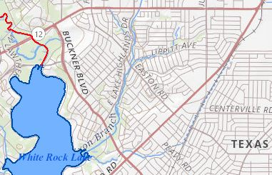
Figure 6. This is a map showing the selected construction project site.
- Click on the stream or reservoir for segment information, including the four-digit Segment ID and whether the segment is impaired.
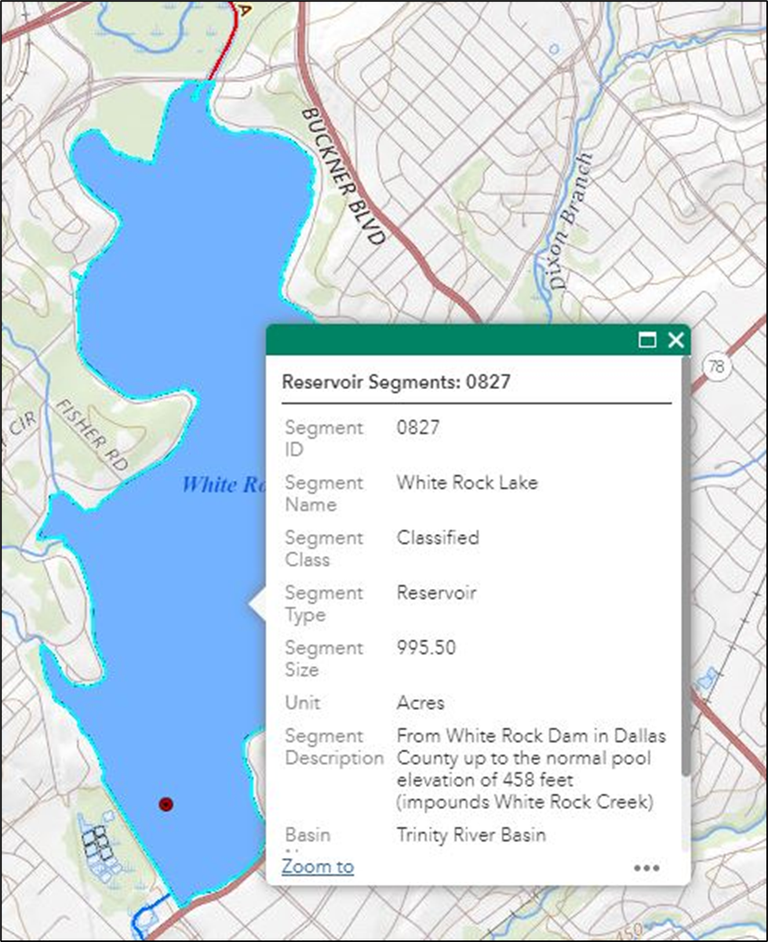
Figure 7. This is the information for the stream or reservoir selected.

Impaired Waters
If it is determined that there is an impaired receiving water, either classified or unclassified segment, you will need to look up the impairment to determine if the construction project will impact it.
- Navigate to the “Texas Integrated Report of Surface Water Quality”. Click on the approved Texas Integrated Report “Index of All Impaired Waters”. Note this report is updated every two years – so even if you are already familiar with a segment, you need to review it in case information has changed.
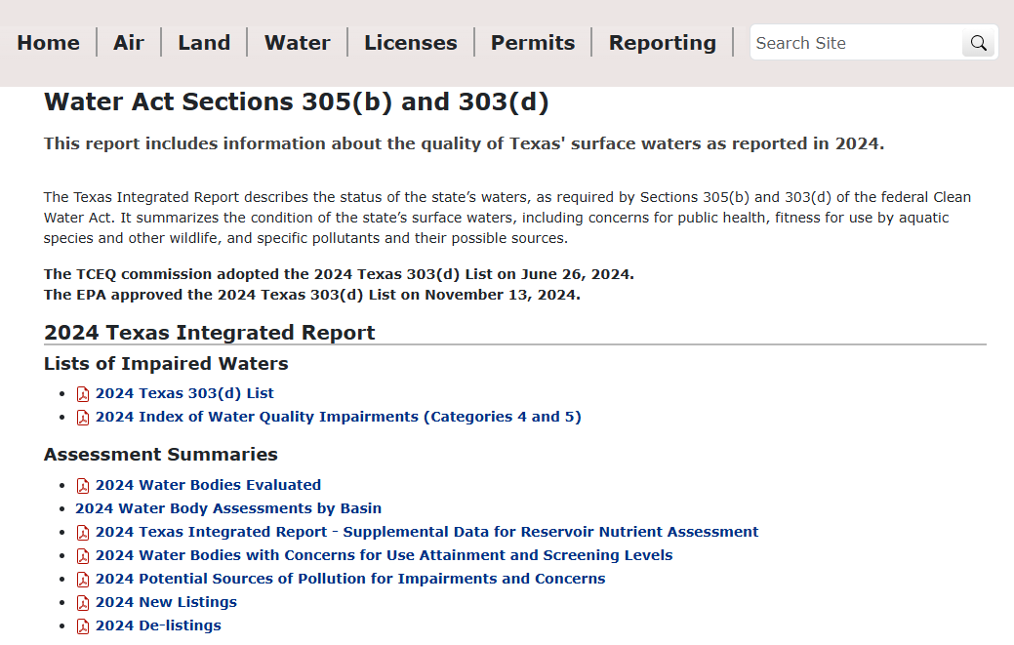
Figure 8. This is the section of the website which lists Impaired Waters.
- Search for the TCEQ classified waterbody segment identified in your analysis from using the TCEQ Surface Water Quality Viewer.
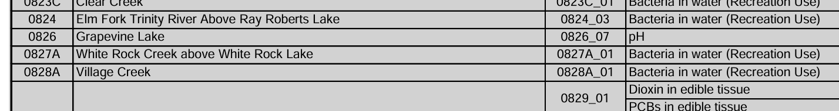
Figure 9. Classified waterbody segment list.
- Once the TCEQ classified waterbody segment is identified, determine the Pollutant of Concern (POC), or impairment, and whether there is a Total Maximum Daily Load (TMDL) and or Implementation Plan (I-Plan).
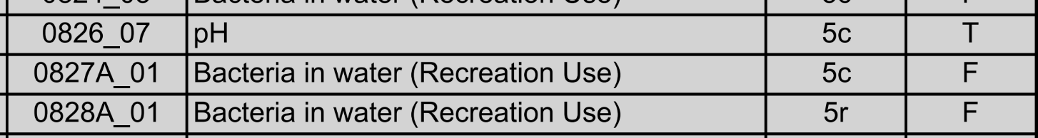
Figure 10. Screenshot showing classified waterbody segments.
- For TMDL and or I-Plan determination, review the “Explanation of Column Headings” on the first page of the Texas Integrated Report and identify the categories representing the TCEQ classified waterbody segment.
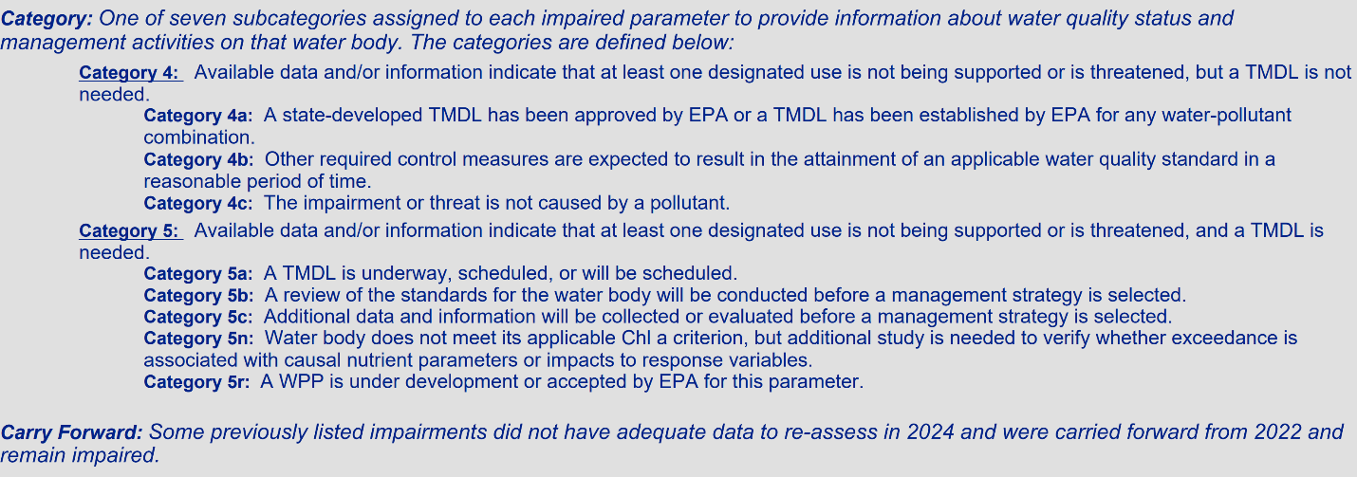
Figure 11. Screenshot of categories assigned to each impaired parameter.
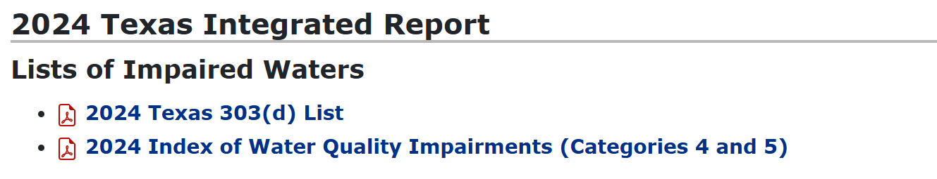
Figure 12. Texas Integrated Report Lists of Impaired Waters

TMDL and or I-Plan Determination
If it is determined that there is a TMDL and or I-Plan associated with the receiving water, you will need to look up that information to see if the project could potentially impact the TMDL and or I-Plan or if additional water quality best management practices are required on the project. Very few projects will have a TMDL and or I-Plan, and even fewer will have required actions or impacts.
- Navigate to the Project of the TMDL Program page to search for TMDLs and I-Plans that might be associated with your project. You can look though “TMDLs or I-Plans in Development” or utilize the “TMDL Summary Table” for a quicker search.
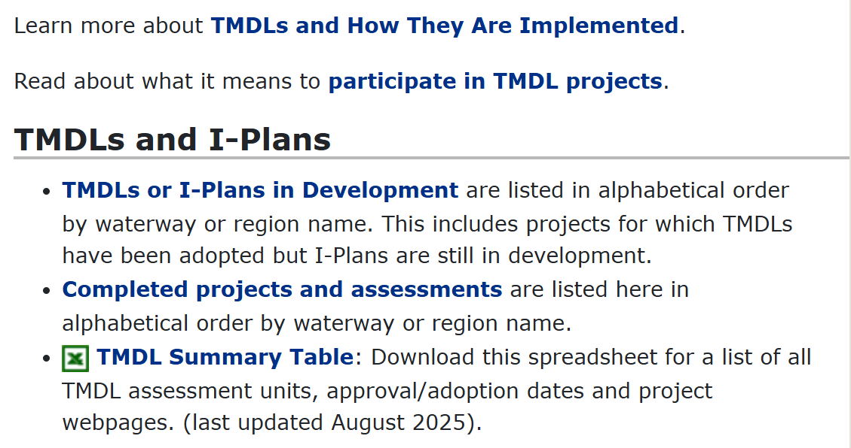
Figure 13. Screenshot of TMDLs and I-Plans.
It appears that example Segment 0827 from the example does not currently have a TMDL associated with it.
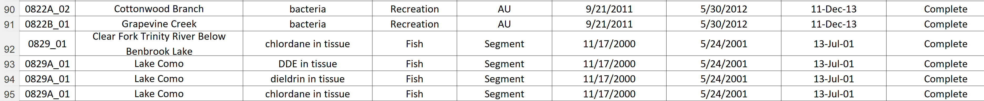
Figure 14. Example of table with Segments and associated TMDLs.
- If a TMDL or I-Plan is found associated with the received water, you can navigate to its page to find out additional information needed to assess project impacts or actions. Bessie’s Creek is an example.
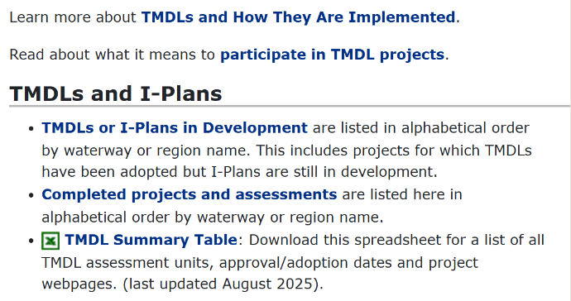
Figure 15. Screenshot of TMDLs or I-Plans in Development
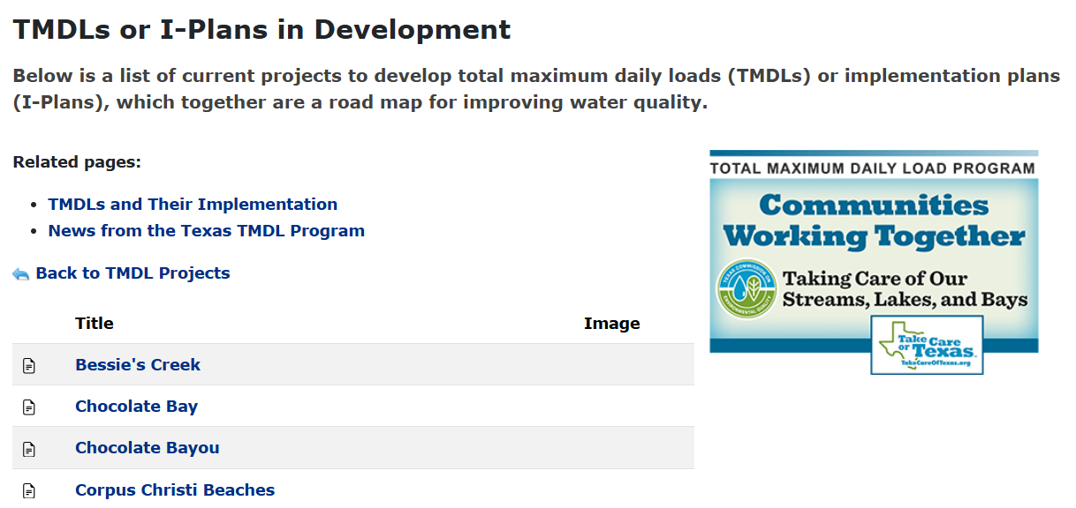
Figure 16. List of current projects to develop TMDLs or implementation plans.
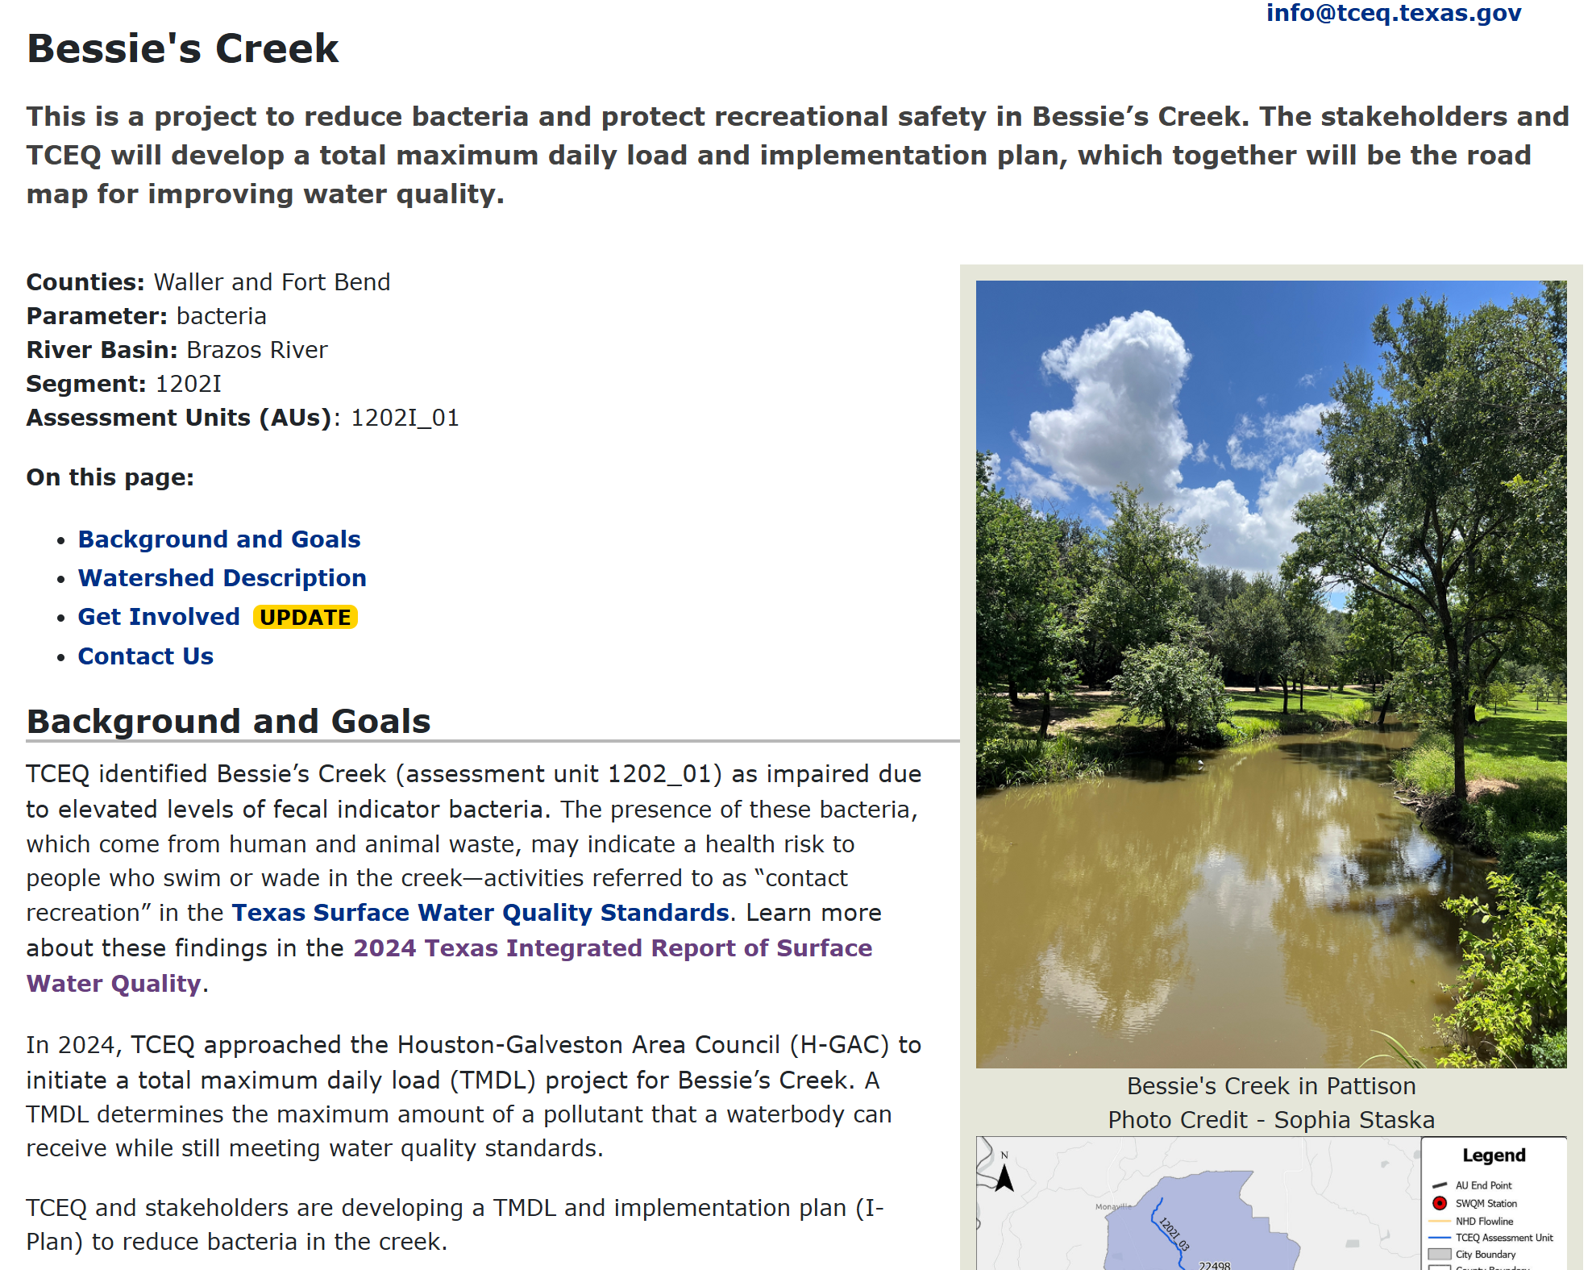
Figure 17. Implementation plan and TMDL for Bessie’s Creek

