Stormwater Pollution Prevention Plan Section 2.1 Summary Sheet Job Aid: 1.4 Total Project Area – Common Plan
This job aid explains the Common Plan of Development concept, which is necessary for calculating total area to be disturbed for determining applicability of the Texas Pollutant Discharge Elimination System (TPDES) Construction General Permit (CGP) for Texas Department of Transportation (TxDOT) projects.

1.0 Common Plan of Development
Construction occurring in separate phases or locations, but still part of a unified development effort, is considered a Common Plan of Development under the CGP. This determination is based on documentation such as construction plans, contracts, or public hearing schedules. For TxDOT projects, the Common Plan of Development typically aligns with a discrete project bid package (construction plans, contract plans, project proposal) as approved for letting, including any subsequent modifications (in other words, Change Orders) and areas of construction support activity (in other words, Project Specific Locations).
Generally, all construction areas under a Common Plan of Development count as one "construction activity" for purposes of the CGP. The total disturbed area of the “construction activity” will determine if the project is considered unregulated, a small, or a large construction activity. The CGP does provide some exception to this requirement, however. The CGP states that “where discreet construction projects occur within a large common plan of development or sale but are located one quarter ¼ mile or more apart, and the area between the projects is not being disturbed, each individual project can be treated as a separate plan of development of sale, provided that any interconnecting road, pipeline or utility project that is part of the same “common plan” is not included in the area to be disturbed”.
The following sections detail some of the nuances and exceptions relating to the concept of Common Plan of Development.

1.1 Project Phasing
The project’s construction activities are often divided into phases, which helps to manage the overall flow of construction, allocation of resources, and minimize the amount of disturbed area at any one-time. While this approach may result in a lower amount of disturbed area at any one-time, primary operators must still consider that each phase of construction contributes to the larger Common Plan of Development. All phases of construction, together, constitute one construction activity according to the CGP. The total area to be disturbed across all phases of construction must be taken into account when evaluating CGP applicability for a project.
Example: The graphic below depicts a highway widening project in which the construction is planned to occur in two, non-concurrent phases of construction. Phase I of construction is expected to disturb 0.75 acres of soil and occur within the months of January through April. Phase II is also expected to disturb 0.75 acres of soil but will occur within the months of May through August. There will be 0.1 acres of overlapping land that will be disturbed during both Phase I and Phase II of construction.
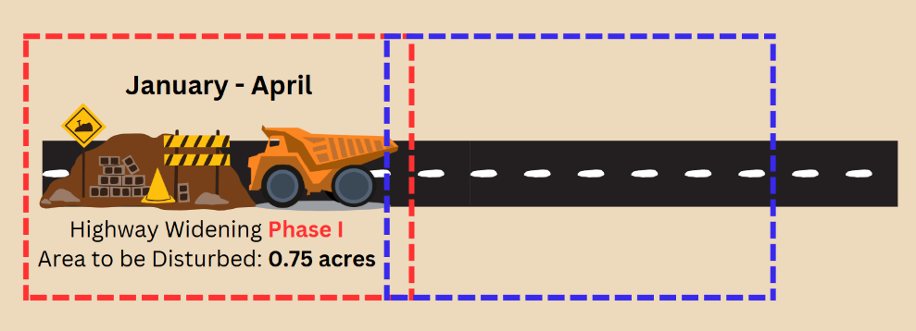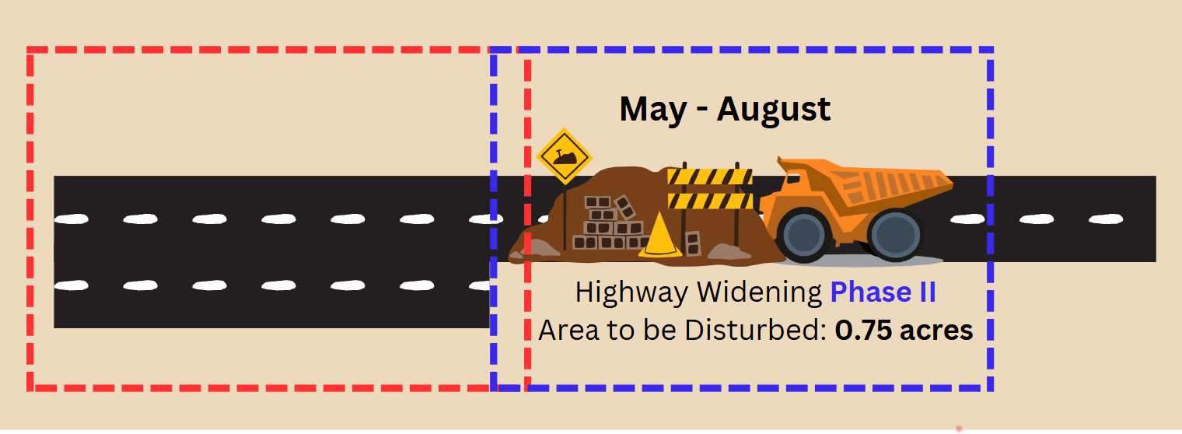
Figure 1. Phased Construction Project under a Common Plan of Development.
In this case, both phases of construction make up the larger highway widening project and are therefore part of a Common Plan of Development. The CGP would consider both phases of construction to be part of one construction activity. Although the two phases of construction will not occur concurrently, the area that will be disturbed during both phases must be used to determine the total area to be disturbed for the construction activity. The following calculation must be made to determine the total area to be to be disturbed for the construction activity:
Total Area to be Disturbed = 0.75 acres (Phase I Disturbed Area) + 0.75 acres (Phase II Disturbed Area) – 0.1 acres (overlapping area to be disturbed during both Phase I and Phase II) = 1.4 acres
This construction activity will disturb a total area of 1.4 acres and is considered a Small Construction Activity, regulated by the CGP.
Note: Some construction projects may be identified as “phases” in title or as part of long-term abstract planning, however, still qualify as distinct Common Plans of Development for the purposes of the CGP. Such is the case when engineering and construction planning, contract bidding, public hearings and notices, and construction for different “phases” occurs independently.

1.2 Non-Contiguous Areas of Construction
In many cases, non-contiguous areas of construction that are part of a Common Plan of Development cannot be considered distinct construction activities with respect to the CGP and must be considered one construction activity. In this situation, the sum of the area to be disturbed at all locations of construction within the Common Plan of Development must be used to determine the total area to be disturbed for a single, overarching construction activity.
Example 1: The graphic below depicts a bridge reconstruction project where two existing bridges are to be redesigned and reconstructed in two distinct, non-contiguous locations within the same highway. At each location, 0.75 acres of soil is expected to be disturbed. The distance between the two locations is 0.15 miles and no soil disturbing activity relating to the project will occur between the two locations.
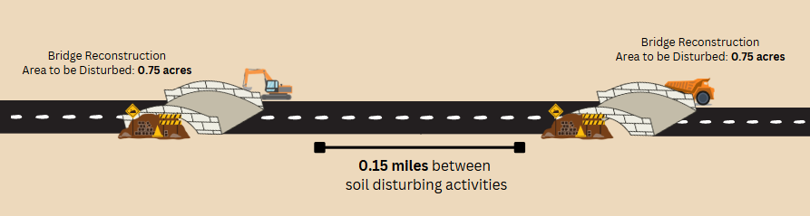
Figure 2. Non-Contiguous Areas of Construction within a Common Plan of Development.
Because the two locations where bridge reconstruction is occurring are part of a Common Plan of Development, with a distance of only 0.15 miles separating the two locations, both areas of construction will make up a single construction activity with regard to the CGP. The sum of the disturbed area for the two locations of cable barrier installation will constitute the total area to be disturbed for the construction activity.
Total Area to be Disturbed = 0.75 acres (Bridge Reconstruction Location 1 Disturbed Area) + 0.75 acres (Bridge Reconstruction Location 2 Disturbed Area) = 1.5 acres
This construction activity will disturb a total area of 1.5 acres and is considered a Small Construction Activity, regulated by the CGP.
Note: Per the CGP, non-contiguous areas of construction that are part of a Common Plan of Development can be considered distinct construction activities, provided they are located at least 0.25 miles apart and no associated construction will occur within the intermediate area(s).
Example 2: The graphic below depicts a project consisting of the installation of three high-mast light poles, all part of the same Control-Section-Job (CSJ). The three locations where light poles will be constructed are non-contiguous with one another, with at least 0.25-miles distance between each area of construction. No associated construction will occur within the intermediate areas between each location of light pole construction. Approximately 0.4 acres of soil disturbance is expected at each location.
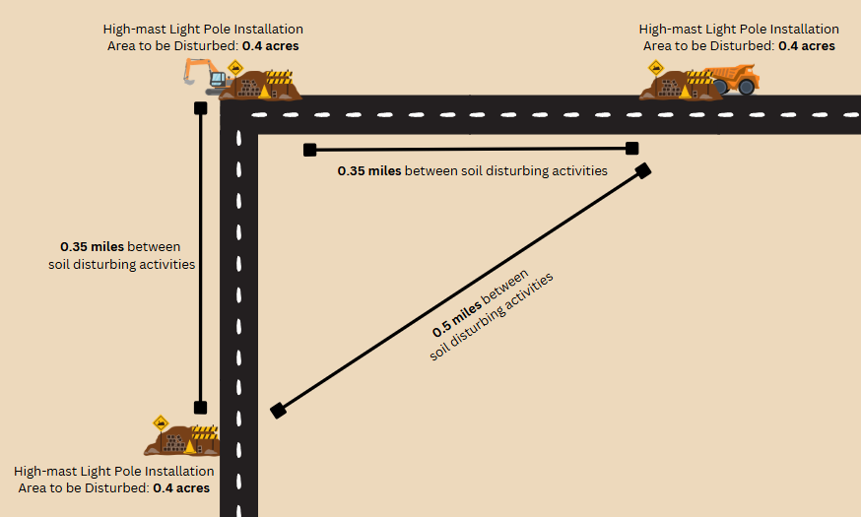
Figure 3. Non-Contiguous Areas of Construction Treated as Distinct Construction Activities.
Because there is a distance of at least 0.25-miles where no associated construction will occur between each light pole construction location, each light pole construction location can be considered a separate construction activity with regard to the CGP, despite the fact that the three areas of light pole construction make up a Common Plan of Development. The area to be disturbed at each location is 0.4-acres, therefore, the activities are not regulated by the CGP because the total area to be disturbed at each discrete location is less than 1 acre.
Conversely, if these three light pole construction locations were less than ¼ mile apart, or additional work – such as sidewalk repairs – was occurring in between each location, it would be considered one construction activity with regard to the CGP. The project would then be considered a small construction activity because the total area to be disturbed would be greater than 1 acre but less than 5 acres. In this case, the project would be regulated by CGP, requiring the development and implementation of a Stormwater Pollution Prevention Plan (SWP3).

1.3 Multiple Primary Operators
When determining CGP applicability, all Primary Operators associated with a construction project must reference the total area to be disturbed for the entirety of the Common Plan of Development. An individual Primary Operator cannot only consider soil disturbing activities specific to their actions or areas of work within a Common Plan of Development as a distinct construction activity, in the context of the CGP.
Example: The graphic below depicts a highway widening project in which there are three primary operators with day-to-day operational control over separate sections of a larger construction project (in other words, the Common Plan of Development). The three sections of construction are contiguous to each other.
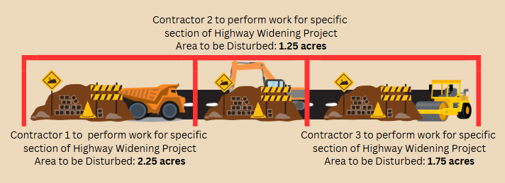
Figure 4. Contiguous Areas of Construction within a Common Plan of Development with Different Primary Operators.
Each of the three primary operators oversees a distinct section of the construction project, where the disturbed area for each section is between 1 and 5 acres. However, all three sections comprise one larger, Common Plan of Development, where 5.25 acres of land will be disturbed. Because all three sections of construction are part of a Common Plan of Development, the three sections will be considered one construction activity under the CGP. In this case, each operator is considered a primary operator of the same Large Construction Activity, and each must obtain separate permit coverage under the CGP, for a common Regulated Entity (RN).
Note: This situation is unlikely to occur on TxDOT construction projects.

1.4 Project Specific Locations (PSLs)
Project Specific Locations (PSLs), are areas of construction support activity, including both onsite and offsite areas where activities such as concrete and asphalt batch plant operation, equipment staging or storage, and materials storage, occur. When offsite PSLs are located within 1 mile of the project limits, and exist solely to support the project, the PSL may be considered part of the construction activity.
Example: The graphic below depicts a shoulder widening project in which 4.5 acres of soil is expected to be disturbed within the project area. The contractor has elected to operate a dedicated, offsite PSL for equipment staging and materials storage, adjacent to the limits of construction for the shoulder widening project. 1.0 acre of soil is expected to be disturbed within the area of the PSL.
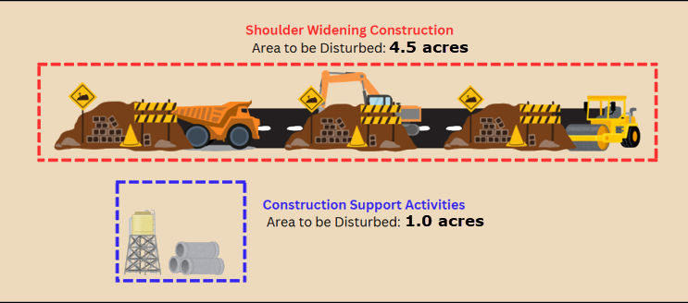
Figure 5. Offsite Project Specific Locations and Total Area to be Disturbed.
Because the PSL is located within 1 mile of the project area and exists solely to support the shoulder widening project, TxDOT and the Contractor have two options:
Option 1: Consider both the project area and off-site PSL to be one construction activity.
Under Option 1, the sum of the area to be disturbed for the project area and the offsite PSL must be used to determine the total area to be disturbed for the construction activity, per the CGP.
Total Area to be Disturbed = 4.5 acres (shoulder widening project area to be Disturbed) + 1.0 acre (offsite PSL area to be disturbed) = 5.5 acres
This construction activity will disturb a total area of 5.5 acres and is considered a Large Construction Activity, regulated by the CGP. A Notice of Intent (NOI) would be required to be submitted and the PSL would be incorporated into the project’s Shared SWP3, implemented by TxDOT and the Contractor.
Option 2: Consider the project area and the offsite PSL to be two discrete construction activities.
Under Option 2, the total area to be disturbed for the project area and the offsite PSL will not be added and instead be considered independently per the CGP.
Total Area to be Disturbed = 4.5 acres (Shoulder Widening Project Area to be Disturbed) = 4.5 acres
Total Area to be Disturbed = 1.0 acre (Offsite PSL Area to be Disturbed) = 1.0 acre
The Shoulder Widening Project and the offsite PSL will be considered two, discrete Small Construction Activities, regulated by the CGP. An NOI will not be required to be submitted for either project, however, a specific SWP3 will need to be developed and implemented for each project. In this case, the Contractor would maintain sole responsibility for implementing a compliant SWP3 for the PSL, as well as participating in a Shared SWP3 with TxDOT for the project.
Note: For offsite, off right of way (ROW) PSLs, it is typically the responsibility of the contractor to obtain any necessary permits or authorizations for those activities, independent of the TxDOT project, even in cases where the PSL exists to exclusively serve the TxDOT project. TxDOT is not considered an operator for any offsite, off-ROW PSLs, however, contractors are still required to notify TxDOT of any offsite, off-ROW PSLs that will be utilized to support the project, as well as provide copies of any pertinent permits or authorizations.

1.5 Change Orders
A Common Plan of Development may change after project letting due to a Change Order. Per the Construction Division’s (CST) Construction Contract Administration Manual (CCAM), an environmental review is required to be conducted to identify potential impacts to a project’s Environmental Permits, Issues, and Commitments (EPIC). As part of this process, changes must be reviewed for potential impacts to a project’s regulated status under the CGP and other changes that may be required to be reflected in the site-specific SWP3. For example, a Change Order might require modifications to erosion and sedimentation controls that must be reflected in the SWP3 or increase the total area to be disturbed, that must be reflected in the SWP3. A Change Order resulting in an increase or decrease of the total area to be disturbed could also change the project’s regulated status under the CGP.
Example: The graphic below shows a construction project scoped to only provide drainage upgrades for a highway frontage road, where the total area to be disturbed was 0.75 acres. After construction began, TxDOT executed a donation agreement with an adjacent landowner to provide a turn lane for their private business, as part of the project. The Change Order to add a turn lane as part of the drainage upgrades project increased the total area to be disturbed by 0.4 acres.
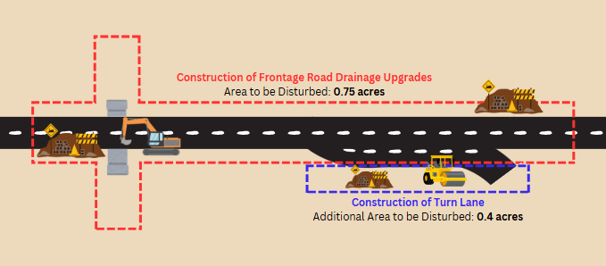
Figure 6. Change Orders Expanding the Common Plan of Development.
Following the execution of a Change Order, the Common Plan of Development now includes both the construction associated with the originally planned drainage upgrades and the construction of the turn lane. Both activities will be considered one construction activity per the CGP. In addition to making modifications to the project’s SWP3, the project’s size classification under the CGP must also be reevaluated, and the sum of both activities will be used to establish the total area to be disturbed for the construction activity.
Total Area to be Disturbed = 0.75 acres (Area to be Disturbed for Originally Planned Construction of Frontage Road Drainage Upgrades) + 0.4 acres (Area to be Disturbed for added Construction of Turn Lane) = 1.15 acres
This construction activity will disturb a total area of 1.15 acres and is now considered a Small Construction Activity, regulated by the CGP. Note that if a similar situation was to increase the total disturbed area for a construction project to 5.0 acres or more, the project would then be considered a Large Construction Activity requiring the submittal of a NOI to Texas Commission on Environmental Quality (TCEQ).

2.0 Pertinent CGP Definitions
Common Plan of Development – A construction activity that is completed in separate stages, separate phases, or in combination with other construction activities. A common plan of development (also known as a “common plan of development or sale”) is identified by the documentation for the construction project that identifies the scope of the project, and may include plats, blueprints, marketing plans, contracts, building permits, a public notice or hearing, zoning requests, or other similar documentation and activities. A common plan of development does not necessarily include all construction projects within the jurisdiction of a public entity (for example, a city or university). Construction of roads or buildings in different parts of the jurisdiction would be considered separate “common plans,” with only the interconnected parts of a project being considered part of a “common plan” (for example, a building and its associated parking lot and driveways, airport runway and associated taxiways, a building complex, etcetera.). Where discrete construction projects occur within a larger common plan of development or sale but are located one quarter (¼) mile or more apart, and the area between the projects is not being disturbed, each individual project can be treated as a separate plan of development or sale, provided that any interconnecting road, pipeline or utility project that is part of the same “common plan” is not included in the area to be disturbed.
Construction Activity – Includes soil disturbance activities, including clearing, grading, excavating, construction-related activity (for example, stockpiling of fill material, demolition), and construction support activity. This does not include routine maintenance that is performed to maintain the original line and grade, hydraulic capacity, or original purpose of the site (for example, the routine grading of existing dirt roads, asphalt overlays of existing roads, the routine clearing of existing rights-of-way, and similar maintenance activities). Regulated construction activity is defined in terms of small and large construction activity.
Construction Support Activity – A construction-related activity that specifically supports construction activity, which can involve earth disturbance or pollutant-generating activities of its own, and can include, but are not limited to, activities associated with concrete or asphalt batch plants, rock crushers, equipment staging or storage areas, chemical storage areas, material storage areas, material borrow areas, and excavated material disposal areas. Construction support activity must only directly support the construction activity authorized under this general permit.
Large Construction Activity – Construction activities including clearing, grading, and excavating that result in land disturbance of equal to or greater than five (5) acres of land. Large construction activity also includes the disturbance of less than five (5) acres of total land area that is part of a larger common plan of development or sale if the larger common plan will ultimately disturb equal to or greater than five (5) acres of land. Large construction activity does not include routine maintenance that is performed to maintain the original line and grade, hydraulic capacity, or original purpose of the site (for example, the routine grading of existing dirt roads, asphalt overlays of existing roads, the routine clearing of existing rights-of-way, and similar maintenance activities).
Primary Operator – The person or persons associated with construction activity that meets either of the following two criteria:
- the person or persons have on-site operational control over construction plans and specifications, including the ability to make modifications to those plans and specifications; or Construction General Permit Texas Pollutant Discharge Elimination System (TPDES) General Permit No. TXR150000 Part I, Section B Page 9
- the person or persons have day-to-day operational control of those activities at a construction site that are necessary to ensure compliance with a SWP3 for the site or other permit conditions (for example, they are authorized to direct workers at a site to carry out activities required by the SWP3 or comply with other permit conditions).
Small Construction Activity – Construction activities including clearing, grading, and excavating that result in land disturbance of equal to or greater than one (1) acre and less than five (5) acres of land. Small construction activity also includes the disturbance of less than one (1) acre of total land area that is part of a larger common plan of development or sale if the larger common plan will ultimately disturb equal to or greater than one (1) and less than five (5) acres of land. Small construction activity does not include routine maintenance that is performed to maintain the original line and grade, hydraulic capacity, or original purpose of the site (for example, the routine grading of existing dirt roads, asphalt overlays of existing roads, the routine clearing of existing rights-of-way, and similar maintenance activities).
Stormwater (or Stormwater Runoff) – Rainfall runoff, snow melt runoff, and surface runoff and drainage.
Stormwater Associated with Construction Activity – Stormwater runoff, as defined above, from a construction activity.

