
Guidance: Assessing Project Impacts to Eastern Black Rail (Laterallus jamaicensis ssp. jamaicensis)
Contents
1.0 Introduction 2
2.0 Conducting Habitat Assessments 2
2.1 Desktop Assessment 3
2.1.1 Vegetation 3
2.1.2 Hydrology 4
2.1.3 Habitat Categories 5
2.1.4 Documentation 6
2.2 Field Habitat Assessment 6
2.2.1 Documentation 7
3.0 Conducting Presence/Absence Surveys 7
3.1 Survey Protocol 8
4.0 Voluntary Conservation Measures for Consultations 10
4.1 Measures to be Implemented During Project Design 10
4.2 Measures to be Implemented Prior to Construction 12
4.3 Measures to be Implemented During Construction 14
4.4 Measures to be Implemented Following Project Construction 15
5.0 References 15
Appendix A: Supplemental Photos 17
Revision History 19

1.0 Introduction
This guidance document standardizes habitat assessments, presence/absence surveys, and voluntary conservation measures (VCMs) for the federally threatened Eastern Black Rail (BLRA; Laterallus jamaicensis ssp. jamaicensis). The purpose of this document is to provide a resource to ensure that the potential presence of and impacts to BLRA and their habitats are appropriately and consistently evaluated and documented across Texas Department of Transportation (TxDOT) projects. Contact the appropriate TxDOT Environmental Affairs Division (ENV), Natural Resources Management (NRM) Section Biology Subject Matter Expert to confirm or clarify this guidance as needed. In addition to the methodology outlined below, habitat assessments and presence/absence surveys for BLRA should be performed in accordance with TxDOT’s Guidance: Performing Habitat Assessments and Presence/Absence Surveys. This guidance does not preclude technical experts from using specific knowledge, data sources, methods, and/or data collection to determine or ascertain project impacts to BLRA. Adherence to this guidance does not preclude the need to consult with the United States Fish and Wildlife Service (USFWS) when effects are anticipated to occur.

2.0 Conducting Habitat Assessments
Habitat assessments for BLRA should focus on providing information on the plant communities, vegetation structure (in other words, height, density, composition, and diversity), and hydrology within the assessment area (in other words, the project area and 200-meter (m) buffer). This information can be used to evaluate and document potential impacts of TxDOT projects on this species and its habitat. Habitat assessments help determine the appropriate pathway to compliance with Section 7 of the Endangered Species Act (ESA). This guidance incorporates steps and resources provided by USFWS and the Texas Coastal Ecological Services Field Office (TCESFO).

2.1 Desktop Assessment
Prior to conducting a desktop assessment confirm that the project is within range of BLRA by consulting the USFWS Information for Planning and Consultation (IPaC) list and the Texas Parks and Wildlife Department (TPWD) Rare, threatened, and endangered species (RTEST) list. Instructions on how to obtain these lists can be found in the guidance document Instructions: Preparing a Species Analysis Spreadsheet. For TxDOT projects, an assessment area should encompass the project area and a 200-meter buffer. The 200-meter buffer includes potential refugia outside the project area for BLRA that may be present within the project area and are displaced by project activities. Online databases, LiDAR, topographic maps, and aerial imagery should be used to identify and evaluate potential BLRA habitat within the assessment area for each project. Databases that include habitat or features used by BLRA include Texas Parks and Wildlife Department (TPWD) Texas Ecosystem Analytical Mapper (TEAM) and Ecological Mapping System of Texas (EMST), USFWS National Wetland Inventory (NWI), and National Hydrography Dataset (NHD).

2.1.1 Vegetation
BLRA typically occupy areas that are moist to shallowly flooded with sufficient upland gradient to use during high tide and high-water events (Haverland 2019, Nadeau and Conway 2015, USFWS 2018, Watts 2016). They use areas with herbaceous vegetation that provide dense overhead cover and structure that curves horizontally overhead to form “tunnels” that allow movement under the vegetative canopy. On the Texas Gulf Coast, BLRA prefer high elevation zones of coastal salt marshes dominated by gulf cordgrass (Spartina spartinae) and saltmeadow cordgrass (Spartina patens). Additional indicators of potential BLRA habitat include salt grass (Distichlis spicata) and sea oxeye (Borrichia frutescens). Coastal salt marshes may also have shrub components of eastern baccharis (Baccharis halimifolia) or marsh elder (Iva frutescens). Occupied habitats, both coastal and inland, are typically composed of fine-stemmed emergent plants (rushes, grasses, and sedges) with high stem densities, and dense herbaceous canopy cover that is generally less than 1 meter tall, though in cattail and bulrush marshes the height of vegetation is taller than 1 meter (Flores and Eddleman 1995, Legare and Eddleman 2001, Roach and Barrett 2015, USFWS 2018). Photographs of suitable habitat in areas of known BLRA occupancy on the Texas Gulf Coast are included in Appendix A.
At sites along the Atlantic and Gulf Coasts where BLRA have been recorded during the breeding season, the species utilized salt marshes (61%), impoundments (23%), freshwater wetlands (12%), coastal prairies (10%), and grassy fields (2%) (Watts 2016). Watts (2016) noted impoundments included waterfowl management units, rice fields, wetland restoration or mitigation sites, spoil deposition sites, abandoned mines, and farm ponds.
On the Texas Gulf Coast, BLRA occupancy has been correlated with the following EMST vegetation associations (Haverland 2019):
- Gulf Coast: Salty Prairie
- Coastal: Salt and Brackish Low Tidal Marsh
- Coastal: Salt and Brackish High Tidal Marsh
- Chenier Plain: Fresh and Intermediate Tidal Marsh

2.1.2 Hydrology
NWI feature types that are irregularly flooded include E2EM1P, E2EM1N, PEM1J. These feature types are a potential indicator of aquatic features that may provide suitable habitat for BLRA when associated with the vegetation associations discussed above. BLRA habitat is not exclusive to these feature types and errors may exist in digital datasets that could lead to the over or underestimation of potential habitat within an assessment area. For example, roadside ditches are often mapped as NWI features but they are considered existing water control structures and are exempted by the 4(d) rule (85 Federal Register (FR) 63764). Per USFWS, the definition of ditches includes ditches that receive runoff from roadways.

2.1.3 Habitat Categories
BLRA habitat is not necessarily evident during desktop assessments and may change over time based on flooding events and land use changes. A site visit is recommended to verify landscape and habitat characteristics. BLRA habitat preferences vary across their range, but on the Texas Gulf Coast, suitable breeding and wintering habitats can be identified by the following characteristics:
- Species Composition: coastal salt marshes dominated by gulf cordgrass and saltmeadow cordgrass with a shrub component of eastern baccharis or marsh elder.
- Vegetation Structure: primarily herbaceous vegetation that provides dense overhead canopy cover and “tunnels” for BLRA movement.
- Hydrology: moist or shallowly (1 to 6 cm deep) flooded soils. During the breeding season, water depths less than 2.5 cm are necessary for chicks to be able to forage.
- Topography: Gradual elevational gradients are needed to provide refugia during potential flooding events.
Less preferred habitat includes more vertical herbaceous species such as smooth cordgrass (Sporobolus alterniflorus SYN= Spartina alterniflora), Typha spp., and Juncus spp. in relatively deep (greater than 6 cm) water. Because these vegetation types lack the appropriate canopy cover, they would not be considered suitable habitat unless directly adjacent to Spartina-dominated coastal salt marsh.
In Texas, BLRA occupy coastal environments year-round (USFWS 2018). These characteristics may support a recommendation for occupancy within an assessment area but cannot be used as justification for absence, similar to Texas Natural Diversity Database records.

2.1.4 Documentation
The supporting documentation associated with the desktop assessment of BLRA habitat should include figures that depict the following:
- Project Area and Assessment Area (aerial)
- BLRA Vegetation Associations within the Assessment Area
- Assessment Area LiDAR or microtopography data
- Water Features within the Assessment Area
- BLRA Habitat Suitability within the Assessment Area (utilizing “nesting”, “foraging”, “refugia”, and “non-habitat” categories only)
Optional figures: BLRA Known Occurrences, Soils, Protected Lands, etcetera. Additional figures may be added based on project-specific considerations or needs.

2.2 Field Habitat Assessment
Due to the fine scale variations in vegetation and topography in BLRA preferred habitat, areas of potential BLRA habitat determined in desktop habitat assessments should be verified in the field. Ground-truthing ensures species composition and any land use changes not evident or captured from databases used in the assessment are addressed. Pedestrian surveys of accessible potential habitat can be used to note and photograph vegetation characteristics (species, density, canopy cover, average height) and hydrology within the assessment area. If access is limited, surveyors may use binoculars or scopes to observe general habitat characteristics from adjacent accessible land. Some areas may warrant drone operations, though drone usage should be limited to September to March to avoid impacts to potential nesting BLRA and other species and must be coordinated with the TxDOT ENV UAS Coordinators, ENV NRM Biology SME, and TxDOT’s Unmanned Aircraft System (UAS) Program.

2.2.1 Documentation
Field data collection documentation should include:
- Representative photographs of project and assessment areas
- General vegetation inventory of observed species with qualitative description of density, average heights, canopy cover, and water depths when possible

3.0 Conducting Presence/Absence Surveys
If a proposed project is anticipated to temporarily or permanently remove habitat that was deemed suitable and is part of a contiguous patch that is 2 acres or greater in size, presence/absence surveys should be conducted to determine BLRA occupancy in accordance with USFWS protocols outlined below. Potential habitat within roadside ditches would not be considered as contributing to the 2 acres due to the 4(d) rule exempting existing water control structures. If absence is confirmed during a season of presence/absence surveys, TxDOT will document a no effect call in the Species Analysis Spreadsheet in accordance with TxDOT’s Instructions: Preparing a Species Analysis Spreadsheet and may proceed with the project without consulting with USFWS.
If the project let date does not allow for a season of presence/absence surveys, or if surveys confirm BLRA presence within the ROW, TxDOT may assume BLRA presence, consult with USFWS under section 7 of the ESA, and pursue mitigation options. Note that formal consultations require a minimum of 12 months lead time, with a strong preference for 18 months lead time for preparation and processing prior to the environmental clearance date. Please discuss specific project timelines with the appropriate ENV NRM Biology SME as soon as possible when consultation is anticipated.

3.1 Survey Protocol
BLRA survey protocol follows the range-wide recommendations presented by USFWS (2023). Use of playback surveys is the preferred method for surveying and should follow these recommendations:
- Timing
  - A minimum of five surveys should occur within the breeding season (March 16 – June 15 on the Texas Gulf Coast) with a minimum of 7 days between visits. Six surveys are recommended, and additional surveys may be added during the late breeding season but should not replace surveys conducted during the peak breeding season.
  - Surveys should occur from 30 minutes before sunrise to approximately 3 hours after sunrise, and/or approximately 3 hours before sunset to 30 minutes after sunset.
- Survey routes and spacing
  - A survey route should be established with fixed survey points.
  - Survey points should be approximately 400 meters (1,300 feet) apart.
  - Points should be placed in accessible potential habitat, avoiding areas that become inaccessible due to tidal conditions. If habitat is accessible only by roads or dikes, points can be placed along a linear path. If the habitat is fragmented or can be directly accessed, points should be placed within the habitat in any direction. Points should be grouped to minimize travel time and maximize survey time.
- Survey conditions
  - Surveys should occur when average wind speeds are less than 20 km/h (12.5 miles per hour (mph)).
  - Surveys should not occur when wind speed exceeds 20 kilometers per hour (km/h) or during sustained rain or heavy fog.
  - Surveys should not occur during periods of unusually high background noise.
- Playback options
  - Five passive minutes are followed by 2 minutes of intermittent playback, 1 minute of silence, 1 minute of playback, and a final minute of silence (totaling 10 minutes).
  - Each minute of playback includes 15 seconds of calls followed by 15 seconds of silence, repeated twice.
  - The first minute is the kickee-doo/kic-kic-kerr (KKD) call, and the second and third minute include a mix of KKD, churt, and grr-grr-grr calls from several individuals with varying pitch and frequency. Each 15-second segment is unique and should not be repeated.
  - A standard playback file is available from USFWS.
  - The ink-ink-ink adult calls and chick calls should not be used.
- Broadcast equipment and placement
  - Broadcast speakers should be placed approximately 120 centimeters (cm) (4 feet) above the ground and approximately 3 meters (10 feet) from the surveyor to avoid impacting surveyors’ hearing abilities.
  - Speakers should be pointed toward the center of potential habitat, away from surveyors, and should not be rotated during playback. Speakers should not be directed toward habitat outside of the project in order to avoid detecting birds not impacted by the project.
  - Sound pressure should be 80-90 decibels at 1 meter (3 feet) in front of the speaker, tested prior to arriving at the first survey point.
- Documentation
  - Data recorded at each survey point prior to the start of the survey include background noise levels, cloud cover, temperature, wind speed, and start time. Data sheets are available from USFWS.
  - If BLRA are detected, record azimuth and approximate distance of the bird from the surveyor as well as call types.
  - A single surveyor should complete a datasheet at each survey point and data should not be altered after the survey route is completed.
Surveyors should be proficient with marsh bird calls. USFWS does not anticipate having surveyors permitted through section 10(a)(1)(A), though USFWS training recordings are available. Additional details regarding survey protocol are available from USFWS (2023).

4.0 Voluntary Conservation Measures for Consultations
The following voluntary conservation measures (VCMs) are for consideration for BLRA consultations with USFWS for TxDOT projects. Project specific VCMs must be discussed with the appropriate ENV NRM Biology SME.

4.1 Measures to be Implemented During Project Design
- When the proposed project is located within BLRA nesting and foraging habitat, construction shall be conducted outside of the BLRA breeding, nesting, and molting period from March 1 to September 30, if practicable.
- The project shall be designed to minimize excavation and vegetation removal and maximize the use of existing, previously disturbed ROW within the project area.
- If it is necessary to clear BLRA habitat, clearing shall be accomplished at one time during the construction period and no pockets of suitable BLRA habitat should remain within the project area that could attract BLRAs into the construction area.
- Equipment, material staging, and access routes shall not be placed in BLRA habitat and must be individually approved by TxDOT District staff.
- Areas of nesting and foraging habitat adjacent to the project area shall be identified in project plans and construction fencing shall be provided so that construction activities would not occur in those area.
- TxDOT design appropriate temporary best management practices (BMPs) to minimize construction phase erosion and sedimentation impacts and include these in any required Texas Commission on Environmental Quality (TCEQ) permitting documents, such Storm Water Pollution Prevention Plan (SWP3), and TxDOT construction plans, in accordance with the Texas Pollutant Discharge Elimination System (TPDES) Construction General Permit (CGP) requirements.
- All Borrow material necessary for project construction shall not be taken from BLRA nesting and foraging habitat). Borrow material should be inspected for invasive plant species.
- When work is performed at night, temporary lighting shall be fully shielded and pointed downward, no brighter than necessary, minimized for blue light emissions, and directed at the work zone. When construction is not being conducted at night, all construction site lights should be turned off.
- The use of permanent lighting shall follow Dark Skies guidelines established by the McDonald Observatory. TxDOT has standard practices (Special Specification 6391 LED Decorative Illumination Assembly) when providing permanent lighting that complies with and goes beyond Dark Sky Guidelines.
- TxDOT will include all conservation measures into the Environmental Permits, Issues, and Commitments (EPIC) sheet in the project plans and General Notes as appropriate. This will include a work strategy to avoid impacts to BLRA.

4.2 Measures to be Implemented Prior to Construction
- TxDOT will hold a pre-construction meeting with its employees and contractors working on the project. TxDOT shall provide specific instructions on the implementation of TxDOT’s proposed VCMs. Instructions specific to the contractor(s) related to implementation of the VCMs as documented in the EPICs and project plans. TxDOT shall provide pre-construction awareness training to project contractors, which includes information on protected species and habitat that may occur in the project area and outside the ROW and requirements to avoid effects to these species and their habitats.
  - The contractor will also be provided information at the pre-construction meeting about how to identify BLRA adults, chicks, eggs, and vocalizations, and to work within the established footprint of the project area. The work strategy to avoid impacts to BLRA will also be reviewed during the pre-construction meeting.
- The contractor will be required to have all Project Specific Locations (PSLs) for staging areas approved by TxDOT District environmental staff before moving into the selected sites to ensure that these areas are not located BLRA habitat or Waters of the U.S.
- The contractor shall be made aware at the pre-construction meeting that all construction equipment and personal vehicles should be within the PSLs when they are not in use or are parked for the night. If equipment must be left within BLRA habitat, coordination with the Service is necessary.
- TxDOT will include notes in the EPIC sheet for the contractor to minimize, to the maximum extent practicable, clearing of vegetation within the existing ROW. Where needed, signage within the project area may direct the contractor to avoid disturbance in ecologically sensitive areas.
- Marking the project boundary with flagging or construction fencing (when appropriate) will occur in cases where there is a risk of damage to suitable BLRA habitat adjacent to and outside of the project area. In some cases, the installation of small mesh construction fences around the project perimeter may be warranted to prevent disturbance to BLRA habitat or to prevent BLRAs from entering the project area. If used, fencing will be removed and disposed of properly off-site after construction has been completed.
- Potential habitat within the ROW can be cleared or mowed during the BLRA non-breeding season, from October 1 through February 28, as long as BLRA are flushed into adjacent refugia prior to the activity as follows,
  - Immediately prior to the start of clearing activities, a monitor shall slowly walk in transects parallel to and beginning directly adjacent to the roadway and moving towards refugia outside the project area. Clearing or mowing shall be conducted in the same way, allowing for the escape of the birds towards refugia. See Figure A.
Figure A. Clearing patterns to be walked by monitors prior to mowing and clearing activities
- Clearing or mowing is effective at preventing BLRA from straying into the project area if vegetation is not allowed to grow back to the vegetative structure preferred by the species.

4.3 Measures to be Implemented During Construction
- TxDOT will require the contractor to adhere to TxDOT’s standard plans and specifications.
- TxDOT will require the contractor to implement and adhere to the project SWP3 and CGP including:
  - the selection and placement and maintenance of BMPs, which may include temporary vegetation, silt fencing, wildlife friendly matting, mulch, sodding, interceptor swales, diversion dikes, mulch filter berms, biodegradable erosion control logs, silt fencing, rock berms, bio-degradable erosion control logs, and triangular filter dike;
  - the placement of BMPs before construction activities are initiated;
  - the monitoring and maintenance of BMPs throughout the project, and;
  - regarding equipment maintenance, materials storage, spill containment and response, waste containment and disposal.
- TxDOT will limit the clearing of vegetation and topsoil to only the areas needed to accomplish the project or activity.
- Construction activities resulting in vibrations over an extended period, such as pile driving adjacent to nesting habitat, must occur outside the nesting season.
- If construction activities will occur between March 1 and September 30:
  - Work activities will be avoided from 1 hour before sunset to 2 hours after sunrise adjacent to BLRA nesting and foraging habitat to allow peak vocalizations for BLRA populations to be undisturbed.
  - Periods of construction inactivity will be avoided between March 1 – September 30 to discourage birds from establishing nests near the project area and abandoning the nest when construction resumes.
- The contractor will employ a ‘soft start’ to construction activities year-round, meaning that each time the activity begins after a period of inactivity, such as after lunch breaks or overnight, construction activities will gradually increase over a period of 30 minutes to allow birds to relocate.
- Should BLRA chicks or eggs be observed within or near the construction site, all activity will be immediately suspended and TxDOT environmental staff will be contacted. In turn, TxDOT will notify the USFWS TCESFO office at 281-286-8282 and via email within 24 hours, or if other than Friday through Sunday, then 72 hours.

4.4 Measures to be Implemented Following Project Construction
- All construction areas will be restored to pre-construction contours.
- Disturbed areas shall be re-vegetated according to TxDOT’s standard practices in accordance with the SWP3 and CGP. Re-vegetation efforts shall provide appropriate and sustainable cover to prevent erosion and siltation.
- The number of ingress/egress routes through potential BLRA should be limited to minimize ground disturbance effects during maintenance activities.

5.0 References
Flores, R. E., & W.R. Eddleman. 1995. California black rail use of habitat in southwestern Arizona. The Journal of Wildlife Management 59:357-363.
Haverland, A. A. 2019. Determining the status and distribution of the eastern Black Rail (Laterallus jamaicensis) in coastal Texas. PhD dissertation, Texas State University.
Legare, M. L., & W.R. Eddleman. 2001. Home range size, nest-site selection, and nesting success of black rails in Florida. Journal of Field Ornithology, 72, 170-177.
Nadeau, C. P., & C.J. Conway. 2015. Optimizing water depth for wetland-dependent wildlife could increase wetland restoration success, water efficiency, and water security. Restoration Ecology 23:292-300.
Roach, N., and K. Barrett. 2015. Managed habitats increase occupancy of black rails (Laterallus jamaicensis) and may buffer impacts from sea level rise. Wetlands DOE 10.1007/s13157-015-0695-6.
U.S. Fish and Wildlife Service. 2018. Species status assessment report for the Eastern Black Rail (Laterallus jamaicensis jamaicensis), Version 1.2. June 2018. Atlanta, GA.
U.S. Fish and Wildlife Service. 2023. Eastern Black Rail Call-Response Survey Protocol for Range-Wide Monitoring, Version 1.1. April 2023.
Watts, B.D. 2016. Status and distribution of the eastern black rail along the Atlantic and Gulf Coasts of North America. The Center for Conservation Biology Technical Report Series, CCBTR-16-09. College of William and Mary/Virginia Commonwealth University, Williamsburg, VA. 148 pp.

Appendix A: Supplemental Photos
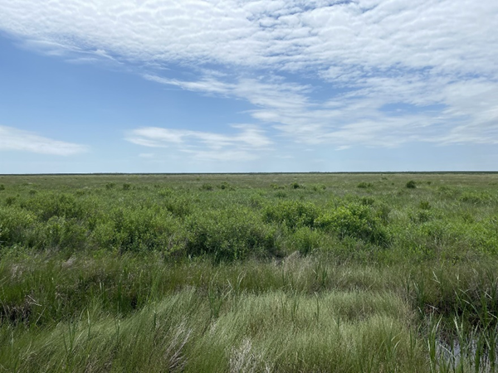
Figure B. A mix of Salt and Brackish High Tidal Marsh Salt and Brackish Low Tidal Marsh in an area of known occupancy in Anahuac National Wildlife Refuge (NWR). The mix of Spartina sp., herbaceous grasses, and marsh elder provides the preferred vegetation
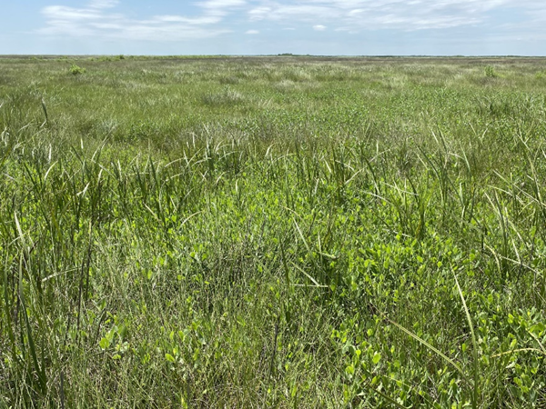
Figure C. BLRA habitat is adjacent to the area depicted in Photo 1. Fewer shrub species and a more diverse mix of grass species are present. Herbaceous canopy cover and stem density are sufficient for BLRA movement and occupancy.
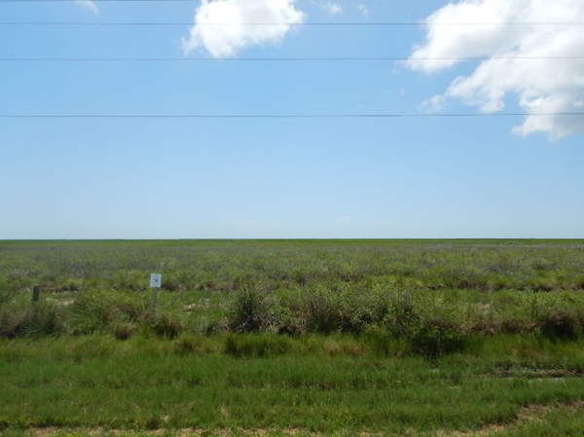
Figure D. Salt and Brackish High Tidal Marsh Salt and Brackish Low Tidal Marsh in an area of known BLRA occupancy at San Bernard NWR. The low and high tidal marshes are dominated by gulf cordgrass and fewer shrub species are evident than at Anahuac NWR
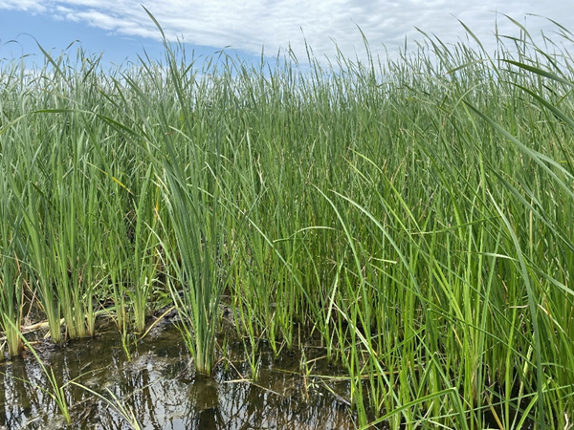
Figure E. A Typha-dominated marsh mapped by EMST as Fresh and Intermediate Tidal Marsh. BLRA may use this habitat for foraging if adjacent to their preferred Spartina-dominated habitat, but the depth of standing water and absence of herbaceous canopy cover would

Revision History
Table 1. Document revision history
Effective date (month year) | Reason for and description of change
March 2026 | Version 2  - Updated for accessibility compliance and TxDOT branding standards.
June 2024 | Version 1  - Provides standards for habitat assessments, presence/absence surveys, and voluntary conservation measures for the federally threatened Eastern Black Rail.

