Guidance: Texas Kangaroo Rat Survey Methodology Recommendations

1.0 Introduction
This document was developed to guide best practices for determining suitable habitat and detecting the presence of federally proposed endangered and state-listed threatened Texas kangaroo rats (TKR; Dipodomys elator). As of the date of this document, TKR is proposed for federal protection as an endangered species. A critical habitat designation is also under consideration for this species. To determine the appropriate course of action, it is essential to evaluate the potential impacts on TKR. This evaluation may include a formal Section 7 conference or consultation with United States Fish and Wildlife Service (USFWS), contingent upon the species’ listing status.
Additionally, due to TKR’s status as a threatened species in Texas, any direct field observations should be reported to the Texas Natural Diversity Database (TXNDD). Observations should be submitted using the TXNDD Reporting Form and must include a map indicating the precise location of the TKR sighting.
Appropriate personal protective equipment (PPE) should be worn to prevent injury to technicians working along roadsides. Additional PPE may be required based on project requirements.
- Hardhat
- Safety vest
- Protective footwear
A supplement to this guide provides more detailed information on the ecology of the species, more in-depth information for conducting surveys, alternative survey methods, and recommended protection measures and is available upon request from ENV-Bio@txdot.gov. Sample field data collection forms are included in Section 3 of this document.
Methods described in this guidance and the supplement include survey methodologies conducted at night. If any night surveys are conducted, the Texas Department of Transportation (TxDOT) district, Texas Parks and Wildlife Department (TPWD) game wardens, and local law enforcement must be notified once a schedule is developed and prior to any night surveys.

2.0 Methods

2.1 Desktop Habitat Assessment
A Desktop Habitat Assessment should be conducted to determine whether field-based presence and or absence surveys are recommended. The Desktop Habitat Assessment considers the presence of critical habitat, historical species occurrence records, and habitat suitability (Figure 1). The protocol for conducting the desktop habitat assessment is thoroughly described in the supplement available upon request from
ENV-Bio@txdot.gov. Broadly, field-based presence and or absence surveys are recommended for projects occurring within any of the 11 Texas counties within the species range, and:
- Intersecting proposed or designated critical habitat, or
- Having species occurrence records within 0.8 kilometers (0.5 miles) of the project in the last 25 years, or
- Having suitable habitat within the project area.
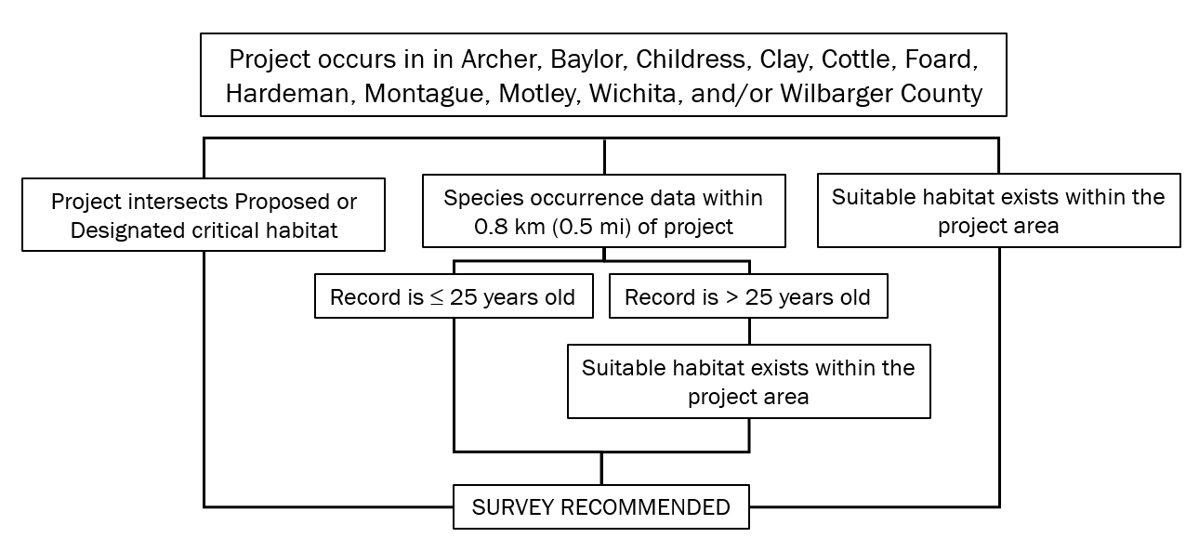
Figure 1. The Desktop Habitat Assessment considers several factors to determine if a field-based presence and or absence survey is recommended for TKR.

2.1.1 Habitat Suitability
A field-based presence and or absence survey is necessary if any part of the habitat within the project area can be considered suitable for TKR (Figure 2). Suitable habitat will have less than 50 percent woody vegetation cover and:
- At least 30 centimeters (12 inches) of soil horizon consists of clay, clay-loam, or loam textured soils with no restrictive (impermeable) layer in the top 50 centimeters (20 inches), or
- Landcover class is cropland, pastureland, or mix-grass and or shortgrass prairie, or
- Project area is along an unpaved roadway with at least 2 meters (6.5 feet) of unpaved roadsides strip of at least 2 meters (6.5 feet) wide.
Unsuitable habitat is characterized by:
- Restrictive (impermeable) soil layer within the top 50 centimeters (20 inches) of soil depth, or
- At least 30 centimeters (12 inches) of sandy textured soil, or
- Greater than 50 percent woody vegetation cover, or
- A paved roadway with less than 1 hectare (2.5 acres) of other suitable habitat within 0.8 kilometers (0.5 miles) of the road.
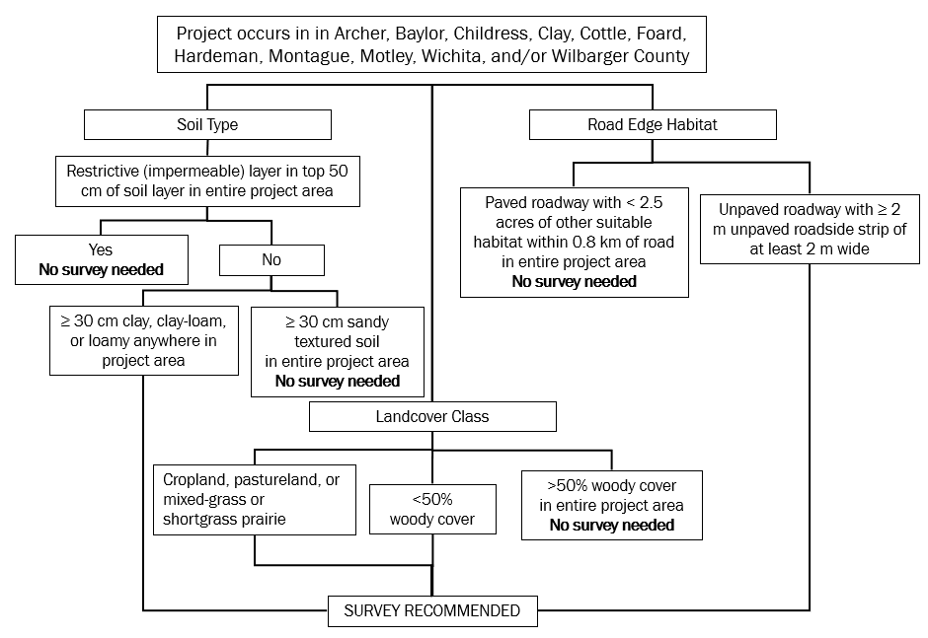
Figure 1. Habitat suitability factors used to determine if a field-based presence and or absence survey is recommended.

2.2 Presence and or Absence Surveys
If a field-based presence and or absence survey is recommended due to the apparent presence of suitable habitat based on the desktop habitat assessment, the field-based survey should occur within the project area and an additional 500 foot buffer around the project area, when possible. If right-of-entry (ROE) is not granted, surveys can be restricted to the right-of-way (ROW). Field-based presence and or absence surveys consist of habitat characterization, daytime burrow surveys, and nighttime camera trapping and or spotlight surveys (spotlight surveys may require additional coordination with USFWS and are described in the supplemental document). The supplemental document provides additional information related to species identification, habitat features, and survey methodologies. Section 3 provides Example Field Data Collection Forms.
Nighttime survey timing must include consideration of weather conditions. TKR will remain in their burrows during inclement weather (for example, temperatures below 40 degrees Fahrenheit [5 degrees Celsius] and wind speeds greater than 20 miles per hour or [32 kilometers per hour], and precipitation). If weather conditions exceed these minimum thresholds, spotlight surveys should be terminated and resumed when conditions have improved.

2.2.1 On-site Habitat Characterization
The first step in the presence and or absence survey process is to characterize the habitat within the project area and an additional 500 foot buffer (when ROE is granted). Surveyors should record features that may represent barriers to dispersal (for example, water features, paved roads, rail roads, etcetera) as well as areas of unsuitable habitat on field data collection form. Representative photos of each habitat characteristic should be documented, and areas of unsuitable habitat should be mapped. Other survey area characteristics that may be recorded include the level of habitat connectivity and or fragmentation, overall habitat patch size(s), and the existing level of human disturbance.
General habitat characteristics to identify during assessment include, but are not limited to:
- soil type
- dominant vegetation types
- average vegetation height
- percent woody cover
- percent bare ground

2.2.2 Daytime Burrow Surveys
- Survey coverage includes the proposed project limits and a 500 feet (152 meters) buffer when right-of-entry has been secured on adjacent lands, otherwise only survey within the ROW
- Surveys involve walking line transects at regular 15 meters (50 feet) intervals to identify potential TKR burrows and document their characteristics as follows:
- Dipodomys burrow entrances are baseball sized (approximately 7.2 to 7.5 centimeters [2.8 to 3 inch] in diameter)
- Below ground tunnels descend at an angle no greater than 45 degrees
- Trails and runways to burrow entrances should be apparent

2.2.3 Nighttime Camera Trapping
Determinations of presence rely on a visual confirmation of the species which may be determined by camera trapping. The supplemental document provides details important to camera trapping methodology, which should follow these general guidelines:
- Notify TxDOT district, TPWD game wardens, and local law enforcement prior to conducting nighttime surveys
- Motion-sensitive cameras, utilizing an infrared flash, should be used to monitor suspected TKR burrow entrances for a minimum of three days
- To the extent possible, position cameras so that they are not in sight of major roads or human trails
- Cameras can be attached to rebar with zip ties approximately 1.5 – 3 meters (5 – 10 feet) from burrow entrances
- Place each camera at a 90-degree angle to the path of travel, approximately two feet above the ground and angled slightly downward with a clear view of the entrance and runway
- Set cameras to deploy beginning 30 minutes after sunset and ending 30 minutes before sunrise
- Cameras should be set to capture a single still photo when triggered with a 30-second delay between triggers

2.3 Data Collection and Reporting
When encountered, data collection on identified Dipodomys burrows should include all of the information indicated in the example Daytime Burrow Survey Data Collection Form in Section 3. This includes locality information, a survey of the surrounding area for other burrows, and specific information pertaining to the morphology of the burrow itself.
When positive identification of the species is made, data collection should include the following:
- Location of observation
- Time of observation
- Distance from burrow
- Bait type, if used
- Notes on habitat use, if apparent

3.0 Example Field Data Collection Forms

3.1 Daytime Burrow Survey Data Collection Form
The tables below provides an example of data recommended for recording suspected TKR burrow locations and characteristics. Use a new sheet for each observation. Be sure to indicate if a camera trap was placed at this location. Example text in blue.
Table 1. Daytime Burrow Survey Data
Daytime Burrow Surveys | Burrow Data
Site Location Name | Boggy Creek at CR 114
Date | January 9
Weather Conditions | High Winds >20 miles per hour (mph), 48˚F
Table 2. Daytime Burrow Survey Characteristics
Suspected Burrow Survey Characteristics | Burrow Characteristics
Burrow ID (Surveyor initials and a number) | EKB_01
Location (latitude and longitude coordinates) | 34.221352, -99.410821
Number of burrows in close proximity | 1
Burrow entrance diameter (centimeters) | 7.6
Angle of Burrow Tunnel | <20 degrees
Runway to Burrow apparent (yes or no)? | yes
Photo of surrounding habitat included (yes or no)? | yes
Photo of burrow entrance included (yes or no)? | yes
Camera Trap placed at this location (yes or no) | yes

3.2 Nighttime Spotlight Surveys Data Collection Form
The tables below provides an example of data recommended for recording survey details and any positive identifications of TKR. Example text in blue.
Table 3. Nighttime Spotlight Burrow Survey Data
Nighttime Burrow Surveys | Day 1 | Day 2 | Day 3
Site Location Name | Boggy Creek at County Road 114 | No Text | No text
Date | January 10 | No Text | No text
Weather Conditions | Moderate Winds >15 mph, 55˚F | No Text | No text
Table 4 Nighttime Spotlight Burrow Surveys Details
Survey Details | Day 1 | Day 2 | Day 3
Surveyor Initials | EKB | No Text | No text
Survey Type | Driving Spotlight Survey | No Text | No text
Extent of Survey | Unpaved road within assessment area approximately 1500 linear meters | No Text | No text
Time of total darkness | 6:48 p.m. | No Text | No text
Time of first survey | 7:15 p.m. | No Text | No text
Total number of surveys performed | 5 | No Text | No text
Time surveys ended | 9:11 p.m. | No Text | No text
Were TKR observed (yes or no)? | no | No Text | No text
If yes, how many individuals? | Not applicable | No Text | No text
List the approximate coordinates for each positive ID | Not applicable | No Text | No text
Other species observed | 3 non-Dipodomys rodent species, 2 rabbits (Sylvilagus spp.), and 1 grey fox (Urocyon cinereoargenteus) | No Text | No text
Other notes | Surveys ended early due to inclement weather. Wind speeds increased to > 20 mph | No Text | No text

Revision History
Table 5. Document revision history
Effective date (month year) | Reason for and description of change
October 2026 | Version 3  - Updated for accessibility compliance and TxDOT branding standards.
January 2025 | Version 2  - Weather considerations for nighttime surveys added to Presence/Absence Survey section.
September 2024 | Version 1  - Provides standards for habitat assessments and presence/absence surveys for the federally proposed endangered Texas kangaroo rat.

