

Environmental Handbook: Hazardous Materials
This handbook outlines the process steps necessary to address hazardous materials during the developent of a project.
Contents
Environmental Handbook: Hazardous Materials 1
1.0 Introduction 4
1.1 TxDOT Policy 5
1.2 Responsible Party 6
1.3 Applicable Project Types 6
1.4 Critical Sequencing 7
1.5 Helpful Suggestions 7
1.6 Additional Resources 8
2.0 Overview 8
3.0 Procedural Requirements 11
3.1 Requirement Triggers 12
3.2 Procedural Process 12
4.0 Project Scoping and Planning 13
4.1 Project Scoping 13
4.2 Constraints Mapping 13
5.0 Site Assessments 13
5.1 Initial Site Assessment (ISA) 14
5.2 Environmental Site Assessment (ESA): Phase I and II 16
6.0 General Requirements for NEPA Hazardous Material Statements 17
7.0 Design Changes and Reevaluations 18
8.0 Public Participation and Coordination with Resource Agencies and Local Entities 19
9.0 Documentation Requirements 20
10.0 Review and Approval Process 21
11.0 Abbreviations and Acronyms 23
Revision History 24

1.0 Introduction
This handbook outlines the steps necessary to address hazardous materials during the development of a project.
The term “hazardous materials” refers to a broad category of hazardous wastes, hazardous substances, and toxic chemicals that can negatively impact human health or the environment. The term is not limited to its regulatory definitions but implies a wide array of issues. The presence or suspected presence of hazardous materials can pose a myriad of legal, regulatory, financial, and technical problems to the project sponsor and their officials. A project sponsor becomes exposed to substantial liability if he or she purchases a parcel of land contaminated with hazardous materials or if owned property when wastes were placed there (either by the owner, third-party illegal disposal practices, or by the activities of tenants). Under a number of federal and state statutes, claims can be made against the project sponsor for a variety of cleanup costs, as well as for personal or property damages. In addition to these costs, the additional time delay that results from cleaning up a hazardous material site can add significantly to overall project costs.
Examples of hazardous material sites and issues commonly encountered on a transportation project include the following:
- Industrial sites
- Petroleum storage tank sites
- Oil and gas well sites
- Landfills
- Pipelines
- Structures with asbestos containing materials
- Structures with lead containing materials
- Contaminated soil and groundwater associated with any of the above listed concerns
Hazardous materials may be encountered on practically all transportation projects. In addition, hazardous material sources can be found in existing, adjacent, and proposed right of way (ROW). Consequently, the potential for hazardous materials should be assessed as early as possible when developing transportation plans or during project programming and development.
While the emphasis in this handbook is on addressing hazardous materials during the planning stages of a project, project sponsors should be aware that it may be necessary to address hazardous material concerns during the construction and post construction stages of the project. Additional guidance for addressing hazardous materials during these stages of the project is listed in Section 1.6 and in the TxDOT Hazardous Materials Toolkit).

1.1 TxDOT Policy
The Texas Department of Transportation (TxDOT) Hazardous Materials in Project Development Manual states that the following goals should be accomplished during the advanced planning and environmental documentation stages of project development.
- Assess hazardous material concerns in the early planning stage of project development.
- Consider hazardous material concerns in alignment selection.
- Determine additional investigations, considerations, or coordination required for subsequent stages of project development because of the known or possible presence of hazardous materials.
- Coordinate assessment or investigation findings, decisions, considerations, and commitments with affected parties, entities, internal functional areas, and agencies.
- Document the hazardous materials assessment, alignment selection decisions regarding hazardous materials, and preliminary commitments due to the known or possible presence of hazardous materials.

1.2 Responsible Party
The project sponsor is responsible for the following actions associated with hazardous material sites.
- Identifying and evaluating hazardous material concerns in the early planning stage of project development, including consideration of hazardous material concerns in alignment selection
- Documenting the hazardous materials assessment, alignment selection decisions regarding hazardous materials, and preliminary commitments due to the known or possible presence of hazardous materials
- Coordinating with the TxDOT Environmental Affairs Division (ENV) and assisting as necessary to ensure that hazardous materials commitments are met in a timely manner consistent with the project schedule
- Confirming the need for additional hazardous material investigations for subsequent stages of project development (for example, design, construction, and post construction) because of the known or possible presence of hazardous materials
- Coordinating hazardous material assessment findings, decisions, considerations, and commitments with affected parties and regulatory agencies

1.3 Applicable Project Types
Hazardous material concerns may be encountered on any transportation project; consequently, project sponsors must consider hazardous material concerns for all types of projects. In addition, there are certain types of construction activities that may increase the chances for encountering hazardous materials. Projects that have a higher risk for encountering hazardous materials have one or more the following activities:
- Structure demolition operations or structure modifications
- Excavations operations to include tunneling, underpass construction, vertical alignment changes, trenching, drilled shafts, or storm sewers
- Pipeline and underground utility installations or adjustments
- Known encroachments into the project area
- De-watering operations
- Purchase of new ROW or easement

1.4 Critical Sequencing
Project sponsors must conduct an assessment for hazardous materials in the advanced planning phase of project development so that hazardous materials issues can be considered in the National Environmental Policy Act (NEPA) process. Section 6.0 describes the site assessment process in more detail. Any subsequent investigations needed should be conducted as soon as practical in the project development process so that necessary preventive measures can be addressed in the project’s design and prior to the project’s construction. However, it is recognized that subsequent investigations may be delayed, pending the selection of a preferred alternative, access limitations, or funding availability.

1.5 Helpful Suggestions
Persons conducting or coordinating hazardous materials site assessments and investigations should be familiar with applicable federal, state, and local environmental laws and regulations regarding hazardous materials and hazardous material investigation, abatement, and remediation options. Additionally, knowledge of hydrogeology, environmental engineering, manufacturing processes, chemistry, and biological processes may be necessary. A multi-disciplinary team of experienced professionals may be needed to assess or investigate projects at high risk for hazardous materials. This team may include structural and environmental engineers, geologists, hydrogeologists, biologists, chemists, toxicologists, or industrial hygienists. The team will identify major concerns, and any corrective or preventative activities required to resolve them. These activities may include health and safety training, acquisition of licenses and permits, or coordination with regulatory agencies.

1.6 Additional Resources
- TxDOT’s Hazardous Materials in Project Development Manual
- FHWA’s Hazardous Waste Sites Affecting Highway Project Development (August 5, 1988)
- FHWA’s Supplemental Hazardous Waste Guidance (January 16, 1997)
- FHWA’s Policy Revision to Support the Brownfields Economic Redevelopment Initiative (March 4, 1998)
- Scheduling Considerations, Internal or External Coordination and Recommended Practices for Resolving Hazmat Issues, which is available in the TxDOT Hazardous Materials Toolkit.

2.0 Overview
No state or federal statutes require the identification of hazardous materials to proceed with a transportation project. However, it is in the project sponsor’s best interest to evaluate each project for the presence of hazardous materials for the following reasons:
- Hazardous material sites can result in claims being made against the project sponsor for a variety of cleanup costs.
- Hazardous material sites can add significantly to overall project costs and add additional time to the project schedule.
- Hazardous material sites can increase the health risks for workers, the general public or the ecological environment if the hazardous materials are not identified and managed properly.
Federal Highway Administration (FHWA) Technical Advisory T 6640.8A Section V.G.20 and other FHWA Guidance referenced previously, in Section 1.6 strongly emphasizes project sponsors perform the following tasks with regard to hazardous materials:
- Identify and assess sites potentially contaminated with hazardous materials early in project development.
- Coordinate early with federal, state, and local agencies to assess the contamination and the cleanup needed.
- Avoid or minimize involvement with substantially contaminated properties.
Avoidance is the preferred option unless the risks and costs of proceeding with contaminated property can be justified. The emphasis on early investigation and avoidance and minimization of contaminated property is based on extensive experience, showing that serious hazardous materials issues can result in very excessive project delays, impacts, costs, and liability.
However, experience with minor hazardous material issues - such as limited contamination with underground storage tanks, structural asbestos, etcetera - shows that not all contaminated property must be avoided, and some can be dealt with in a relatively predictable manner. For this type of contaminated property, the keys are still early investigation and recognition that the extent of the problem is limited and reasonable to deal with for the particular project circumstances.
Initiatives, such as state and federal brownfields programs and state and federal regulatory risk-based cleanup approaches, provide some flexibility regarding avoidance and minimization, and these options should be considered when available. Accordingly, the project sponsor should perform the following actions regarding hazardous materials.
- Evaluate all properties for each alternative analyzed in the draft environmental document for sites potentially contaminated with hazardous materials.
- For the final environmental document: evaluate further the identified potentially-contaminated properties associated with the preferred alternative through additional on-site investigations - including limited on-site sampling of soil, water, air, or other media - to confirm the presence or absence of contamination; estimate the magnitude and extent of the contamination; and the estimated type and cost of any preventative action or cleanup.
- Coordinate actions, as necessary, to address the hazardous material issue before, during, and after the project is constructed.
TxDOT and FHWA’s expectation is that that the first two actions listed above will be performed for all potentially contaminated properties to which the project sponsor can obtain access, and FHWA’s expectation is that the project sponsor will exhaust every reasonable means to work with property owners and the regulatory agencies to gain access.
If voluntary access cannot be obtained, the project sponsor is encouraged to seek court-granted access or limited coordination action for investigation of potentially substantially contaminated property for the preferred alternative, while still pursuing and negotiating voluntary access. For potentially contaminated properties of the preferred alternative where access has been denied, the project sponsor should use all available information, and the best professional judgment of staff experienced with hazardous waste contamination to estimate either the worst case that most reasonably can be expected or the most likely case for the extent, cleanup, and cost for the potential contamination.

3.0 Procedural Requirements
The procedural requirements outlined below were developed by TxDOT to provide practitioners with a general understanding of the procedural requirements necessary to manage hazardous materials during project development. Figure 1 illustrates the general process for hazardous materials management, and additional information about procedural methods is provided in Sections 6.0, 7.0 and 8.0.
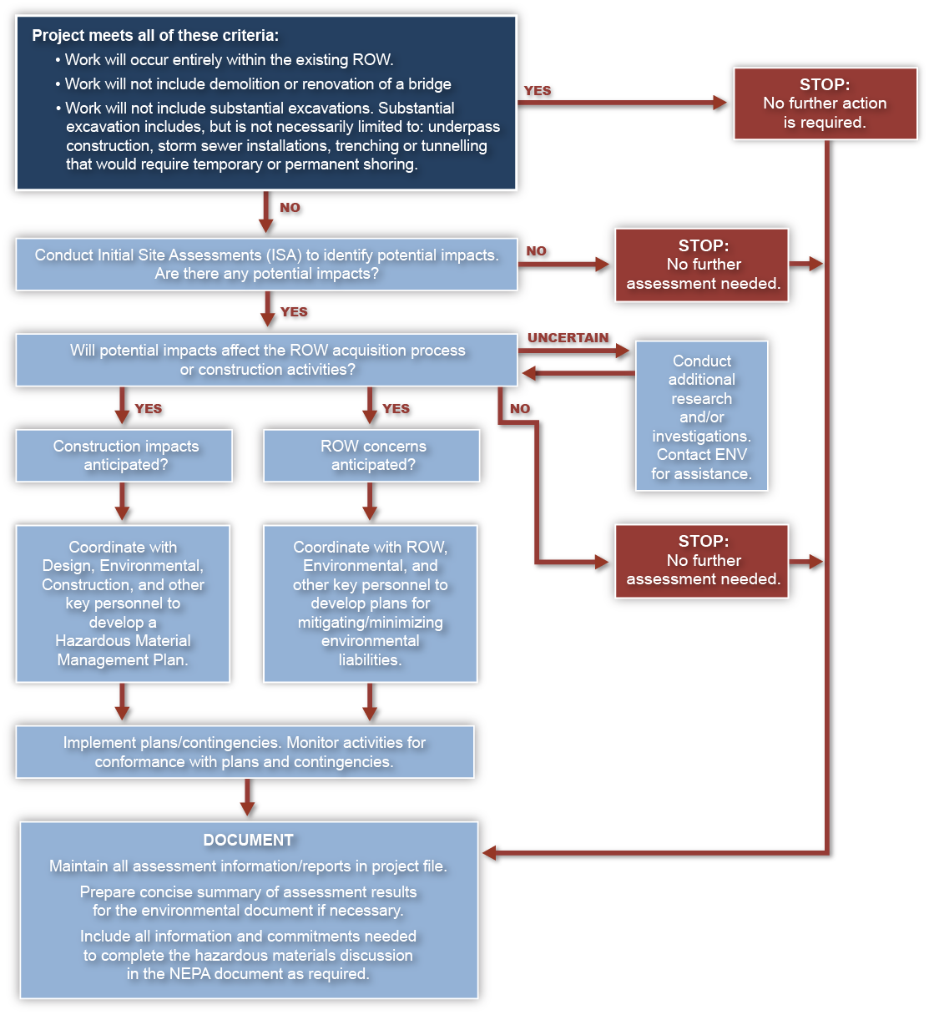
Figure 1. General Procedural Process for Hazardous Materials Management

3.1 Requirement Triggers
The project sponsor must identify and assess potentially contaminated sites by using the site assessment process if any of the following project conditions are met:
- Work will occur outside the existing ROW.
- Work will include demolition or renovation of a bridge as defined by TxDOT Standard Specifications for Construction and Maintenance of Highways, Streets, and Bridges
- Work will include substantial excavation operations. Substantial excavation includes but is not necessarily limited to underpass construction; Storm sewer installations; or trenching and tunneling that would require temporary or permanent shoring.

3.2 Procedural Process
Once triggered, the procedural process consists of the following general actions; however, not every action will be required for every project. For example, if the site assessment identifies no issues, then only Steps One and Two are necessary.
Step One – Conduct a site assessment to identify potential hazardous materials impacts.
Step Two – Document the completion of the hazardous materials site assessment if the assessment identified no issues.
Step Three – Conduct additional assessments if the initial site assessment identified hazardous material issues that could impact the project.
Step Four – Coordinate with key project personnel to develop a hazardous material management plan to address the hazardous material issues before, during, and after construction.
Step Five – Communicate the hazardous material management plan to key project personnel and contractors.
Step Six – Document the hazardous materials issue and the hazardous materials management plan.

4.0 Project Scoping and Planning
Ensuring proper management for hazardous materials on transportation projects requires planning that begins in the earliest stages of project development. An appropriate hazardous materials assessment in the project scope is essential to identify hazardous materials issues that might impact project design, ROW acquisition, or construction.

4.1 Project Scoping
The project scope must address responsibilities and scheduling for studies or tasks associated with hazardous materials assessment. The scoping document may require periodic adjustment based on the findings of the assessment or changes in project design.

4.2 Constraints Mapping
The results of the hazardous materials assessment must be documented and communicated so that any constraints can be considered during subsequent phases of project development. In particular, hazardous materials issues which might impact project design or construction should be documented as one of the project’s Environmental Permits, Issues, and Commitments (EPICs) to be considered in Project Scheduling and Estimates (PS&E) development and during construction.

5.0 Site Assessments
TxDOT uses the following three types of hazardous materials site assessment standards:
- Initial Site Assessment (ISA) – This is a non-intrusive assessment for identifying hazardous materials and waste sites that could potentially impact a roadway project.
- Phase I Environmental Site Assessment (ESA) – This is a non-intrusive, generally site-specific assessment. The Phase I ESA is conducted in accordance with ASTM E 1527 standards.
- Phase II Environmental Site Assessment (ESA PH II) – This is an intrusive assessment conducted to confirm the presence soil or groundwater contamination or waste through the collection and analysis of representative site samples.
Refer to TxDOT’s Hazardous Materials in Project Development Manual, Chapter 2, for additional information about the ISA, Phase I ESA, or ESA PH II.

5.1 Initial Site Assessment (ISA)
The ISA is the primary tool for investigating TxDOT projects for the possible presence of hazardous materials, and this tool is used during the advanced planning phase. The ISA process is very similar to the Phase I ESA process, but the primary difference is that the ISA typically covers multiple parcels of land for a project corridor, as opposed to the single parcel or business development typical for an ASTM Phase I ESA.
The purpose of an ISA is to assess thoroughly the possible presence of hazardous materials within the proposed project limits. The project limits include the existing or proposed ROW and surrounding or adjacent properties. The ISA is a non-intrusive assessment, meaning the information can be gathered without actually collecting and analyzing soil, groundwater, or other types of samples. Information gathered from an ISA should be considered in alternative analysis and selection.
The components of the ISA include the following:
- Reviewing project design and ROW requirements
- Reviewing existing and previous land use
- Reviewing regulatory agency databases and files
- Performing project site visits or field surveys
- Conducting interviews, as needed
- Determining the need for further investigation or coordination
Project sponsors will use professional judgment to determine the appropriate level of investigation for each component of an ISA. The appropriate level of investigation for an ISA will depend on the project design and ROW requirements. TxDOT’s Hazardous Materials Initial Site Assessment provides guidance for determining the appropriate level of investigation for an ISA. For additional information about preparing an ISA, refer to TxDOT’s Hazardous Materials Initial Site Assessment TxDOT Hazardous Materials Toolkit.
If no concerns are identified after completing the ISA, the hazardous materials assessment is complete. Document the completion of the hazardous materials assessment and retain the results of the ISA in the project file.
If concerns are identified during the ISA, then further research, coordination, investigations, or considerations are necessary. Additionally, any assessment or investigation limitations that occur as the ISA is conducted may warrant more assessment or investigation in subsequent stages of project development. These limitations can include, but are not limited to, access denial to properties or structures and insufficient access to property owners, operators, or other authorities needed to evaluate potential concerns.
The need for additional investigation depends on the project design and ROW requirements. For example, additional investigation may be required for projects with significant excavation work, de-watering operations, structure removal, or ROW acquisition of properties with past land uses at high risk of hazardous material concerns. Additional investigation may include regulatory agency file reviews, or Phase II ESA investigations, and asbestos or lead surveys.

5.2 Environmental Site Assessment (ESA): Phase I and II
When appropriate, TxDOT may conduct a Phase I ESA to evaluate a parcel or business to satisfy a specific ROW or project need. The Phase I ESA is in accordance with ASTM standards and the corresponding Environmental Protection Agency (EPA) “all appropriate inquiry” requirements for hazardous substance liability protection.
TxDOT uses the ESA PH II to evaluate property further for the possible presence of hazardous materials. The main purpose of conducting the ESA PH II is to determine whether known or possible contamination might be in the project area and encountered during construction. Completion of the ESA PH II prior to the project’s final NEPA decision is typically not necessary.
The information from the ESA PH II may be useful in developing cost-effective preventive action plans or specifications to handle any contamination found. The ESA PH II also may help to determine closure requirements of regulated facilities or contaminated areas.
ESA PH II site investigations generally include the following:
- Development of a soil or groundwater sampling and analysis plan, such as locations of borings, depths of borings, locations of monitor wells, groundwater gradient, and hydrogeologic or hydraulic testing
- Identification and characterization of the contamination through media sampling and analytical testing
- Determination of the horizontal and vertical extents of contamination that might be encountered prior to or during construction
- Assessment of worker safety and public health exposure concerns
- Determination of the regulatory handling, reuse, or disposal requirements for contaminated media
- Recommendation of a cost-effective preventive action plan to ensure the contamination is not aggravated

6.0 General Requirements for NEPA Hazardous Material Statements
Any required environmental documentation should include a statement about hazardous materials, even if no concerns are found. This statement should provide sufficient evidence that the project was adequately investigated for known or possibly unknown hazardous material contamination within the proposed project limits. The following are general guidelines for hazardous material statements in the environmental documentation:
- Describe dates, types, or scopes of site assessments or investigations conducted
- State who performed the site assessments or investigations
- Disclose any limitations of the site assessments or investigations
- Describe whether further investigation is needed
- Justify any postponement or dispensing of further investigation
- Summarize the findings of the site assessments or investigations for each alternative considered
- Describe any early coordination or consultation with the regulatory agencies, local entity, or property owners
- Justify avoiding or not avoiding known or suspected hazardous material contamination within the preferred alternative or corridor alignment
- Summarize efforts to avoid or minimize involvement with known or suspected hazardous material contamination sites during construction
- Disclose known or suspected hazardous material contamination that is expected to be encountered during construction
- Describe any required special considerations, contingencies, or provisions to handle known or suspected hazardous material contamination during ROW negotiation and acquisition, property management, design, or construction
- Describe any required further coordination, approvals, permits, and site closures with the regulatory agencies
Examples of environmental documentation language for different scenarios are provided in Hazardous Materials in Project Development Manual, Chapter 2, Section 4.

7.0 Design Changes and Reevaluations
Project sponsors should perform the following steps for design changes and reevaluations.
- Review the documentation for original or subsequent ISA(s). If an ISA has not already been performed, one is required for the portions of the project that have not already been constructed.
- Review the documentation for any investigations performed after the original environmental documentation, such as investigations to confirm the presence of, determine the extent of, or determine proper handling requirements of the contamination.
- Determine if any changes, new information, or circumstances require further assessment, research, or investigation. Reevaluate the original ISA to determine if assumptions based on preliminary design or ROW requirements are still valid.
- Perform follow-up site visits and update regulatory database list searches.

8.0 Public Participation and Coordination with Resource Agencies and Local Entities
Project specific circumstance may warrant public participation when developing plans to address hazardous materials on a project. In addition, there may be public participation requirements associated with a contaminated property that is under the oversight of EPA or Texas Commission on Environmental Quality (TCEQ) and located within the project limits. In these cases, coordination with EPA or TCEQ is necessary to determine if public participation is required because of the activity associated with the transportation project.
Prior to development of transportation plans and project programming, project sponsors should consult with regulatory agencies and review regulatory lists of known hazardous waste sites scheduled for cleanup that are located on or near the project. Sites under investigation, corrective action, enforcement, permit plans, or closure plans regulated by either EPA or TCEQ will require early coordination to determine site status, obtain approval for intrusive sampling and analysis plans, and determine design considerations that might be needed during construction. Coordination may occur with both the applicable regulatory agencies and the responsible property owner or operator of the site.
Requests for assistance or coordination with federal, state, and local agencies to assess the degree of contamination, scope of treatment, and disposal measures should be considered, initiated, and documented during advanced planning and subsequent stages of project development. Coordination with regulatory agencies, property owners or local agencies may take place concurrently with project development.
Local public agency or entity agreements with city and county agencies or a metropolitan planning organization may have been developed prior to the ISA for off-system or enhancement projects. These agreements typically require local entities to be responsible for the remediation of any identified hazardous material concerns. These agreements also may have delegated responsibilities for performing and funding site assessments, additional investigation, permits, site closure, preventive action, waste management, monitoring during construction, and post-construction monitoring.
The potential liability and estimated costs for additional testing and analysis, site closure, or waste management may create a need for additional approvals or funding from the local entity or Metropolitan Planning Organization. If site assessments identify known or possible hazardous material contamination, then additional and continued coordination will be necessary between the project sponsor and the appropriate local entity.

9.0 Documentation Requirements
For project documentation purposes, project sponsors will retain the following hazardous materials related information in the project file, when applicable.
- Site investigation report and all supporting data and figures, such as regulatory database search information, aerial photographs, interview notes, photographs, etcetera
- ESA PH II investigation reports
- Asbestos or lead inspection reports
- Preventative action plans
- Asbestos or lead abatement plans
- Correspondence related to regulatory coordination
- Special provisions and plan notes related to the management of hazardous materials
- Field logbooks
- Field data
- Specialty contractor or subcontractor agreements
- Media sample chain-of-custody records
- Analytical laboratory data
- Quality assurance and quality control reports
- Computer files
- Other applicable reports.

10.0 Review and Approval Process
The project sponsor has the authority for the final approval associated with identifying and evaluating hazardous material concerns in the early planning stage of project development to include consideration of hazardous material concerns in alignment selection, mitigation, and management within the constraints of any applicable hazardous materials’ regulatory requirements.
If the project’s hazardous materials site assessment did not reveal any involvement with hazardous materials, the normal action is for the project sponsor to approval the environmental document and the project then can proceed to the next stages of project development. If concerns are revealed, the project sponsor may still approve the project with the understanding that commitments for the project will be followed throughout the next stages of project development and construction. The project sponsor is responsible for ensuring commitments for further investigation, approvals, permits and coordination regarding hazardous materials are communicated to the appropriate right-of-way, design, and construction staff.
Following completion of the NEPA process, state and federal regulators may need to review and approve actions related to a project’s hazardous materials management prior to or during the project’s construction. The regulatory coordination, review, and approval process for several types of hazardous material issues are summarized in the TxDOT Guidance - Scheduling Considerations, Internal and External Coordination and Recommended Practices for Resolving Hazardous Materials Issues which is available at the TxDOT Hazardous Materials Toolkit website.

11.0 Abbreviations and Acronyms
Table 1. Abbreviations and Acronyms
Abbreviation or Acronym | Definition
ASTM | American Society for Testing Materials
ENV | Environmental Affairs Division of TxDOT
EPA | Environmental Protection Agency
EPICs | Environmental Permits, Issues, and Commitments
ESA | Environmental Site Assessment
ESA PH II | Environmental Site Assessment Phase II
FHWA | Federal Highway Administration
ISA | Initial Site Assessment

Revision History
Table 2. Document revision history
Effective Date  (Month Year) | Reason for and Description of Change
February 2026 | Version 4  - Updated to comply with accessibility and TxDOT branding standards.
July 2014 | Version 3  - Updated information associated with work actions that trigger the need for completion of a hazardous materials site assessment. This revision was necessary as result of revising the Hazmat Initial Site Assessment (ISA) threshold criteria in other TxDOT guidance. Other editorial edits were made throughout.
April 2014 | Version 2  - Made minor editorial edits to Section 3. Modified Figure 1 and Section 5 wording to be consistent with wording in the CE Checklist related to hazardous materials.
February 2014 | Version 1  - Used to focus on the identification, management, coordination, and documentation of hazardous materials during the National Environmental Policy Act process.

