


Vendor Contact

A TxDOT CCIS Job Aid


12/10/2025

R



Vendor Contact Users
Vendor Contacts are assigned by the consulting firm. Vendor Contacts manage the firms Precertification & PTC form records.

CCIS
Consultant Certification Information System (CCIS) is system administered by Texas Department of Transportation to manage precertifications and complete Project Team Composition. (PTC) Forms for consulting firms.

Table of Contents
Purpose 3
Initial CCIS Community Access Request 3
Creating a New Vendor Contact 4
Password Reset for Vendor Contacts 6
Updating Firm Information 7
Completing Firm Renewal 8
Download a Renewal Certificate 10
Creating a New Employee 10
Transferring an Employee Record 11
Adding Employee Precertifications* 11
Requesting Additional Details on a Denied Application 12
Adding Employee Projects* 13
Adding Employee Certifications* 15
Submitting Renewal Certificates – ONLY for Work
Categories 3.7.1 & 4.7.1 17
Project Team Composition (PTC) Form 18
Resetting the PTC Form 24

Please note, sections marked* are required for Precertification Applications

Purpose
The purpose of this Job Aid is to provide guidance to consulting firms and their assigned Vendor Contacts on navigating the CCIS system. This includes managing the firms’ information, employees, precertifications, and Project Team Composition (PTC) forms.

Initial CCIS Community Access Request
New firms should follow these steps to create a new firm account. If you would like to request access to an existing firm, please navigate to the Vendor Contact Request Submission section of this Job Aid.
- Navigate to the CCIS login screen.
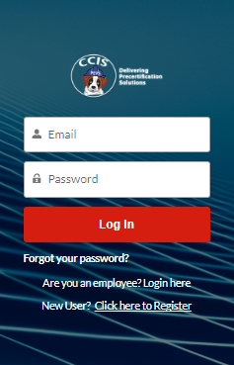
- Select New User? Click here to Register.
- Complete all fields in the form. The fields with an asterisk (*) next to them are mandatory to move forward.
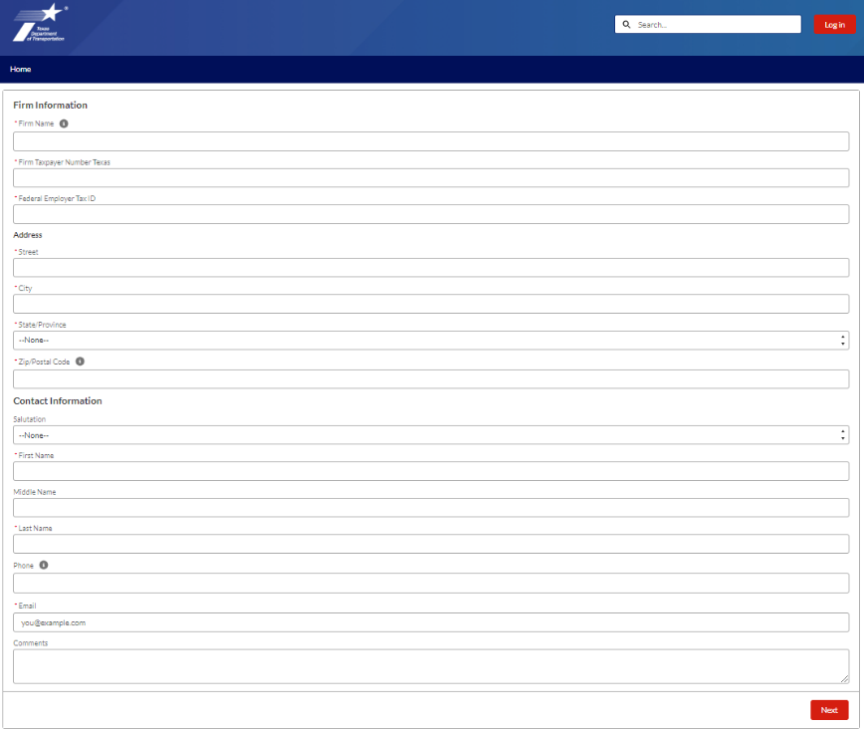
- After completing the fields select Next on the bottom right corner.
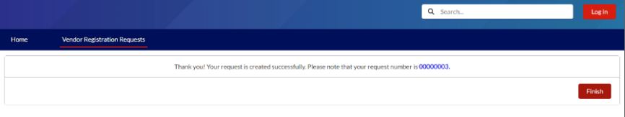
- This message will generate: Thank you! Your request is created successfully. Please note that your request number is 00000XXX. Select Finish.
- Your request is entered into a queue for approval by the Precertification Manager.
- If accepted, you will receive an email with your credentials to log into the system.
- If declined, you will receive an email notification with a reason for denial.
- Upon approval, you will receive an email with login credentials. The email will contain a link for a password reset. Click the link in the email to set up a new password.
- You now have access to the CCIS community and your Firm’s Account.

Creating a New Vendor Contact
An existing registered Vendor Contact from the firm should follow these instructions to request CCIS access for a new vendor contact for the same firm. Each Vendor Contact should have their own login credentials, and they should not be shared between users.

- Login to CCIS.
- Select the Firm Information tab at the top of the screen.
- Select your Account name (your firm’s name).
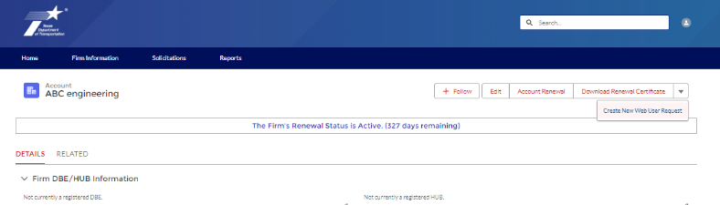
- On the top right corner of the Account page, select the down arrow, and then Create a New Web User Request.
- Complete all fields in the form and select Next. The fields with an asterisk (*) next to them are mandatory to move forward.
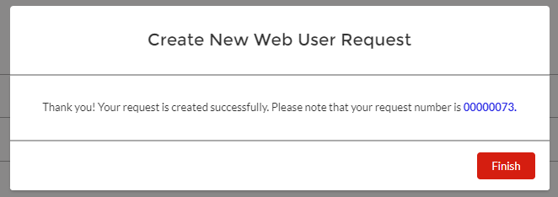
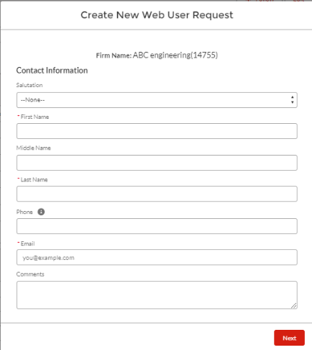
- This message will generate: ‘Thank you! Your request is created successfully. Please note that your request number is 00000XXX.’ Select Finish.
- If accepted, the new user will receive an email with log in credentials.
  - The email will contain a link for a password reset. The new user must click the link in the email to set up a new password and complete their new user registration.
- If declined, the user who created the request will receive an email notification with a reason for denial.

Password Reset for Vendor Contacts
Follow these instructions to reset your CCIS Password.
- Navigate to the login screen for CCIS.
- Select Forgot your password?
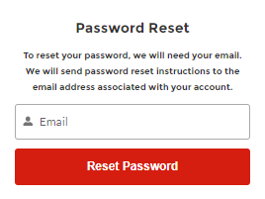
- Enter the email address you used to register in CCIS and select Reset Password.
- You will receive an email containing a link to reset your password.
- Click the link in the email and create a new password for your CCIS Community Page login.
- Enter your new password twice. Your password must include:
  - 10 characters
  - 1 letter
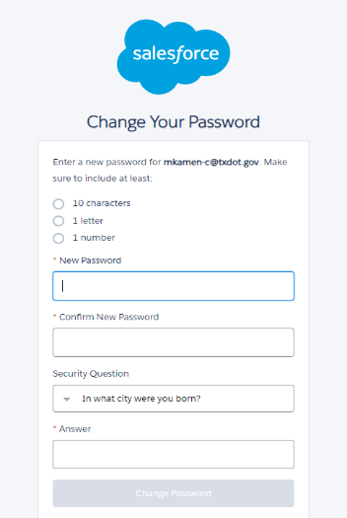
  - 1 number

- Select Change Password.

Updating Firm Information
Follow these instructions to update your firm information.
- Login to CCIS.
- Select the Firm Information tab at the top of the screen.
- Select your Account name (your firm’s name).
- On the Details tab you can edit the following:
  - DBE & HUB status
  - Firm CEO name
  - Personnel Totals
- On the Details tab, these items are not editable by you. If any of these items require updating, please email the Precertification Manager, PEPS_CCIS_Precert@TxDOT.gov.
  - Account Name
  - Federal Emp Tax ID
  - Firm Taxpayer Number Texas
  - Administratively Qualified Data
  - Administratively Qualified Expiry Date.
- On the Related tab you will find the following sections.
  - Vendor Contacts
  - Employees
  - Firm Branches
  - Previous Vendor Names – please do not edit these fields. We are currently working to have this edit option disabled. If you have a firm name change, please email the Precertification Manager, PEPS_CCIS_Precert@TxDOT.gov.
  - Equipment
  - Precertifications

Completing Firm Renewal
Follow these instructions to complete your firms’ Account Renewal. All Account information needs to be renewed by March 31st every year. As a reminder, Vendor Contacts will receive an email reminding them to renew at the following times.
- First week in January
- First week in March
- On April 1st notifying them that their Account is now inactive.
- Login to CCIS.
- Select the Firm Information tab at the top of the screen.
- Select your Account name (your firm’s name).
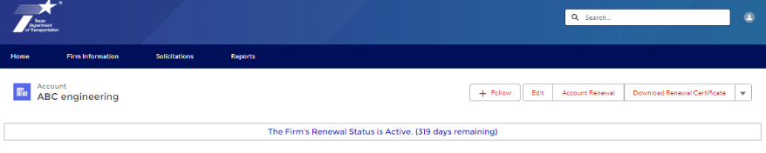
- Select Account Renewal at the top right corner of the Firm’s Account screen.
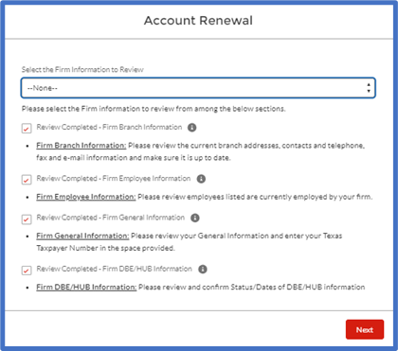
- Select each item from the dropdown menu and update as needed. As you go through each section the fields will auto-populate with a checkbox. After all fields are checked, select Next.
- You will receive the confirmation message: Your firm Renewal has been completed. You can generate and download the PDF file using the Download Renewal Certificate button on Account page.
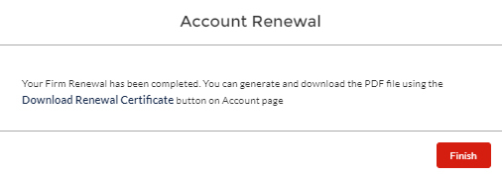
- Select Finish to complete your renewal.

Download a Renewal Certificate
Follow these instructions to download your firm’s renewal certificate.
- Login to CCIS.
- Select the Firm Information tab at the top of the screen.
- Select your Account name (your firm’s name).
- At the top right corner of the firms’ Account screen, select Download Renewal Certificate.
- The file will generate, and you have the option to download or print.

Creating a New Employee
Follow these instructions to create a new employee record in CCIS. Before following these instructions, please confirm with the new employee and the Precertification Manager that the employee has no previous history in CCIS with another firm. If an employee has previous precertifications that need to be transferred, please skip to Transfer Employee Record section.
- Login to CCIS.
- Select the Firm Information tab at the top of the screen.
- Select your Account name (your firm’s name).
- Select the Related tab on your firms’ Account screen.
- Navigate to the Employees (Associated Firm) section and select New at the top right corner of this section.
- Enter all required fields and select Save.

- At the top of the screen, you will receive a confirmation message:
- You will now find the employee listed in your Employees (Associated Firm) section in CCIS.

Transferring an Employee Record
Follow these instructions to transfer employee precertifications to your firm.
- Send an e-mail to PEPS_CCIS_Precert@TxDOT.gov to request the transfer of the employee’s record to your firm.
- The Precertification Manager will confirm within 2-3 business days to confirm the transfer or request additional details, if needed.

Adding Employee Precertifications*
Follow these steps for each work category you are seeking approval for the employee. Before proceeding with this section, please be sure you have your employee’s completed Precertification Application Form.
- Login to CCIS.
- Select the Firm Information tab at the top of the screen.
- Select your Account name (firm name).
- Select the Related tab on your firms’ Account screen.
- Navigate to the Employees (Associated Firm) section and select the employee you are working on.
- Select the Related tab on the Employee Record screen.
  - Toward the middle of the screen, you will find the Precertifications already entered for this employee, if any.
- At the top right corner of the screen, select Add Precertification to add a new work category.
- Select the Group and Work Category you would like to add for this employee.
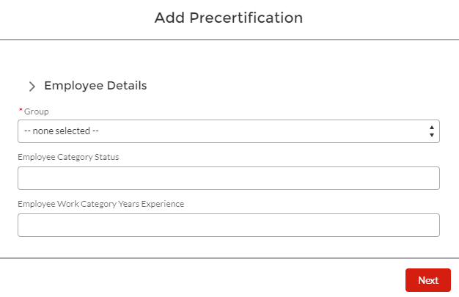
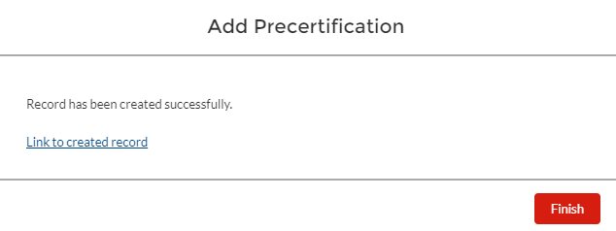
- Select Next to create the record.
- Select the Link to created record.
- This opens the Precertification Record screen.
- Once you are ready to submit this request for review, select Submit for Approval at the top right corner of this Precertification Record screen.
  - Before submitting, be sure you have entered all applicable projects and certifications associated with this work category.

Requesting Additional Details on a Denied Application
Follow these instructions to request additional details on a denied application. To protect the integrity of the precertification review process, the identity of the subject matter experts (Review Officers) is not shared. The Precertification Manager bridges the gap in case any questions arise.
- Send an e-mail to PEPS_CCIS_Precert@TxDOT.gov to request the additional details on a denial.
The Precertification Manager will reach out to the Review Officer and respond back to your e-mail within 5 business days with the response from the Review Officer.

Adding Employee Projects*
Follow these steps for each project record you need to create for each employee. Before proceeding with this section, please be sure you have your employees completed
Precertification Application Form.
- Login to CCIS.
- Select the Firm Information tab at the top of the screen.
- Select your Account name (your firm’s name).
- Select the Related tab on your firms’ Account screen.
- Navigate to the Employees (Associated Firm) section and select the employee you are working on.
- If the employee is not listed here, please reference the instructions on this Job Aid for Creating a New Employee or Transferring an Employee Record.
- Select the Related tab on the Employee Record screen.
- At the bottom of this screen, you will find the Projects already entered for this employee, if any.
- At the top right corner of the screen, select Add Project to add a new project record for this employee.
- Enter the required information in all fields.
- Important Note: The Project General Description should be populated with a general description of the project. You will enter the specific work performed by the applicant in an upcoming screen.
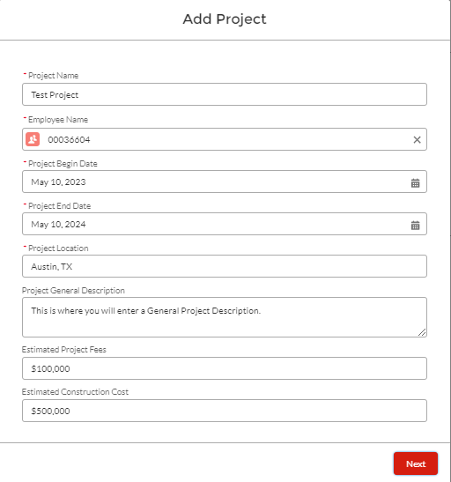
- Select Next.
- Select at least one group and work category for which you would like this project to be considered.
- In the Description of Work Category, enter the detailed description of the work performed by the employee as it relates specifically to this work category.
The information entered here is what is reviewed by the Review Officer for approval.
  - It is important that you are entering the details from the perspective of the employee.
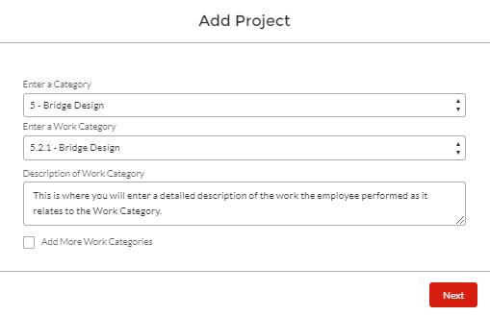
  - This should be entered in first person format, using terms such as ‘I performed,’ ‘I designed,’ ‘I managed,’ etc.

- You may check the box to Add More Work Categories and follow steps 10-11 above.
- Once you are done adding work categories, select Next.
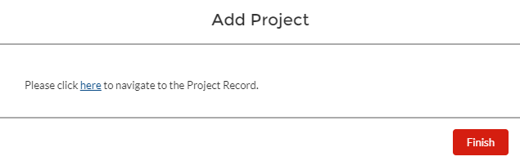
- To view the completed project record, select Here on the pop-up window, or select Finish and find the project listed in the Projects section at the bottom of the screen.
- To view the associated work categories, select Related in the project record.
- To add additional work categories, you would like to be considered with this project, select New.
- Follow steps 10-11 in the Adding Employee Projects section and select Save.

Adding Employee Certifications*
Follow these steps for each project record you need to create for each employee. Certifications include training courses required for a work category, licenses, educational degrees, etc. Before proceeding with this section, please be sure you have your employee’s completed Precertification Application Form.
- Login to CCIS.
- Select the Firm Information tab at the top of the screen.
- Select your Account name (your firm’s name).
- Select the Related tab on your firms’ Account screen.
- Navigate to the Employees (Associated Firm) section and select the employee you are working on.
  - If the employee is not listed here, please reference the instructions on this Job Aid for Creating a New Employee or Transferring an Employee Record.
- Select the Related tab on the Employee Record screen.
  - At the top of this screen, you will find the Certifications already entered for this employee, if any.
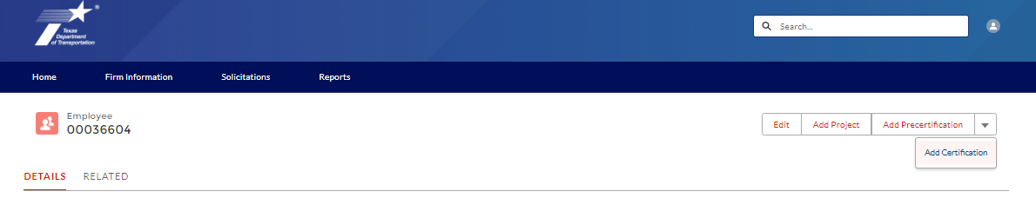
- At the top right corner of the screen, select the down arrow and Add Certification to add a new certification record for this employee

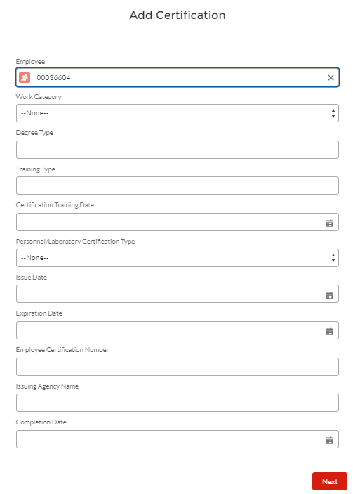
- Enter required information in all fields and select Next.

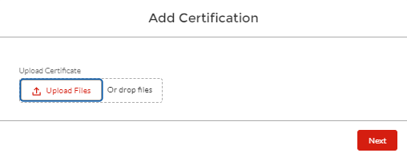
- Upload certification documents, if applicable, and select Next.

Submitting Renewal Certificates – ONLY for Work Categories 3.7.1 & 4.7.1
Follow these steps for submitting renewal certificates for work categories 3.7.1 & 4.7.1. This should be completed every 5 years for each training requirement. Typical review processing time is 10 business days.
- Login to CCIS.
- Select the Firm Information tab at the top of the screen.
- Select your Account name (your firm’s name).
- Select the Related tab on your firms’ Account screen.
- Navigate to the Employees (Associated Firm) section and select the employee you are working on.
- Select the Related tab on the Employee Record screen.
- Select the certification record previously created for the same course you are updating.
- At the top right corner of the Certification screen, select Submit Certificate for Review.
- Complete all required fields.

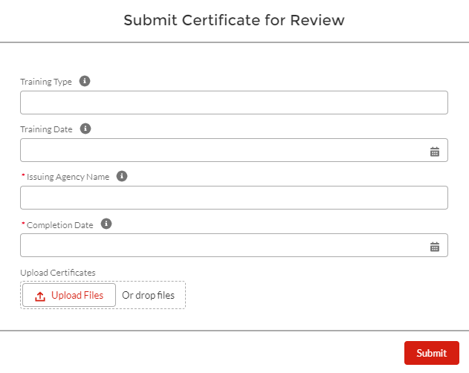
- Upload a copy of the certificate of completion.
- Select Submit to place this certificate in queue for review and approval by the Review Officer.

Project Team Composition (PTC) Form
Follow these instructions to complete a PTC Form.
- Login to CCIS.
- Select the Solicitations tab at the top of the screen.
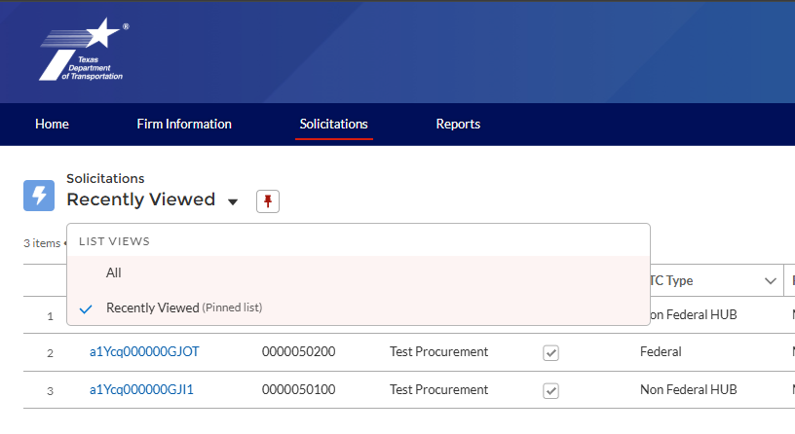
- Select the List View to view All open solicitations.

- Select the Solicitation Salesforce ID (blue text) for the solicitation you are working on.
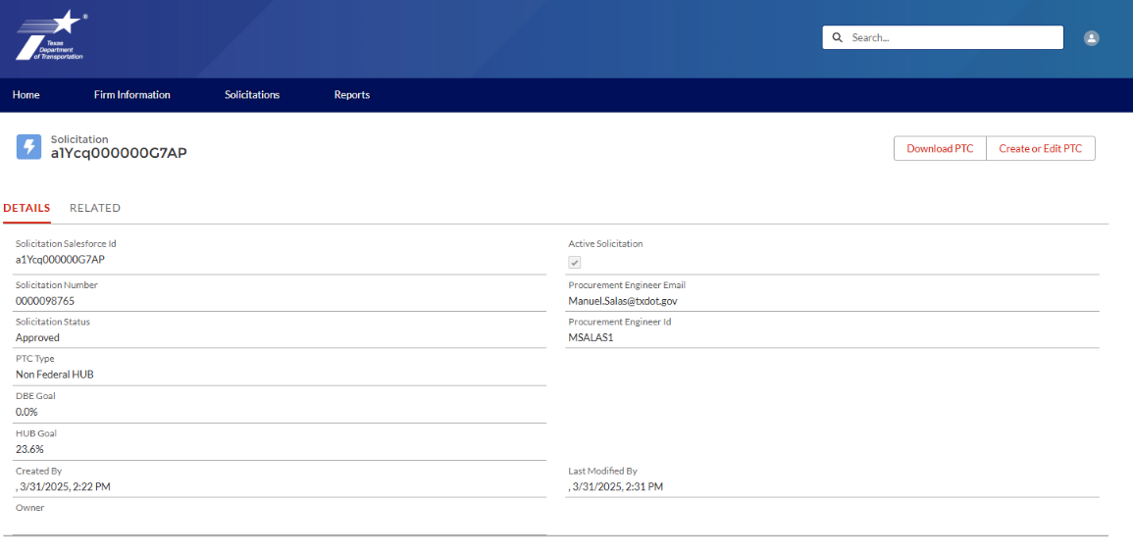
- Select Create or Edit PTC to begin editing the PTC form.

- A pop-up of the PTC Instructions page appears when you open the solicitation. After carefully reading through the instructions, select OK.
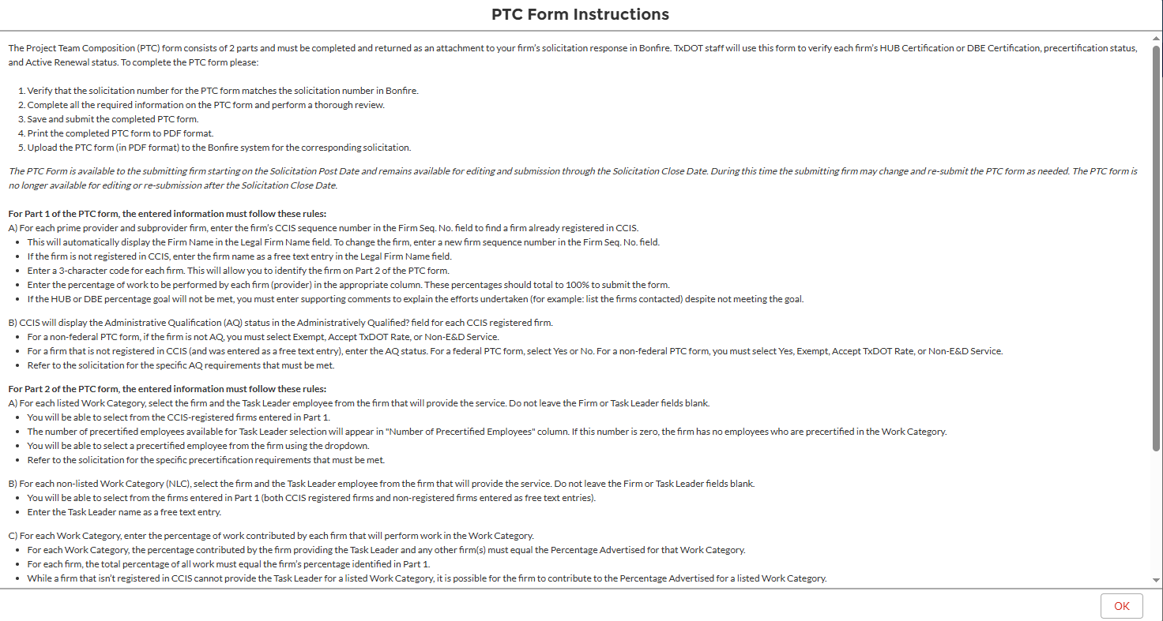
  - You may refer to these instructions later by selecting PTC Instructions at the top right corner throughout the editing process.
- On part 1 of the PTC form, the following fields are auto-populated fields based on the information from your Firm Information as previously recorded in CCIS.
  - DBE/HUB status – if this field is populating incorrectly, navigate to the Firm Information tab, and follow the instructions from the Updating Firm Information section of this job aid to make necessary updates. After you save changes in Firm Information, navigate back to the Solicitations tab, and open the PTC Form. The DBE/HUB status is auto populated with any updates made.
  - Legal Firm Name – if this field is populating incorrectly, send an e-mail to the Precertification Manager PEPS_CCIS_Precert@TxDOT.gov.
  - Vendor ID Number – if this field is populating incorrectly, send an e-mail to the Precertification Manager PEPS_CCIS_Precert@TxDOT.gov.
- Enter your firm’s Acronym/Abbreviation and Prime Percentage.
  - Acronyms/Abbreviations are assigned by the Prime provider. Prime and subproviders will be identified by their assigned acronym/abbreviation in the next section of the PTC form.
- In the subsequent section for Subproviders, enter the following information for each provider.
  - Firm Sequence Number – if the subprovider is not registered in CCIS, skip to step 10.
  - Acronym/Abbreviation
  - Administratively Qualified (AQ) status –
    - For a Federal procurement this field is auto populated.
    - For a Non-Federal Procurement this field is auto populated if Yes. If the field does not auto populate, then this firm is not Administratively Qualified, and you must select one of the following options from the dropdown menu:
Non-E&D Service
No-Accept TxDOT Rate
No-Exempt
  - Percentage
- Enter the following information for each provider that is not registered in CCIS.
  - Acronym/Abbreviation
  - Legal Firm Name
  - Vendor ID Number
  - AQ status
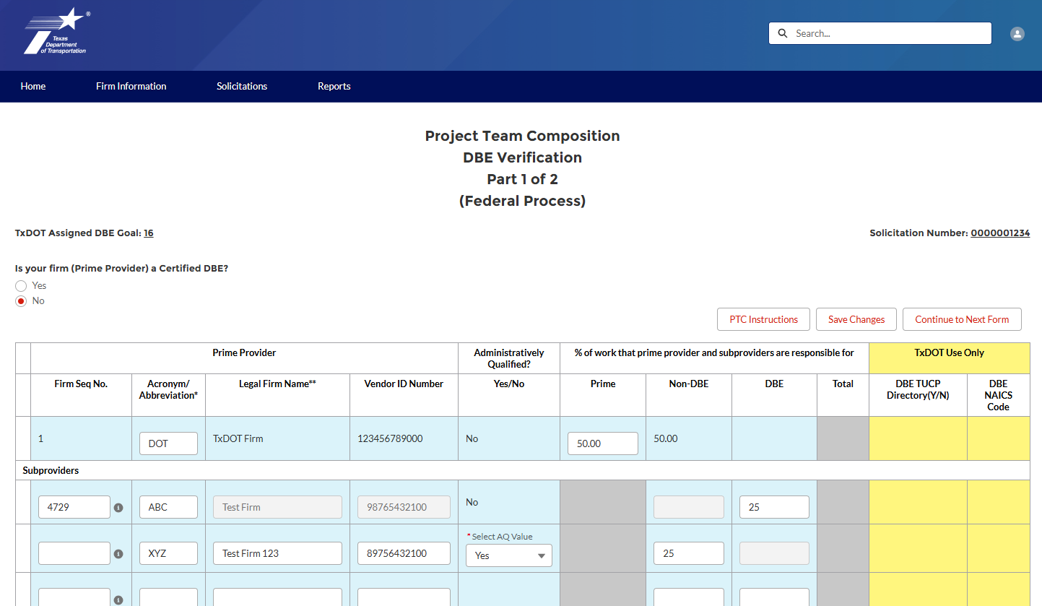
  - Percentage

- After you have completed Part 1 of the PTC form, select Save Changes.
  - Ensure that the Total column equals 100%.
- Select Continue to Next Form to move on to Part 2.
- On part 2 of the PTC form, Work Categories are listed in each row. For each Work Category, select the Firm/Task Leader that you are proposing for the procurement.
- For each Work Category, enter the percentages as you plan to divide amongst Prime and Subproviders.
  - If you are planning to assign a percentage of an Engineering and Design (E&D) related service to a firm that is not Administratively Qualified (as indicated in Part 1), then you will be required to provide an explanation.
    - Important Note: on a Federal Procurement, the prime and subproviders are required to be Administratively Qualified to perform any E&D related service.
- After you have completed part 2 and your total Work Category percentage equals 100% select Save Changes.
- You must select Complete to initiate a validation check. The CCIS system will validate the following information:
  - Total percentages have been met for each Work Category.
  - A firm and Task Leader have been selected for each Work Category.
  - Total Work Category percentage distributed equals 100%.
  - Validated HUB or DBE goals have been met.
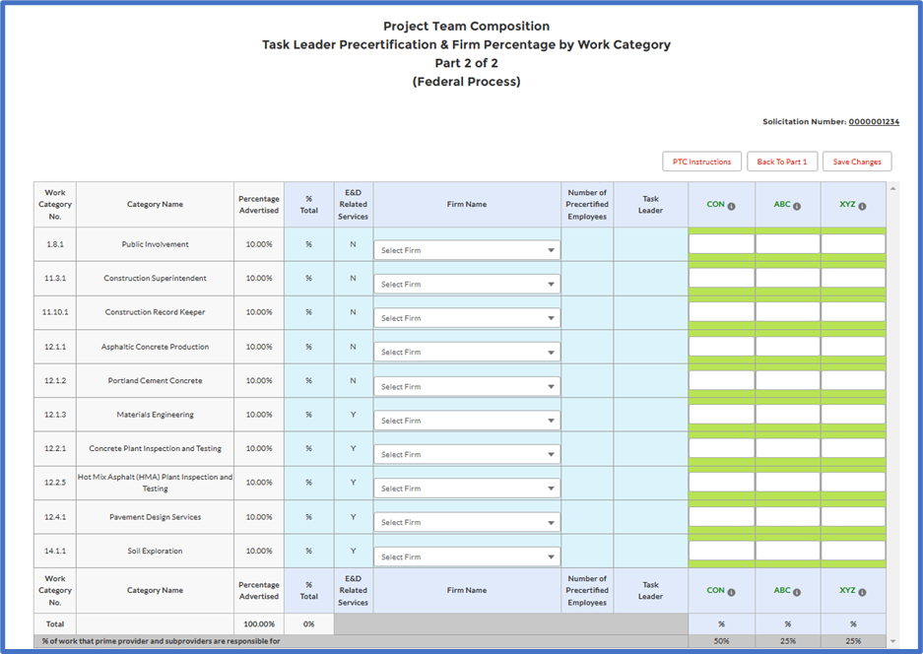
    - If the goal has not been met, a pop-up window appears where you will be prompted to provide an explanation.
- After completing validations on the PTC form, select the Solicitations tab, and select the solicitation you are working on.
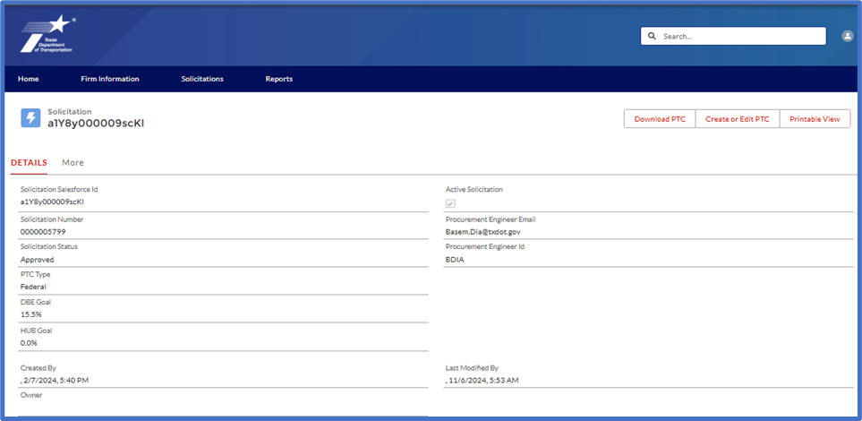
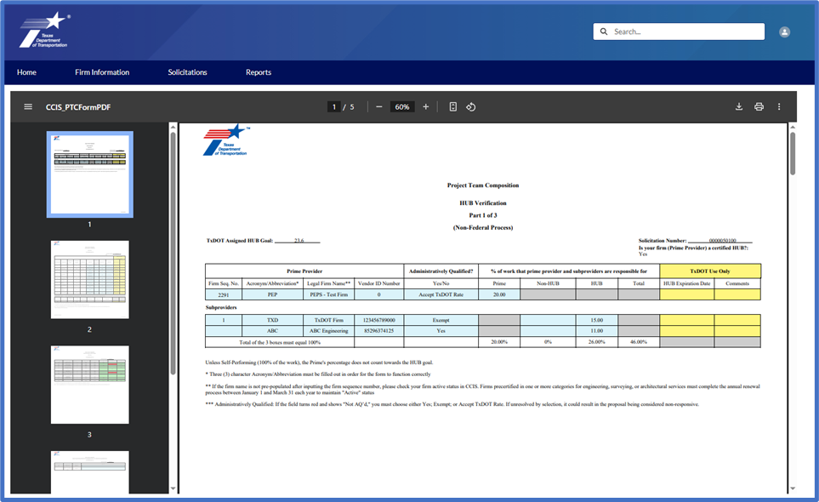
- Select Download PTC to generate a PDF file of the PTC form you have just completed.

- Select the Download icon and complete your internal quality review check.
- For the quality review check – be sure to double check all data recorded on your downloaded PTC form. Be sure that all information matches your records, and all calculations add up correctly.
- If the downloaded PTC form does not look correct, do not try to edit the PTC form in CCIS. Follow the instructions in the next section to reset the PTC form.
- Upload your completed PTC form to the TxDOT Procurement Portal.

Resetting the PTC Form
Follow these instructions to clear your entire PTC form and start over from the beginning.
- Login to CCIS.
- Select the Solicitations tab at the top of the screen.
- Select the List View to view All open solicitations.
- Select the Solicitation Salesforce ID (blue text) for the solicitation you are working on.
- Select Create or Edit PTC to begin editing the PTC form.
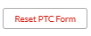
- Select Reset PTC Form at the top right corner on part 1 of the PTC form.
- Start over following the instructions found in the Project Team Composition section of this Job Aid.

