


TxDOT Active Engineering and

Engineering Related Contracts

(Rider 51) Dashboard User Guidance
02/11/2026

Introduction
This is a guidance document for the TxDOT Active Engineering and Engineering Related Contracts (Rider 51) dashboard. This dashboard displays basic contract information for contracts that that are currently active—meaning they have been executed but not yet terminated—as well as contracts in suspended status.

Steps
- Bookmark this dashboard using the following link:
https://tableau.txdot.gov/views/ActiveEngineeringContracts/ActiveEngineerinContracts
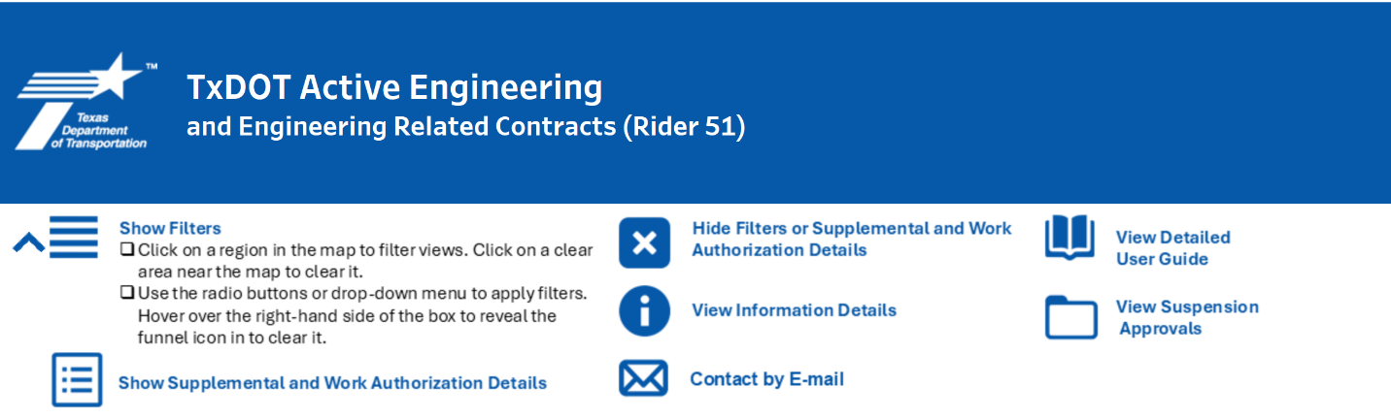
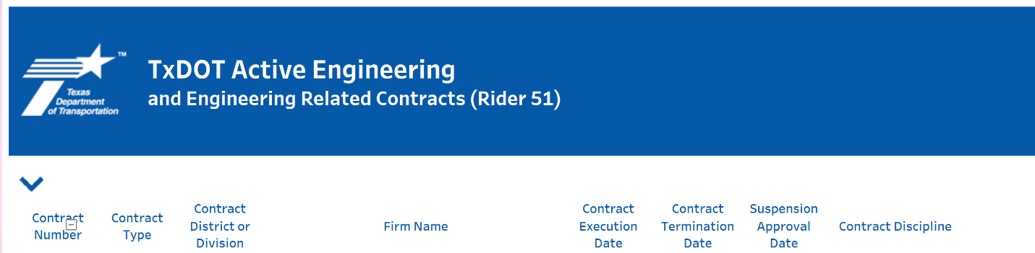
- Hide or show the Help window using the up or down arrow.
Hide Help Window
Show Help Window
The following steps explain how to use the navigation buttons on the dashboard.

- Hover over the info icon to see detailed notes. This will show the current data scope.

- Click the book icon to view this User Guidance.

- Hide the filters panel using the 'X' button. By default, this panel is open when the dashboard loads.
Hide Filters Panel

- Click the three horizontal bars located in the top menu to unhide the panel, then select and customize the view.
    - Hover over a district on the map to display its name and number.
    - Click a district to filter the work authorization to that district or division.

Note that while it is possible to select the region using the filters options below the map, this will require that you click on the X near the funnel icon to clear filters.

  - All divisions are represented by Austin district on the map.
  - If the district selected does not include an executed work authorization, the details window will default to displaying the district or division managing the contract.
  - Click on a region in the gray area near the map to clear the map filter.
  - Filter by Category, Contract Status, District or Division name, Contract Type, Contract Discipline Type, and Contract Number.
- Indefinite Deliverable (ID) contract: A service-oriented contract of limited dollar value and duration (maximum of five years) that includes a general scope of services and uses work authorizations to define the specific project assignment and prime provider’s responsibilities, as defined by TAC Rule 9.32
- Specific Deliverable (SDW) contract: A project-oriented contract that includes a detailed scope of services that sufficiently defines a detailed negotiated budget and schedule, as well as the prime provider's responsibilities. The contract may use work authorizations to issue the work (TAC Rule 9.32)
- Specific Deliverable without Work Authorizations (SDWO) contract: An SD contract authorizing all work upon contract execution.
- Specific Deliverable Multiphase (SDM) contract: A type of specific deliverable contract where the services are divided into phases and the specific scope of work and associated costs are negotiated by phase as the project progresses (TAC Rule 9.32)
- Note that filters have autofill functionality. Enter text in the textbox to narrow down options. All filters have this functionality and can be used simultaneously.
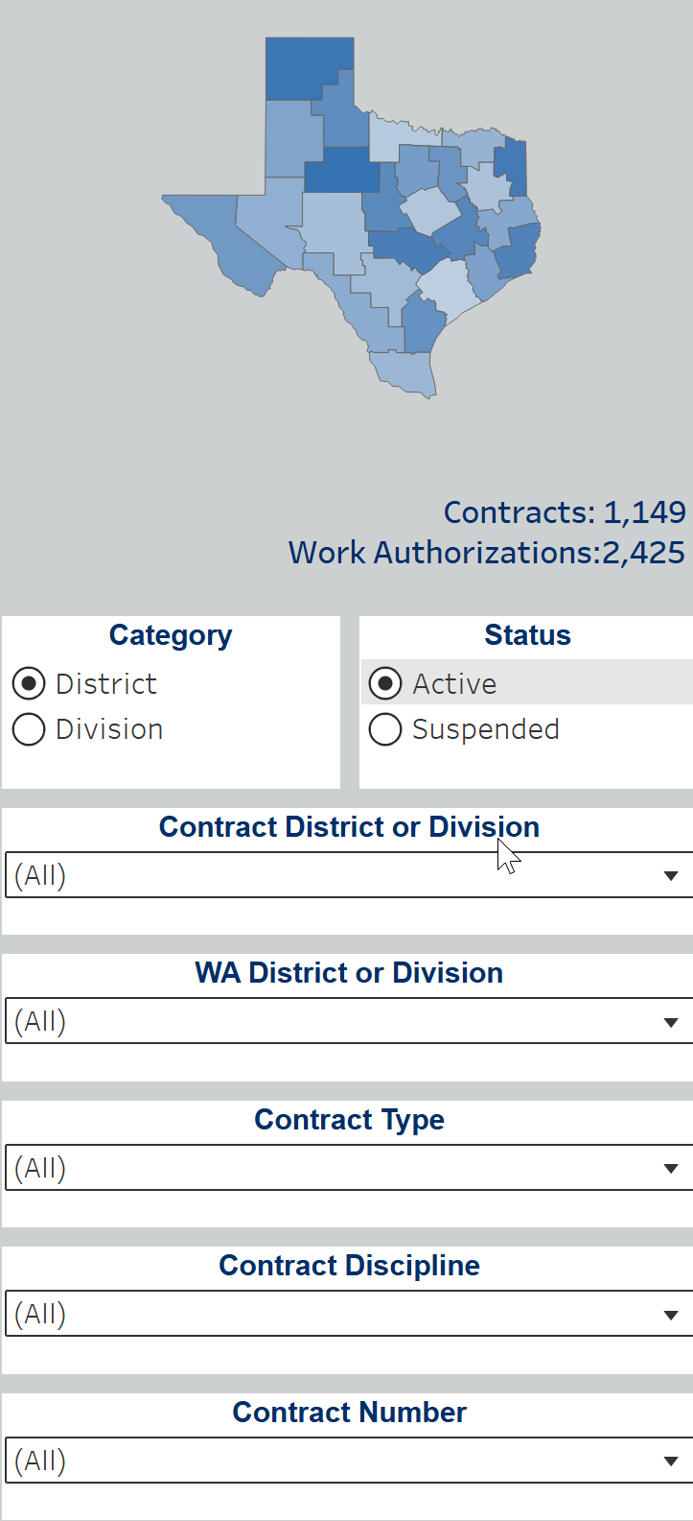
- Click on any open white space in the dashboard to apply a selection.

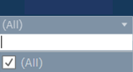
- Check ALL options box or click on the X near the funnel icon to clear filters.
- Hide the filters by clicking on the large X icon located in the top menu.
- The main display shows contracts and relevant information including but not limited to, contract type, discipline type, contract district, and execution and termination dates.
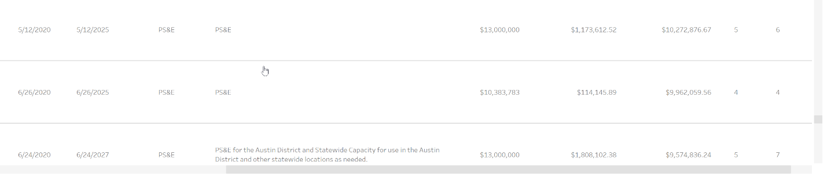
- Drag the gray scroll bar on the right side to move up and down, or on the bottom to move left and right, to view content outside the visible area of the main window.
L-R Scroll
U-D Scroll
- Click on the details icon to view supplemental or work authorization details (ID/Number and execution dates).


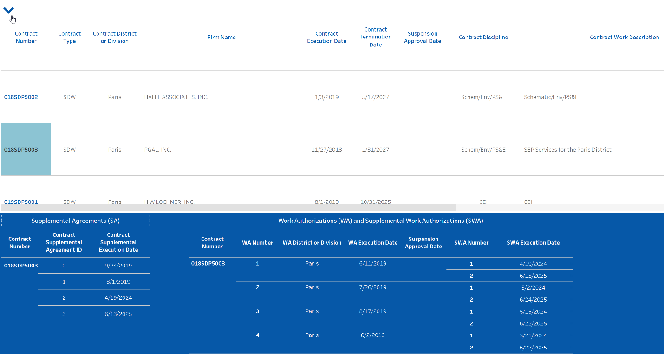
- Select a contract number in the main display to filter the supplemental details window.
Select Contract Number to filter supplemental details.
SA & SWA ID/Number and Execution Dates

- Hide the supplemental details by clicking on the large X icon located to the left of the envelope icon in the top menu.
- Use the plus or minus symbol to expand/collapse columns to view/hide details.
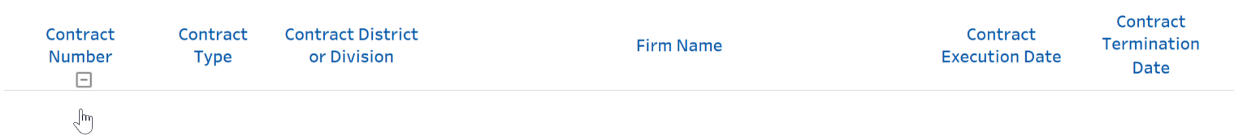
- Hover over the header Contract Number, a minus (-) sign will appear, indicating collapsible capability. Click it to hide columns.

- Hover over the header Contract Number, a plus (+) sign will appear, indicating expandable capability. Click it to show columns.
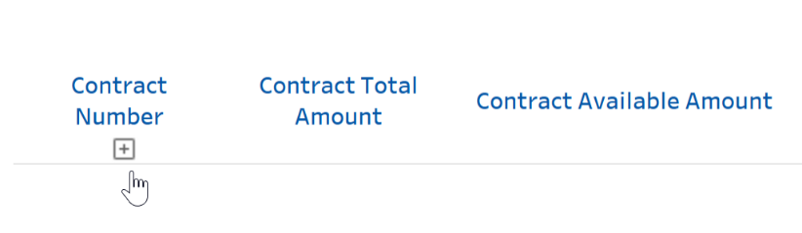
- Continue to expand the fields until the plus sign no longer appears. This means the view is fully expanded.

- Click on the folder icon to view suspension notifications.

- Click on the contact icon to e-mail icon to send inquiries to PEPS_Controls_Center@txdot.gov.

