Work Categories Tableau Dashboard
A Texas Department of Transportation (TxDOT) Job Aid for navigating the Standard Work Categories Dashboard

Purpose
This Job Aid is designed for TxDOT staff and external partners who need to navigate standard work category data using the Work Categories Tableau Dashboard. This guide outlines how to find specific work categories and download dashboard data efficiently.

Overview
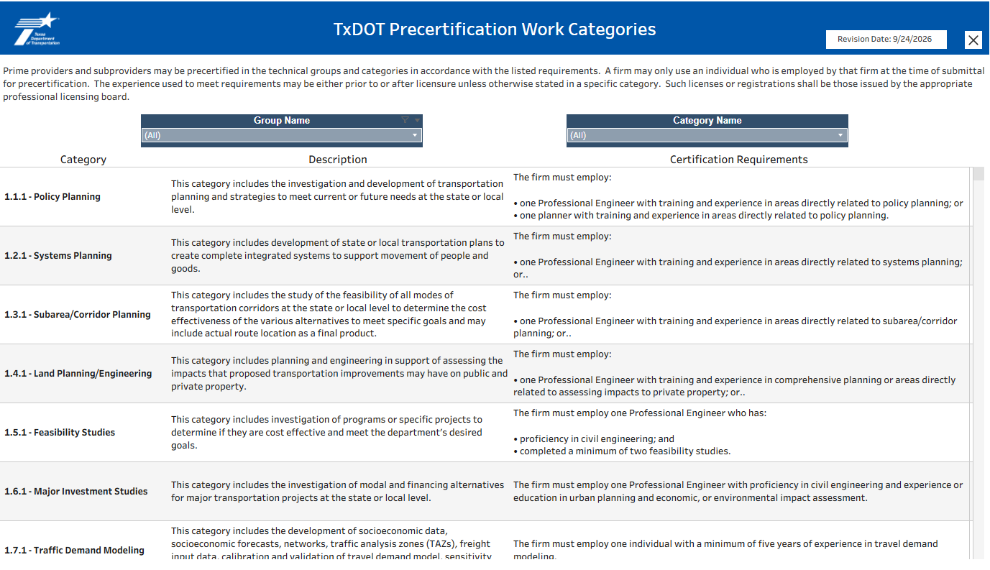
Figure 1: TxDOT Precertification Work Categories dashboard
Upon opening the dashboard, you will see the full list of standard work categories listed in numerical order. Use the vertical scroll bar to the right to navigate through the work categories.

How to find and View Specific Work Categories
Figure 2: Filter options
There are two options for filtering. You can filter by
- Group Name – to view all work categories within one group
- Category Name – to view one work category
- Remember to clear filters afterwards to restore the full list of work categories.

View All

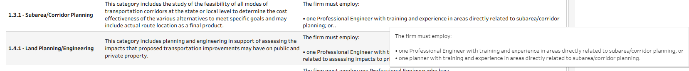
Figure 3: Cursor hovering over the field to view full text
Standard view shows the first 4 lines of language for both work category descriptions and Certification Requirements. To view all language for one cell, hover over the cell with your cursor. A new window will pop up with the full description or requirement.

Downloading
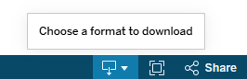
Figure 4: Selection of the download icon
Select the download icon on the dashboard toolbar, at the bottom right corner. Select PDF from the list of export options.
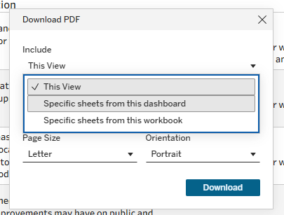
Figure 5: Selection of “Specific sheets from this dashboard” to download
Select specific sheets from this dashboard.
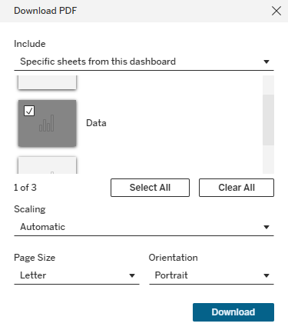
Figure 6: Selection of the “Data” field to download
Select Data only and then Download to save the file to your device.
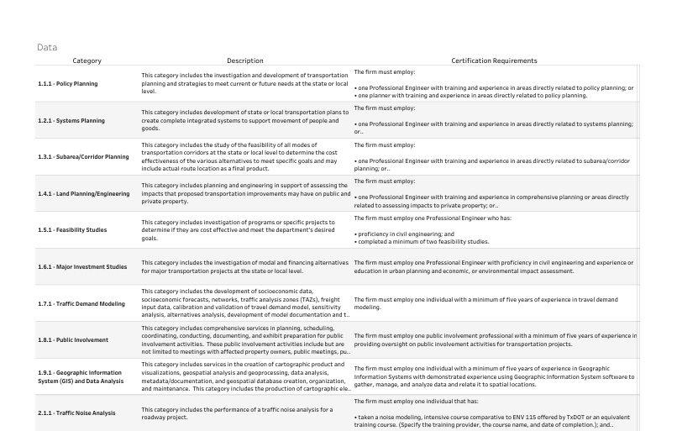
Figure 7: Downloaded view of the dashboard
Note: This action downloads a full list of the work categories. Please be advised that long block text will remain truncated. If you require the complete text, you must view it interactively on the live dashboard using the hover/pop-up feature.

